Chapter 9: Adrenergic Agents
Intro:
- The structure of sympathomimetics is based on a benzene ring with various amine side‐chains attached at the C1 position
- Where a hydroxyl group is present at the C3 and C4 positions, the agent is known as a catecholamine (because 3,4‐dihydroxybenzene is otherwise known as catechol)
- Synthetic adrenergic agents are classified according to receptor type and whether they act as agonists or antagonists
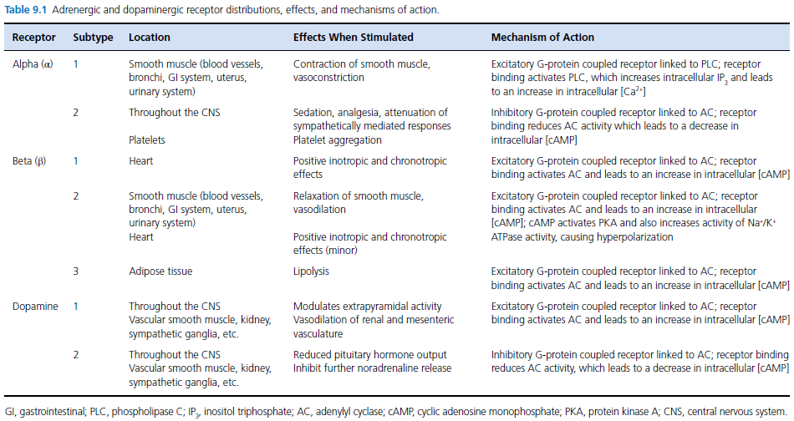
Epinephrine
- Non-selective and direct agonist at all of the adrenergic receptors (i.e., α1, α2, β1, and β2)
- Low doses of epinephrine administered by bolus (0.01 mg/kg IV) cause β1‐ and β2‐adrenergic agonist effects to predominate
- In low doses, peripheral β2‐adrenergic agonist effects result in a decrease in diastolic blood pressure and peripheral vascular resistance
- At high doses (0.1 mg/kg IV), α1‐adrenergic effects predominate, causing a marked rise in systemic vascular resistance
- Mean arterial blood pressure increases at infusion rates of 0.5 μg/kg/min and higher
- At the infusion rates tested, epinephrine was not associated with an increase in systemic vascular resistance, reflecting the predominant β‐adrenergic effects at these lower dose rates
- Epinephrine will produce a small increase in minute volume through its bronchodilator effects, which are β2‐adrenergic receptor mediated
- Pulmonary vascular resistance is increased at higher dose rates reflecting agonism at pulmonary vascular α1‐adrenergic receptors
- Plasma glucose concentration is increased via multiple mechanisms, including:
  - Inhibition of insulin secretion (an α2‐ and β2‐adrenergic effect)
  - Glycogenolysis in liver and muscle (an α1‐ and β2‐adrenergic effect)
  - Lipolysis (a β2‐ and β3‐adrenergic effect)
  - Gluconeogenesis (an α1‐ and β2‐adrenergic effect)
- Serum potassium concentration will increase initially following epinephrine administration, followed by hypokalemia caused by increased uptake of potassium into cells (a β2‐effect)
- Epinephrine causes the release of renin from the kidney through multiple mechanisms, including stimulation of intrarenal β1‐ and β2‐adrenergic receptors in addition to extrarenal adrenergic receptors
- Following intravenous administration, epinephrine is rapidly metabolized by mitochondrial monoamine oxidase and catechol‐O‐methyltransferase within the liver, kidney, and circulation to inactive metabolites
Norepinephrine
- Norepinephrine acts as an agonist at α1‐, α2‐ and β1‐adrenergic receptors, with effects at α‐adrenergic receptors predominating at clinically used dose rates
- Norepinephrine differs from epinephrine in the absence of a methyl group on the nitrogen atom
- Norepinephrine will also cause coronary vasodilation to promote increased coronary blood flow
- Norepinephrine (0.3 and 1.0 μg/kg/min) was effective at improving cardiovascular function and maintaining splanchnic function in foals
- The arrhythmogenic effects of norepinephrine are similar to those of epinephrine
- Unlike epinephrine, approximately 25% of administered norepinephrine is extracted from the circulation as it passes through the lung, where it is deactivated by monoamine oxidase and catechol‐O‐methyltransferase in the endothelial cells of the pulmonary microvasculature
Dopamine
- At low doses (1–2 μg/kg/min), effects on dopamine (DA)‐1 and DA‐2 receptors predominate
- As dose rates increase further, β1‐ and β2‐adrenergic receptor effects predominate
- α1‐adrenergic receptor effects are noted at infusion rates greater than 10 μg/kg/min
- Dopamine will also stimulate the release of endogenous norepinephrine from presynaptic storage sites at adrenergic receptors to cause an endogenous sympathomimetic effect
- Doses less than 7 μg/kg/min were insufficient to support hemodynamic variables in dogs, 10 μg/kg/min in cats
- Premature ventricular complexes much more common with dopamine
- Increased urine output associated with dopamine administration is caused by improved hemodynamic function in combination with inhibition of proximal tubular Na+ reabsorption
- Dopamine will produce vasodilation in mesenteric vascular beds mediated by DA‐1 receptor activation
- Dopamine is metabolized via monoamine oxidase and catechol‐O‐methyltransferase in the liver, kidney, and plasma to inactive compounds that are excreted in the urine as sulfate and glucuronide conjugates
Synthetics
Dobutamine
- Dobutamine primarily stimulates β1‐adrenergic receptors, but at higher dose rates (5–10 μg/kg/min) will also stimulate β2‐ and α1‐ adrenergic receptors
- Dobutamine has the potential to be proarrhythmogenic at high doses
- May cause seizures in cats
- Can cause down regulation of β1‐adrenergic receptors after 24 hours
Dopexamine
- Dopexamine is a potent stimulator of β2‐adrenergic receptors with weak agonist effects at β1, DA‐1 and DA‐2 receptors
- It has no effect on α1‐adrenergic receptors
- Dopexamine inhibits the neuronal uptake of endogenous catecholamines

Isoproterenol
- Isoproterenol is a very potent synthetic catecholamine that is an agonist at β1‐ and β2‐adrenergic receptors
- It has no α‐adrenergic receptor effects
- Isoproterenol is used to increase heart rate and myocardial contractility during anesthesia
- Isoproterenol is a potent bronchodilator, increasing anatomic deadspace and thus ventilation perfusion mismatching
- It causes stimulation of the central nervous system and therefore can increase the level of arousal during general anesthesia
- Isoproterenol increases splanchnic and renal blood flow via selective vasodilation mediated by stimulation of β‐adrenergic receptors
Phenylephrine
- Phenylephrine is a direct‐acting sympathomimetic amine with potent α1‐adrenergic receptor agonist effects
- It has no effect on β‐adrenergic receptors
- Phenylephrine has no stimulatory effects on the central nervous system
- Hepatic and renal blood flow are reduced, mediated by α1‐adrenergic receptor‐induced vasoconstriction
- Phenylephrine will reduce uterine blood flow and it is generally recommended to avoid administration during pregnancy
- It is metabolized in the liver by monoamine oxidase
Methoxamine
- Methoxamine is a direct‐acting sympathomimetic amine with specific α1‐adrenergic receptor agonist effects
- The clinical effects of methoxamine are similar to those of phenylephrine; however, methoxamine is purported to have a longer duration of action
α2‐Adrenergic receptor agonists (Dexmedetomidine, medetomidine, detomidine, xylazine, romifidine)
- These agents are not classified as sympathomimetics but they are used extensively in veterinary medicine for their excellent sedative and analgesic properties
Mixed α‐ and β‐adrenergic receptor agonists
Ephedrine
- Ephedrine has both direct and indirect sympathomimetic actions, acting as an agonist at α1‐, α2‐, β1‐, and β2‐adrenergic receptors
- It also inhibits the action of monoamine oxidase on norepinephrine
- Tachyphylaxis occurs with repeated dosing due to depletion of norepinephrine stores and therefore a reduction in the magnitude of indirect sympathomimetic effects
Adrenergic receptor antagonists
Prazosin: α1‐Adrenergic receptor antagonists
- Highly selective α1‐adrenergic receptor antagonist
- Stimulation of α1‐adrenergic receptors in the bladder neck and proximal urethra narrow the bladder outlet maintaining continence
- Prazosin produces vasodilation of arteries and veins and reduces systemic vascular resistance; this is associated with a reduction in blood pressure, with diastolic blood pressure being impacted most significantly
α2‐Adrenergic receptor antagonists (Atipamezole, yohimbine, tolazoline)
- These agents are used for the reversal of sedation produced by α2‐adrenergic receptor agonists such as medetomidine and dexmedetomidine
Non‐selective α‐adrenergic receptor antagonists
Phentolamine
- Phentolamine is a competitive non‐selective α‐adrenergic receptor blocker, with three times greater affinity for α1‐ than α2‐adrenergic receptors
- Phentolamine is used in the management of hypertensive crises due to excessive administration of sympathomimetics and pheochromocytoma
Phenoxybenzamine
- Long‐acting, non‐selective α‐adrenergic receptor blocker, with greater affinity for α1‐ than α2‐adrenergic receptors
β1‐Adrenergic receptor antagonists
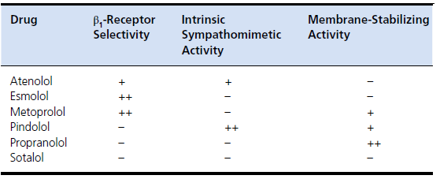
Non‐selective β‐adrenergic receptor antagonists
- Propranolol is a non‐selective β‐adrenergic antagonist without intrinsic sympathomimetic activity
- Sotalol, in addition to being a non‐selective β‐adrenergic antagonist without intrinsic sympathomimetic activity, is a class III antiarrhythmic and has potassium channel‐blocking effects

Chapter 10: Sedatives and Tranquilizers
Phenothiazines
- In humans, drugs of this class are used for antipsychotic and antiemetic effects
- Extrapyramidal side‐effects have been noted, typically with longterm use in humans or overdose in veterinary patients (tremor, coma/catalepsy, and rigidity)
- Activity at receptors, including adrenergic, muscarinic, dopaminergic, serotonergic, and histamine receptors
- The sedative effects of the phenothiazines are mediated primarily by blockade of dopamine receptors, specifically D2 receptors
- This pre‐ and postsynaptic G‐protein coupled receptor blockade leads to a decrease in cAMP and adenylate cyclase activity, calcium conductance, and alterations in postsynaptic potassium conductance
- Blockade of α1‐adrenergic, muscarinic, and histamine (H1) receptors may also play a role in sedation
- α1‐Adrenergic receptor antagonism mediates the decrease in blood pressure
Acepromazine
- Muscle relaxation is a hallmark of this sedation
- Stroke volume, cardiac output, and arterial blood pressure has been shown to decrease by 20–30% in conscious dogs administered 0.1 mg/kg IV
- Premedication with acepromazine will increase the dose of epinephrine required to induce a ventricular arrhythmia, likely due to α‐adrenergic receptor blockade
- Hematologic effects of acepromazine administration include decreased packed cell volume (PCV) and a reduction of platelet aggregation
- Hematocrit is reduced in some dogs and horses by 20–30% shortly after acepromazine administration as a result of splenic engorgement after α1‐adrenergic receptor blockade

Benzodiazepines
- γ‐Aminobutyric acid (GABA) is the primary inhibitory neurotransmitter in the CNS
- Enhances the GABA_{A} receptor’s affinity for GABA, resulting in increased chloride conductance and hyperpolarization of postsynaptic cell membranes
- Agonists facilitate the activity of GABA, this results in sedation, anxiolysis, muscle relaxation, and anticonvulsant effects typically associated with these medications
Diazepam
- Diazepam is poorly water soluble and is therefore supplied for injection in a solution of an organic solvent, including propylene glycol and ethanol
- In dogs, the elimination half‐life of diazepam following IV administration is approximately 3.2 h
- Diazepam is an unreliable sedative but is useful for providing central muscle relaxation and as an anticonvulsant
Midazolam
- Rapidly absorbed after IM administration
- Similarly to diazepam, midazolam is metabolized by hepatic microsomal enzymes
- Midazolam is unpredictable as a sedative
α2‐Adrenergic receptor agonists
- α2‐Adrenergic receptors are scattered throughout the body, in neural tissue, most organs, and extra‐synaptically in vascular tissue and platelets
- α2‐Adrenergic receptors are G‐coupled proteins
- When stimulated they inhibit adenyl cyclase activity, leading to a decrease in cAMP concentrations within the cell
- In the CNS, α2‐adrenergic receptor agonist binding leads to sedation, analgesia, muscle relaxation, and centrally mediated effects on heart rate and afterload (through decreased sympathetic nervous system activity)
- In the brainstem, binding of agonists to α2‐adrenergic receptors in the locus coeruleus and rostroventral lateral medulla (the primary areas for sympathetic outflow from the CNS) cause sedation as the discharge frequency of tracts into the cortex slows
Dexmedetomidine/medetomidine
- Dexmedetomidine is primarily used in dogs and cats, it is the dextrorotatory isomer of medetomidine
- Systemic arterial blood pressure increases initially followed by hypotension
- Dexmedetomidine at 10 and 20 μg/kg reduced the heart rate in dogs by 60 and 66%, respectively, within 5 min of IV injection
- Systolic and diastolic blood pressure increased in a stepwise fashion, with peak effects (20 and 26% changes) at 5 min
- Cardiac output decreased by approximately 66% in isoflurane‐anesthetized dogs, and increased slowly to half of baseline over 3.5 h
- As with all α2‐adrenergic agonists, the plasma glucose concentration is generally increased with dexmedetomidine
- Urine production is increased in dogs and cats

Questions:
- Fill in the blanks
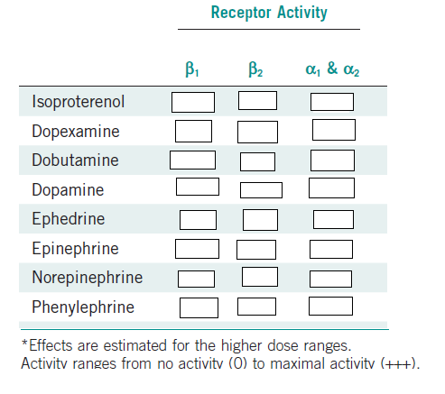
- True or False: In the 2010 paper by Debacker “Comparison of Dopamine and Norepinephrine in the Treatment of Shock. The New England Journal of Medicine” Norepinephrine was associated with a higher rate of survival compared to Dopamine
- True or False: In the 2010 paper by Debacker “Comparison of Dopamine and Norepinephrine in the Treatment of Shock. The New England Journal of Medicine” Norepinephrine was associated with a higher rate of arrhythmias compared to Dopamine
- What was the conclusion of the 2008 paper by Myburgh “A comparison of epinephrine and norepinephrine in critically ill patients. Intensive Care Medicine” ?
  - Norepinephrine achieved a MAP of >70 faster than epinephrine
  - Norepinephrine resulted in fewer arrhythmias than Epinephrine
  - There was no difference in the achievement of a MAP >70 between epinephrine and norepinephrine
  - There was decreased splanchnic perfusion with norepinephrine compared to epinephrine
- Which drug is α-1 selective
  - Prazosin
  - Phenoxybenzamine
  - Phentolamine
  - Dexmedetomidine
- How does dexmedetomidine cause sedation?
- Hematocrit is reduced in some dogs by ___________ shortly after acepromazine administration as a result of splenic engorgement
  - 0%
  - 10-15%
  - 20-25%
  - 50%

