Chapter 8 – Central Venous Pressure : An Indicator of Circulatory Hemodynamics

Interaction of System Components
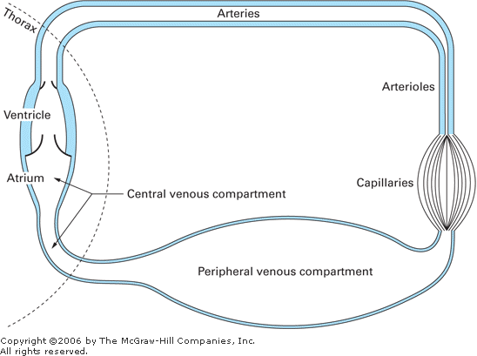
- Closed circuit ; venous side divided in (1) a large and diverse peripheral venous compartment and (2) a smaller intrathoracic central venous compartment.

Mean Circulatory Filling Pressure
- = theoretical pressure ; the actual pressure that would exist throughout the system in the absence of flow.
- Two major variables that affect mean circulatory filling pressure :
- Circulating blood volume
- Peripheral venous vessel tone.

Central Venous Pressure
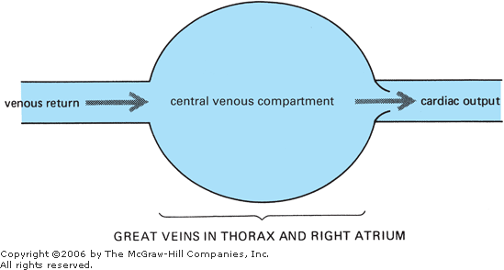
- Venous return must = CO
  - … or blood would gradually accumulate in either the central venous compartment or the peripheral vasculature. However, there often are temporary differences between CO and venous return.
  - Any change in central venous volume produces a corresponding change in CVP.
- CVP (= cardiac filling pressure)
  - Positive influence on cardiac output (Starling's law of the heart).
  - Negative effect on venous return.
  - CVP is always automatically driven to a value that makes CO = venous return.

Influence of Central Venous Pressure on Venous Return
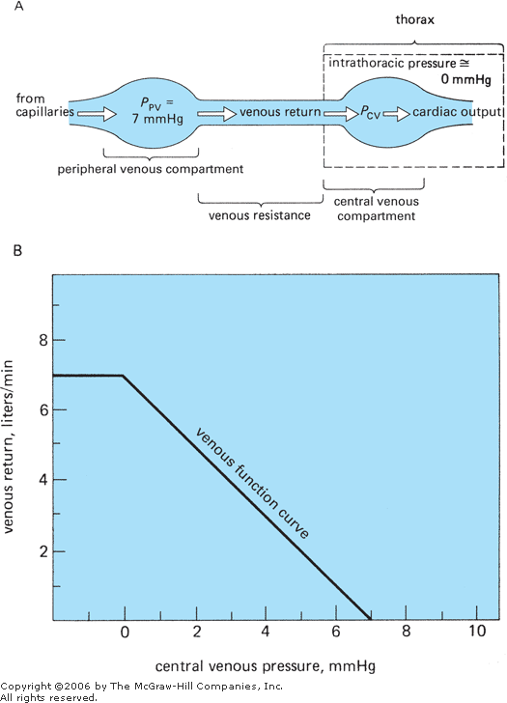
- The normal pressure in the peripheral venous compartment (P_{PV}) is usually very close to mean circulatory filling pressure (blood volume and peripheral venous vessel tone)
- = P/R,
- Decreasing CVP (for same P_{PV}) increase in pressure drop across the venous resistance elevation in venous return.
- Venous function curve
  - Venous return increases as central venous pressure drops.
  - If CVP reaches very low values and falls below the intrathoracic pressure, the veins in the thorax collapse = plateau
- The slope of the venous function curve is determined by the value of the venous vascular resistance.
  - Lower venous vascular resistance steeper.

Influence of Peripheral Venous Pressure on Venous Return
- Two ways to change peripheral venous pressure
- Changes in the volume of blood
- Changes in venous tone
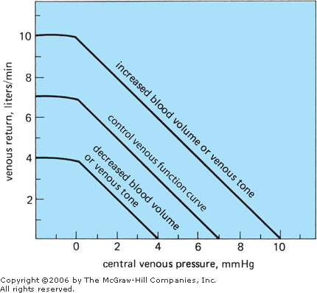

Determination of Cardiac Output & Venous Return by Central Venous Pressure
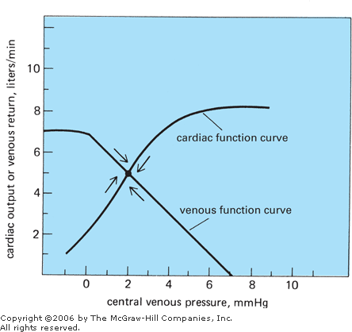.
The cardiovascular system automatically adjusts to operate at the point where the cardiac and venous function curves intersect.
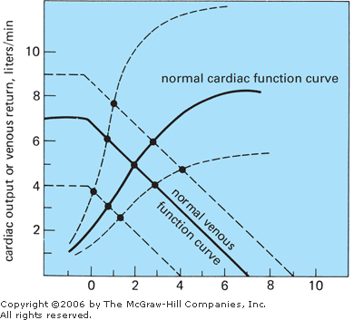

Questions

- Draw a normal venous function curve (with the correct units)

- On the same graph, draw a normal cardiac function curve (with the correct units)

You are treating a polytrauma dog that lost a large amount of blood.
- Draw the venous function curve of this patient.

- What would be the effect of the blood loss on this patient’s cardiac output ? Why ?

- Draw the cardiac function curve that you would expect to see in this patient secondary to activation of cardiac sympathetic nerve.

- Draw the venous function curve if there was also increased sympathetic activity to the veins.

That’s very basic…. Read this paper : “The Role of Venous Return in Critical Illness and Shock-Part I: Physiology.” Critical care medicine 41(1): 255–62.

- Define mean circulatory filling pressure

- What are the 2 major variables that affect mean circulatory filling pressure ?

Questions & Answers
- Draw a normal venous function curve (with the correct units)
- On the same graph, draw a normal cardiac function curve (with the correct units)

You are treating a polytrauma dog that lost a large amount of blood.
- Draw the venous function curve of this patient.
- What would be the effect of the blood loss on this patient’s cardiac output ? Why ?
Decrease in cardiac output due to decrease in venous return, which would lead to a decreased CVP and therefore decrease in cardiac filling pressure. By the Starling’s Law decrease in end-diastolic volume decreased CO
- Draw the cardiac function curve that you would expect to see in this patient secondary to activation of cardiac sympathetic nerve
- Draw the venous function curve if there was also increased sympathetic activity to the veins
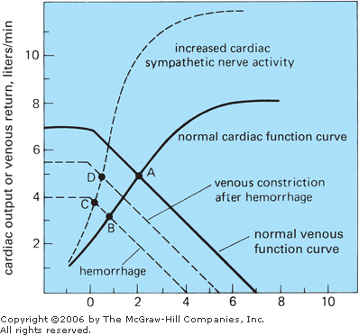

- Define mean circulatory filling pressure
The pressure that would exist throughout the system in the absence of flow

- What are the 2 major variables that affect mean circulatory filling pressure ?
Circulating blood volume and peripheral venous vessel tone

