Chapter 7 – Vascular Control

- Short-term vascular diameter adjustments are made by regulating the contractile activity of vascular smooth muscle cells
- These contractile cells are present in the walls of all vessels except capillaries
- Smooth muscle cells
  - 1. contract and relax much more slowly
  - 2. can change their contractile activity as a result of either action potentials or changes in resting membrane potential
  - 3. can change their contractile activity in the absence of any changes in membrane potential
  - 4. can maintain tension for prolonged periods at low energy cost
  - 5. can be activated by stretch
- In the smooth muscle:
  - 1. Intracellular free Ca2+ first forms a complex with the calcium-binding protein calmodulin
  - 2. The Ca2+ -calmodulin complex then activates a phosphorylating enzyme called myosin light-chain kinase {MLC kinase)
  - 3. This enzyme allows the phosphorylation by adenosine triphosphate {ATP) of the light-chain protein that is a portion of the cross-bridge head of myosin (MLC)
  - 4. MLC phosphorylation enables cross-bridge formation and cycling during which energy from ATP is utilized for tension development and shortening
- Smooth muscle cells have resting membrane potentials ranging from -40 to -65 mV and thus are generally less negative than those in striated muscle
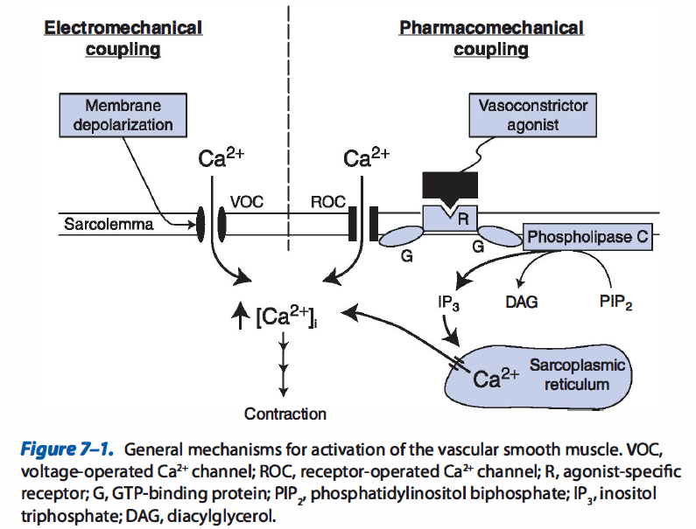
- Hyperpolarization of the cell membrane is one mechanism for causing smooth muscle relaxation and vessel dilation
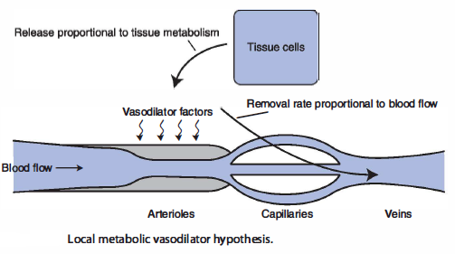
- Local feedback mechanism exists that automatically operates on arterioles to regulate a tissue's blood flow in accordance with its metabolic needs
- With increased metabolic activity or oxygen deprivation, cells in many tissues may release adenosine, which is an extremely potent vasodilator agent
Local influences
- Acetylcholine and several other agents (including bradykinin, vasoactive intestinal peptide, and substance P) stimulate endothelial cell nitric oxide production because their receptors on endothelial cells are linked to receptor-operated Ca2+ channels
- Nitric oxide is produced within endothelial cells from the amino acid, L-arginine, by the action of an enzyme, nitric oxide synthase
- Nitric oxide synthase is activated by a rise in the intracellular level of the Ca2+
- Nitric oxide is a small lipid-soluble molecule that, once formed, easily diffuses into adjacent smooth muscle cells where it causes relaxation by stimulating cGMP production as mentioned previously
- Prostaglandins and thromboxane are a group of several chemically related products of the cyclooxygenase pathway of arachidonic acid metabolism
- Histamine is synthesized and stored in high concentrations in secretory granules of tissue mast cells and circulating basophils
- When released, histamine produces arteriolar vasodilation (via the cAMP pathway) and increases vascular permeability, which leads to edema formation and local tissue swelling
- Norepinephrine causes an increase in the tone of arterioles after combining with an α-adrenergic receptor on smooth muscle cells.
- Norepinephrine appears to increase vascular tone primarily by pharmacomechanical means
- The mechanism involves G-protein linkage of a-adrenergic receptors to phospholipase C and subsequent Ca2+ release from intracellular stores by the action of the second messenger IP3
- Constriction of the veins (venoconstriction) is largely mediated through activity of the sympathetic nerves that innervate them
- These sympathetic nerves release norepinephrine, which interacts with α1-receptors and produces an increase in venous tone and a decrease in vessel diameter
Coronary blood flow
- The major right and left coronary arteries that serve the heart tissue are the first vessels to branch off the aorta
- Most of the blood that flows through the myocardial tissue returns to the right atrium by way of a large cardiac vein called the coronary sinus
- In a resting individual, the myocardium extracts 70% to 75% of the oxygen in the blood that passes through it
- Myocardial oxygen consumption is the most important influence on coronary blood flow
- Large forces and/or pressures are generated within the myocardial tissue during cardiac muscle contraction
- Systolic compressional forces on coronary vessels are greater in the endocardial (inside) layers of the left ventricular wall than in the epicardial layers
- Coronary arterioles are densely innervated with sympathetic vasoconstrictor fibers, yet when the activity of the sympathetic nervous system increases, the coronary arterioles normally vasodilate rather than vasoconstrict
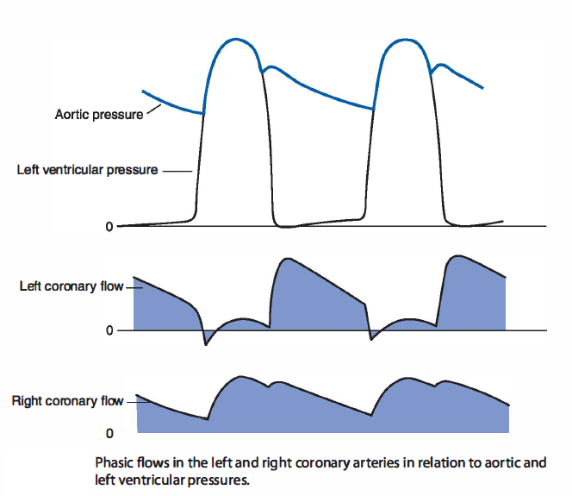
Skeletal muscle flow
- Skeletal muscles constitute 40% to 45% of body weight and at rest receives approximately 15% of the cardiac output
- Resting skeletal muscle has a high level of intrinsic vascular tone
- Local metabolic control of arteriolar tone is the most important influence on blood flow through exercising muscle
Cerebral blood flow
- Interruption of cerebral blood flow for more than a few seconds leads to unconsciousness and to brain damage within a very short period
- Cerebral blood flow is regulated almost entirely by local mechanisms
- Cerebral blood flow decreases whenever arterial blood Pco2 falls below normal
- Sympathetic and parasympathetic neural influences on cerebral blood flow are minimal
- The "blood-brain barrier" refers to the tightly connected vascular endothelial cells that severely restrict transcapillary movement of all polar and many other substances
Splanchnic blood flow
- Because of the high blood flow through and the high blood volume in the splanchnic bed, its vascular control importantly influences overall cardiovascular hemodynamics
- The organs of the splanchnic region receive approximately 25% of the resting cardiac output and contain more than 20% of the circulating blood volume
- Sympathetic neural activity plays an important role in vascular control of the splanchnic circulation
- Local metabolic activity associated with gastrointestinal motility, secretion, and absorption is associated with local increases in splanchnic blood flow
Renal blood flow
- The kidneys normally receive approximately 20% of the cardiac output of a resting individual
- Renal blood flow is strongly influenced by sympathetic neural stimulation
Cutaneous blood flow
- The physiological role of skin blood flow is to help regulate body temperature
- Decreases in body temperature decrease skin blood flow and vice versa
- Structural adaptation of the cutaneous vascular beds promote heat loss or heat conservation
Pulmonary blood flow
- Pulmonary blood flow equals cardiac output
- Pulmonary vascular resistance is about one-seventh of total systemic vascular resistance
- Pulmonary arterioles constrict in response to local alveolar hypoxia
- Low capillary hydrostatic pressure promotes fluid reabsorption and prevents fluid accumulation in pulmonary airways

Questions:

- The _____________________ perfuses the left ventricle myocardium and empties deoxygenated blood directly into the left ventricle
- True or False: Smooth muscle cells contract and relax much more slowly
- Nitric oxide is produced within endothelial cells from the amino acid_________________ by the action of an enzyme_____________________
- Pulmonary vascular resistance is about _____________ of total systemic vascular resistance
  - The same
  - ½
  - 1/5
  - 1/7

