Chapter 45
Thoracic blocks
- Intercostal nerve blockade involves injection of a local anesthetic solution adjacent to several contiguous intercostal nerves
- Interpleural analgesia involves deposition of a local anesthetic solution into the pleural space that exists between the parietal and visceral pleurae
- Multiple studies in dogs have shown that interpleurally administered local anesthetics works by gravity dependent, multidermatomal blockade of intercostal nerves
Intercostal nerve blocks
- The thoracic and cranial lumbar (L1, L2) spinal nerves are responsible for sensory innervation of the trunk
- The ventral branches of the thoracic spinal nerves (T2–T13) contribute to the peripheral nerves that are found within the intercostal spaces between adjacent ribs
- Intercostal nerves lie immediately caudal to each rib and run in close proximity to the intercostal arteries and veins that lie beneath the parietal pleura along the caudal aspect of the associated ribs
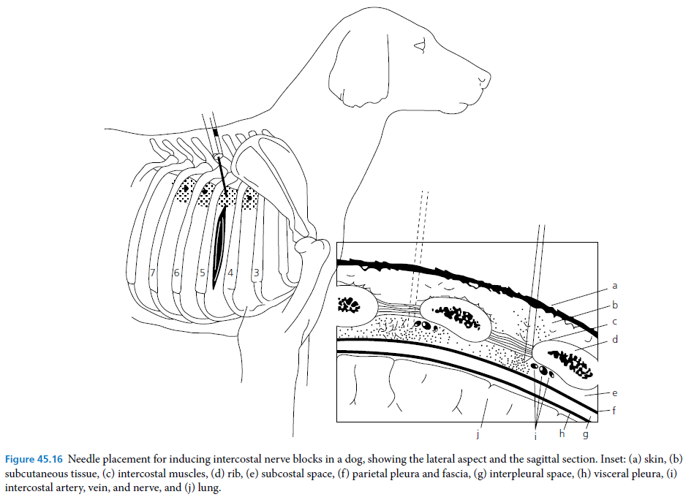
- After calculating the maximum dose to be used for the patient, an appropriate volume of local anesthetic (0.5–1.0 mL) is then slowly injected through the needle at the site on the caudal aspect of the rib to perform an individual intercostal nerve block
Interpleural regional analgesia
- An over the‐needle catheter is connected to a syringe filled with 2–3 mL of saline via a three‐way stopcock, and is advanced onto the lateral aspect of the seventh or eighth rib at its midpoint
- The large surface area of the pleura can potentially result in rapid absorption of the administered local anesthetic solution and high plasma levels of the local anesthetic can result, potentially leading to local anesthetic systemic toxicity
- Investigators observed a loss of diaphragmatic function on the injection side after administration of 1.5 mg/kg of interpleural bupivacaine

Transversus abdominis plane (TAP) block
- Deposition of a local anesthetic solution into a neuro‐fascial plane, effectively blocking the nerves that supply the anterior abdominal wall that exists within the potential space between the transversus abdominis and internal abdominal oblique muscles
- The abdominal wall consists of three muscle layers: the external abdominal oblique, the internal abdominal oblique, and the transversus abdominis, in addition to their associated fascial sheaths
- The segmental ventral branches of the caudal thoracic and cranial lumbar nerves innervate the skin, muscles, and parietal peritoneum of the ventral abdominal wall
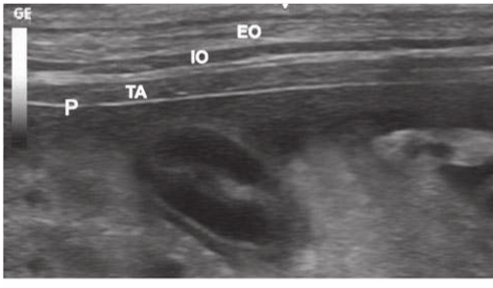

Pelvic limb
- The pelvic limb is supplied by two nerve plexuses (lumbar and sacral) that need to be partly or entirely blocked to provide surgical anesthesia and analgesia to the entire pelvic limb (including the hemipelvis)
- Blocking the femoral/saphenous nerve will provide anesthesia of the femur (mid‐diaphysis to distal), femorotibial joint (medial aspect of the femorotibial joint capsule), femorotibial intraarticular structures, skin of the dorsomedial tarsus and first digit
- The sciatic nerve block (if used alone) is sufficient to perform surgery of the foot and hock
- Both nerves (femoral and sciatic) must be blocked for almost any stifle procedure
- At the caudal aspect of the iliopsoas muscle, the femoral nerve exits the muscle and courses across the femoral triangle
- The femoral triangle is demarcated by the iliopsoas muscle proximally, the pectineus muscle caudally, and the sartorius muscle cranially
Sciatic nerve block
- The sciatic nerve courses down the pelvic limb between the greater trochanter and the ischiatic tuberosity
- The sciatic nerve gives rise to the muscular branches that supply the hamstring muscles (semitendinosus and semimembranosus muscles)
Intra-articular blocks
- A commonly used strategy for pain management following joint surgery is the intra‐articular administration of analgesics such as local anesthetics or opioids
- The intra‐articular injection of local anesthetics desensitizes intra‐articular structures only and may reduce the dose and interval for administrating supplemental analgesic therapy
Epidural anesthesia
- The lumbosacral approach (L7–S1) to performing epidural anesthesia in dogs and cats is technically easy to perform owing to the relatively wide intervertebral space at this location, although more cranial approaches in dogs have also been described
- A sacrococcygeal approach to the epidural space has been described in cats to minimize the risk of dural puncture and help facilitate urethral catheterization in blocked cats
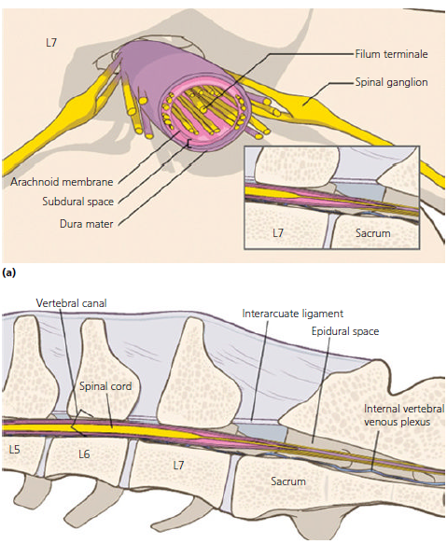
- Animal may be placed in either sternal or lateral recumbency
- The standard lumbosacral puncture site is located between the dorsal spinous processes of L7 and S1
- The needle is advanced through the skin and into the subcutaneous tissue
- The needle is then advanced through the supraspinous and interspinous ligaments
- Resistance will be noted as the needle penetrates these ligaments, if during any of these manipulations
- The needle comes into contact with bony structures, it should be withdrawn slightly, and redirected cranial or caudal as appropriate in a gentle and controlled manner
- If a drop of saline or local anesthetic solution is placed in the hub of a Tuohy needle, as the needle penetrates into the epidural space it will usually be aspirated into the space
- Resistance to injection of air or fluid is felt while the needle is advanced through the intervertebral ligaments
- If pressure is being applied to the plunger of a ‘loss of resistance’ (LOR) syringe, a sudden loss of resistance to injection will be appreciated when the needle punctures the ligamentum flavum and enters the epidural space
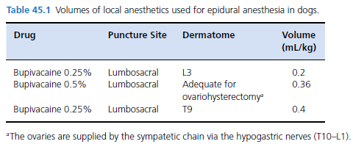
Intravenous regional anesthesia (IVRA)
- IVRA is relatively straightforward to perform: a tourniquet is applied to a limb proximal to the planned surgical site and a local anesthetic is injected intravenously distal to the tourniquet
- Since blood vessels and nerves are typically found in close proximity in the extremities, following intravenous injection the local anesthetic spreads from the vessels into the nearby tissues to reach the nerve trunks
- Lidocaine is the only local anesthetic that is recommended for use with IVRA in the veterinary literature, and has been used at doses of 2.5–5 mg/kg and at concentrations of 0.25–2%

Questions:
- Label the following boxes

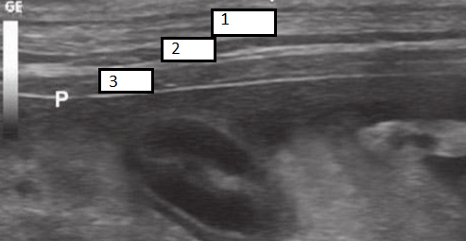

- Explain how to perform a lumbosacral epidural (from start to finish)

- The femoral triangle is demarcated by the _______________ muscle proximally, the pectineus muscle _____________, and the ______________muscle cranially

