Changes in the P–QRS–T morphology
Wandering atrial pacemaker
- Result of the dominant pacemaker shifting from the SA node to other pacemaker cells
- This is a normal variant and not uncommon in dogs
- It is thought to be associated with high vagal tone
Left atrial enlargement
- When there is left atrial enlargement the P wave is often prolonged and sometimes also notched
- Prolonged and notched P wave is referred to as P-mitrale
- The notching occurs as a result of asynchronous depolarization of the atria
- The dilated left atrium depolarizing fractionally at a later stage as compared to the right atrium
Right atrial enlargement
- When there is right atrial enlargement the P wave is increased in amplitude
- Such tall P waves are referred to as P-pulmonale
Left ventricular enlargement
- Tall R waves are suggestive of left ventricular enlargement
- An R wave in lead I greater than that in lead II or aVF may be associated with hypertrophy
- Other ECG features that may be associated with LV enlargement are
  - Prolongation of the QRS duration
  - S–T segment sagging
  - Shift in the MEA to the left
Right ventricular enlargement
- Deep S waves are suggestive of RV enlargement
- Also prolongation of the QRS duration or a shift in the MEA to the right
Low-voltage QRS complexes
- QRS complexes will be smaller the further the electrodes are from the heart and depend on the resistance to electrical conduction between the heart and the electrodes
- Small complexes in dogs maybe associated with
  - Obesity
  - Effusions (pericardial, pleural, ascites)
  - Hypothyroidism
  - Hyperkalemia
  - Pneumothorax
  - Some respiratory diseases
  - Hypovolemia
  - Normal variation
Electrical alternans
- Electrical alternans is associated with movement of the heart within pericardial effusion
- Movement of the heart causes a slight alternating change in the cardiac axis and is seen on the ECG as an alternating variation in QRS amplitude
Q–T interval abnormalities
- Prolonged Q–T intervals may be seen in
  - hypocalcaemia
  - hypokalemia
  - hypothermia
  - quinidine
  - ethylene glycol poisoning
- Shortened Q–T interval may be seen in
  - hyperkalemia
  - hypercalcemia
  - digitalis
  - atropine
  - β-blockers and calcium channel antagonists
S–T segment abnormalities
- S–T depression may be seen in
  - myocardial ischemia (e.g. cardiomyopathy, trauma)
  - potassium imbalance
  - digitalis toxicity
- S–T elevation may be seen in
  - pericarditis (pericardial effusion)
  - severe ischemia/infarction, e.g. full wall thickness
Hyperkalemia
- progressive bradycardia
- increased amplitude of the T wave, appearing narrow and spiked
- progressive decrease in amplitude of the R wave
- progressive reduction in amplitude of the P wave
- disappearance of the P wave, i.e. atrial standstill
- progression to slow junctional rhythm
- ends with ventricular fibrillation or asystole

Questions:
1. True or False: Left atrial enlargement causes tall P waves

2. Name 3 reasons/disease processes why low voltage QRS complexes can occur

3. List electrolyte abnormalities that cause Q-T prolongation

4. Diagnosis
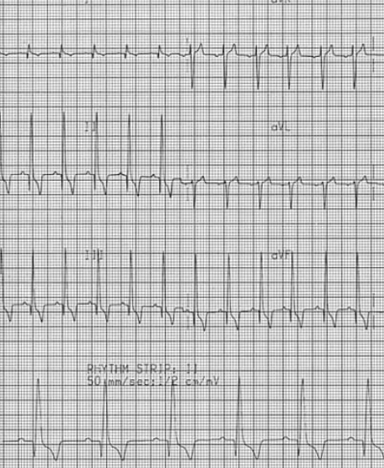

Answers /Questions:
- True or False: Left atrial enlargement causes tall P waves
Left atrial enlargement - When there is left atrial enlargement the P wave is often prolonged and sometimes also notched
2. Name 3 reasons/disease processes why low voltage QRS complexes can occur
  - Obesity
  - Effusions (pericardial, pleural, ascites)
  - Hypothyroidism
  - Hyperkalemia
  - Pneumothorax
  - Some respiratory diseases
  - Hypovolemia
  - Normal variation
3. List electrolyte abnormalities that cause Q-T prolongation
Hypocalcemia
hypokalemia
4. Diagnosis
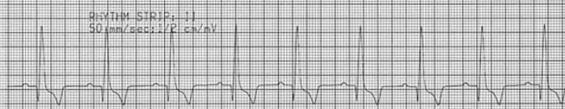
Left ventricular enlargement

Left ventricular enlargement
- Tall R waves are suggestive of left ventricular enlargement
- An R wave in lead I greater than that in lead II or aVF may be associated with hypertrophy
- Other ECG features that may be associated with LV enlargement are
  - Prolongation of the QRS duration
  - S–T segment sagging
  - Shift in the MEA to the left

