TOBIAS p. 633

Casts
- Synthetic casting tapes: expensive, thermomoldable, light weight, radiolucent, conform well, easy to apply.

Application of casts
- Tape stirrup
- Cast stockinet – exceed distal and proximal ends by 1-2inches
- Doughnuts made with cast padding or rolled stockinet over bony prominence
- Cast padding – extend the cast by 1cm proximally and distally, padding should not exceed two layers, 50% overlap

Types of casts
- Full leg cast: immobilize joint above and below.
  - Indication: minimally displaced stable (or unstable if reducible) fractures of radius ulna, tibia, fibula in young animals. Can also be used for additional support of tenuous internal fixation
- Half cast:
  - Indication: minimally displaced fractures of metacarpus and metatarsus
- Walking bar: applied to a cast, to prevent direct weight bearing on toes. To apply contour an aluminum splint rod to end of cast
  - Indication: fractures of metacarpals or metatarsals or when cast is too short
- Bivalved Cast: no stockinet, tape both halves around limb
  - Indications: when frequent casts changes are expected

FOSSUM p1053-1055: Classification of fractures

Classification of Fractures
(1) Whether the fracture is open to the environment

(2) Degree of damage and displacement of the fragments
- Complete or incomplete
- Describe the distal segment

(3) The type of fracture
- Greenstick
- Avulsion – insertion point of tendon or ligament fractures and distracted from rest of bone
- Transverse - perpendicular line to long axis
- Oblique – angle to perpendicular line to long axis
  - Short oblique – fracture line is ≤45°
  - Long oblique – fracture line is ≥45°
- Spiral – wrap around long axis of bone
- Comminuted – multiple fracture lines

(4) Whether the fracture fragments are reducible (able to support weight bearing) or nonreducible

(5) Location of the fracture
- Metaphysis, diaphysis, physis

Velocity of forces causing fracture dictates number of fragments and soft tissue injury

Open Fractures
Classified based on: (1) Mechanism of puncture, (2) Severity of soft tissue injury

- Grade I open fracture – small puncture hole that was caused by the fractured bone
- Grade II open fracture – variably sized skin wound associated with fracture that resulted from external trauma
- Grade III open fracture – severe bone fragmentation associated with extensive soft tissue injury with or without skin loss

Physeal Fractures
- Salter Harris classification scheme identifies the location of the fractures line

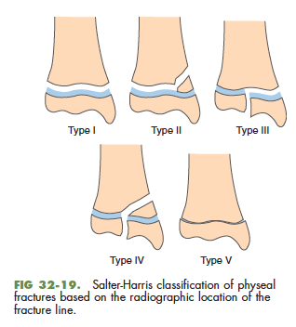

Questions
- Describe the fracture based on direction and number of fractures lines
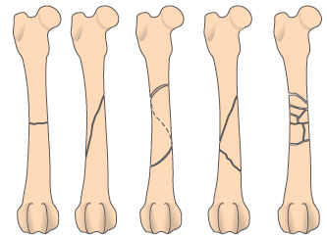

- Which type of Salter-Harris fracture involves both the epiphysis and metapysis?
  - Salter Harris type I
  - Salter Harris type II
  - Salter Harris type III
  - Salter Harris type VI
  - Salter Harris type V

- Describe the fracture depicted below

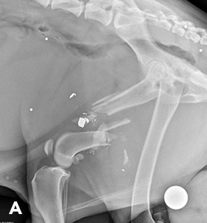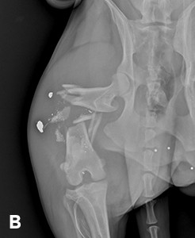

Answers
1.
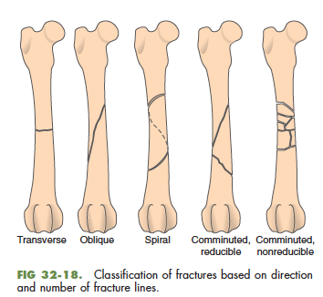

- Which type of Salter-Harris fracture involves both the epiphysis and metapysis?
  - Salter Harris type I
  - Salter Harris type II
  - Salter Harris type III
  - Salter Harris type VI
  - Salter Harris type V

3. Lateral radiograph of mid-diaphyseal right comminuted femoral fracture due to trauma associated with a bullet. When both views are compared, caudoproximal and medial displacement can be seen.

