Cardiovascular Response to Physiological Stress
Effect of Respiratory Activity
- Inhaling and exhaling has major effects on venous return and cardiac output
- During inspiration: intrathoracic pressure falls by 7 mmHg, diaphragm contracts, chest wall expands → promote air movement into and out of lungs, venous return increases → Respiratory Pump
- Normal Sinus Arrhythmia: right side heart filling is increased during inspiration → Starling’s Law → stroke volume and cardiac output transiently increase, this will also lead to an increase in left sided output → transient increase in arterial pressure → transient increase in firing of arterial baroreceptors → increase in cardiac parasympathetic nerve activity and decrease sympathetic nerve activity → decreased heart rate

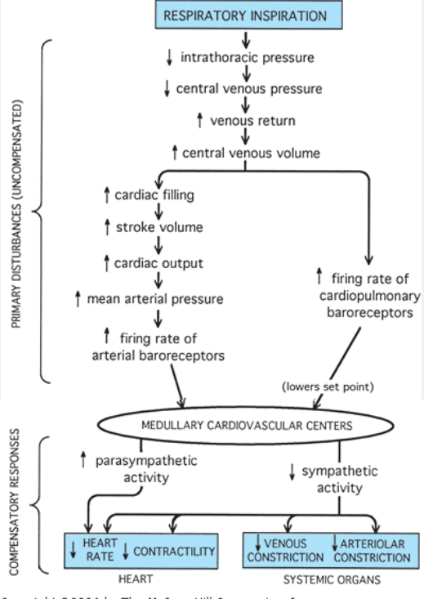

- In exercise: deep, rapid breathing increases venous return
- Yawning: transient decrease in intrathoracic pressure that increases venous return, especially if combined with stretching
- Coughing: transient increase in intrathoracic pressure, leading to a decrease in cardiac output, a “fit” could lead to a syncope
- Valsalva maneuver: forced expiration against a closed glottis, normally during defecation, lifting a heavy object, blowing a balloon
  - At initiation of the maneuver, arterial pressure is elevated for several beats, from the intrathoracic pressure transmitted to the thoracic aorta → fall in venous return and fall in blood pressure → compensatory reflex increase in heart rate and peripheral vasoconstriction (red face = high peripheral venous pressure)
  - At cessation of the maneuver, abrupt fall in pressure for a couple of beats, due to fall of intrathoracic pressure, venous blood quickly fill central venous pool → stroke volume, cardiac output, arterial pressure increase rapidly → reflex bradycardia
- Positive pressure ventilation: intrathoracic pressure increases, decreases venous return during lung inflation, compression on pulmonary microcirculation → increase in right ventricular afterload

Effect of Exercise
Responses to Acute Exercise
- Depends on several factors:
  - Type of exercise:
    - Dynamic (rhythmic or isotonic)
    - Static (isometric)
  - Intensity and Duration of the Exercise
  - Age of the Individual
  - Level of Fitness
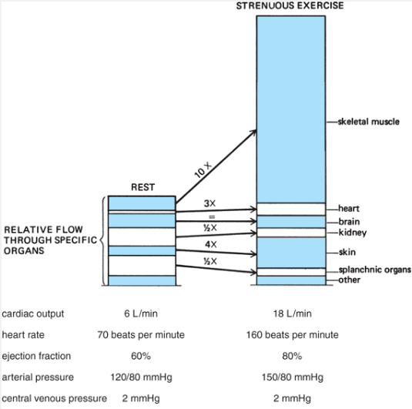

Dynamic Exercise:
- Stress and or anticipation of exercise originates in the cerebral cortex → corticohypothalamic pathways → medullary cardiovascular centers, this is called “Central Command”
- This acts on neural portion of arterial baroreceptor system and causes MAP to be regulated at a higher level (set-point-raising influence)
- Chemoreceptors and mechanoreceptors in active skeletal muscles produce a second set-point-raising influence
- Decrease in Total Peripheral Resistance, due to metabolic vasodilator accumulation and decreased vascular resistance in active skeletal muscle (pressure lowering disturbance), this leads to a strong increase in sympathetic activity from arterial baroreceptor reflex
- MAP is elevated, but decreased total peripheral resistances causes it to fall to lower levels than the set-point raising influence would have managed by itself, however the arterial baroreceptor reflex produces most of the increase of sympathetic activity that accompanies exercise
- Coronary blood flow increases substantially, due to metabolic vasodilation of coronary arterioles as a result if increased cardiac work and myocardial oxygen consumption
- Skeletal muscle pump promotes venous return from extremities
- Respiratory pump also promotes venous return during exercise

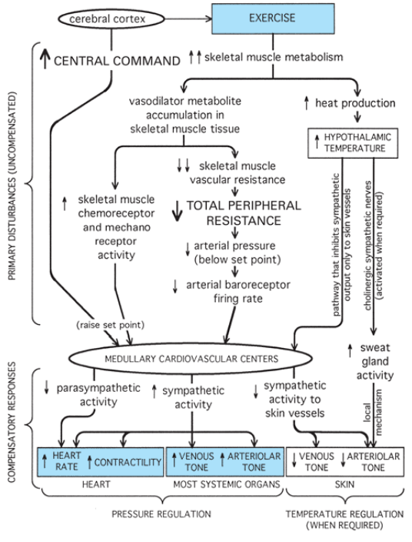

Static Exercise:
- Causes a compression of vessels in the contracting muscles and a reduction of blood flow through them
- Total peripheral resistance does not fall and may even increase
- Static exercise produces an increase in HR, cardiac output and arterial pressure, due to increased sympathetic drive; however HR and cardiac output are less increased than dynamic exercise and a more increased SAP/DAP/MAP.
- Higher afterload leads to a higher cardiac work compared to dynamic exercise

Chronic Exercise:
- Increased circulating blood volume, decreased heart rate, increased stroke volume, decreased arterial blood pressure at rest
- Decreased myocardial oxygen demand, increase in the cardiac reserve (potential for increasing cardiac output)
- Ventricular chamber enlargement → endurance training
- Increased myocardial mass and ventricular wall thickness → strength training
- Deconditioning occurs with the cessation of the exercise program, changes reverse quickly

Age Related Changes:
In the heart:
- Decrease in resting and maximum cardiac index
- Decrease in maximum heart rate
- Increase in contraction and relaxation time of heart muscle
- Increase in myocardial stiffness during diastole
- Decrease in number of functioning myocytes
- Accumulation of pigment in myocardial cells
In the vascular bed:
- Decrease in capillary density in some tissues
- Decrease in arterial compliance
- Increase in total peripheral vascular resistance
In arterial baroreceptors:
- Decrease in afferent activity from arterial baroreceptors
- Amount of norepinephrine in sympathetic nerve endings of myocardium decreases
- Myocardial response to catecholamines declines

Together these lead to increased arterial pulse pressure and MAP and a greater afterload on the heart.

Questions
- Explain why sinus arrhythmia develops?
- How is venous return encouraged during dynamic exercise?
- Mention 3 cardiovascular age related changes

Questions:
- Explain why sinus arrhythmia develops?
During inspiration intrathoracic pressure decreases → venous return increases → increased right side heart filling → stroke volume and cardiac output transiently increase → transient increase in arterial pressure → transient increase in firing of arterial baroreceptors → increased parasympathetic tone and decreased sympathetic tone → decreased heart rate

- How is venous return encouraged during dynamic exercise?
Skeletal muscle pump, Respiratory pump

- Mention 3 cardiovascular age related changes
Increased MAP
Decrease in resting and maximum cardiac index
Decrease in maximum heart rate
Increase in contraction and relaxation time of heart muscle
Increase in myocardial stiffness during diastole
Decrease in number of functioning myocytes
Accumulation of pigment in myocardial cells
Decrease in capillary density in some tissues
Decrease in arterial compliance
Increase in total peripheral vascular resistance
Decrease in afferent activity from arterial baroreceptors
Amount of norepinephrine in sympathetic nerve endings of myocardium decreases
Myocardial response to catecholamines declines

