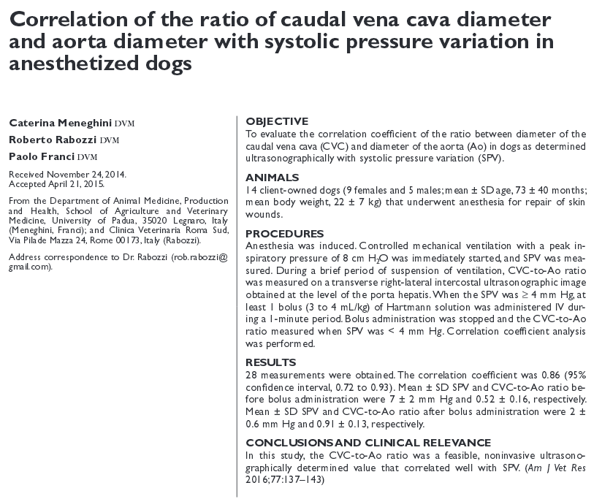
- SVP is the difference between maximum and minimum systolic pressure over a respiratory cycle and has been shown to be a reliable indicator of hypovolemic status in mechanically ventilated dogs with physiologically normal cardiovascular function in an experimental setting
- SPV of > 4.52% in anesthetized mechanically ventilated dogs with physiologically normal cardiovascular function most likely predicts a cardiovascular response (> 10% increase in MAP, > 10% decrease in heart rate, or both) after a bolus (3 mL/kg) of crystalloids
- SPV cannot provide reliable information about volemia when the R-R interval is variable and when severe lung disease substantially alters lung compliance
- CVC-to-Ao ratio is a dimensionless index and therefore is independent of body size
- Ao diameter is independent of mild to moderate volemia and does not change substantially during fluid administration
- Inferior vena cava in humans is commonly scanned in a right paramedian substernal view, and the diameter is determined on a long-axis view of the vessel – technically plausible in dogs
- In dogs: right lateral transverse intercostal approach at the level of the porta hepatis (11th or 12th intercostal space)
- This view provides on the same image, the transverse ultrasonographic view of the Ao on the left side, CVC in the middle, and portal vein on the right side – Figure 1, measurement error attributable to movement of the CVC during the respiratory cycle is minimized
- Dogs considered normovolemic on the basis of the SPV had a CVC-to-Ao ratio of approximately 1
- CVC:Ao ratio can be a significant predictor of the volume of fluids needed to restore cardiac preload in dogs with high SPV
- Cannot be reliably used in patients affected by intrathoracic disease (eg, right heart failure, cardiac tamponade, pneumothorax, pleural effusion, or pulmonary thromboembolism) or patients with increased abdominal pressure (presence of fluids or masses), both of which cause CVC dimensions to be partially or totally unrelated to volemic status

