LANGE MEDICAL: CV PHYSIOLOGY
CHP 9: REGULATION OF ARTERIAL PRESSURE

Arterial pressure is closely regulated
- Short term (seconds): changes in activity of autonomic nerves leading to heart and peripheral vessels
- Long term (minutes to days): changes in cardiac output brought about by changes in blood volume

SHORT TERM REGULATION
1. Arterial baroreceptor reflex
- Responsible for regulating arterial pressure in the short term
- Arterial baroreceptor reflex involves the following:
  - Pressure sensing by stretch sensitive baroreceptor nerve endings in the walls of arteries. Increased stretch causes increased action potential generation rate by the arterial baroreceptors
  - Neural integrating centers in the brainstem that adjust autonomic nerve activity in response to the pressure information they receive from the arterial baroreceptors
  - Responses of the heart and vessels to changes in autonomic nerve activity 31
- Arterial baroreceptors adapt to long term changes in arterial pressure.
  - For this reason cannot serve as a mechanism for long term regulation of arterial pressure
- Action potentials generated by the carotid sinus baroreceptors travel through the carotid sinus nerves (Hering’s nerves), that join glossopharyngeal nerves (CN IX) before entering the CNS
  - Afferent fibers from aortic baroreceptors run to CNS in the vagus nerve (CN X)

Increased input from the arterial baroreceptors simultaneously:
- Inhibit the activity of the spinal sympathetic excitatory tract
- Stimulate the activity of the spinal sympathetic inhibitory tract
- Stimulate the activity of parasympathetic preganglionic nerves

An increase in the arterial baroreceptor discharge rate (caused by increased arterial pressure) :
- causes a decrease in the tonic activity of cardiovascular sympathetic nerves
- and simultaneous increase in tonic activity of cardiac parasympathetic nerves

Conversely, Decreased arterial pressure :
- causes increased sympathetic activity
- and decreased parasympathetic activity

2. Other CV Reflexes and Responses
- Reflexes from receptors in heart and lungs
- Mechanoreceptors and chemoreceptors located in atria, ventricles, coronary vessels and lungs
- Role in neurohormonal control of CV system incompletely understood
- Involved in regulating blood volume and body fluid balance
- Sense pressure (or volume) in atrial and central venous pool
  - increased CVP and volume cause receptor activation by stretch elicits reflex decrease in sympathetic activity
    - tonic inhibitory influence on sympathetic activity

- Chemoreceptor reflexes
- Low PO2 and/or high PCO2 levels in the arterial blood cause reflex increases in respiratory rate and mean arterial pressure
  - Result of increased activity of arterial chemoreceptors )located in carotid arteries and aortic arch) and central chemoreceptors (located in CNS)
- Cerebral ischemic response triggered by inadequate brain blood flow
  - Causes strong sympathetic vasoconstriction and cardiac stimulation
  - If blood flow inadequate for several minutes cerebral ischemic response wanes and is replaced by marked loss of sympathetic activity
- Cushing reflex – variant of cerebral ischemic response
  - Benefit: prevents collapse of cranial vessels and preserves adequate brain blood flow
  - Hypertension - Involves CNS chemoreceptors reacting to consequences of reduced cerebral circulation producing strong sympathetic activation
  - Bradycardia – [presumably resulting from elevated reflex vagal activity from arterial baroreceptor input

- Receptors from reflexes in exercising skeletal muscle
- Chemoreceptors in skeletal muscle responding to muscle ischemia

- Dive reflex
- Bradycardia and intense vasoconstriction in all systemic organs except brain and heart
- Bradycardia produced by enhanced cardiac parasympathetic activity and peripheral vasoconstriction caused by enhanced sympathetic activity

- CV responses associated with emotion
- Responses originate in the cerebral cortex and reach medullary cardiovascular centers through cortico-hypothalamic pathways
- E.g. Blushing, alerting response (fight or flight), vasovagal syncope
- Vasovagal syncope – loss of consciousness due to decreased cerebral blood flow that is produced by sudden dramatic loss of arterial blood pressure that occurs as a result of a sudden loss of sympathetic tone and a simultaneous large increase in parasympathetic tone and decrease in the heart rate
  - Influence on medullary cardiovascular centers come from cortex via depressor centers in anterior hypothalamus

- Reflex responses to pain
  - Can have positive or negative influence on arterial pressure
  - Superficial or cutaneous pain causes rise in BP in manner similar to that associated with alerting response
  - Deep pain from receptors in the viscera or joints – causes a cardiovascular response similar to that which accompanies vasovagal syncope (increased parasympathetic tone, and serious decrease in blood pressure)

- Temperature regulation reflexes
- Temperature regulation responses are controlled by the hypothalamus which can operate through CV centers to discretely control the sympathetic activity to regulate vasoconstriction of cutaneous vessels

3. Summary
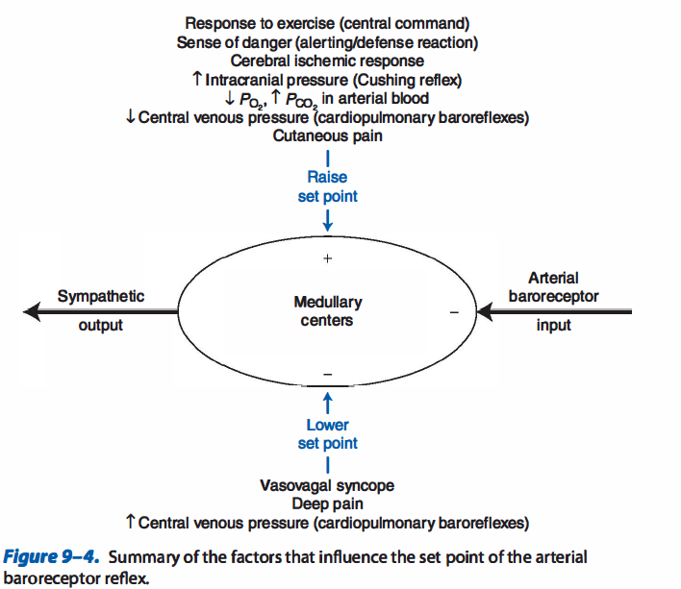
Arterial baroreceptor input is shown as inhibitory because an increase in arterial baroreceptor firing rate results in a decrease in sympathetic output

Two categories of nonarterial baroreceptor influences on the medullary CV centers (shown in figure)
- Those that increase arterial pressure by raising the set point for the arterial baroreceptor reflex and thus cause an increase in sympathetic activity
- Those that decrease arterial pressure by lowering the set point for the arterial baroreceptor reflex and thus cause a decrease in sympathetic activity

LONG TERM REGULATION
1. Fluid balance and arterial pressure
- ‘Fluid balance’: Involves the kidneys, their sodium handling and regulation of blood volume

Circulating blood volume can influence arterial pressure because:
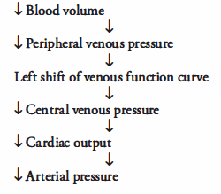

Increase in arterial pressure causes an increase in urinary output rate and thus a decrease in blood volume. Decreased blood volume tends to lower arterial pressure:
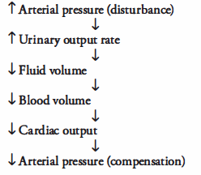
*In the long term arterial pressure can only be that which makes the urinary output rate equal to the fluid intake rate

2. Effect of arterial pressure on urinary output rate
- Glomerular filtration is influenced by hydrostatic and oncotic pressures
- The glomerular filtration rate is decreased by factors that decrease glomerular capillary pressure (i.e. decreased arterial blood pressure or vasoconstriction of preglomerular renal arterioles)
- Urine produced as net result of GF and renal tubular fluid reabsorption
  - UO rate = GFR – Renal fluid reabsorption rate
- Aldosterone (produced by adrenal glands) is primary regulator of sodium reabsorption in tubular cells
  - Regulated by release of angiotensin II
    - Angiotensin II concentration regulated by renin (produced in kidneys)
    - Renin converts angiotensinogen angiotensin II
    - Angiotensin I converted to angiotensin II by ACE

- Rate of renin release by the kidneys is influenced by several factors.
  - An increase in activity of renal sympathetic nerves causes a direct release of renin through β1-adrenergic mechanism.
  - Renin release is triggered by factors associated with a lowered GFR
    - Such as activation of sympathetic vasoconstrictor nerves to renal arterioles
- Anything that causes renin release causes a decrease in urinary output rate because increased renin causes increased sodium (therefore fluid) reabsorption
- Vasopression (ADH) released from posterior pituitary gland
  - Stimulus is increased internal osmolarity (detective by osmoreceptors in the hypothalamus)
  - Vasopressin increases water permeability of distal renal tubules (enhancing water reabsorption) and decreases renal water excretion

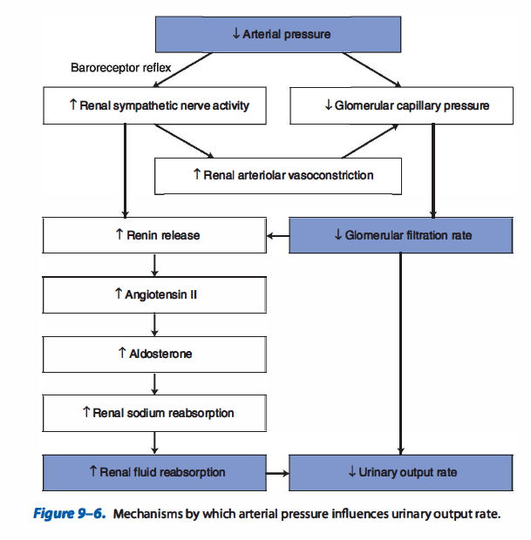

Questions
1. Will the following variables increase or decrease in response to a rise in arterial pressure (consider components of arterial baroreceptor reflex)
a. arterial baroreceptor firing rate
b. parasympathetic activity to the heart
c. sympathetic activity to the heart
d. arteriolar tone
e. venous tone
f. peripheral venous pressure
g. total peripheral resistance
h. cardiac output

2. What net short-term alterations in MAP and sympathetic activity would the following produce?
a. blood loss through hemorrhage
b. cutaneous pain
c. systemic hypoxia
d. local metabolic vasodilation in the skeletal muscle – increase

3. In the normal operation of the arterial baroreceptor reflex, a cardiovascular disturbance that lowers mean arterial pressure will evoke a decrease in which of the following?
a. baroreceptor firing rate
b. sympathetic nerve activity
c. heart rate
d. total peripheral resistance
e. myocardial contractility

4. True or False. Normal kidneys tend to retain sodium and fluid in the body whenever sympathetic nerve activity is high

Answers
1. Will the following variables increase or decrease in response to a rise in arterial pressure (consider components of arterial baroreceptor reflex)
a. arterial baroreceptor firing rate - increase
b. parasympathetic activity to the heart - increase
c. sympathetic activity to the heart - decrease
d. arteriolar tone - decrease
e. venous tone - decrease
f. peripheral venous pressure - decrease
g. total peripheral resistance - decrease
h. cardiac output - decrease

2. What net short-term alterations in MAP and sympathetic activity would the following produce?
a. blood loss through hemorrhage
b. cutaneous pain
c. systemic hypoxia
d. local metabolic vasodilation in the skeletal muscle – increase

a and d) are primary disturbances to the cardiovascular system. These will directly reduce the mean arterial pressure. Reflex adjustments largely mediated by the arterial baroreceptors will result in a higher-than-normal sympathetic activity.

b and c) elicit set point-increasing inputs to the medullary cardiovascular system that result in a higher-than-normal sympathetic output for any given level of input from the arterial baroreceptors. Thus in the presence of these disturbances, the system will operate at higher-than-normal mean arterial pressure and sympathetic activity.

3. In the normal operation of the arterial baroreceptor reflex, a cardiovascular disturbance that lowers mean arterial pressure will evoke a decrease in which of the following?
a. baroreceptor firing rate
b. sympathetic nerve activity
c. heart rate
d. total peripheral resistance
e. myocardial contractility

4. True or False. Normal kidneys tend to retain sodium and fluid in the body whenever sympathetic nerve activity is high.

