Chp 1: Overview of the Cardiovascular System

1. Homeostatic role of the CV system
- Diffusion: the process by which solutes are exchanged between plasma (through capillaries) and interstitial fluid.
- Convection: the process by which substances are transported between organs.

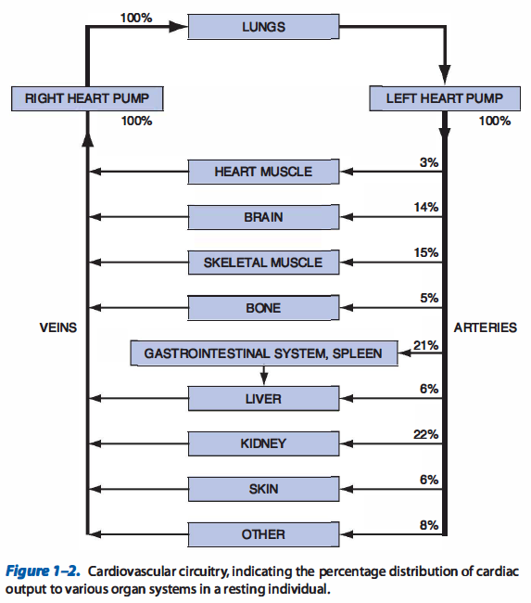

- Organs that serve to recondition the composition of blood (lungs, kidneys) receive blood flow that exceeds the amount of flow that is necessary to supply the nutrient needs of the tissue
- Blood flow to brain, heart muscle, and skeletal organs only supplies metabolic needs of the tissue. These organs do not recondition the blood for the benefit of any other organ
- Task of providing adequate blood flow to the brain and the heart muscle receives a high priority in the overall operation of the CV system

2. The basic physics of blood flow
Poiseuille equation (factors that influence flow through cylindrical vessel)
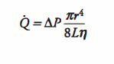
r= inside radius of tube
L = tube length
η = tube viscosity
ΔP = change in pressure

Fick Principle
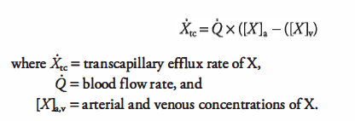

3. The heart
- Blood flow through all organs is passive and occurs only because arterial pressure is kept higher than venous pressure

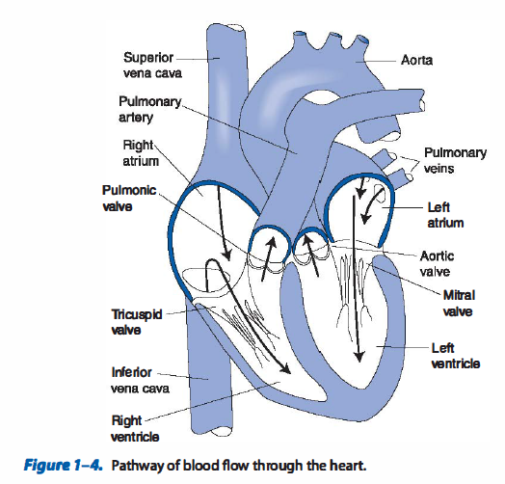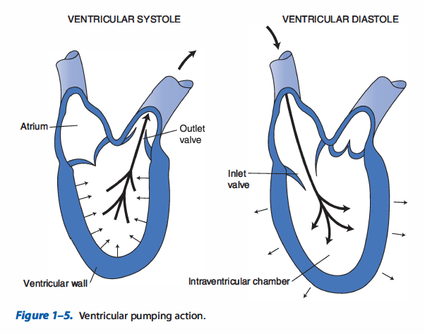

Cardiac Output (CO)
- The amount of blood pumped per minute from each ventricle (CO) is determined by the volume of blood ejected per beat (stroke volume) and the number of heartbeats per minute (HR):
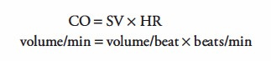

- All influences on cardiac output act through changes in either the heart rate or stroke volume:
SV = ECV – ESV

- Stroke volume can only be changed by changes in end diastolic volume (EDV) and/or end systolic volume (ESV)
- Cardiac output can only be changed by changes in HR, EDV, ESV

Cardiac excitation
- The SA node contains specialized cells that function as the heart’s pacemaker and initiate that action potential that is conducted through the heart.
- AV node contains slowly conducting cells that normally function to create a slight delay between atrial contraction and ventricular contraction
- Purkinje fibers are specialized for rapid conduction and ensure that all ventricular cells contract at nearly the same instant

Anatomic and neural influences (sympathetic and parasympathetic)
Adrenergic sympathetic fibers innervates all portions of the heart.
- Release NE on cardiac cells.
- NE interacts with β1-adrenergic receptors on cardiac muscle cells to:
  - increase heart rate
  - increase action potential conduction velocity
  - increase force of contraction
  - increase rate of contraction and relaxation

Cholingergic parasympathetic nerve fibers travel to heart via vagus nerve and innervate SA node, AV node and atrial muscle.
- Release acetylcholine on cardiac muscle cells.
- Acetylcholine interacts with muscarinic receptors on cardiac muscle cells to:
  - decrease heart rate (SA node)
  - decrease action potential conduction velocity (AV node)
  - decrease force of contraction of atrial muscle cells (not ventricular)
  - overall, acts to decrease cardiac pumping

Starling’s Law of the Heart
- Stroke volume increases nearly in proportion to increases in end-diastolic volume

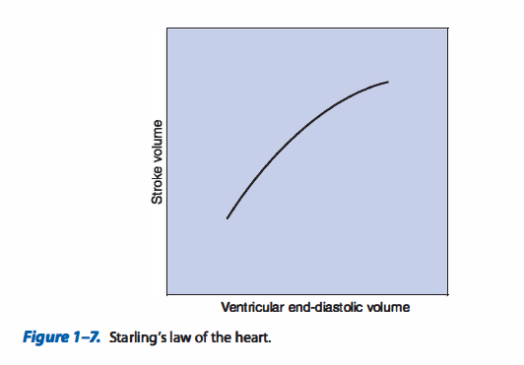

- Stroke volume (therefore CO) is strongly influenced by cardiac filling during diastole

The vasculature
- Major vessel classifications are arteries, arterioles, capillaries, venules, veins
- All lined with layer of endothelial cells
- Arterioles have much thicker walls with more smooth muscle and less elastic material than arteries – diameters can be actively changed.
- Capillaries contain no smooth muscle and lack ability to change their diameters actively. Capillaries are exchange vessels of CV system
- Veins have thin walls, and smooth muscle. Diameters can actively change

Control of vessels
- Sympathetic nerves innervating arterioles release NE that interact with α-adrenergic receptors on smooth muscle cells to case contraction and arteriolar constriction.
- Venules and veins are also richly innervated by sympathetic nerves. Increased activity = decreased venous volume increasing cardiac filling and CO by starling’s law of the heart

Blood
- Plasma: liquid component of blood, complex solution of electrolytes and proteins.
- Serum: fluid obtained from blood sample after it has been allowed to clot. Composition same to that as plasma without clotting proteins.

Questions
1. Define cardiac output and identify its 2 determinants

2. Identify the distribution of sympathetic and parasympathetic nerves in the heart and list basic effects of these nerves on the heart

Answers
Cardiac Output (CO)
- The amount of blood pumped per minute from each ventricle (CO) is determined by the volume of blood ejected per beat (stroke volume) and the number of heartbeats per minute (HR):

- All influences on cardiac output act through changes in either the heart rate or stroke volume:
SV = ECV – ESV

- Stroke volume can only be changed by changes in end diastolic volume (EDV) and/or end systolic volume (ESV)
- Cardiac output can only be changed by changes in HR, EDV, ESV

2.
Adrenergic sympathetic fibers innervates all portions of the heart.
- Release NE on cardiac cells.
- NE interacts with β1-adrenergic receptors on cardiac muscle cells to:
  - increase heart rate
  - increase action potential conduction velocity
  - increase force of contraction
  - increase rate of contraction and relaxation

Cholingergic parasympathetic nerve fibers travel to heart via vagus nerve and innervate SA node, AV node and atrial muscle.
- Release acetylcholine on cardiac muscle cells.
- Acetylcholine interacts with muscarinic receptors on cardiac muscle cells to:
  - decrease heart rate (SA node)
  - decrease action potential conduction velocity (AV node)
  - decrease force of contraction of atrial muscle cells (not ventricular)
  - overall, acts to decrease cardiac pumping

