CHAPTER 8

- 2 classification - The Vaughan-Williams scheme and The Sicilian Gambit

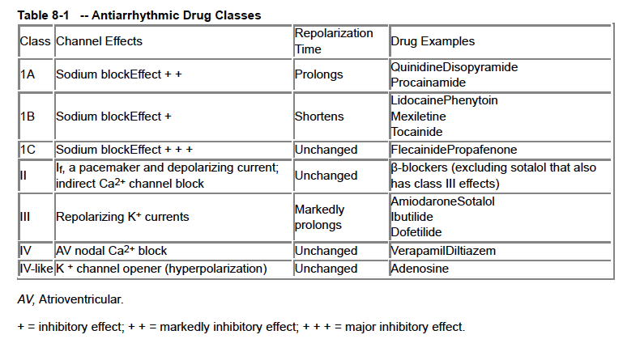
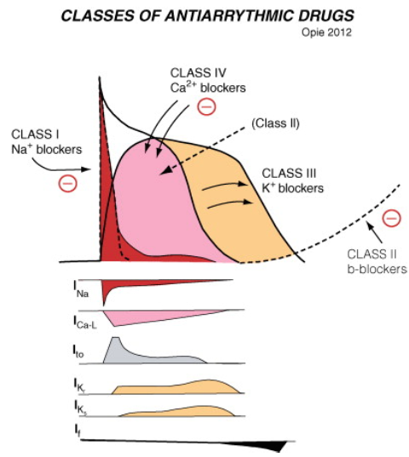
Class 1 = sodium channel blockers
- IA: Quinidine, procainamide
  - Inhibition (moderate blockade) of fast Na+ channels, depression of phase 0
  - PROLONGS action potential duration
    - Prolongation of QT/depression of conduction/promotion of reentry proarrhythmic
  - Slow conduction
  - Healthy tissue

- IB: Lidocaine, mexilitine
  - Inhibition (weak blockade) of fast Na+ channels
  - SHORTENS action potential
    - Little effects on atrial tissue (AP is already shorter than that of ventricular tissue)
  - Diseased tissue
  - Relatively little effect on the rapid Na+ channels at normal HR
  - Little effect on conduction velocity
- IC: Flecainide, propafenone
  - Strong fast Na+ channel blockers
  - Little effect on AP duration
  - Slow conduction

- Lidocaine (IB)
  - More effective in the presence of a high extracellular potassium concentration (correct hypokalemia)
  - Diseased/ischemic tissue
  - Metabolized in liver
    - 2 factors govern metabolism: liver BF and liver microsomal activity (inducers: barbiturates, phenytoin, rifampin; decreased clearance: cimetidine, propranolol, halothane)
  - Rapid distribution CRI
    - Rapid onset, short half-life
  - Indications: tachyarrhythmias, sustained VT, very frequent VPCs seriously interfering with hemodynamic

Class II = β-adrenergic antagonists (β-blockers)
- Act on the current I_{f} = pacemaker current and I_{Ca-L} (indirect inhibition as the level of tissue cAMP falls)
- Indications: inappropriate or unwanted sinus tachycardia, paroxysmal atrial tachycardia, exercise-induced ventricular arrhythmias, catecholamine-induced arrhythmias (pheochromocytoma) (= increased sympathetic β-adrenergic activity)
- Vary in selectivity (β₁ vs β₂)
  - Esmolol: selective β₁ antagonist ( ½ life = 9 minutes, full recovery w/in 18-30 min, metabolized by RBCs)

QUESTIONS
- On this schematic, the black line represents the normal ventricular action potential. Which line represents the ventricular action potential following administration of mexiletine?
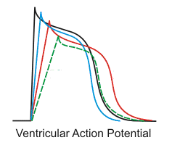

- Complete the table
Class | Effect on AP (⬆⬇=) | Strength of blockade | Examples
IA
IB
IC

- Lidocaine interacts with Na+ channels when those channels are in which state (open, closed, inactivated)? Why is this important?

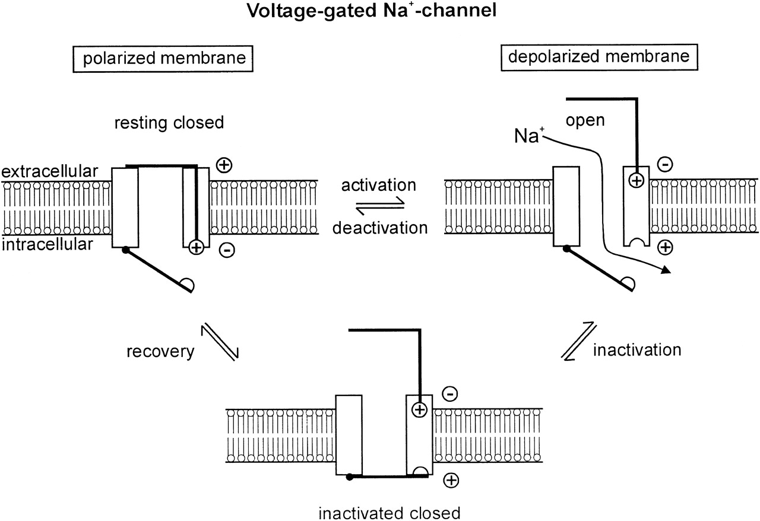
- Which currents (2) do β-blockers act on?

- Where is esmolol metabolized?

QUESTIONS AND ANSWERS
- On this schematic, the black line represents the normal ventricular action potential. Which line represents the ventricular action potential following administration of mexiletine?
Mexiletine is a class IB antiarrhythmic.
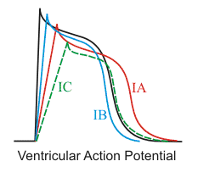
- Complete the table
Class | Effect on AP (⬆⬇=) | Strength of blockade | Examples
IA | ⬆ | Moderate | Procainamide, quinidine
IB | ⬇ | Weak | Lidocaine, mexilitine
IC | = | Strong | Flecainide, propafenone

- Lidocaine interacts with Na+ channels when those channels are in which state (open, closed, inactivated)? Why is this important?
Class Ib drugs bind primarily to Na channels in the inactivated state, a state that Na channels exist in during the action potential plateau. Atrial cells have a very short plateau duration (e.g. 1/3rd the duration of ventricular myocytes). Only a small amount of Class Ib drug binding can therefore develop in atrial cells during normal sinus rhythm (in contrast to ventricular cells). Class Ia and Ic drugs bind much more extensively to open Na channels (a state occupied during the action potential upstroke), and their effect is therefore much less dependent on the length of the action potential plateau. Class Ib drugs (lidocaine, mexiletine, phenytoin) are generally not effective against supraventricular arrhythmias. In contrast, Class Ia drugs (quinidine, procainamide) are effective against both atrial and ventricular arrhythmias.

- Which currents (2) do β-blockers act on?
I_{f} = pacemaker current and I_{Ca-L} (indirect inhibition as the level of tissue cAMP falls)

- Where is esmolol metabolized?
In the RBCs, independently of renal or hepatic function

