OPIE. DRUGS FOR THE HEART.
Drugs for the heart: Beta blockers (Pharmacologic properties of b-blockers - from the past into the future)

I. Pharmacologic properties of various β -blockers
β -blocker ‘generations’
- First generation nonselective agents block all β receptors (β1, β2)
  - Propranolol
- Second generation cardioselective agents at low doses have relative selectivity for β1 (largely cardiac)
  - Atenolol, metoprolol, acebutolol, bisoprolol
- Third generation vasodilatory agents act through 2 mechanisms:
  - 1. Direct vasodilation, possibly mediated by release of nitric oxide (carvedilol, nebivolol)
  - 2. α-adrenergic blockade (labetalol, carvedilol)
  - 3. β2-intrinsic sympathomimetic activity (ISA) stimulates arterioles to relax (pindolol, acebutolol)
    - Agents are less used at present and do not neatly fit into the generations

Nonselective agents (combined β1-β2-blockers)
- β1-receptors antagonism: affects heart rate, conduction, and contractility, yet
- β2-receptors antagonism: smooth muscle contraction with risk of bronchospasm in predisposed individuals
- Eg. Propranolol, nadolol and sotalol (nadolol and sotalol longer active and lipid-insoluble)

Combined β1–β2–α-blocker
- Carvedilol - preferential use in heart failure, in which this combination of receptor blockade should theoretically be ideal
- Better outcomes with carvedilol than metoprolol in the COMET study

Cardioselective agents (β1-selectivity)
- Acebutolol, atenolol, betaxolol, bisoprolol, celiprolol, and metoprolol
- Cardioselective agents are as antihypertensive as the nonselective ones
- Preferable in patients with chronic lung disease or chronic smoking, insulin-requiring diabetes mellitus, and in stroke prevention
- No β-blocker is completely safe in the presence of asthma; low-dose cardioselective agents can be used with care in patients with bronchospasm or chronic lung disease or chronic smoking
- Cardioselectivity varies between agents, but is always greater at lower doses
- Bisoprolol is among the most selective
- Cardioselectivity declines or is lost at high doses

Vasodilating β-blockers
- Carvedilol and nebivolol are the prototypes (see Fig. 1-10)

Antiarrhythmic β-blockers
- All β -blockers are potentially antiarrhythmic by virtue of Class II activity
- Sotalol is a unique β -blocker with prominent added Class III antiarrhythmic activity

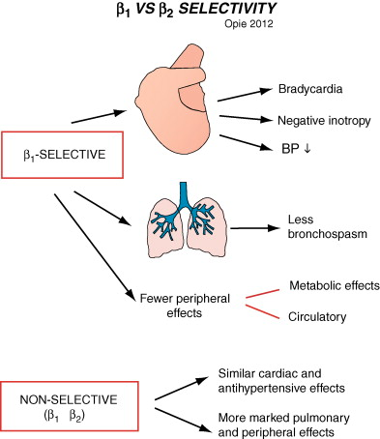

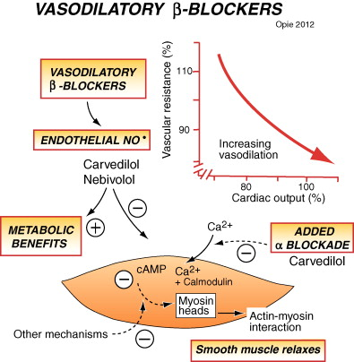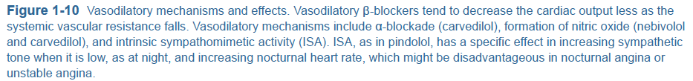
II. Pharmacokinetic properties of β-blockers
Plasma half-lives
- Esmolol IV has the shortest of all half-lives at only 9 min

Protein binding
- Propranolol, pindolol, labetalol, and bisoprolol are highly protein bound
- Hypoproteinemia calls for lower doses

First-pass liver metabolism
- Found with highly lipid-soluble compounds (propranolol labetalol, and oxprenolol)
- Major hepatic clearance also found with acebutolol, nebivolol, metoprolol, and timolol
- First-pass metabolism varies greatly among patients and alters the dose required
- In liver disease or low-output states the dose should be decreased
- First-pass metabolism produces active metabolites
- Lipid-insoluble hydrophilic compounds (atenolol, sotalol, nadolol) are excreted only by the kidneys and have low brain penetration

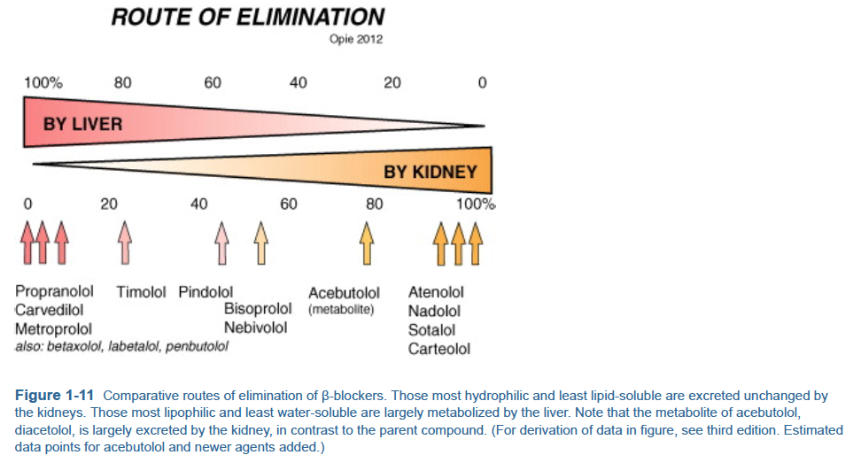

III. Concomitant diseases and choice of β-blocker
Respiratory disease
- In patients with a history of asthma, no β-blocker can be considered safe
- Cardioselective β1-blockers in low doses are best for patients with reversible bronchospasm

Renal disease
- β-blocker eliminated by the liver rather than the kidney

Diabetes mellitus
- β-blockade in insulin-requiring diabetics may mask signs of hypoglycemia
- Lesser risk with the cardioselective agents

IV. Side Effects of β-blockers
Four major mechanisms of β-blocker side effects
- Smooth muscle spasm (bronchospasm and cold extremities)
- Exaggeration of the cardiac therapeutic actions (bradycardia, heart block, excess negative inotropic effect)
- Central nervous system penetration (insomnia, depression)
- Adverse metabolic side effects. The mechanism of fatigue is not clear.

Central side effects
- Depression
- Lipid solubility hypothesis: lipid-soluble β-blockers (epitomized by propranolol) with their high brain penetration are more likely to cause central side effects
  - However, detailed comparison of propranolol and atenolol showed that the latter, which is not lipid soluble, causes far fewer central side effects than does propranolol (Conant J, et al: Central nervous system side effects of beta-adrenergic blocking agents with high and low lipid solubility. J Cardiovasc Pharmacol 1989; 13:656-661.)
- The lipid-solubility hypothesis does not explain why metoprolol, which is moderately lipid soluble, appears to interfere less with some complex psychological functions than does atenolol and may even enhance certain aspects of psychological performance

Effects on quality of life
- Weight gain is undesirable and contrary to the lifestyle pattern required to limit cardiovascular diseases, including the metabolic syndrome and hypertension
- β-blockade may precipitate diabetes
- During exercise, β-blockade reduces the total work possible by approximately 15% and increases the sense of fatigue

Adverse metabolic side effects and new diabetes
- Capacity of β-blockers to increase new diabetes, whether given for hypertension or postinfarct

V. Contraindications to β-blockade
*cautions may be overridden by the imperative to treat (i.e. post infarct patients)
 | Contraindication
Cardiac | Absolute | Severe bradycardia, high-degree heart block, cardiogenic shock, overt untreated left ventricular failure (versus major use in early or stabilized heart failure)
Cardiac | Relative | Prinzmetal’s angina (unopposed α-spasm), high doses of other agents depressing SA or AV nodes (verapamil, diltiazem, digoxin, antiarrhythmic agents)
Pulmonary | Absolute | Severe asthma or bronchospasm. Risk of fatalities
Pulmonary | Relative | Mild asthma or bronchospasm or chronic airways disease.  Use agents with cardioselectivity plus β2-stimulants (by inhalation)
CNS | Absolute | Severe depression  *especially avoid propranolol
CNS | Relative | Vivid dreams- avoid highly lipid-soluble agents and pindolol; avoid evening dose  Visual hallucinations- change from propranolol  Fatigue- (all agents).  Psychotropic drugs (with adrenergic augmentation)- may adversely interact
Peripheral, Vascular | Absolute | Active disease - gangrene, skin necrosis, severe or worsening claudication
Peripheral, Vascular | Relative | Cold extremities, absent pulses, Raynaud phenomenon.  Avoid nonselective agents (propranolol, sotalol, nadolol)  Prefer vasodilatory agents
Diabetes Mellitus | Relative | Insulin-requiring diabetes- nonselective agents decrease reaction to hypoglycemia; use selective agents
Metabolic Syndrome or Prediabetes |  | β-blockers may increase blood sugar by 1-1.5 mmol/L and impair insulin sensitivity especially with diuretic co-therapy; consider use of carvedilol or nebivolol.
Renal Failure | Relative | As renal blood flow falls, reduce doses of agents eliminated by kidney
Liver Disease | Relative | Avoid agents with high hepatic clearance (propranolol, carvedilol, timolol, acebutolol, metoprolol)  Use agents with low clearance (atenolol, nadolol, sotalol)  If plasma proteins low, reduce

VI. Overdose of β-blockers
- Bradycardia may be countered by IV atropine
- If serious, temporary transvenous pacing may be required
- Dobutamine can be given in doses high enough to overcome the competitive β-blockade (15 mcg/kg/min)

Questions
- Name one absolute contraindication for the following systems:
Cardiac:
Pulmonary:
CNS:

- What are the four major mechanisms of beta-blocker side effects

- True or False. Atenolol, which is not lipid soluble, causes far fewer central side effects than does propranolol

- Cardioselectivity is greatest at which dose?
  - Low
  - High
  - All

Answers
- Name one absolute contraindication for the following systems:
Cardiac: severe bradycardia, preexisting high-degree heart block, sick sinus syndrome, and overt LV failure unless already conventionally treated and stable
Pulmonary: overt asthma or severe bronchospasm; depending on the severity of the disease and the cardioselectivity of the β -blocker used, these may be absolute or relative contraindications
CNS: severe depression (especially for propranolol)

- What are the four major mechanisms of beta-blocker side effects
  - smooth muscle spasm (bronchospasm and cold extremities)
  - exaggeration of the cardiac therapeutic actions (bradycardia, heart block, excess negative inotropic effect)
  - central nervous system penetration (insomnia, depression)
  - adverse metabolic side effects. The mechanism of fatigue is not clear.

- True or False. Atenolol, which is not lipid soluble, causes far fewer central side effects than does propranolol

- Cardioselectivity is greater at which level of dose?
  - Low dose
  - High dose
  - Any dose

