Three main results of arrhythmias
- Signs of hemodynamic compromise (such as collapse)
- Progression of concurrent cardiac disease
  - In patients without underlying heart disease, right sided heart failure often occurs first due to lower filling pressures
- Sudden death
Questions for antiarrhythmic therapy
- Is there a treatable underlying condition
- What are the potential adverse effects of the arrhythmia
- Whar are the potential effects (beneficial and adverse) of antiarrhythmic therapy

Conditions that cause arrhythmias (altering myocardial structure, intra or extracellular fluid, neuronal control)
- Structural disease
- Trauma
- Autonomic imbalance
- Hypoxia
- Metabolic disturbances
- Inflammation
- Drugs/Toxins
- Extreme temperatures

Vaughan Williams Classifications
- Class I block sodium channels in myocardium and His-Purkinjie tissue
  - Slows phase 0 depolarization and slows impulse conduction
- Class II are antiadrenergic drugs (mainly beta adrenergic receptor blockers)
  - Catecholamines stimulate beta receptors by activating pacemaker currents and stimulating calcium channels
- Class III prolong repolarization in all heart tissue by inhibition of potassium channels.
  - This slows or stops impulse conduction
- Class IV agents are calcium-channel blockers which act mainly in nodal tissues and decrease rate of depolarization in these cells.

Vaughan Williams Subdivision of class I
- Ia drugs also prolong repolarization (as in class III drugs)
  - This may be beneficial in rapid tachycardias
- Ib drugs have preference to slow conduction in abnormal myocardium. They also hasten repolarization (opposite of Ia) in diseased myocardium, helping with synchrony
- Ic drugs are the most potent sodium channel blockers, but have minimal class III effects (repolarization)

Specific Drugs
- Lidocaine
  - Rapid 1st pass hepatic metabolism (IV only)
  - Rapid onset, good safety profile
  - Highly protein bound
  - Max dose 6-8 mg/kg over 10 minutes
    - Lidocaine looeses efficacy over about 10-15 minutes post bolus
      - But half life is hours due to accumulation in tissues and active metabolites , so tapering may not be required
  - Cat dose is 0.5mg/kg bolus, up to 2mg/kg over 10 min max
  - CRI dose of 25-100mcg/kg/min can be done after, usually starting with 50
    - **Note, this is the only source I have seen with 100mcg/kg/min max dose, other sources say 80 is max)
  - Adverse effects
    - Neuro signs including tremors and seizures (treatable with diazepam)
    - GI effects
    - Cats are more susceptible to neuro signs
  - Hypokalemia can reduce efficacy of lidocaine
- Mexiletine
  - Very similar to lidocaine, but longer half life and less first pass hepatic metabolism
    - Can be given orally
  - Chronic ventricular tachyarrhythmias
  - Side effects are more GI and less neuro than lidocaine
  - Can be combined synergistically with beta blockers
  - No doses for cats
- Beta Blockers
  - Catecholamine agonism of beta 1 receptors increase cAMP within cardiac myocytes, increasing work, pacemaker currents, and calcium dependent triggered activity
  - All beta blocker are similar in beta-1 effects
  - Main difference is beta-2 effects, pharmacokinetics, and additional properties
  - Work on both nodes and can decrease conduction via AV node
  - Can decrease clinical signs of ventricular arrhythmias without decreasing absolute frequency
  - Adverse effects
    - Acutely impair cardiac function in patients with myocardial failure
    - Lethargy, collapse, hypotension and CHF are most common effects
    - Non-selective beta-blockers (i.e. those with beta-2 blocking effects) can cause respiratory difficulty due to bronchoconstriction
      - Can also occur with high doses of beta-1 selectives
- Sotalol
  - Class III and II (beta blocker with potassium channel blocking)
    - Beta 1 and beta 2 properties
  - Potassium channel inhibition delays re-polarization, which prolonges action potentials in all heart tissue
  - NOT protein bound
  - Renal excretion
  - Can be used for ventricular and supraventricular arrhythmias
  - Adverse effects
    - Negative inotropy and chronotropy
      - Can precipitate CHF in patients with heart disease or systolic dysfunction
    - Bronchoconstriction
- Amiodarone
  - Has class I, II, III, and IV actions on all heart tissue
  - Lipophilic and protein bound
  - Poor oral bioavailability
  - VERY long elimination half-life (weeks!)
    - Requires loading dose and then smaller dose
  - Can cause positive Coombs’ test when administered chronically
  - Can increase serum digoxin concentrations
  - Has fewer negative inotropic effects than sotalol
    - May be better for control of ventricular arrhythmias in dogs with CHF of systolic dysfunction
  - Nexterone dose (based on Levy et al 2016)
    - 2mg/kg IV over 10 minutes
    - 0.8mg/kg/hr over 6 hours
    - 0.4mg/kg/hr thereafter
- Diltiazem
  - Calcium channel blocker (class IV)
    - Slows sinus rate and AV node conduction
    - Arteriodilation
  - Protein bound and hepatic metabolism (short half-life)
  - IV dose of 0.1-0.25mg/kg over 1-2 minutes (up to 0.75mg/kg over 30 min)
  - Is relatively safe during CHF
- Digoxin
  - Inhibition of sodium potassium ATPase pump
    - Increases intracellular calcium concentrations in heart tissue
  - Increased vagal tone
    - Decreased sinus rate and AV node conduction
  - Increased baroreceptor sensitivity
  - Slight positive inotropic effect
  - Can cause tachyarrhythmias
  - Low protein binding
  - Renal excretion (must monitor renal values)
  - Serum concentration increased by amioderone
  - Adverse effects
    - SLUD signs
    - Depression
    - Tachyarrhythmias, ventricular bigemony/trigemony, slow sinus or ventricular rates
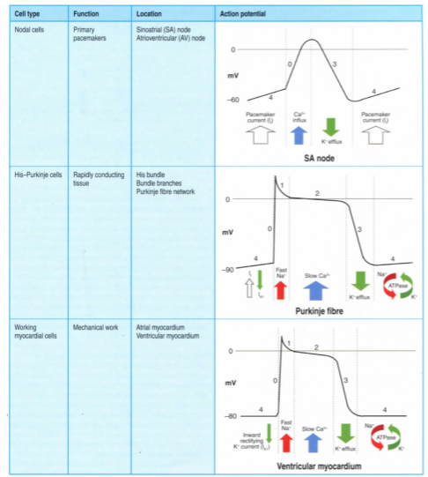
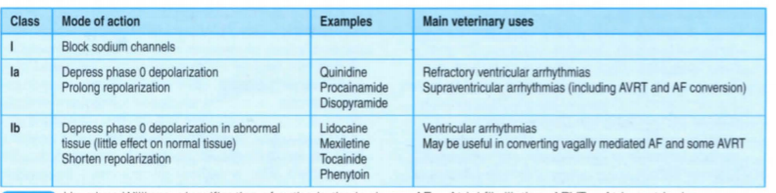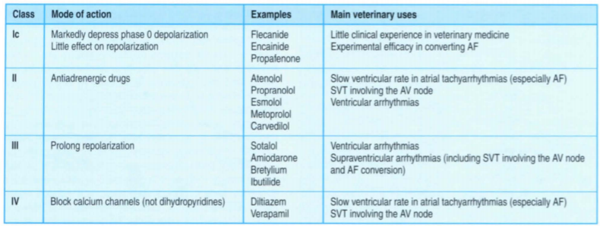

Questions:
- You are presented with a 8-year old female spayed Labrador in ventricular tachycardia (rate 230), evidence of systolic dysfunction on focused ultrasound exam, and end-inspiratory crackles heard on auscultation. The patient's systolic blood pressure is 70. Which of the following drugs would be the most appropriate for control of the arrhythmia?
  - Mexiletine
  - Sotalol
  - IV diltiazem
  - IV Amiodarone
- Which of the following drugs undergoes primarily renal excretion?
  - Digoxin
  - Lidocaine
  - Diltiazem
  - Mexiletine
- Vaughan Williams Class III antiarrhythmics function primarily on the ________ which has ________ effects on myocardial tissue:
  - Calcium channels; increased duration of action potential
  - Potassium channels; decreased duration of action potential
  - Calcium channels; decreased duration of action potential
  - Potassium channels; increased duration of action potential
- Which of the following would be considered a relative contra-indication for administration of non-selective beta-blockers in a feline patient?
  - Renal disease
  - Systolic anterior motion of the mitral valve
  - Feline allergic bronchitis
  - Concurrent therapy with mexiletine
- Which of the following drugs is least protein-bound?
  - Sotalol
  - Digoxin
  - Lidocaine
  - Diltiazem

Answers:
Questions:
- You are presented with a 8-year old female spayed Labrador in ventricular tachycardia (rate 230), evidence of systolic dysfunction on focused ultrasound exam, and end-inspiratory crackles heard on auscultation. The patient's systolic blood pressure is 70. Which of the following drugs would be the most appropriate for control of the arrhythmia?
  - Mexiletine
  - Sotalol
  - IV diltiazem
  - IV Amiodarone
- Which of the following drugs undergoes primarily renal excretion?
  - Digoxin
  - Lidocaine
  - Diltiazem
  - Mexiletine
- Vaughan Williams Class III antiarrhythmics function primarily on the ________ which has ________ effects on myocardial tissue:
  - Calcium channels; increased duration of action potential
  - Potassium channels; decreased duration of action potential
  - Calcium channels; decreased duration of action potential
  - Potassium channels; increased duration of action potential
- Which of the following would be considered a relative contra-indication for administration of non-selective beta-blockers in a feline patient?
  - Renal disease
  - Systolic anterior motion of the mitral valve
  - Feline allergic bronchitis
  - Concurrent therapy with mexiletine
- Which of the following drugs is least protein-bound?
  - Sotalol
  - Digoxin
  - Lidocaine
  - Diltiazem

