World J Cardiol. 2015 Apr 26; 7(4): 204–214
Autonomic and endocrine control of cardiovascular function

Σ receptors | Σ neurotransmitters | PΣ receptors | PΣ neurotransmitters
α₁₋₂  β₁₋₂ | Preganglionic: ACh | Nicotinic  Muscarinic (M₂₋₃) | Preganglionic: ACh
α₁₋₂  β₁₋₂ | Postganglionic: NE | Nicotinic  Muscarinic (M₂₋₃) | Postganglionic: ACh
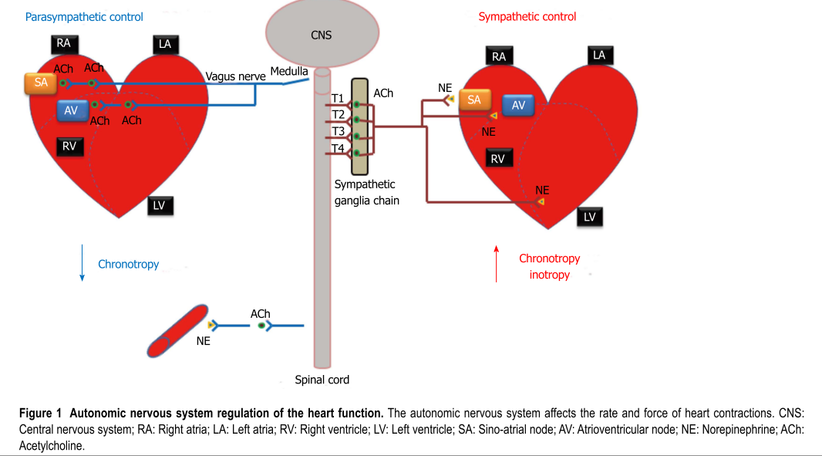

β₁ | β₂ | α₁ | α₂
SA, AV nodes  Cardiomyocytes (A&V) | Vascular SM, skeletal muscle, coronary circulation | Vascular SM | Vascular SM
⬆HR (SAN)  ⬆contractility (increased IC calcium and increase Ca release from SR)  ⬆velocity (AVN)  Induces renin release | Vasodilation  *Not innervated; epinephrine | Vasoconstriction | Vasoconstriction

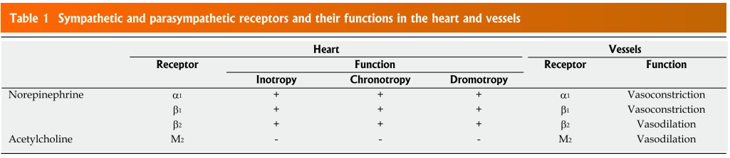
M₂ | M₃
Nodal and atrial tissue  Sparse in ventricles | Vascular endothelium
⬇HR  ⬇conduction velocity (AVN)  ⬇contractility (atrial) | Vasodilation (NO)

- In contrast to sympathetic activity, the parasympathetic nervous system has little effect on myocardial contractility
  - It is a matter of debate whether parasympathetic stimulation can exhibit negative inotropic effects, as the vagus nerve does not directly innervate cardiomyocytes other than that of the sinoatrial and atrioventricular nodes, however, recent in vivo studies may suggest otherwise, at least in the atrium

Cellular signal transduction
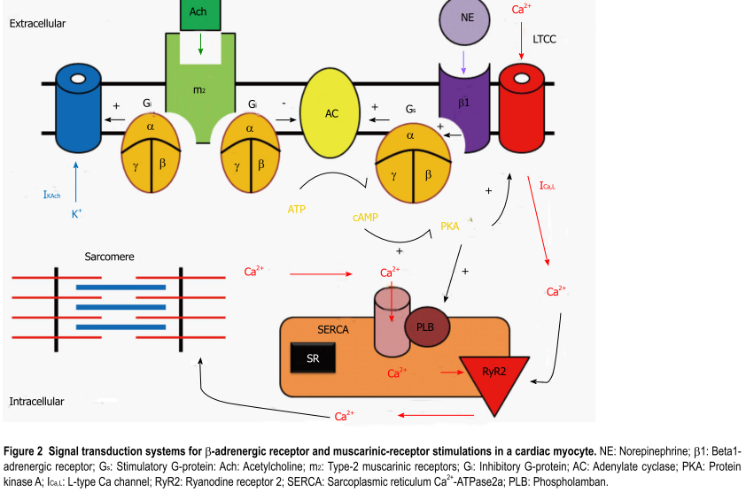

Autorhythmic cells
- The funny current is thought to be the pace making current in the SA
node. It is a non-selective cation channel that can
inwardly conduct both sodium and potassium ions.
As the membrane potential becomes increasingly
hyperpolarized during phase 3 and 4 of the action
potential, I_{f}
increases inward potassium and sodium
currents, which causes the phase 4 diastolic depolarization. I_{f}
channels are activated by direct binding of
cAMP.
- In addition to the funny current, one of the other
driving mechanisms behind the automaticity of the pacemaking cells within the SA node is the calcium clock
. As the SR fills with calcium, the probability of
spontaneous calcium release increases; in contrast, when the SR calcium stores are depleted, the probability of spontaneous calcium release is reduced. Increased Ca2+
entry also increases automaticity
because of the effect of [Ca2+
]on the transient inward
current carried by the sodium-calcium exchange current (INCX
). When these pacemaking mechanisms depolarize the resting membrane potential reach
the threshold voltage, which induces the opening of L-type Ca channel (LTCC), and an action potential is fired
- M₂
receptor stimulation opens
muscarinic potassium channels (KACh)
. These channels
are opened by M₂
receptors binding to ACh and produce
a hyperpolarizing current that opposes the inward pacemaker current. Therefore, the parasympathetic stimulation increases outward K+
permeability, slowing the heart rate and reducing automaticity

Regulation of cellular calcium handling and cardiac contraction
- Excitation-contraction coupling in cardiomyocytes is dependent on calcium-induced calcium release, whereby an action potential initiates an increase in cellular calcium through opening of the LTCC on the cellular membrane. This creates a positive feedback loop by activating the ryanodine receptors of the SR causing the release of an even greater amount of calcium.
- Free intracellular calcium is resequestered into the SR via the SR ATPase pump (SERCA), or is pumped from the cell via the sodium-calcium exchanger on the cellular membrane.
- Sympathetic stimulation leads to the elevation
of cAMP levels and the activation of PKA, which phosphorylates the α₁
subunits of the LTCCs. This increases the opening probability of LTCCs and the
inward Ca2+
current, and thus enhances the force of
cardiac contraction. In addition, PKA phosphorylates
phospholamban, thus relieving its inhibition of SERCA,
which in turn facilitates Ca2+ uptake by the SR and
increases the amount of Ca2+
available for release by the AP. Also increases the Ca2+
sensitivity of the contractile machinery, mediated by phosphorylation of troponin C
Autonomic regulation of vascular function
- Most vessels only receive sympathetic innervation, while capillaries receive no innervation.
- These sympathetic nerve fibers tonically release NE, which activates α₁-adrenergic and β₂-adrenergic receptors on
blood vessels thereby providing basal vascular tone.
- Since there is greater α₁
than β₂
receptors in the arteries, activation of sympathetic nerves causes vasoconstriction and increases the systemic vascular resistance primarily via α₁
receptor activation. On the other hand, modified sympathetic nerve endings in the adrenal medulla release circulating epinephrine, which also binds to α₁
and β₂ in vessels. However, β-adrenergic receptors show greater affinity for epinephrine than for norepinephrine. Therefore, circulating epinephrine at low concentrations activates only β₁
-adrenergic
(mainly in the heart) and β₂
-adrenergic (mainly in
vessels) receptors, which increase cardiac output and cause vasodilation, respectively.

Cardiovascular reflexes
- Baroreceptor reflex
Location | Sense what? | Inform who? | Results
Aortic arch  Carotid sinuses | Increase in BP  (distension) | Rostral ventrolateral medulla (medulla oblongata) | Vasodilation  Negative inotropic and negative chronotropic effects  (Σ inhibition and PΣ activation)
Venae cavae  Pulmonary veins | Drop in BP | Hypothalamus/pituitary  Kidneys | Release of AHD  Activation of RAAS
Atria | Distension of atria | Medulla  SA | Σ activation  Increase in HR

- Chemoreceptor reflex
Location | Sense what? | Inform who? | Results
Peripheral: carotid and aortic bodies | O₂  CO₂  pH | Through CNIX and CNX medullary center | Decrease in PΣ stimulation (increase in HR and respiration), increase in Σ
Central: ventrolateral medulla | CO₂  pH

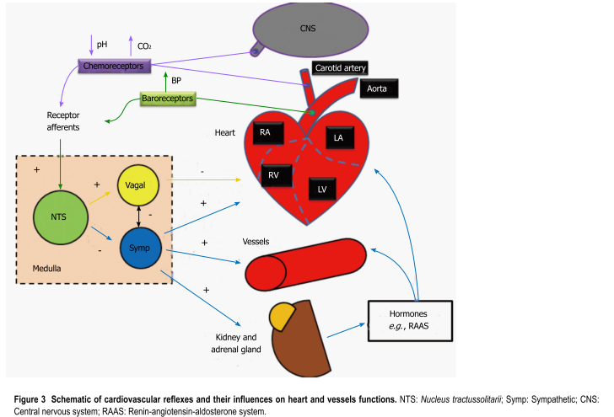

Endocrine/paracrine reflexes and the regulation of blood pressure
- Adrenal medulla
  - Chromaffin cells; 80% epinephrine, 20% NE
  - Another
neurotransmitter, dopamine, has limited actions
in the autonomic nervous system and may excite or
inhibit depending on the receptors. Dopamine can be
converted into norepinephrine and thus can increase
heart rate and blood pressure.
  - Epinephrine at low concentrations is
β₂
-selective, producing vasodilatation,
while at high concentrations it also stimulates α₁
, α₂,
and β₁ receptors, producing vasoconstriction (α), and increases heart rate and contractility (β1)
- Posterior pituitary
  - ADH
  - Secreted in response to a reduction in plasma
volume, an increase in plasma osmolarity, or an
increase in cholecystokinin
  - Water retention
  - Vasoconstriction
- Kidney
  - Calcitriol, EPO, renin
  - RAAS
- Heart
  - ANP
    - ANP is produced, stored, and released by atrial
myocytes (while also being produced in the ventricles,
brain, suprarenal glands, and renal glands).
    - Stimuli for release:
      - Distention of
the atria
      - β-adrenergic stimulation
      - Hypernatremia
      - Increases in angiotensin ⅡI
      - Increases in endothelin
    - Effects
      - Upon the vasculature: blocks catecholamines
      - In the heart: inhibits hypertrophy by blocking norepinephrine- stimulated protein synthesis.
      - Exhibit cardioprotective properties related to its ability to block cardiac fibrosis following ischemia-reperfusion injuries
  - BNP
    - Produced by ventricular cardiomyocytes,
    - Works in a similar fashion to ANP
    - Secreted in response to excessive stretching of ventricular myocytes
    - Level is typically increased in patients with left ventricular dysfunction. Elevated levels of BNP are thought to be indicative of poor left ventricular function and heart failure
- Other
  - Endothelin-1
    - Produced by endothelial cells
    - Vasoconstrictor
    - May play a role in cardiac hypertrophy via cellular alkalinization
    - Receptors
      - ET_{A}: smooth muscle vasoconstriction
      - ET_{B}
: release of nitric oxide from endothelial cells, thus
resulting in vasodilatation
      - ET_{B2}
: vasoconstriction.
      - ET_{C}: unknown
  - Thyroxin
    - Increases the effect of epinephrine
    - Increases the number of β₁
receptors and is thus indirectly responsible for increasing cardiac output
(in both an inotropic and chronotropic manner) and
increasing respiration rates. It is directly responsible
for increasing basal metabolic rates by increasing
protein and carbohydrate metabolism
    - Arrhythmia (a-fib or others)

QUESTIONS
- M₂ receptors activation will lead to …
  - Vasodilation
  - Vasoconstriction
  - Increase in HR
  - Decrease in HR

- Epinephrine, at low concentration, is _______-selective
  - α₁
  - α₂
  - β₁
  - β₂

- Ivrabadine is a selective-inhibitor of the I_{f} current. Therefore, it is going to predominantly act at the level of the …
  - Sinoatrial node
  - Atrioventricular node
  - Atrial cardiomyoctes
  - Ventricular cardiomyocytes

- Describe the response to an elevated blood pressure

- Explain how sympathetic stimulation enhances the force of
cardiac contraction

QUESTIONS & ANSWERS

- M₂ receptors activation will lead to …
  - Vasodilation
  - Vasoconstriction
  - Increase in HR
  - Decrease in HR

- Epinephrine, at low concentration, is _______-selective
  - α₁
  - α₂
  - β₁
  - β₂

- Ivrabadine is a selective-inhibitor of the I_{f} current. Therefore, it is going to predominantly act at the level of the …
  - Sinoatrial node
  - Atrioventricular node
  - Atrial cardiomyoctes
  - Ventricular cardiomyocytes

- Describe the response to an elevated blood pressure
Elevation in BP will stretch the carotid arteries and aorta causing the baroreceptors to increase their basal rate of action potential generation. APs are conducted by CNIX and CNX to the cardioregulatory and vasomotor center in the medulla oblongata. As a result of the increased stimulation from the BR the cardioregulatory center increases parasympathetic stimulation to the heart which decreases the HR. Also as a result of the increased stimulation from the BR, the cardiovascular center decreases sympathetic stimulation to the heart which decreases HR and contractility. The vasomotor center decreases sympathetic stimulation to blood vessels causing vasodilation. Decreased HR, SV, and vasodilation bring the elevated BP back toward normal.

- Explain how sympathetic stimulation enhances the force of
cardiac contraction
Epinephrine binds to β₁-adrenergic receptor and activates stimulatory G protein (G_{s}) by causing conformational change in G_{s} so that the dissociated α_{s} subunit can then bind to and activate adenylyl cyclase. This will catalyze the conversion of ATP into cAMP. cAMP will activate protein kinase A. PKA phosphorylates LTCCs which will enhance the opening probability of LTCCs and the inward calcium current, and thus the force of cardiac contraction.

