Antiarrhythmics – Mixed Class III

Mixed Class III – Amiodarone and Sotalol
- Class I –Lidocaine, has shown evidence for increased mortality, hence this class has become more commonly used
- Increase the action potential duration, hence increase the effective refractory period, leading to prolonged QT interval
- In the presence of hypokalemia, hypomagnesemia, bradycardia, QT prolongation may predispose to Torsades de pointes (less incidence with amiodarone)

Amiodarone
- Wide-spectrum antiarrhythmic, mostly class II, but also powerful class I activity and ancillary class II and class IV activity – blocks Na, Ca and repolarizing K channels
- Lengthens the effective refractory period by prolonging the action potential duration in all cardiac tissues, including bypass tracts
- Non-competitively blocks α and β adrenergic receptors (class II effect)
- Weak Ca antagonist (Class IV) may produce bradycardia and AV nodal inhibition, and low incidence of torsades de pointes
- Weak coronary and peripheral vasodilator actions
- Highly lipid soluble, 95% protein bound, slow GI absorption (30-50%), loading doses are necessary
- Extensive hepatic metabolism – desethylamiodarone, excreted through lachrymal glands, skin and biliary tract
- Indications: recurrent Vfib or hemodynamically unstable Vtach, unresponsive to lidocaine, conversion of chronic Afib (conversion takes up to 6 hours)
- IV amiodarone may produce hypotension
- Contraindications: severe sinus node dysfunction with marked sinus bradycardia or syncope, 2nd or 3rd degree AV block, cardiogenic shock, severe chronic lung disease
- Side effects: sinus bradycardia, <0.5% incidence torsades de pointes, hypothyroidism (6%), pulmonary toxicity (1-17%), hepatotoxicity (15-30%), corneal microdeposits (>90%)

Sotalol
- Less effective than amiodarone, chosen when amiodarone toxicity is feared
- Non-cardioselective, hydrophilic, non-protein bound, eliminated through kidneys
- Indications: sinus tachycardia, Paroxysmal SVT, WPW arrhythmias, recurrence of Afib, ischemic ventricular arrhythmias, recurrent sustained Vtach or Vfib
- Side effects: fatigue (20%), bradycardia (13%), torsades de pointes, bronchospasm
- Contraindications: sick sinus syndrome, 2nd or 3rd AV block (unless pacemaker is placed), bronchospastic disease (asthma),
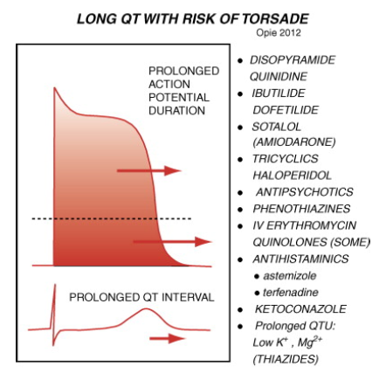

Questions:
What are the indications for Amiodarone?

Name 4 factors that may predispose to producing Torsades de Pointes when using class II antiarrhythmics

Answers:
What are the indications for Amiodarone?
- Recurrent Vfib
- Hemodynamically unstable Vtach, unresponsive to lidocaine
- Conversion of chronic Afib (conversion takes up to 6 hours)

Name 4 factors that may predispose to producing Torsades de Pointes when using class II antiarrhythmics
- Hypokalemia
- Hypomagnesemia
- Bradycardia
- QT prolongation

