Anesthetic Considerations during Pregnancy and for the Newborn
Summary
- Physiology during pregnancy changes, HR increases, BP increases by 10-30 mmHg, normal PaCO2 is 30 mmHg, GFR increases (lower BUN and Creat), PCV decreases, etc.
- Middle trimester is the safest for anesthesia
- Most drugs cross placenta and may cause neonatal cardioresp depression, lower doses and reversals should be used

Pregnancy-associated changes in maternal physiology
- Cardiovascular
  - Maternal blood volume increases by 40%, plasma increases > than rbc, resulting in decreased Hb
  - Cardiac output > 30-50% during pregnancy
  - Plasma estrogens decrease peripheral vascular resistance – increased cardiac output
  - During labor and postpartum CO >10-25%
  - SAP > 10-30 mmHg
- Pulmonary
  - Serum progesterone increases respiratory center PaCO2 sensitivity
  - PaCO2 approaches 30 mmHg at parturition
  - O2 consumption > 20%
  - Progesterone – bronchodilation
  - FRC decreases due to craniodorsal displacement of diaphragm, increased pulmonary blood volume
- Gastrointestinal
  - Decreased gastric motility and gastric emptying
  - Acid, Cl and enzymes increase in gastric secretion
  - Lower esophageal sphincter tone is decreased, intragastric pressure is increased
  - Metoclopramide
  - H2 blocker
  - Risk of vomiting increases with hypotension, hypoxia and toxic reactions to anesthesia – Maropitant, Ondansetron
- Liver and kidney
  - ALT, ALKP mildly increased
  - Renal plasma flow and GFR 60% increased – lower BUN and creat
- Urine blood flow
  - Directly proportional to systemic perfusion pressure and inversely proportional to vascular resistance created in myometrial blood vessels
  - Anesthesia reduces uterine blood flow and fetal viability
  - Sympathomimetics cause uterine vasoconstriction (epinephrine, norepinephrine, phenylephrine)

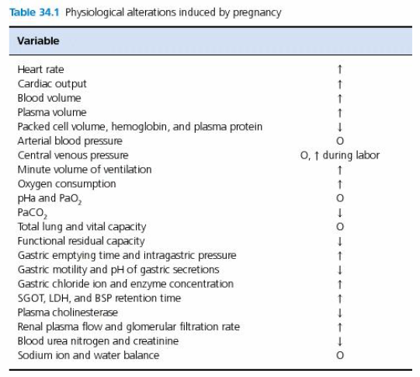

Anesthesia during pregnancy
- 1st trimester – GA can produce fetal teratogenesis, spontaneous abortion, fetal death
- Middle trimester – safest period of gestation, spontaneous abortion and fetal death can occur
- 3rd trimester – risk of premature labor and fetal death
- Avoid NSAIDs after the 1st trimester to avoid premature closure of the ductus arteriosus
Anesthetic drugs and cesarean section
- Anticholinergic agents:
  - Glycopyrrolate increases gastric pH decreasing severity of Mendelson's syndrome (chemical pneumonitis from aspiration during anesthesia, especially at parturition), does not cross placenta
- Tranquilizers and Sedatives:
  - Acepromazine can produce severe maternal and fetal depression even at low doses
  - Benzodiazepines can produce neonatal depression and lethargy, hypotonus, apnea and hypothermia immediately after birth, can use flumazenil
  - Α2 adrenergic agonists: xylazine should not be used – maternal and fetal respiratory and circulatory depression, no vet med information on dexmedetomidine
- Opioids:
  - Cross placenta and cause neonatal respiratory
  - Butorphanol and buprenorphine produce less respiratory depression than pure opiate agonists
  - If naloxone is needed, delivery to neonates, not to mother before birth as analgesia will also be reversed
- Sedative-hypnotics:
  - Thiopental causes neonatal resp depression, sleepiness and decreased activity
  - Suckling activity is decreased for up to 4 days
  - Propofol produce cardiovascular and resp depression, quick recovery
  - Propofol + iso protocol increased puppy survival after c-section
  - Etomidate is suitable for induction, repeated administration can cause acute hemolysis
  - Alfaxalone causes minimal cardiopulmonary depression and is short acting
- Dissociatives:
  - Ketamine leads to puppy risk associated with respiratory depression, apnea, and increased mortality at birth.
- Neuroleptanalgesia
  - Opioid + tranquilizer – see above
- Inhalation agents
  - Cross placenta, degree of neonatal depression is proportional to degree of depth of anesthesia in the mother
  - Isofluorane, Sevofluorane and desfluorane are preferred since induction and recovery is rapid
- Skeletal muscle relaxants
  - Cross placenta to a limited extent, limited effect on neonates
  - Controlled positive-pressure ventilation should be used
  - Reversal: neostigmine or edrophonium
- Local anesthetics
  - Neonatal depression rarely occurs after epidural, but can occur with excessive volumes of drug used for local infiltration

Anesthetic techniques for cesarean section
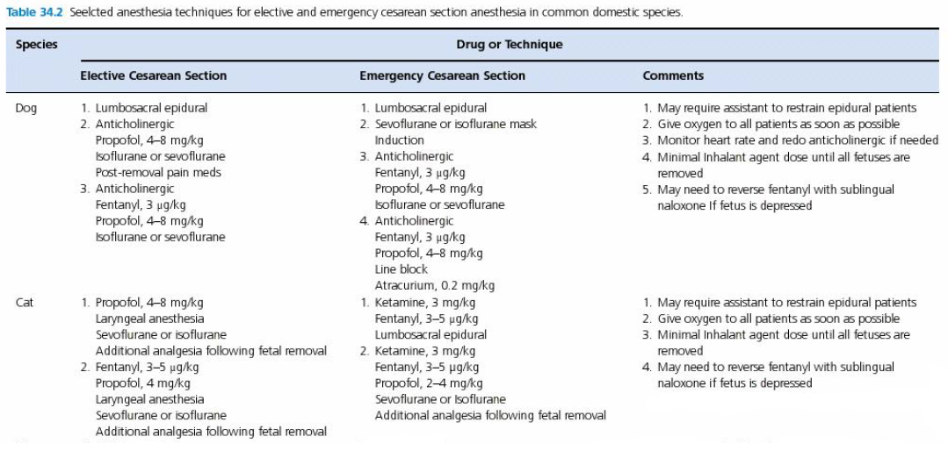
Care of the newborn
- Clear oropharynx of fluid and the head of membranes
- Umbilical vessels should be milked towards the neonate, clamped and ligated
- Towel dry and rub to stimulate breathing, support neck
- Reversal of opioids: naloxone 1-2 drops intranasal or sublingual
- Oral dose of 2.5% dextrose (0.1-0.5 mL)
- Keep warm
- Doxapram puppies: 1-5 drops on oral mucosa, IM or SQ, kittens: 1-2 drops
- Newborn puppy viability has been associated with umbilical vein blood lactate, >5 was correlated with increased neonate mortality within 48 hr of delivery
Perioperative pain management
- NSAIDs are acceptable

Questions
- T or F: Mild azotemia can be expected during the third trimester of pregnancy due to a decrease of GFR.

- T or F: NSAIDs administered after the first trimester can produce the premature closure of the ductus arteriosus

- T or F: The risk of aspiration pneumonia is increased during pregnancy due to an increase in intragastric pressure and decreased lower esophageal sphincter tone

Answers
- T or F: Mild azotemia can be expected during the third trimester of pregnancy due to a decrease of GFR. GFR increases during pregnancy

- T or F: NSAIDs administered after the first trimester can produce the premature closure of the ductus arteriosus

- T or F: The risk of aspiration pneumonia is increased during pregnancy due to an increase in intragastric pressure and decreased lower esophageal sphincter tone

