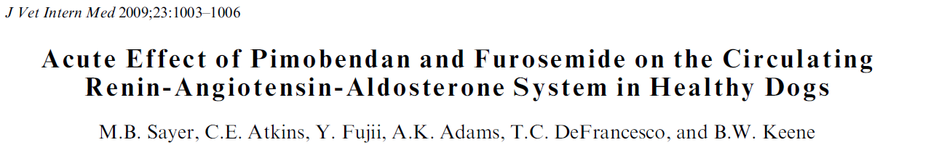

Key Points
- Experimental, cross-over study, dogs were administered pimobendan (0.5 mg/kg q12h) for 4 days followed by furosemide (2 mg/kg q12h) and then, after a wash-out period, a combination of the drugs
- Aldosterone : creatinine (A : Cr) was measured at the end of each treatment cycle
- There was no significant increase in the average urinary A: Cr with the administration of
- There was a significant increase in the average urinary A: Cr after administration of furosemide and with the combination of furosemide and pimobendan

Take away
- Short-term administration of high-dose pimobendan, does not activate the RAAS in healthy dogs
- Pimobendan did not prevent RAAS activation associated with furosemide therapy
- These results in healthy dogs suggest that furosemide therapy, with or without pimobendan, should be accompanied by RAAS suppressive therapy
Questions:

- Pimobendan is a phosphodiesterase _________ inhibitor
  - II
  - III
  - IV
  - V
- What tests can be run/values measured to assess activation of the RAAS.

Questions:

- Pimobendan is a phosphodiesterase _________ inhibitor
  - II
  - III
  - IV
  - V
- What tests can be run/values measured to assess activation of the RAAS.
  - Serum renin
  - angiotensin II
  - aldosterone
  - urinary aldosterone secretion either by 24-hour urinary aldosterone excretion or by the urinary aldosterone : creatinine ratio (A : Cr)

