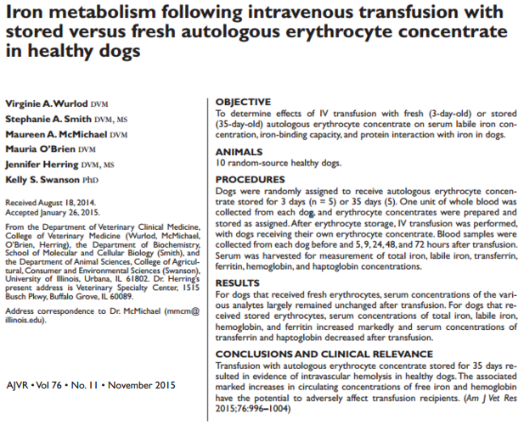

- Prospective study involving 10 healthy dogs
- Dogs transfused autologous pRBCs stored for 3 days (n=5) or 35 days (n=5)
- Dogs that had blood stored for 35 days had serum iron and cell free hemoglobin concentrations
  - Indicates RBC destruction and can worsen inflammatory response and infection
- Take home: Blood stored for less time is better

