ACEI
MOA:
- Renin is produced by renal juxtaglomerular cells in response to
  - Impaired blood flow (hypotension)
  - Salt depletion (sodium diuresis)
  - B₁-adrenergic stimulation
- Renin stimulates production of angiotensin I by the liver
- Angiotensin I is converted to angiotensin II, mostly by endothelium and lung tissue by angiotensin converting enzyme (ACE)
  - ACEI act at same binding site that binds to angiotensin I
  - Competitive inhibition
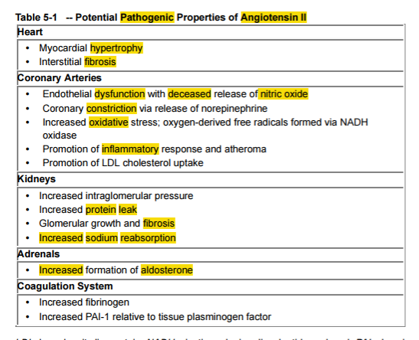

Angiotensin can be generated by alternative means
- Theoretical, however since ARBs and ACEI have similar efficacy, does not appear to be clinically relevant
Angiotensin works via 2’ messengers to have effects on ventricular remodelling and vasoconstriction
- Phosphodiesterases, protein kinase C, inositol trisphosphate signalling, etc…
Angiotensin II receptor subtypes
- AT-1
  - Site of action of ARBs
- AT-2
  - Have more understood roles in fetal development. Adult role unclear
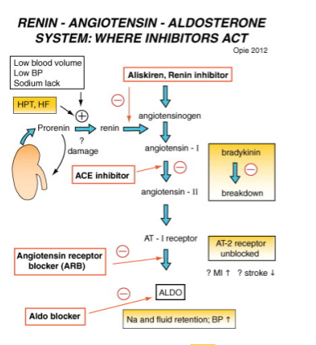

Aldosterone
- Increased 20x in plasma during heart failure and contributes to water retention and cardiac fibrosis
- Acts on the nuclear mineralocorticoid receptors (MR) within the principal cells of the distal tubule and the collecting duct of the kidney nephron, it upregulates and activates the basolateral Na+/K+pumps, which pumps three sodium ions out of the cell, into the interstitial fluid and two potassium ions into the cell from the interstitial fluid. This creates a concentration gradient which results in reabsorption of sodium (Na+) ions and water (which follows sodium) into the blood, and secreting potassium (K+) ions into the urine (lumen of collecting duct).
- Aldosterone upregulates epithelial sodium channels (ENaCs) in the collecting duct and the colon, increasing apical membrane permeability for Na+ and thus absorption.
- Cl− is reabsorbed in conjunction with sodium cations to maintain the system's electrochemical balance.
- Aldosterone stimulates the secretion of K+ into the tubular lumen
- Aldosterone stimulates Na+ and water reabsorption from the gut, salivary and sweat glands in exchange for K+.
- Aldosterone stimulates secretion of H+ via the H+/ATPase in the intercalated cells of the cortical collecting tubules
- Aldosterone upregulates expression of NCC in the distal convoluted tubule chronically and its activity acutely

Other effects of AT-II
- Increases release of norepi and its alpha-1 action on vessels

ACEI cause increase bradykinin, (ACE inactivates bradykinin) which leads to:
- Increased nitric oxide and PGE₂ which is also a vasodilator

Side effects of ACEIs
- Cough
- Hypotension
- Hyperkalemia (especially if combined with other drugs that act on aldosterone)
- Renal Injury
- Angioedema
  - Rare in humans

ARBs

- Avoid some of ACEI side effects, especially related to bradykinin-related effects
  - Cough and angioedema
- Human studies show similar reductions in BP, but no good studies showing they are superior
  - Often comes down to tolerability and achievement of goals
    - Patient didn’t tolerate ACEI or ACEI didn’t work as expected? Try ARB
- ARBs and ACEI have similar reductions in proteinuria
- Some evidence that adding ARBs to ACEI in heart failure can improve outcomes in humans
- In HUMAN proteinuric CKD, combination can improve outcomes
  - Good evidence
  - Recommended to reserve combination therapy until refractory to ACEI alone
- Dog experimental model of CHF (Pacing induced) showed ARB + ACEI may prevent more LV stiffness and myocardial fibrosis than one alone (Funabiki 2004)

Losartan
- First ARB in clinical use. Most studies
- Seems to have low dose ceiling
  - Better to add low dose diuretic instead of increasing dose for better BP control
- Major effect within 1 week, but max effect in 3-6 weks.

Telmisartan
- No active metabolites
- Long half-life (once daily dosing)
- Has dual AT-1 blocker and PPAR_{y} - agonist activity (benefit of this seems to be more of a human diabetes thing)
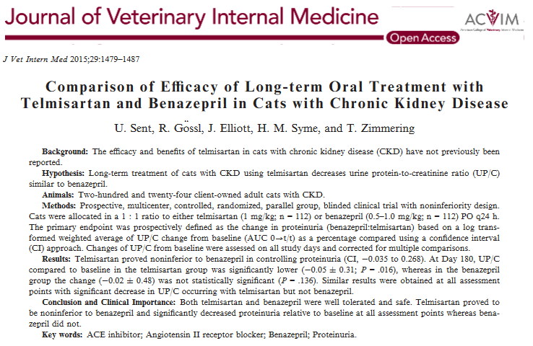

Questions:

True/False: Angiotensin receptor blockers have been show in humans to be superior to angiotensin converting enzyme inhibitors as measured by reduction of blood pressure.

The main difference between angiotensin converting enzyme inhibitors and angiotensin receptor blockers is:
- ACE inhibitors have been shown to have decreased side effects, such as cough
- ARBs are not contraindicated in hyperkalemic patients
- ACE inhibitors more significantly reduce left ventricular myocardial fibrosis
- ARBs lack activity on the bradykinin pathway

Aldosterone’s main site(s) of action within the nephron is at the:
- Proximal tubule and distal tubule
- Distal tubule and collecting ducts
- Collecting ducts alone
- Ascending loop of Henle

Answers

True/False: Angiotensin receptor blockers have been show in humans to be superior to angiotensin converting enzyme inhibitors as measured by reduction of blood pressure.

The main difference between angiotensin converting enzyme inhibitors and angiotensin receptor blockers is:
- ACE inhibitors have been shown to have decreased side effects, such as cough
- ARBs are not contraindicated in hyperkalemic patients
- ACE inhibitors more significantly reduce left ventricular myocardial fibrosis
- ARBs lack activity on the bradykinin pathway

Aldosterone’s main site(s) of action within the nephron is at the:
- Proximal tubule and distal tubule
- Distal tubule and collecting ducts
- Collecting ducts alone
- Ascending loop of Henle

