NOTES P759-775

Functional types of movement in the gastrointestinal tract
- Propulsive movements
- Mixing movements

The usual stimulus for intestinal peristalsis is distention of the gut
Effectual peristalsis requires an active myenteric plexus

Myenteric reflex or the peristaltic reflex refers to peristalsis normally begins on the orad side of the distended segment and moves toward the distended segment, pushing the intestinal contents in the anal direction. At the same time, the gut sometimes relaxes several centimeters downstream toward the anus.

Local intermittent constrictive contractions occur every few centimeters in the gut wall - “chopping” and “shearing” the contents

Gastrointestinal blood supply and blood flow
Almost all of the fats absorbed from the intestinal tract are not carried in the portal blood but instead are absorbed into the intestinal lymphatics and then conducted to the systemic circulating blood by way of the thoracic duct, bypassing the liver.

After a meal, the motor activity, secretory activity, and absorptive activity all increase; likewise, the blood flow increases greatly but then decreases back to the resting level over another 2 to 4 hours
- Several vasodilator substances are released from the mucosa of the intestinal tract during the digestive process. Most of these are peptide hormones, including cholecystokinin, vasoactive intestinal peptide, gastrin, and secretin.
- Some of the gastrointestinal glands also release into the gut wall two kinins, kallidin and bradykinin (vasodilators, cause increased mucosal vasodilation)
- Decreased oxygen concentration in the gut wall can increase intestinal blood flow at least 50 to 100 percent (causes four fold increase of adenosine)

Arterial flow into the villus and the venous flow out of the villus are in directions opposite to each other (and lie in close opposition). Much of the blood oxygen diffuses out of the arterioles directly into the adjacent venules without ever being carried in the blood to the tips of the villi.
- In circulatory shock, the oxygen deficit in the tips of the villi can become so great that the villus tip or even the whole villus suffers ischemic death and can disintegrate.

Stimulation of the parasympathetic nerves going to the stomach and lower colon increases local blood flow at the same time that it increases glandular secretion.

Sympathetic stimulation, has a direct effect on essentially all the gastrointestinal tract to cause intense vasoconstriction of the arterioles with greatly decreased blood flow.
- Autoregulatory escape - local metabolic vasodilator mechanisms that are elicited by ischemia override the sympathetic vasoconstriction, returning toward normal the necessary nutrient blood flow to the gastrointestinal glands and muscle

Secretory function of the alimentary tract
Secretory glands serve two primary functions
- Digestive enzymes are secreted in most areas of the alimentary tract, from the mouth to the distal end of the ileum.
- Mucous glands, from the mouth to the anus, provide mucus for lubrication and protection of all parts of the alimentary tract.

Basic Mechanisms of Stimulation of the Alimentary Tract Glands
Enteric nervous stimuli
- Tactile stimulation
- Chemical irritation
- Distention of the gut wall.

Autonomic stimulation
- Parasympathetic stimulation - Increases the rates of alimentary glandular secretion. Especially true of glands in upper portion of tract i.e. innervated by the glossopharyngeal and vagus parasympathetic nerves, such as the salivary glands, esophageal glands, gastric glands, pancreas, and Brunner’s glands in the duodenum
- Sympathetic stimulation can have a dual effect: (1) sympathetic stimulation alone slightly increases secretion and (2) if parasympathetic or hormonal stimulation is already causing copious secretion by the glands, superimposed sympathetic stimulation reduces the secretion (because of vasoconstrictive reduction of the blood supply)
- Glandular secretion by hormones – secreted by gastrointestinal mucosa in response to the presence of food in the lumen of the gut

Basic Mechanism of Secretion by Glandular Cells
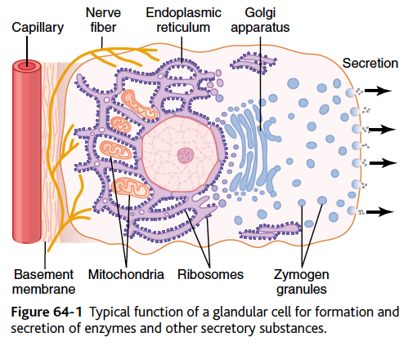
The control signal first increases the cell membrane permeability to calcium ions, and calcium enters the cell. The calcium in turn causes many of the vesicles to fuse with the apical cell membrane.

Important characteristics of mucus
- Adhere tightly to the food or other particles and to spread as a thin film over the surfaces
- It has sufficient body that it coats the wall of the gut and prevents actual contact of most food particles with the mucosa.
- Has a low resistance for slippage, so the particles can slide along the epithelium with great ease.
- Mucus causes fecal particles to adhere to one another to form the feces that are expelled during a bowel movement.
- Strongly resistant to digestion by the gastrointestinal enzymes.
- Glycoproteins of mucus have amphoteric properties, which means that they are capable of buffering small amounts of either acids or alkalies; also contains moderate quantities of bicarbonate ions, which specifically neutralize acids

Questions
- The usual stimulus for intestinal peristalsis is:
  - Eating
  - Fasting
  - Distention of the gut
  - Chemical or physical irritation of the epithelial lining in the gut

- True or False. Almost all of the fats absorbed from the intestinal tract are carried in the portal blood

- Increased blood flow during increased gastrointestinal activity is caused by
  - Decreased oxygen concentration in the gut wall
  - Increased oxygen concentration in the gut wall
  - Release of motilin
  - Downregulation of kallidin and bradykinin

- Explain why ‘shock gut’ occurs in the case of circulatory shock.

- Name two important characteristics of mucus

Additional questions
- True or False. Electrical signals that initiate muscle contractions travel fastest sideways than along the length of the bundle

- Fill in the blank. Normal resting membrane potential in the smooth muscle fibers of the gut is between _________ millivolts, and __________ occur automatically when resting membrane potential becomes -40.
  - −50 and −60, spike potential
  - -50 and -60, slow wave
  - -45 and -55, spike potential
  - -45 and -55, slow wave

- In gastrointestinal smooth muscle fibers, the channels responsible for action potentials are ___________ channels
  - Sodium channels
  - Calcium channels
  - Sodium-Calcium channels
  - Potassium-Calcium channels

- Name 2 factors that depolarize the membrane (makes it more excitable)

Answers
- The usual stimulus for intestinal peristalsis is:
  - Eating
  - Fasting
  - Distention of the gut
  - Chemical or physical irritation of the epithelial lining in the gut
2 to 3 centimeters behind this point, and a contractile ring appears that initiates a peristaltic movement

- True or False. Almost all of the fats absorbed from the intestinal tract are carried in the portal blood
Almost all of the fats absorbed from the intestinal tract are not carried in the portal blood but instead are absorbed into the intestinal lymphatics and then conducted to the systemic circulating blood by way of the thoracic duct, bypassing the liver.

- Increased blood flow during increased gastrointestinal activity is caused by
  - Decreased oxygen concentration in the gut wall
  - Increased oxygen concentration in the gut wall
  - Release of motilin
  - Downregulation of kallidin and bradykinin

- Explain why ‘shock gut’ occurs in the case of circulatory shock.
Arterial flow into the villus and the venous flow out of the villus are in directions opposite to each other (and lie in close opposition). Much of the blood oxygen diffuses out of the arterioles directly into the adjacent venules without ever being carried in the blood to the tips of the villi.
- In circulatory shock, the oxygen deficit in the tips of the villi can become so great that the villus tip or even the whole villus suffers ischemic death and can disintegrate.

- Name two important characteristics of mucus
Important characteristics of mucus
  - Adhere tightly to the food or other particles and to spread as a thin film over the surfaces
  - It has sufficient body that it coats the wall of the gut and prevents actual contact of most food particles with the mucosa.
  - Has a low resistance for slippage, so the particles can slide along the epithelium with great ease.
  - Mucus causes fecal particles to adhere to one another to form the feces that are expelled during a bowel movement.
  - Strongly resistant to digestion by the gastrointestinal enzymes.
  - Glycoproteins of mucus have amphoteric properties, which means that they are capable of buffering small amounts of either acids or alkalies; also contains moderate quantities of bicarbonate ions, which specifically neutralize acids

Additional answers
- True or False. Electrical signals that initiate muscle contractions travel fastest sideways than along the length of the bundle
False. Within each bundle, the muscle fibers are electrically connected with one another through large numbers of gap junctions that allow low-resistance movement of ions from one muscle cell to the next.

- Fill in the blank. Normal resting membrane potential in the smooth muscle fibers of the gut is between _________ millivolts, and __________ occur automatically when resting membrane potential becomes -40.
  - −50 and −60, spike potential
  - -50 and -60, slow wave
  - -45 and -55, spike potential
  - -45 and -55, slow wave

- In gastrointestinal smooth muscle fibers, the channels responsible for action potentials are ___________ channels
  - Sodium channels
  - Calcium channels
  - Sodium-Calcium channels
  - Potassium-Calcium channels
Allow especially large numbers of calcium ions to enter along with smaller numbers of sodium ions. These channels are much slower to open and close than are the rapid sodium channels of large nerve fibers.

- Name 2 factors that depolarize the membrane (makes it more excitable)
Answer: (1) stretching of the muscle, (2) stimulation by acetylcholine released from the endings of parasympathetic nerves, and (3) stimulation by several specific gastrointestinal hormones

NOTES P753-759

Slow Waves
Most gastrointestinal contractions occur rhythmically, and this rhythm is determined mainly by the frequency of so-called “slow waves”.
Slow waves are not action potentials, they are slow, undulating changes in the resting membrane potential. Rhythm of contraction of the different parts of the stomach varies
They mainly excite the appearance of intermittent spike potentials, and the spike potentials in turn actually excite the muscle contraction.

Spike Potentials
True action potentials
Occur automatically when the resting membrane potential of the gastrointestinal smooth muscle becomes more positive than about −40 millivolts

Factors that depolarize the membrane (makes it more excitable) (1) stretching of the muscle, (2) stimulation by acetylcholine released from the endings of parasympathetic nerves, and (3) stimulation by several specific gastrointestinal hormones

Factors that hyperpolarize membrane (less excitable, more negative) (1) the effect of norepinephrine or epinephrine on the fiber membrane and (2) stimulation of the sympathetic nerves that secrete mainly norepinephrine at their endings.

The slow waves do not cause calcium ions to enter the smooth muscle fiber (only sodium ions).
During the spike potentials, generated at the peaks of the slow waves, significant quantities of calcium ions do enter the fibers and cause most of the contraction.

Some smooth muscle of the gastrointestinal tract exhibits tonic contraction, as well as, or instead of, rhythmical contractions.
Tonic contractions caused by (1) continuous repetitive spike potentials, (2) hormones or other factors that bring about continuous partial depolarization of the smooth muscle membrane without causing action potentials, (3) continuous entry of calcium ions into the interior of the cell brought about in ways not associated with changes in membrane potential

Nervous System
Enteric nervous system composed of two plexuses (1) myenteric plexus or Auerbach’s plexus (outer plexus) – controls GI movement (2) submucosal plexus or Meissner’s plexus, that lies in the submucosa (inner plexus) - controls gastrointestinal secretion and local blood flow.

Extrinsic sympathetic (mostly preganglionic, and INHIBITORY) and parasympathetic fibers (mostly post ganglionic, and ACTIVATES) that connect to both the myenteric and submucosal plexuses. Enhances or inhibit GI function.

Acetylcholine most often excites gastrointestinal activity.
Norepinephrine almost always inhibits gastrointestinal activity.

Cranial parasympathetic – vagus nerve
Sacreal parasympathetic – second third and fourth sacral segments to the spinal cord, pass through sacral spine
The sympathetic fibers to the gastrointestinal tract originate in the spinal cord between segments T5 and L2.
The sympathetic nerve endings secrete mainly norepinephrine but also small amounts of epinephrine

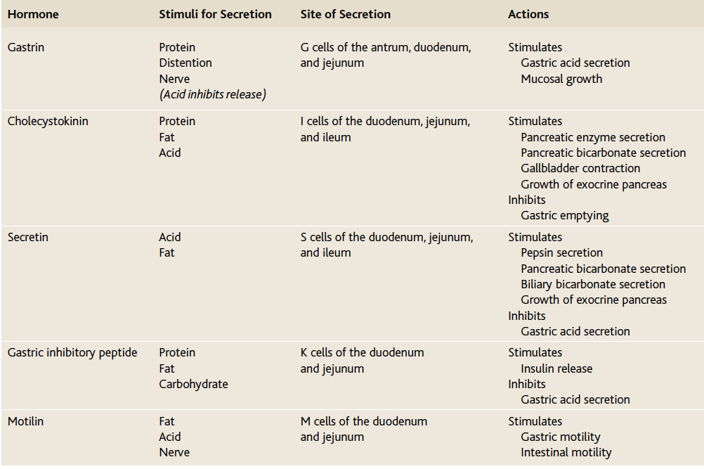

Salivary secretion
The principal glands of salivation are the parotid, submandibular, and sublingual glands
Contains 2 types of proteins (1) a serous secretion (contains ptyalin, an α -amylase) - enzyme for digesting starches (2) mucus secretion (contains mucin) for lubricating and for surface protective purposes
Saliva contains large quantifies of potassium and bicarb
Salivary secretion is a two-stage operation: The first stage involves the acini, and the second, the salivary ducts. The acini secrete a primary secretion that contains ptyalin and/or mucin in a solution of ions I concentrations not greatly different from those of typical extracellular fluid.
- Na2+ are actively reabsorbed from salivary ducts, K+ are actively secreted in exchange for Na2+
- HCO3- are secreted by the ductal epithelium into the lumen of the duct (passive in exchange for chloride, also active process)

Nervous control of salivation
Controlled mainly by parasympathetic signals from the superior and inferior salivatory nuclei in brain stem
Elicited by taste stimuli, smells, in response to reflexes originating in the stomach and upper small intestines—particularly when irritating foods are swallowed or when a person is nauseated

Gastric secretion
Stomach mucosa has two important types of tubular glands:
- Oxyntic glands (also called gastric glands) – secrete hydrochloric acid, pepsinogen, intrinsic factor, and mucus (mainly in fundus – proximal 80%)
  - Composed of three types of cells: (1) mucous neck cells, which secrete mainly mucus; (2) peptic (or chief ) cells, which secrete large quantities of pepsinogen; and (3) parietal (or oxyntic ) cells , which secrete hydrochloric acid and intrinsic factor
  - Driving force for HCl acid secretion by parietal cells is a hydrogen-potassium pump ATPase

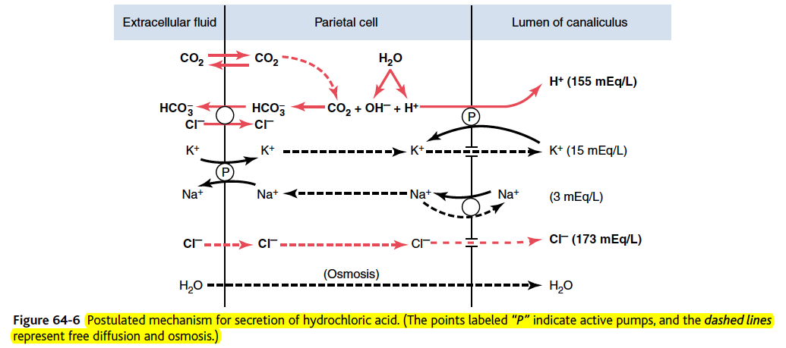

The final secretion from the canaliculus contains water, hydrochloric acid at a concentration of about 150-160 mEq/L, potassium chloride at a concentration of 15 mEq/L, and a small amount of sodium chloride.

- Pyloric glands – secrete mucus (antrum – distal 20%).
  - Contain mostly mucous cells that are identical with the mucous neck cells of the oxyntic glands
  - Another characteristic of this mucus is that it is alkaline. Stomach wall is not directly exposed to the highly acidic, proteolytic stomach secretion

- Basic Factors That Stimulate Gastric Secretion Are Acetylcholine, Gastrin, and Histamine
- When pepsinogen is first secreted, it has no digestive activity. However, as soon as it comes in contact with hydrochloric acid, it is activated to form active pepsin (smaller molecule)
- Pepsin functions as an active proteolytic enzyme in a highly acid medium (optimum pH 1.8 to 3.5), > pH 5 it has almost no proteolytic activity
- Intrinsic factor is essential for absorption of vitamin B12 in the ileum
- Secreted by the parietal cells

Stimulation of gastric acid secretion
Parietal cells operate in close association with another type of cell called enterochromaffinlike cells (ECL cells), the primary function of which is to secrete histamine.

