General link - https://analytics.hathitrust.org/datasets
Full documentation - https://wiki.htrc.illinois.edu/display/COM/Extracted+Features+Dataset

What is the HathiTrust Research Center (HTRC) Extracted Feature (EF) data set?
- A large set of files (in JSON format), one file for each book in the HathiTrust Digital Library (HTDL).
- Each file contains numerical characterization of features extracted from these books.
- JSON format allows computational researchers to query the data about the features of interest, within books of their choosing.

What problem does EF data set solve?
- HTDL – almost 15M books; 5.5M+ in PD (about 39%)
  - For these we can provide viewability in full-text and online, and access to full text for download
  - Can download either as PDF through HTDL interface, or text/images through HT Data API (backend).
- For the remaining 61% that are in copyright, HT can’t provide access to full text or download of full text. Use must be “transformative”.
  - Question: How to provide access for transformative use of computational scholarship, and still avoid providing the untransformed text flow (which would possibly constitute a violation of copyright)?
  - Answer: through the extracted feature data set, which provides for the needs of computational researchers without compromising copyright restrictions. The data set begins that transformation for scholars, extracting various features from pages of books
- So what ARE these transformations? To answer that, think back on how these digital books are structured in HTDL.
  - Books are a coordinated sequence of images and a coordinated sequence of text files. The EF data set follows this structure.
  - EF considers each text file (page level) and extracts features of that page and characterizes these features – most often numerically, which is useful to the computational researcher, and something they most often need for their analysis.
  - EF “meets the researcher halfway” in their research questions: it offers a predigested set of quantifiable features at the page level. It does NOT provide full text flows of books, but is also open enough to allow researchers to use flexibly.
  - Refer to the brown box on the following diagram for a graphical representation.

What are the features which are quantified in the EF data set?
- See https://wiki.htrc.illinois.edu/display/COM/Extracted+Features+Dataset for complete documentation.
- These are outputs of the added processes that HTRC applies to the text pages of the book. The processes themselves are represented in red.

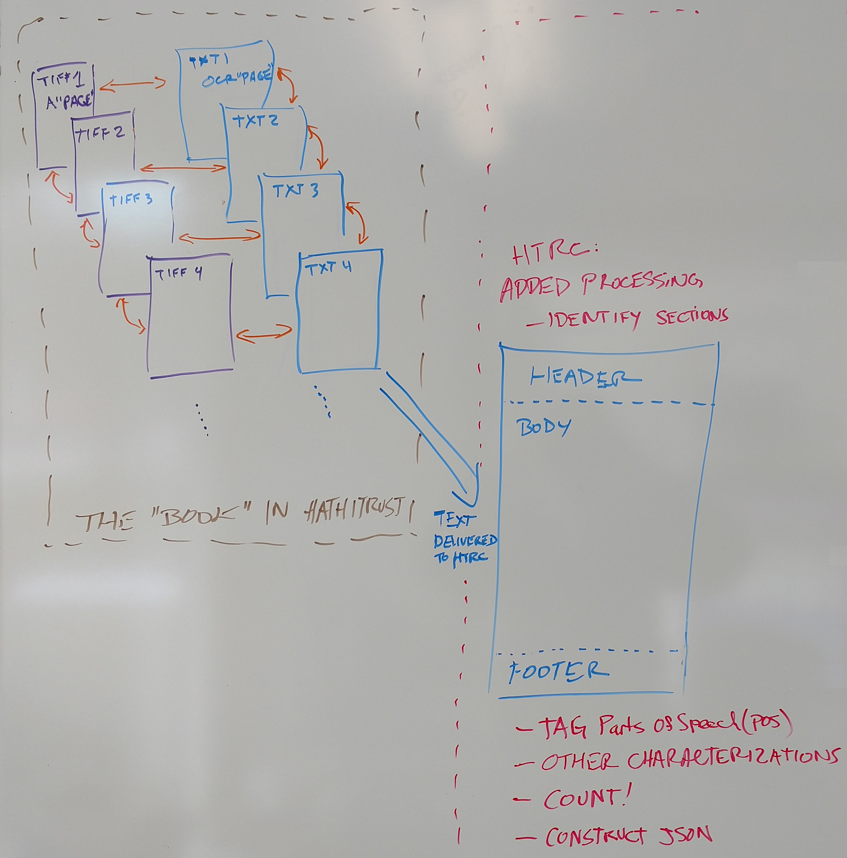

What potentials does the EF data set have? Sample projects from https://wiki.htrc.illinois.edu/display/COM/Extracted+Features+in+the+Wild
- David Mimno’s Word similarity tool - https://mimno.infosci.cornell.edu/wordsim/nearest.html
- HTRC Bookworm - https://bookworm.htrc.illinois.edu/
- Peter Organishiack’s Feature Reader - https://github.com/htrc/htrc-feature-reader

How do you get it?
- RSYNC can allow download for the full set (beware, it is 4 TB), or alternatively, a selected corpus as determined by the scholar. Instructions for download are documented: https://analytics.hathitrust.org/datasets

What if the researcher needs help?
- Documentation is here: https://wiki.htrc.illinois.edu/display/COM/Extracted+Features+Dataset
- Researcher can ask HTRC for help: htrc-help@hathitrust.org
- Cornell researcher can contact Michelle: map6@cornell.edu

