Setting up SHIBBOLETH for Salesforce

Domain Name Setup
Your Salesforce Org needs a domain name setup to do this.
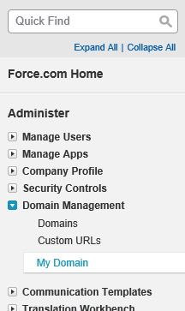
- Go to Setup
- Domain Management
- My Domain
- Insert your domain name that you want to use and check availability. You can’t change this, so carefully select a name.
- 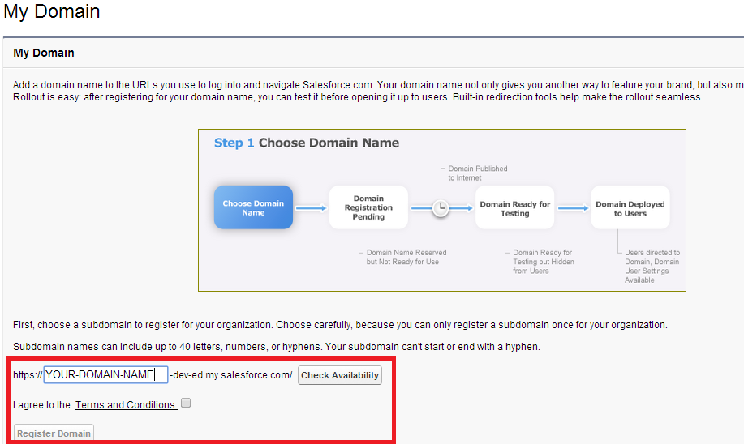
- Once you register your domain, you will have to wait up to an hour for Salesforce to email you that the change has taken effect.

Setup Key Size
- Go to Setup – >Certificate and Key Management
- Click button “Create Self-Signed Certificate”
- Enter a Label and name for the cert and under key size select “4096”
- Click Save

Setup SSO
- Go to Setup -> Administer -> Security Controls -> Single Sign-On Settings
- Click Edit and check the checkbox on SAML Enabled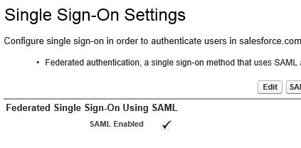
- Click New under the SAML Single Sign-On Settings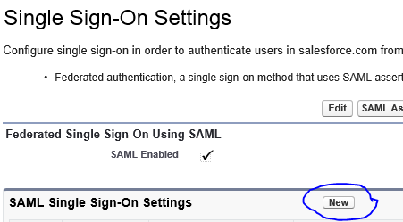
- Fill out the following:
  - Name: CUShib
  - API Name: CUShib
  - Issuer: https://shibidp.cit.cornell.edu/idp/shibboleth
  - Entity Id: https://<Your Domain Name>.my.salesforce.com
  - Download the Cornell Certificate here and click the browse button and upload it to Salesforce
  - Choose certificate in “Request Signing Certificate” and “Assertion Decryption Certificate”
  - On the SAML Identity Type select Assertion contains the Federation ID from the User object
  - SAML Identity Location select Identity is in an Attribute element. Then enter urn:oid:0.9.2342.19200300.100.1.1 in attribute name
  - Identity Provider Login URL: https://shibidp.cit.cornell.edu/idp/profile/SAML2/POST/SSO
  - Service Provider Initiated Request Binding HTTP POST
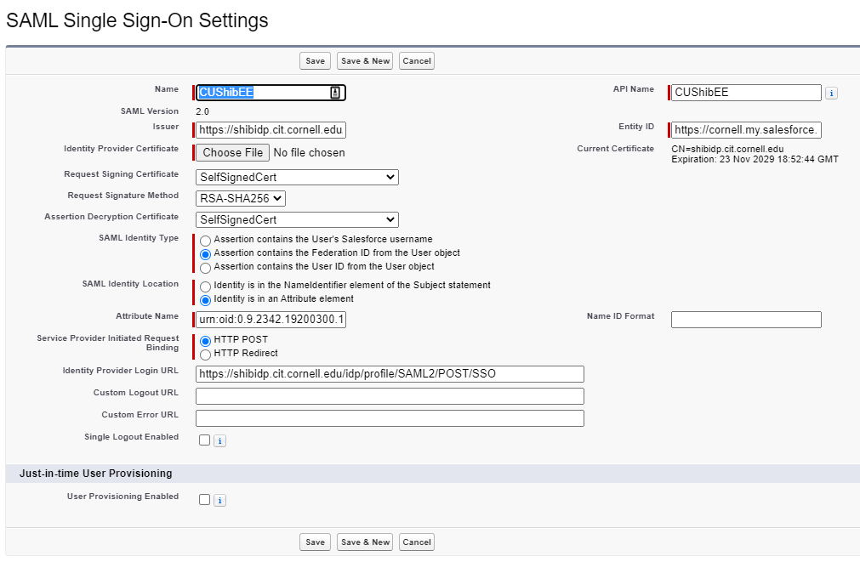
- Click Save then click download Metadata.
- Submit metadata from https://shibrequest.cit.cornell.edu
- When CIT has completed the configuration they will contact you.

Deploy Domain
- Go to Setup
- Domain Management
- My Domain
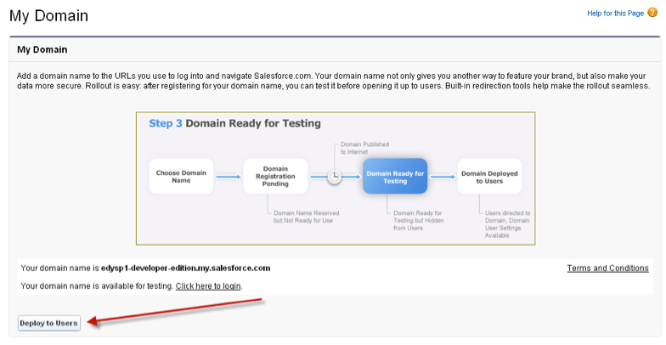
- Click Deploy to Users
- Click Edit and Select CUShib as an authentication method
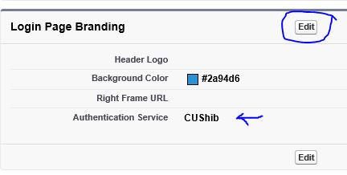

Enabling User Access
- Go to Setup -> Manage Users -> Users
- You will need to do the following for every user that authenticates this way.
  - Click edit next to the user name
  - Scroll down to Single Sigh On Information
    - Federation ID: add their netid


Testing
- Go to your new url to login: https://<Your Domain>.my.salesforce.com
- It should direct you to the Cornell Shibboleth Sign On page.
- After that you should be logged in, if everything was successful.

