Ithaca, New York, United States - Sunrise, sunset, dawn and dusk times, table
Date | Sunrise | Sunset | Length | Change | Dawn | Dusk | Length | Change
Today | 06:05 | 20:18 | 14:13 |  | 05:33 | 20:49 | 15:16
+1 day | 06:06 | 20:17 | 14:11 | 00:02 shorter | 05:34 | 20:48 | 15:14 | 00:02 shorter
+1 week | 06:12 | 20:09 | 13:57 | 00:16 shorter | 05:41 | 20:39 | 14:58 | 00:18 shorter
+2 weeks | 06:19 | 19:58 | 13:39 | 00:34 shorter | 05:50 | 20:28 | 14:38 | 00:38 shorter
+1 month | 06:36 | 19:32 | 12:56 | 01:17 shorter | 06:08 | 20:00 | 13:52 | 01:24 shorter
+2 months | 07:09 | 18:39 | 11:30 | 02:43 shorter | 06:41 | 19:07 | 12:26 | 02:50 shorter
+3 months | 06:44 | 16:54 | 10:10 | 04:03 shorter | 06:15 | 17:24 | 11:09 | 04:07 shorter
+6 months | 07:16 | 17:25 | 10:09 | 04:04 shorter | 06:46 | 17:54 | 11:08 | 04:08 shorter
Notes: Daylight saving time, * = Next day. Change preferences.

Ithaca, New York, United States - Sunrise, sunset, dawn and dusk times, graph
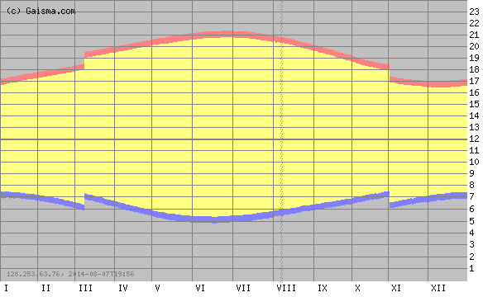
Darkness Dawn Sunshine Dusk Notes: How to read this graph? Change preferences.

Ithaca, New York, United States - Sun path diagram
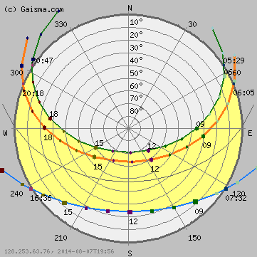
Sun path
Today
June 21
December 21
Annual variation
Equinox (March and September)
Sunrise/sunset
Sunrise
Sunset
Time
00-02
03-05
06-08
09-11
12-14
15-17
18-20
21-23

Ithaca, New York, United States - Solar energy and surface meteorology
Variable | I | II | III | IV | V | VI | VII | VIII | IX | X | XI | XII
Insolation, kWh/m²/day | 1.55 | 2.35 | 3.23 | 4.09 | 4.99 | 5.51 | 5.48 | 4.87 | 3.69 | 2.52 | 1.56 | 1.28
Clearness, 0 - 1 | 0.41 | 0.44 | 0.44 | 0.43 | 0.46 | 0.48 | 0.49 | 0.49 | 0.45 | 0.42 | 0.37 | 0.38
Temperature, °C | -6.55 | -5.15 | -0.17 | 6.73 | 13.60 | 18.75 | 20.95 | 19.87 | 15.61 | 8.98 | 2.91 | -3.55
Wind speed, m/s | 5.99 | 5.90 | 6.06 | 5.95 | 5.25 | 4.90 | 4.50 | 4.38 | 4.69 | 5.08 | 5.68 | 5.83
Precipitation, mm | 53 | 55 | 65 | 78 | 84 | 96 | 90 | 88 | 89 | 82 | 82 | 70
Wet days, d | 16.4 | 14.6 | 15.2 | 13.4 | 13.2 | 12.4 | 10.7 | 11.1 | 10.7 | 12.1 | 15.5 | 17.7
These data were obtained from the NASA Langley Research Center Atmospheric Science Data Center; New et al. 2002
Notes: Help. Change preferences.

Ithaca, New York, United States - Basic information
Latitude: +42.44056 (42°26'26.016"N)
Longitude: -76.49694 (76°29'48.984"W)
Time zone: UTC-5 hours
Local time: 15:59:44
Country: New York, United States
Continent: Americas
Sub-region: Northern America
Distance: ~1.6 km (from your IP)
Altitude: ~270 m
Ithaca, nearby locations
Change preferences.

