Alternative Backwash with Slotted Pipes
Fall 2014

Alberto Arnedo, Ainhoa Arribas Llona, Jorge Guevar

October 3, 2014

Task List

Task Map
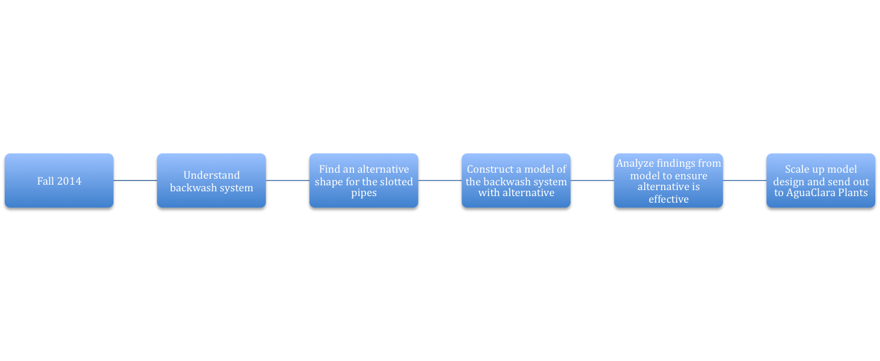

Task Details
1. Understanding the current Backwash system - Jorge, Ainhoa, and Alberto
To be completed by: September 24*
In order to further our endeavors with our main goal of finding an alternative to the slotted pipes in the backwash system, we must all have a mutual and strong understanding of how the backwash system actually works, either through a lab demonstration or a meet up with our research advisor or perhaps a meet up with Professor Monroe. Also, by understanding the backwash system we strive to determine the after effects of removing the slotted pipes from the system as a whole, the paths which the sand and water take within the backwash system can be further understood and thus lead to ideas on alternative ideas to the slotted pipes.
3. Build a model of a Backwash System without Slotted Pipes -Led by Alberto, with help from Jorge and Ainhoa
To be completed by: October 31*
Once research has been complete regarding a new design for the slotted pipes, we hope to build a small-scale model of the system to visually see how the water flows in the system. All research regarding materials to be used for the model, along with model specifications, will be collected and organized by Alberto and each of the team members, with the help of the Shop in the basement of Hollister Hall, will construct a small-scale model. In order to have the specifications, Jorge will work with dimensional analysis in reference to the large-scale backwash system to ensure that the small-scale model will be indicative of the behavior of the actual system. Based on the findings of the small-scale model, we will be able to determine how to scale it up if the findings provide feedback regarding our design to be an alternative to the current design.

3.1. Determine how to close the outlets during backwash.

As the pipes are going to be open, we need to develop a system to close the outlets during the backwash, so that the sand doesn’t mix with the cleaned water.

3.2. Determine how to design pipes and holes in the sand box so that they can be changed.

Construct the model so that the pipes for inlet and outlet can be changed is a difficult challenge. To experiment as much as possible we want to be able to remove the pipes to use different shapes and sizes so that we can improve the model.

3.3 Determining the effects of changing the shape of the pipe - Alberto

To be completed by: October 9*
Perhaps the problem may be that the current shape of the pipe is more prone to clogs than others. For example, instead of using the full, cylindrical shape with slots for the pipes, we could try to incorporate the use a pipe that has the same cylindrical shape but with no slots and that has a relative “U” shape instead of the usual “O” shape. We hope to find a way to not allow for the sand moving with the water in the pipes to clog the pipes. Though the “U” shaped pipe was a suggestion made by Professor Monroe, we hope to look at different shapes for pipes that may also not allow for sand to build up. We will test these different shapes by building models of the pipes and implementing them into our model to be built in the future.

4. Scale up model and implement design-Alberto, Ainhoa, Jorge
To be completed by: November 26*
Once a successful alternative for the slotted pipes has been found, we hope to scale up our small-scale model and create a design to be implemented in the water treatment plants in Honduras and India. We will determine which materials need to be changed, along with how to have these designs constructed easily with current resources in each country.
* Dates are tentative and are subject change.

- Experimentation based on fluids mechanics and geotechnics- Ainhoa
November 1

Since the construction of the scale up model is going to take more or less 2 months, a spreadsheet with different values of velocities, diameters and sand densities will be written so that as rapid as the model is finished, we can begin to experiment with it.

Team Roles
Jorge Guevara: Team Coordinator
- Keep track of the progress the sub team has made with their tasks.
- Arrange meetings to be held outside of designated time weekly.
- Maintain communication with team members and our research advisor.
- Edit any reports that will be submitted.

Ainhoa Arribas Llona: Head of Research
- Ensure the validity of resources used for research.
- Organize research found by other team members and create a Word Document containing the research, the name of the team member who found it, the date when the team member found, and a detailed summary of findings that can be used from the found research.

Alberto Arnedo: Head of Design
- Lead the construction of any models required for the sub team by finalizing the materials needed for the model, the sketch of the model, and a tentative construction schedule.

In addition to the responsibilities assigned with each role, each member of the ABSP subteam must follow the subsequent set of responsibilities:
- Maintain communication through the use of email and the phone app “WhatsApp”
- Submit research summaries and information to the Head of Research
Update each other with findings that will have an impact on the project

