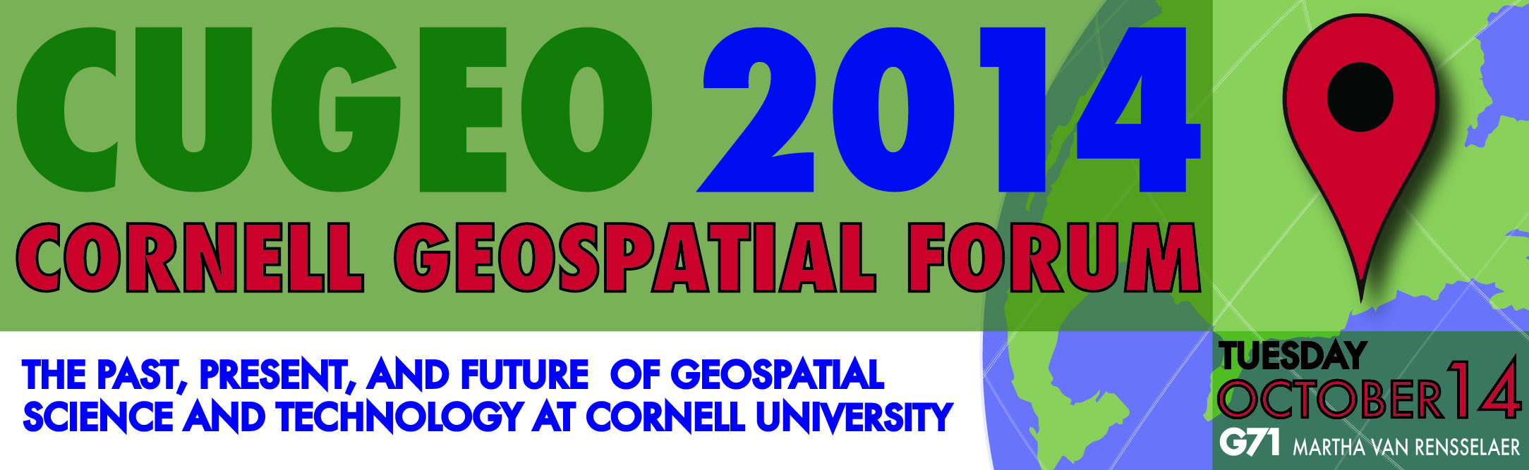
8:30am | Registration and Coffee
9:00am | Opening Remarks  Max Pfeffer, Senior Associate Dean, College of Agriculture and Life Sciences
9:10am | Opening Keynote:  Geospatial Science and Technology at Cornell: Historical and Contemporary Perspectives  Steve DeGloria, Professor of Crop and Soil Sciences; Director of the Institute for Resource Information Sciences
9:40am | Cornell NutriPhone Demo and Keynote:  Smartphone-based Technologies for Mobile and Global Health  David Erickson, Associate Professor of Mechanical and Aerospace Engineering
10:20am | Coffee Break
10:40am | Panel 1: Applications of ArcGIS Online at Cornell  Steve Smith, Crop and Soil Sciences; Institute for Resource Information Sciences  Frank Popowitch, Campus Planning Office  Joe Francis, Associate Professor of Development Sociology; Director of the Program on Applied Demographics
11:30am | Panel 2: Potential Models for a Geospatial Consulting Unit  Francoise Vermeylen, Cornell Statistical Consulting Unit  Wendy Kozlowski, Research Data Management Services Group
12:00pm | Lunch
12:30pm | Models for GIS in Higher Education  Diana Sinton, Executive Director of the University Consortium for Geographic Information Science (UCGIS)
1:10pm | Break
1:20pm | Lightning Talks
2:40pm | Coffee Break
3:00pm | Break-out Working Group Discussions
4:30pm | Discussion Summary and Closing Remarks
5:00pm | Reception: Wine and Cheese


Location and Directions
Most of the sessions will be held in auditorium G71 in Martha Van Rensselaer Hall (MVR). We recommend using the double-door entrance on the west side of the building – the registration table will be located just inside this entrance.
During the afternoon’s break-out working group discussions at 3:00pm, we will be using four other rooms located in MVR and in the new Human Ecology Building (HEB). The four discussion questions will each be assigned to a room during the forum, and announced at the end of the lightning talks.
MVR 151 and 153: from level B (which contains the Commons area and the bottom entrance to G71), take the stairs or elevator up to level 1, where rooms 151 and 153 are located nearly directly above the auditorium G71. To return to the auditorium G71, take the stairs or elevator back to level B.
HEB 101 and 201: cross the Commons area, heading towards the red hallway that leads to HEB. Once inside HEB, continue straight to the elevator and ascend to level 1 for HEB 101 or level 2 for HEB 201. To return to the auditorium G71, take the elevator back down to level T (“terrace”) and return through the red hallway.

Break-out Working Group Discussion Questions
1. What faculty expertise and leadership are required to sustain geospatial science and technology at Cornell? What mechanisms will sustain geospatial science and technology at Cornell? What do you perceive as current and future gaps in faculty expertise and/or leadership in this area?
2. What pedagogical approaches are best suited to improving geospatial teaching and learning at Cornell? What instructional practices ought to be consistently pursued by the teaching and extension faculty and senior academic staff? How can such faculty and staff best be supported in their instructional endeavors? What support infrastructure can be put in place to create a sense of community around teaching and learning with geospatial technologies at Cornell?
3. What institutional programmatic support and infrastructure are required to enhance geospatial research, teaching, and extension programs? Are the higher education models for a more centralized geospatial support infrastructure (e.g., GIS centers at peer institutions) suitable for Cornell campus and its community/culture?
4. What new and emerging geospatial analytical tools, methods, workflows, and technologies are of interest to the Cornell geospatial community and for what areas of inquiry and application? How can these resources best be shared across the Cornell community, and how can innovations be capitalized upon to improve graduate education and competitiveness with potential external funding sources?

In addition to today’s break-out working group discussions, we encourage you to provide your personal responses to all four questions at:
http://tinyurl.com/cugeo2014-questions

