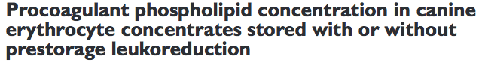
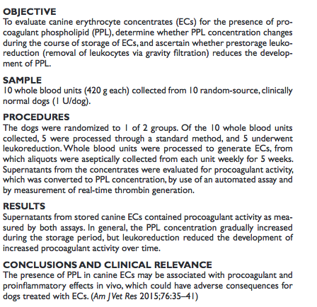

- Why was the study done? During storage, RBCs undergo various changes (RBC storage lesions), example: formation of microparticles (MPs) - small cytosol-containing vesicles surrounded by a membrane bilayer. Marked formation of MPs from all hematologic cell types during storage of human pRBCs has been reported. The presence of PPLs on the surface of MPs allows binding of coagulation factors. MPs derived from stored human pRBCs are able to support thrombin generation in vitro. Leukoreduction can decrease MPs formation – elimination of many of the cells from which they are formed; elimination of proinflammatory mediators that are generated by platelets and WBCs.
- Goals:
  - To evaluate canine pRBCs for the presence of PPL.
  - To determine if the concentration of PPL changes during the course of storage.
  - To determine if leukoreduction reduces the development of PPL.
- Type of study:
- Material and Methods: 10 whole blood units, from 10 healthy dogs; 5 leukoreduced, 5 non-leukoreduced. Preparation of pRBCs. Collection of aliquots from each unit once a week for 5 weeks (analyzed fresh or frozen at -80C) Evaluation of the procoagulant activity of the supernatant (fresh and frozen) and determination of PPL concentration against a standard curve.
- Most important results:
  - Clot times for the fresh and frozen EC supernatant samples were significantly and positively correlated, although there was a bias toward longer clot times (less procoagulant activity) in fresh samples.
  - PPL concentrations in leukoreduced and nonleukoreduced units were similar on storage days 0 and 7, but were significantly higher in nonleukoreduced units on days 14, 21, 28, and 35. The PPL concentration decreased over the initial 21 days of storage in both leukoreduced and nonleukoreduced units; however, there was an approximately 2-fold increase in the PPL concentration in nonleukoreduced units during the last 14 days of storage
  - The ability of PPL in pRBCs supernatant to support thrombin generation in-creased significantly over the time. The pRBCS storage-related change occurred in leukoreduced and nonleukoreduced units, but nonleukoreduced units were significantly better at supporting thrombin generation.
- Conclusion:
  - Accumulation of MP (from RBCS*, also platelets and WBCs) = storage lesion
  - Supernatant of stored canine ECs contains procoagulant activity and prolonged
storage increases the procoagulant activity.
  - Less
procoagulant activity developed over time in ECs
that underwent prestorage leukoreduction.

