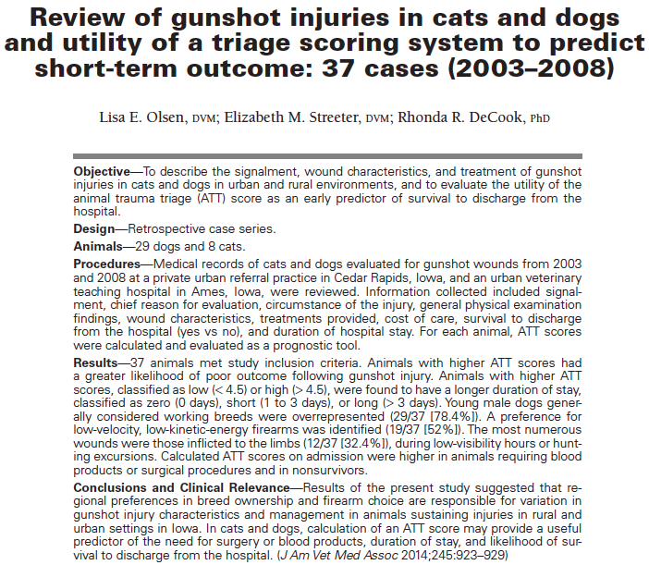
- Background:
Gunshot injuries comprise up to 2.1% of trauma cases. A large percentage of gunshot wounds are inflicted by handguns in urban environments, whereas rifles and shotguns are more common in rural populations. Recommendations for care vary on the basis of injury location and firearm type. The animal trauma triage (ATT) score which assigns a cumulative score based on evaluation of 6 body system categories (perfusion, cardiac, respiratory, eye-muscle-integument, neurologic, and skeletal) has not previously been used in predicting outcome for gunshot injuries in veterinary patients.

- Goal:
To describe the signalment, wound characteristics, and treatment of gunshot injuries in cats and dogs in urban and rural environments, and to evaluate the utility of ATT score as an early predictor of survival to discharge from the hospital.

- Type of study: Retrospective case series
- Material and Methods:
2003-2008; private urban referral practice and urban veterinary teaching hospital in Iowa; reviewed medical records to collect signalment, chief reason for evaluation, circumstance of the injury, general physical examination findings, wound characteristics, treatments provided, cost of care, survival to discharge from the hospital and duration of hospital stay; calculated ATT score. Excluded animals with projectiles found incidentally.

- Most important results:
- n = 37 (29 dogs, 8 cats) ; 3.6 gunshot cases/year = 0.8% of all cases;
- Hunting and working breeds more commonly affected in rural areas;
- Young (< 4 years) overrepresented; males > females; castrated > intact;
- Forelimbs = thorax > abdomen = head and neck > pelvic limbs; lower ATT with injuries to the extremities, 19% had injuries involving more than 1 location;
- 35% handguns; 49% shotguns/pellet-style firearms; 3% airguns; 14% unknown (through-and-through injury without presence of a retained projectile);
- No significant association between the type of firearm and an animal’s duration of stay, cost of care, ATT score, or outcome;
- 32/37 (86.5%) survived;
- Median duration of stay in hospital: 0 – 18/37 treated as outpatient; median cost 1550$ (125-5250$);
- 5/37 required transfusion (sign. higher ATT); higher ATT associated with longer stay in hospital;
- Surgery (ortho or StSx) in 11/37; ATT score higher in dogs requiring surgery (ATT = 6 vs 4);
- A significant relationship was found between ATT and survival: For every 1-point increase in the ATT, the odds of dying increased by a factor of 1.60;
- No significant correlation between survival rate and location of injury, between survival rate and duration of stay, or between survival rate and cost of care.

- Conclusion:
Young male dogs of breeds generally considered working breeds were overrepresented. This study showed a greater incidence of nonfatal extremity wounds induced by low-velocity, low-kinetic firearms. Results of the present study suggested that ATT score has promise as an early predictor of survival in dogs and cats with gunshot trauma. Use of the ATT may help predict need for surgery or transfusion, cost of care, and outcome.

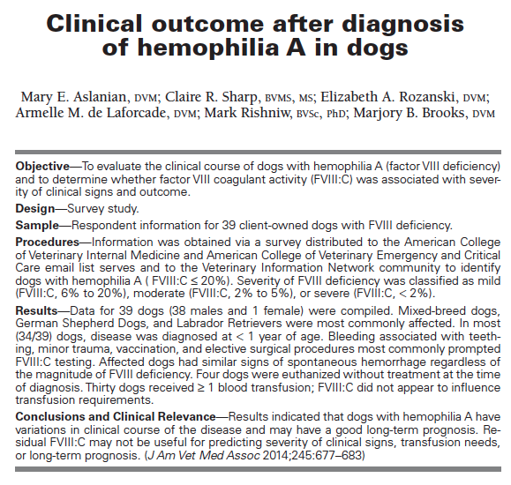
- Why was the study done?
Clinical severity of hemophilia A in humans, as
defined by frequency of bleeding events and transfusion needs, is inversely related to residual FVIII: C. No such studies have
been reported for dogs.

- Goal: To describe the long-term outcome for
a group of dogs with hemophilia A and to determine the relationship between FVIII: C at
diagnosis and severity of clinical signs and prognosis.

- Type of study: Internet survey, retrospective

- Material and Methods:
Hemophilia
A = FVIII: C ≤ 20%;
Severity was classified as mild
(FVIII: C, 6% to 20%), moderate (FVIII: C, 2% to 5%), or severe (FVIII: C, < 2%); collected patient signalment, age at diagnosis, FVIII: C, circumstances surrounding diagnosis, therapeutic interventions.

- Most important results:
- n=39 dogs, 30 MI, 8 MC, 1 FS; 34/39 were < 1 year at the time of diagnosis,
GSD (pure and mixed), and Labrador (pure and mixed;
- Mildly (10), moderately (13), severely (16) affected;
- Spontaneous bruising
or hematoma,
excessive or unanticipated bleeding during an elective surgical procedure, gingival bleeding during loss of deciduous teeth,
bleeding after minor trauma, and spontaneous bleeding
into a body cavity or organ; most common site of bleeding = SQ tissues
- Comparison of dogs with mild,
moderate, and severe FVIII deficiency revealed no significant differences in the proportion of dogs
with spontaneous bleeding.
- 35/39 treated, 4 were euthanized; 30/35 received transfusions (one (10) or at least 2 (20)), FFP;
FV III: C did not appear to influence transfusion requirement (type or number of transfusions);
- 18/35 were alive and being treated at the
time of the survey;
7 euthanized because of FVIII deficiency,
5 died as a result of bleeding; severity of FVIII deficiency was not significantly associated with whether dogs were alive at the
time of the survey versus died or were euthanized because of FVIII deficiency;
- For the 35
dogs that were not euthanized at the time of diagnosis,
median follow-up time was 11 months (range, 1 month
to 10 years), which suggested an acceptable long-term
outcome for hemophilia A.

- Conclusion:
Dogs with hemophilia A have differences in
FVIII: C, although FVIII: C did not appear to be associated with differences in clinical signs at initial evaluation, transfusion requirements, or long-term outcome
when treatment was pursued.

