Respiratory Physiology: The Essentials
Chapter 2: Ventilation

There are 4 lung volumes…

VT = tidal volume = Volume of air inspired or expired in one breath.
IRV = inspiratory reserve volume = Volume of air that can be inspired over and above the normal VT.
ERV = expiratory reserve volume = Amount of air that can be expired by forceful expiration after a normal expiration.
RV= residual volume = Amount of air remaining in the lungs after the most forceful expiration.
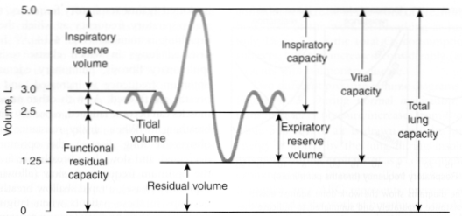

…and 4 lung capacities:

IC = inspiratory capacity = VT + IRV = Amount of air that can be inhaled starting after a normal expiration and distending the lungs to the maximum amount.
VC = vital capacity = IC+ ERV = Maximum amount of air that can be expelled from the lungs after first filling them to their maximum capacity.
FRC = functional residual capacity = ERV + RV = Amount of air remaining in the lungs after a normal expiration.
TLC = total lung capacity = VC + RV

A spirometer is an apparatus for measuring the volume of air inspired and expired by the lungs. TLC, FRC and RV can not be measured with a simple spirometer (need helium dilution or body plethysmograph)

Total ventilation: total volume of air leaving (or entering) the lungs per minute = VT x respiratory rate
Anatomic dead space: volume of the conducting airways (does not participate to gas exchange) (approximately 150 ml in human –Fowler’s method-Nitrogen washout)
Physiological dead space: volume of the lung that does not eliminate CO₂ (Bohr’s method)
In normal subjects, anatomical dead space ≈ physiological dead space; physiological dead space can increase in many lungs disease (with inequality of blood flow and ventilation within the lung – alveoli that are ventilated but not perfused)
Alveolar ventilation: amount of inspired air that reaches the alveoli and available for gas exchange = (VT-VD) x respiratory rate
Alveolar ventilation can be increased by increasing VT and/or respiratory rate.

Bohr equation to estimate physiological dead space using PaCO₂ (which =PACO₂) and PECO₂ (expired CO₂)

$$\frac{VD}{VT}=\frac{PaCO2-PECO2}{PaCO2}$$

PACO₂ and PaCO₂ are inversely related to the alveolar ventilation.

There are regional differences in ventilation:
Lower regions of the lungs ventilate better than do the upper regions because of the effect of gravity on the lung.
In dorsal and lateral positions, the dependent lung is better ventilated.

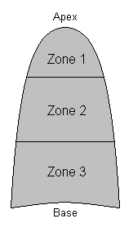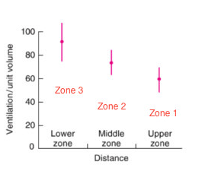

QUESTIONS

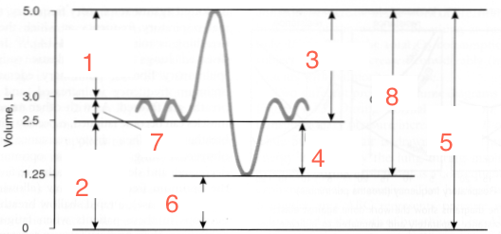
- Identify the lung volume or lung capacity:
1:_____________________________________________
2:_____________________________________________
3:_____________________________________________
4:_____________________________________________
5:_____________________________________________
6:_____________________________________________
7:_____________________________________________
8:_____________________________________________

- _______________________________ is the amount of air remaining in the lungs after a normal expiration. It is equal to _______________________ + _________________________

- Calculate the minute ventilation of a 4 kg male neutered cat (named Matt Damon) who has a respiratory rate of 12 breaths per minute and a tidal volume of 15 ml/kg.

- Matt Damon is a very cooperative cat – you ask him to take a maximal inspiration and he inspires an additional 10 ml. This volume represents his __________________________________.

- True or false. Matt Damon lies on his left side. His right lung has better ventilation than his left lung.

- What is Matt Damon’s physiological dead space if his PaCO₂ = 45 mmHg and his PECO₂ = 35 mmHg?

- Calculate Matt Damon’s alveolar minute ventilation

- Which of this lung volume can’t be measured with a spirometer
a) Inspiratory reserve volume
b) Expiratory reserve volume
c) Residual volume
d)Tidal volume

- What is the definition of anatomical dead space?

- What is the definition of physiological dead space?

QUESTIONS & ANSWERS

- Identify the lung volume or lung capacity:
1: IRV
2: FRC
3: IC
4: ERV
5:TLC
6:RV
7:VT
8:VC

- FRC is the amount of air remaining in the lungs after a normal expiration. It is equal to ERV + RV

- Calculate the minute ventilation of a 4 kg male neutered cat (named Matt Damon) who has a respiratory rate of 12 breaths per minute and a tidal volume of 15 ml/kg.
Minute ventilation = VT * RR
VT = 15 ml/kg * 4 kg = 60 ml/breath
RR =12 bpm
MV = 60 ml/breath * 12 breaths/min = 720 ml/min

- Matt Damon is a very cooperative cat – you ask him to take a maximal inspiration and he inspires an additional 60 ml. This volume represents his IRV.

- True or false. Matt Damon lies on his left side. His right lung has better ventilation than his left lung.

- What is Matt Damon’s physiological dead space if his PaCO₂ = 45 mmHg and his PECO₂ = 35 mmHg?
Bohr equation: $\frac{VD}{VT}=\frac{PaCO2-PECO2}{PaCO2}$
VD = VT * $\frac{PaCO2-PECO2}{PaCO2}$
VD = 60 ml/breath * $\frac{45 mmHg-35 mmHg}{45 mmHg}$ = 13.3 ml
13.3 ml of inspired air do not participate to gas exchange (or 22% of his tidal volume)

- Calculate Matt Damon’s alveolar minute ventilation.
Alveolar minute ventilation = (VT-VD)* RR
(60 ml/breath – 13.3 ml/breath) * 12 bpm = 560.4 ml/min

- Which of this lung volume can’t be measured with a spirometer
a) Inspiratory reserve volume
b) Expiratory reserve volume
c) Residual volume
d)Tidal volume

- What is the definition of anatomical dead space?
The volume of air in the conducting airways that does not participate to gas exchange.

- What is the definition of physiological dead space?
The volume of the lung that does not eliminate CO_{2.}

