Chapter 1: Structure and Function

Key Points:
- Conducting airways (volume of 150mLs) function to lead inspired air into gas exchange regions of the lung. Contain no alveoli = anatomic dead space.
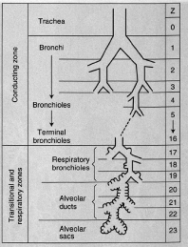
Respiratory zone (volume of 2.5 – 3 L during rest) refers to alveolated region of lung where gas exchange occurs.
Acinus refers to the portion of lung distal to a terminal bronchiole.

- During inspiration diaphragm contracts and cross sectional area of thorax increases. Inspired air flows down to terminal bronchioles by bulk flow (convective flow); beyond this point gas movement is by diffusion in the alveolar region.

Fick’s law of diffusion: amount of gas that moves across a sheet of tissue is proportional to the area of the sheet but inversely proportional to its thickness.

Blood gas interface is extremely thin, 0.2-0.3 um over much of its area.
It has a surface area of between 50-100 square meters.

Diffusion path from alveolar gas to interior of rbc (represented by large arrow): surfactant layer, alveolar epithelium (EP), interstitium (IN), capillary endothelium (EN), plasma.
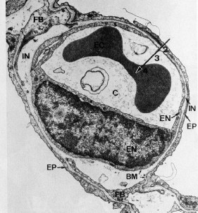

Diameter of capillary segment is 7-10um (just large enough for rbc).
Blood spends 0.75 second in capillaries.

- Pulmonary artery receives whole output of right heart. Resistance of circuit is small, 15mm Hg required for flow of 6 L/min.
Bronchial circulation supplies the conducting airways down to the terminal bronchioles.
Flow through bronchial circulation << pulmonary circulation.

- Surfactant lowers surface tension of alveolar lining layer and increases stability of alveoli.

- Foreign particles in conducting airways are removed by cilia and trapped by mucus (secreted by globlet cells).
Alveoli have no cilia, particles that deposit there are engulfed by macrophages. Material is then removed from lung via lymphatics or blood flow.

Questions
- Fill in the blanks. Name the components of the respiratory and conducting zones.

- Volume of the anatomic dead space and alveolar region, respectively.
  - 150mL, 3L
  - 50mL, 2.5L
  - 100mL, 2.5L
  - 150mL, 1L

- True or False. Gas movement in the alveolar region is chiefly by convection.

- Name the layers that oxygen traverses during its diffusion from alveolar gas to the rbc, with the help of this figure:

- True or False. The lung can function without bronchial circulation.

- What is the function of surfactant?

- Describe how alveoli remove inhaled particles?

Answers:
- Fill in the blanks. Name the components of the respiratory and conducting zones.
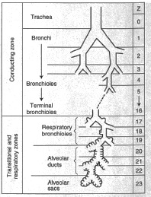

- Volume of the anatomic dead space and alveolar region, respectively.
  - 150mL, 3L
  - 50mL, 2.5L
  - 100mL, 2.5L
  - 150mL, 1L

- True or False. Gas movement in the alveolar region is chiefly by convection (BY DIFFUSION)

- Name the layers that oxygen traverses during its diffusion from alveolar gas to the rbc, with the help of this figure:
Diffusion path from alveolar gas to interior of rbc: surfactant layer, alveolar epithelium (EP), interstitium (IN), capillary endothelium (EN), plasma.

- True or False. The lung can function without bronchial circulation. Flow through bronchial circulation is a fraction of that that through the pulmonary circulation.

- What is the function of surfactant? Surfactant lowers surface tension of alveolar lining layer and increases stability of alveoli.

- Describe how alveoli remove inhaled particles? Alveoli have no cilia, particles that deposit there are engulfed by macrophages. Material is then removed from lung via lymphatics or blood flow.

