West Pulmonary Physiology p75-93

Chapter 6 – Gas transport by the blood

Key points:
- The O2 dissociation curve explains the relation of PO2 and oxygen saturation. It is left shifted by CO and right shifted by increases in H+ concentration, temperature, PCO2, and concentrations of 2,3 DPG.
- CO2 is carried in blood in three forms: bicarbonate, carbamino coumpounds and dissolved. CO2 is 20x more soluble than O2, so the dissolved component is considerably larger.
- Methemoglobin is formed when the ferrous form is oxidized to the ferric form.

Questions:
- What three forms is CO2 carried in blood?

- A PO2 of 40mmHg equates with a saturation of ________ and a PO2 of 100 equates with a saturation of ________.

- What is the chloride shift?

- The O2 dissociation curve is right shifted by what?

- True / False – A large amount of CO is required to left shift the O2 dissociation curve

- ______% of CO2 is dissolved in venous blood. ______% of CO2 is carried as bicarbonate in venous blood.

Answers:
- What three forms is CO2 carried in blood?
Carbamino coumpounds, dissolved, bicarbonate
- A PO2 of 40mmHg equates with a saturation of ____75%____ and a PO2 of 100 equates with a saturation of ____97%____. (75%, 97%)
- What is the chloride shift?
Chloride shift – when the HCO3 builds up in the cell it begins to diffuse out and as a result the Cl diffuses in
- The O2 dissociation curve is right shifted by what?
Increased temp, H+, CO2, and 2,3 DPG
- True / False – A large amount of CO is required to left shift the O2 dissociation curve
- ___5%___% of CO2 is dissolved in venous blood. ___60%___% of CO2 is carried as bicarbonate in venous blood.

Dissolved O2 is proportional to the partial pressure – for each mmHg, there is 0.003 ml O2/100ml of blood = normal arterial blood with PO2 of 100mmHg contains 0.3ml O2 / 100ml.

Hemoglobin –
Heme – iron-porphyrin compound joined to globin
Globin – (4 polypeptide chains) – alpha, beta, gamma

Hemoglobin A – normal adult
Hemoglobin F – fetal – gradually replaced over the first year of life
Hemoglobin S – sickle – valine instead of glutamic acid – crystallizes within red cell, cell changes shape

Methemoglobin – ferrous (Fe++) oxidized to ferric (Fe+++)

Oxygenated form of hemoglobin – relaxed state
Deoxygenated form of hemoglobin – tense state
Oxygen binding to hemoglobin increases affinity for additional oxygen to bind to hemoglobin.
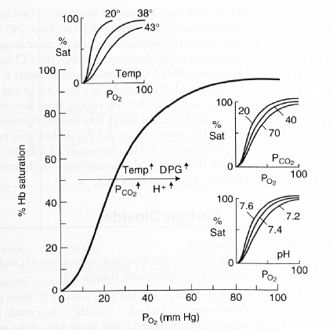
O2 dissociation curve
Useful anchor points:
PO2 40 = sat 75%
PO2 100 = Sat 97%

Advantages of curved shape:
-flat upper portion means that even if PO2 in alveolar gas falls, loading of O2 will be little affected.
-diffusion is hastened due to the continued large partial pressure difference between alveolar gas and blood
-steep lower portion means that the peripheral tissues can draw large amounts of O2 into the tissue cells

Shifted to right
-increased H+ concentration
-increased PCO2
-elevated temp
-elevated concentration of 2,3 DPG (byproduct of RBC metabolism

Shifted to left
-carbon monoxide

Carbon dioxide
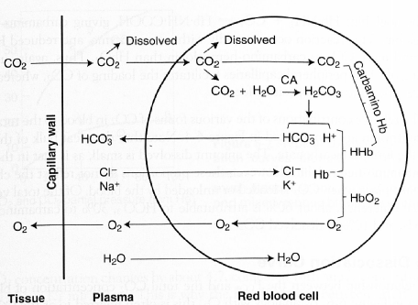
Three forms in blood
- Dissolved (5% arterial, 10% venous)– 20x more soluble than O2 (0.067ml/dl) ~10% of CO2 is dissolved
- Bicarbonate (90% arterial, 60% venous) – CO2 + H2O H2CO# H+ + HCO- First reaction is fast in presence of carbonic anhydrase (CA). Second is fast without enzyme
Chloride shift – when the HCO3 builds up in the cell it begins to diffuse out and as a result the Cl diffuses in.
- Carbamino coumpounds (5% arterial, 30% venous)
Formed by the combination of CO2 with terminal amine groups in blood proteins

Haldane effect – deoxygenation of blood increases CO2 binding affinity

CO2 dissociation curve
More linear than O2
Lower saturation of O2 the larger the CO2 concentration for a given PCO2.
Haldane effect
Right shifted by increases in SO2.

