West Chapter 4 – Blood flow and metabolism

Key points:
- The pressures in the pulmonary circulation are remarkably low despite the fact that it receives the entire cardiac output of the right side of the heart. The mean pressure in the main pulmonary artery is about 15mmHg, with systolic of 25 and diastolic of 8 mmHg. The walls of the pulmonary artery are thing and contain little smooth muscle. Pulmonary vascular resistance decreases when cardiac output increases because of recruitment and distension of capillaries. Pulmonary vascular resistance increases at very low or very high lung volumes.
- Blood flow is unevenly distributed in the upright lung – higher flow at the base than the apex (gravity sure is a bitch). If capillary pressure is less than alveolar pressure at the top of the lung, the capillaries collapse and there is no blood flow.
- Hypoxic pulmonary vasoconstriction (occurs when PO2 of alveolar gas is reduced, functions to shunt blood away fro poorly ventilated lung) reduces blood flow to poorly ventilated regions of the lung by contraction of smooth muscle in the walls of the small arterioles in the hypoxic region. The mechanism is not fully understood. Its release is critical at birth in the transition from fetal lung to breathing lung.
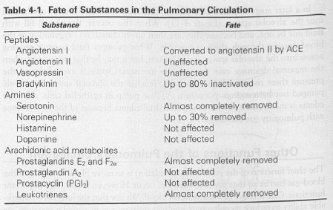
- The lung has metabolic functions, metabolizing vasoactive substances (see chart). It may also function in the clotting mechanism of blood, and can function in the synthesis of phopspholipids (including dipalmitoyl phosphatidylcholine - a part of surfactant).
Questions:

- Label the pressures in the following diagram:

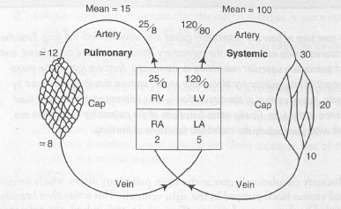
A
B

C
G

I
H
D

K
J
F
E

- Which of the following is present only under abnormal/pathologic conditions in regards to pulmonary blood flow zones?
  - Zone 1
  - Zone 2
  - Zone 3
  - Zone 4
- For following, indicate if the statement represents the mechanism behind zone 1, zone 2, zone 3 pulmonary blood flow.
  - Pulmonary arterial pressure increases and exceeds alveolar pressure. Blood flow is determined by the difference between the arterial and alveolar pressures. Venous pressure is low enough as to not be a contributor to flow in the normal lung.
  - Pulmonary arterial pressure falls below alveolar pressure, closing capillaries and disrupting blood flow?
  - Venous pressure exceeds alveolar pressure, flow is determined by the arterial-venous difference.
- Which of the following is true of hypoxic pulmonary vasoconstriction?
  - It directs blood flow away from ventilated areas of the lung
  - Occurs independently of PaO2.
  - Is a mechanism that occurs when the fetal lung transitions to the breathing lung at birth.
  - Consists of constriction of small pulmonary arteries to minimize ventilation-perfusion mismatch.
- Name other functions of the pulmonary circulation

- The lung is able to activate which of the following precursors?
  - Angiotensin I
  - Angiotensin II
  - Bradykinin
  - Serotonin

Answers:
- 1.

- Which of the following is present only under abnormal/pathologic conditions in regards to pulmonary blood flow zones?
  - Zone 1
  - Zone 2
  - Zone 3
  - Zone 4
- For following, indicate if the statement represents the mechanism behind zone 1, zone 2, zone 3 pulmonary blood flow.
  - Pulmonary arterial pressure increases and exceeds alveolar pressure. Blood flow is determined by the difference between the arterial and alveolar pressures. Venous pressure is low enough as to not be a contributor to flow in the normal lung. Zone 2
  - Pulmonary arterial pressure falls below alveolar pressure, closing capillaries and disrupting blood flow? Zone 1
  - Venous pressure exceeds alveolar pressure, flow is determined by the arterial-venous difference. Zone 3
- Which of the following is true of hypoxic pulmonary vasoconstriction?
  - It directs blood flow away from ventilated areas of the lung
  - Occurs independently of PaO2.
  - Is a mechanism that occurs when the fetal lung transitions to the breathing lung at birth.
  - Consists of constriction of small pulmonary arteries to minimize ventilation-perfusion mismatch.
- Name other functions of the pulmonary circulation
Move blood for gas exchange
Reservoir for blood
Filter blood – small thrombi
Trap white blood cells
- The lung is able to activate which of the following precursors?
  - Angiotensin I
  - Angiotensin II
  - Bradykinin
  - Serotonin

