West Chapter 3 – Diffusion
- Diffusion through tissues is described by Fick’s law
- The rate of transfer of a gas through a sheet of tissue is proportional to the tissue area and the difference in gas partial pressure between the two sides, and inversely proportional to the tissue thickness.
- The rate of transfer is proportional to a diffusion constant, which depends on the properties of the tissue and the particular gas.
- The constant is proportional to the solubility of the gas and inversely proportional to the square root of the molecular weight.
- CO2 diffuses about 20 times more rapidly than does O2 through tissue sheets because it has a much higher solubility but not a very different molecular weight.
- The amount of a substance that gets into the blood and is limited by the diffusion properties of the blood-gas barrier and not by the amount of blood available is said to be diffusion limited.
- The amount of a substance that gets into the blood and is limited by the amount of available blood flow and not at all on the diffusion properties of the blood-gas barrier is therefore perfusion limited.
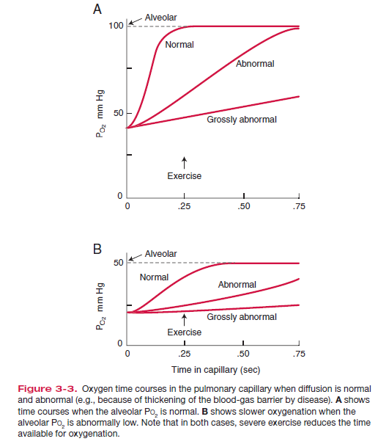
- At rest, the PO2 of the blood virtually reaches that of the alveolar gas after about one-third of its time in the capillary
- The diffusion process is challenged by exercise, alveolar hypoxia, and thickening of the blood-gas barrier
- Vgas = DL (P1 – P2 ) where DL is called the diffusing capacity of the lung and includes the area, thickness, and diffusion properties of the sheet and the gas concerned and where P1 and P2 are the partial pressures of alveolar gas and capillary blood, respectively
- The path length from the alveolar wall to the center of a red blood cell exceeds that in the wall itself, so that some of the diffusion resistance is located within the capillary
- The uptake of O2 (or CO2) can be regarded as occurring in two stages:
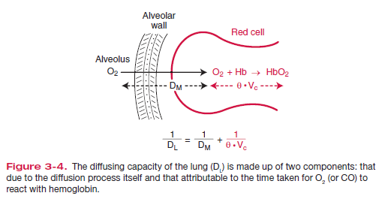
- 1) diffusion of O2 through the blood-gas barrier (including the plasma and red cell interior) and
- 2) reaction of the O2 with hemoglobin.
- In fact, it is possible to sum the two resultant resistances to produce an overall “diffusion” resistance

Questions:
1) What is Fick’s Law of Diffusion

2) With a the amount of the gas in blood is limited by _______________________________of blood-gas barrier and not by amount of blood available

3) With _________________________________________ gas the amount of the gas in blood is limited by ____________________________________________ and not by diffusion properties of blood-gas barrier
4) What is the Equation for diffusing capacity of CO
- DL = Vgas/ (P1 – P2 )
- DL = Vgas (P1-P2)
- DL = Vgas
- Matt Damon
5) Carbon dioxide transfer into blood
- faster than O2 because of higher solubility of CO2
- slower than O2 because of lower solubility of CO2
- faster than O2 because of its higher molecular weight
- slower than O2 because of its higher molecular weight

Questions:
1) What is Fick’s Law of Diffusion
- Amount of gas moving across a sheet of tissue is proportional to the area of the sheet, the gas diffusion constant, and difference in partial pressure, and inversely promotional to thickness
2) With a diffusion limited gas the amount of the gas in blood is limited by diffusion properties of blood-gas barrier and not by amount of blood available

3) With a perfusion limited gas the amount of the gas in blood is limited by available blood flow and not by diffusion properties of blood-gas barrier

4) What is the Equation for diffusing capacity of CO
- DL = Vgas/ (P1 – P2 )
- DL = Vgas (P1-P2)
- DL = Vgas
- Matt Damon

5) Carbon dioxide transfer into blood
- faster than O2 because of higher solubility of CO2
- slower than O2 because of lower solubility of CO2
- faster than O2 because of its higher molecular weight
- slower than O2 because of its higher molecular weight

