Evaluation of variables to describe the shape of volumetric capnography curves

Background and aim - The diagnosis of bronchoconstriction in spontaneously breathing anaesthetised animals remains challenging.
The aim of the present study was to follow the shape of the volumetric capnography curve over a period of severe provoked bronchoconstriction and investigate the usefulness of SII, SIII and dead space parameters to diagnose bronchoconstriction

The expired CO2 volume per breath (VCO2/br) represents the area under the curve and is the integral of the expired CO2 plotted as the function of expired volume. Slope II and III, angle a and airway dead space (VDaw) were calculated by the software.
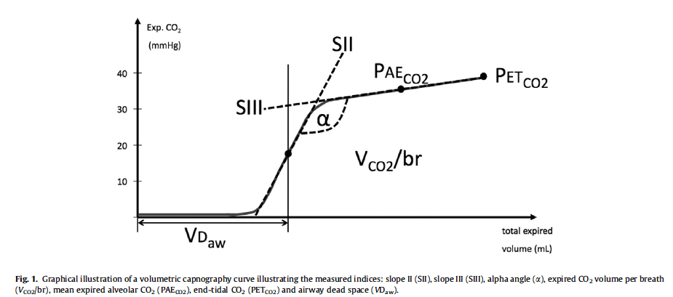

Main Points
1. Volumetric capnography can be used to diagnose and quantitate bronchoconstriction in spontaneously breathing anaesthetised dogs

2. This study describes the changes in shape of the VC curve during profound provoked bronchoconstriction in dogs and confirms the finding that slope III of the capnogram in conjunction with airway dead space (VDaw)/ VT can be used on breath-by-breath basis to verify bronchoconstriction in spontaneously breathing subjects

3. The most striking change in the shape of the VC curve after carbachol challenge was the change in SIII indicating a mismatch between ventilation and perfusion.
The values for the alveolar dead space ratio can be used to confirm the ventilation–perfusion mismatch due to changes in airway caliber.

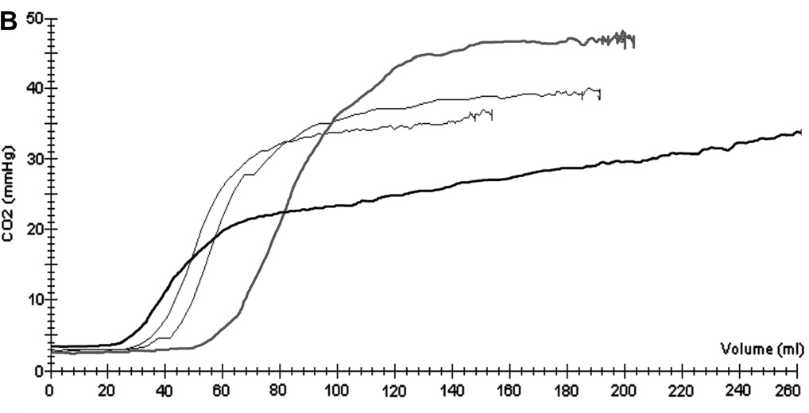
Representative volumetric capnography curves of six dogs (A–F) before bronchoconstriction (grey solid line), at clinical reaction (black solid line), and 10 and 20 min

Questions
- True or False. Changes in shape of the VC curve during profound provoked bronchoconstriction in dogs and confirms the finding that slope II of the capnogram in conjunction with VDaw/ VT can be used on breath-by-breath basis to verify bronchoconstriction

- True or False. Volumetric capnography can be used to diagnose and quantitate bronchoconstriction in spontaneously breathing anaesthetised dogs

- Name one reason for changes in airway resistance

- The position of phase II is best described by the evaluation of:
  - Ventilation perfusion mismatch
  - Airway dead space

- Fill in the blanks
a. SII
b. SIII
c. Expired CO2 volume per breath
d. End tital CO2

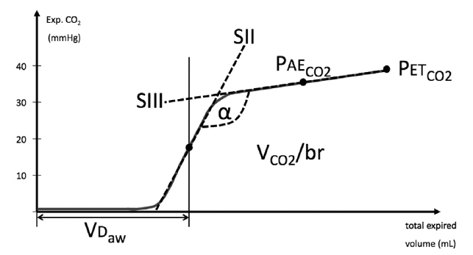

2.
1.
3.

4.

Questions with Answers
- True or False. Changes in shape of the VC curve during profound provoked bronchoconstriction in dogs and confirms the finding that slope II of the capnogram in conjunction with VDaw/ VT can be used on breath-by-breath basis to verify bronchoconstriction
False. Slope III

- True or False. Volumetric capnography can be used to diagnose and quantitate bronchoconstriction in spontaneously breathing anaesthetised dogs

- Name one reason for changes in airway resistance
Answer: Increased secretion, kinks or mucous in the endotracheal tube or simple changes in flow or gas composition

- The position of phase II is best described by the evaluation of:
  - Ventilation perfusion mismatch
  - Airway dead space

- Fill in the blanks

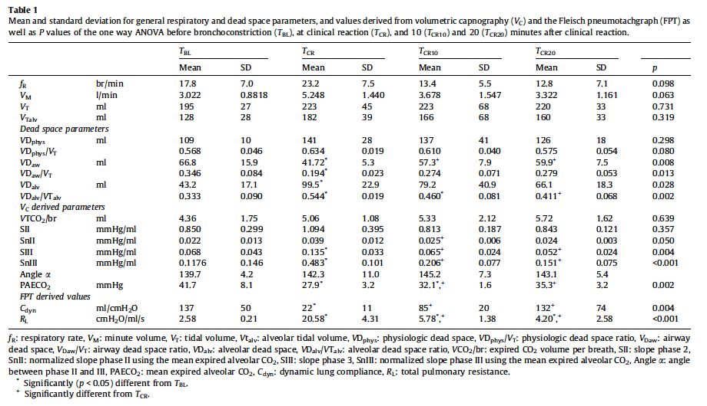
Volumetric capnography curves as lung function test to confirm bronchoconstriction after carbachol challenge in sedated dogs

Background - Volumetric capnography (VC) measures airway dead space based on Fowler’s method and calculates alveolar and physiologic dead space using the Bohr–Enghoff equation. During lung function tests bronchoconstriction can be diagnosed by a decrease in airway dead space and an increase in alveolar dead space leaving the physiologic dead space unchanged. Volumetric capnography requires a capnograph and pneumotachograph

Aim - The aim of this study was to investigate the value of volumetric capnography and derived indices in detecting airflow limitation following carbachol challenge in sedated dogs via a face mask.
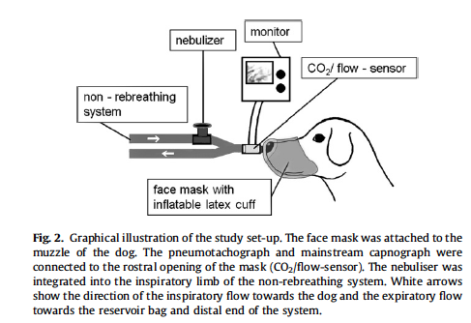

The volumetric capnography curve has three phases: phase 1 represents the exhalation of CO2-free gas from the conducting airways; phase 2 is defined as the S-shaped upswing of the curve where CO2-free gas from the conducting airways and CO2-rich alveolar gas mixes; phase 3 represents the alveolar plateau containing CO2-rich alveolar gas.

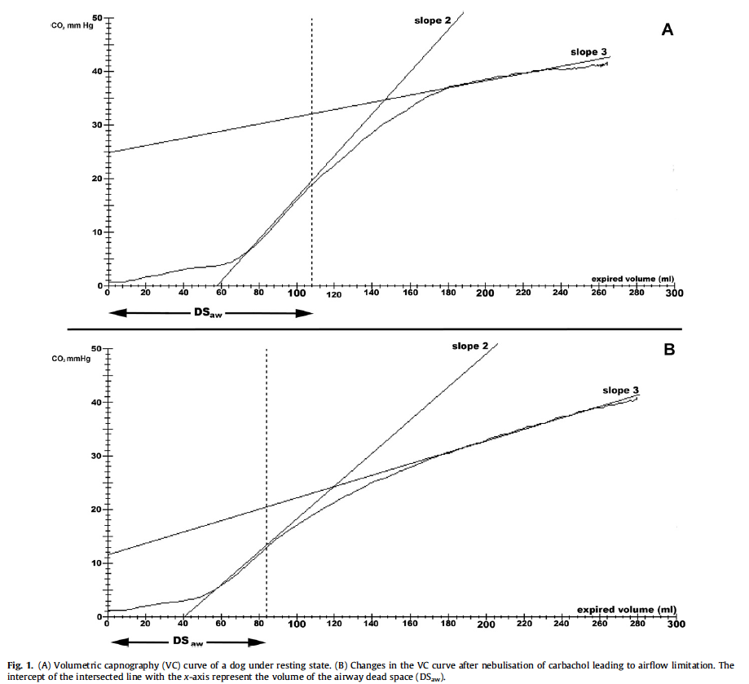

Physiological dead space (VDS phys) is automatically calculated by the software. The calculation is based on mixed expired CO2 and arterial partial pressure of CO2 (PaCO2 ). Both variables are entered into the Bohr–Enghoff equation.
Airway dead space (VDS aw) is computed according to Fowler’s method.
Alveolar dead space (VDS alv) is obtained by subtracting VDS aw from VDS phys.
Physiologic dead space is the sum of airway and alveolar dead space.

Main Points
- Volumetric capnography can be used to verify bronchoconstriction during carbachol challenge in dogs and may have the potential to be used as lung function test to evaluate airway responsiveness. With the use of a tightly fitting face mask, general anesthesia is not required.
- The non-invasive parameters dead space to VT (tidal volume) ratio (VDS aw/VT ) and interceptY2 (intercept of slope 2) are potential markers for bronchoconstriction as changes occurred before clinical signs were visible
- The technique for airway challenge as described in the study offers several advantages:
  - Airway challenge and acquisition of objective data under sedation (preventing the need for general anesthesia and still compiling reproducible data) with minimal cardiovascular compromises
  - Opportunity for oxygen supplementation and prevention of hypoxemia (compared to whole body plethysmography, where no additional oxygen can be administered during airway challenge)
  - Direct contact between the clinician and the animal allowing for clinical monitoring of the animal (compared to whole body plethysmography, where the animal has to sit in a box) and thus the possible avoidance of any sedation
  - Possibility for additional monitoring, such as ECG and measurement of blood pressure (compared to whole body plethysmography, where no additional equipment is allowed in the box) and
  - A lack of cholinergic side effects beyond airflow limitation due to significant changes at the point of first clinical signs

Questions and Answers
- Fill in the blanks. During lung function tests bronchoconstriction can be diagnosed by a ___________________(increase/decrease) in airway dead space and an __________________(increase/decrease) in alveolar dead space leaving the physiologic dead space unchanged.

- True or False. The non-invasive parameters dead space to VT ratio (VDS aw/VT ) and interceptY3 are potential markers for bronchoconstriction as changes occurred before clinical signs were visible.

- Fill in the blanks. (i) Alveolar dead space (ii) Physiologic dead space (iii) Alveolar dead space (iv) Physiologic dead space
a. _________________________________is automatically calculated by the software. The calculation is based on mixed expired CO2 and arterial partial pressure of CO2. Both variables are entered into the Bohr–Enghoff equation.
b. __________________________________ is computed according to Fowler’s method.
c. __________________________________ is obtained by subtracting VDS aw from VDS phys.
d. __________________________________ is the sum of airway and alveolar dead space.

- Name one advantage that the carbachol challenge technique described in this study (using face mask and sedation instead of general anesthesia) offers.

Questions and Answers
- Fill in the blanks. During lung function tests bronchoconstriction can be diagnosed by a ___________________(increase/decrease) in airway dead space and an __________________(increase/decrease) in alveolar dead space leaving the physiologic dead space unchanged.

- True or False. The non-invasive parameters dead space to VT ratio (VDS aw/VT ) and interceptY3 are potential markers for bronchoconstriction as changes occurred before clinical signs were visible.
False. The non-invasive parameters dead space to VT (tidal volume) ratio (VDS aw/VT ) and interceptY2 (intercept of slope 2) are potential markers for bronchoconstriction as changes occurred before clinical signs were visible

- Fill in the blanks. (i) Alveolar dead space (ii) Physiologic dead space (iii) Alveolar dead space (iv) Physiologic dead space
a. Physiological dead space (VDS phys) is automatically calculated by the software. The calculation is based on mixed expired CO2 and arterial partial pressure of CO2. Both variables are entered into the Bohr–Enghoff equation.
b. Airway dead space (VDS aw) is computed according to Fowler’s method.
c. Alveolar dead space (VDS alv) is obtained by subtracting VDS aw from VDS phys.
d. Physiologic dead space is the sum of airway and alveolar dead space.

- Name one advantage that the carbachol challenge technique described in this study (using face mask and sedation instead of general anesthesia) offers.
  - Airway challenge and acquisition of objective data under sedation (preventing the need for general anesthesia and still compiling reproducible data) with minimal cardiovascular compromises
  - Opportunity for oxygen supplementation and prevention of hypoxemia (compared to whole body plethysmography, where no additional oxygen can be administered during airway challenge)
  - Direct contact between the clinician and the animal allowing for clinical monitoring of the animal (compared to whole body plethysmography, where the animal has to sit in a box) and thus the possible avoidance of any sedation
  - Possibility for additional monitoring, such as ECG and measurement of blood pressure (compared to whole body plethysmography, where no additional equipment is allowed in the box) and
  - A lack of cholinergic side effects beyond airflow limitation due to significant changes at the point of first clinical signs

