Vasodilatory shock

- There may be common mechanisms for the vasodilatation and resistance to vasopressors that occur in most types of vasodilatory shock
- Three such mechanisms have thus far been implicated in this syndrome: activation of ATP-sensitive potassium channels (K_{ATP} channels) in the plasma membrane of vascular smooth muscle, activation of the inducible form of nitric oxide synthase, and deficiency of the hormone vasopressin.
- At high cytosolic concentrations, calcium forms a complex with calmodulin, and this complex activates a kinase that phosphorylates the regulatory light chain of myosin.
- The phosphorylation of myosin allows the activation of myosin ATPase by actin and the cycling of myosin crossbridges along actin filaments, a process that contracts the muscle.
- Conversely, vasodilators such as atrial natriuretic peptide and nitric oxide activate a kinase that, by interacting with myosin phosphatase, dephosphorylates myosin and thus prevents muscle contraction.
- The resting membrane potential of vascular smooth muscle ranges from –30 to –60 mV, depending on the cell type.
- A more positive potential (depolarization) opens the voltage-gated calcium channels, increases the cytosolic calcium concentration, and induces vasoconstriction.
- Conversely, hyperpolarization closes these channels, decreases the cytosolic calcium concentration, and induces relaxation.
- The opening of K_{ATP} channels allows an efflux of potassium, thus hyperpolarizing the plasma membrane and preventing the entry of calcium into the cell.
- This is why pharmacologic activation of K_{ATP} channels (with diazoxide, for example) inhibits catecholamine-induced or angiotensin II–induced vasoconstriction.
- Increased synthesis of nitric oxide contributes to the hypotension and resistance to vasopressor drugs that occur in vasodilatory shock.
- It is likely that the vasodilating action of nitric oxide in vasodilatory shock is mediated mainly by the activation of myosin light-chain phosphatase.
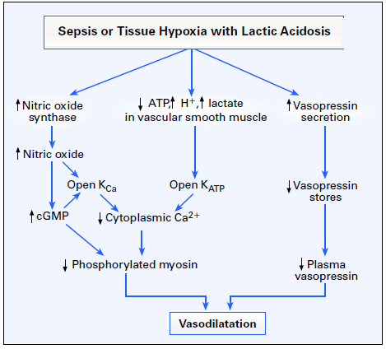
- During the initial phase of hemorrhagic or septic shock, vasopressin (along with other vasoconstrictors) contributes to the maintenance of arterial pressure.
- As shock worsens, the initially very high concentrations of vasopressin in plasma decrease.
- Unregulated nitric oxide synthesis, by activating soluble guanylate cyclase and generating cGMP, causes dephosphorylation of myosin and hence vasorelaxation.

Questions:

- In this paper what are the three listed primary mechanisms that result in vasodilatory shock.

- In vascular smooth muscle a more positive potential (depolarization) opens the voltage-gated calcium channels, increases the cytosolic calcium concentration, and induces ________________.

- In vascular smooth muscle hyperpolarization closes these channels, decreases the cytosolic calcium concentration, and induces ___________________.

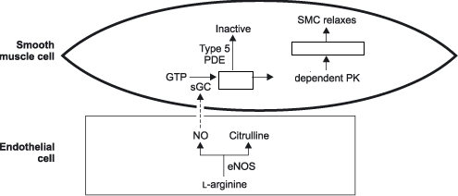

- What is the common result of acidosis, and increased nitric oxide synthase that results in vasodilation
  - ↓ Vasopressin
  - ↑ K⁺
  - ↓ Phosporylated myosin
  - ↑ cGMP
  - A world without Matt Damon

Questions with answers:

1) In this paper what are the three listed primary mechanisms that result in vasodilatory shock.

- Activation of ATP-sensitive potassium channels (KATP channels) in the plasma membrane of vascular smooth muscle
- Activation of the inducible form of nitric oxide synthase
- Deficiency of the hormone vasopressin.

2) In vascular smooth muscle a more positive potential (depolarization) opens the voltage-gated calcium channels, increases the cytosolic calcium concentration, and induces vasoconstriction.

3) In vascular smooth muscle hyperpolarization closes these channels, decreases the cytosolic calcium concentration, and induces relaxation.
4) 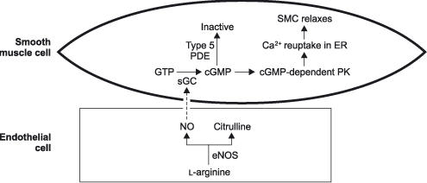

5) What is the common result of acidosis, and increased nitric oxide synthase that results in vasodilation
- ↓ Vasopressin
- ↑ K⁺
- ↓ Phosporylated myosin
- ↑ cGMP
- A world without Matt Damon

