CATEGORIES OF SHOCK
- Hypovolemic shock
  - Decreased circulating blood volume in relation to the total vascular capacity
  - Characterized by a reduction of diastolic filling pressures and volumes (due to fall in ventricular preload)
  - Cardiac index (CI) and stroke volume index (SVI) are typically reduced
- Mixed venous oxygen saturation (MVo2) may be decreased and arteriovenous oxygen content difference widened
- Clinical characteristics: pale, cool, skin, tachycardia (or if severe shock, bradycardia), tachypnea, flat, nondistended peripheral veins, decreased jugular venous pulse, decreased urine output, and altered mental status
- Lactic acidosis

- Cardiogenic shock
  - Related to cardiac pump failure due to loss of myocardial contractility/ functional myocardium or structural/mechanical failure of the cardiac anatomy
  - Characterized by elevations of diastolic filling pressures and volumes due to increased ventricular preload (increased ventricular volumes, pulmonary wedge pressure [PWP] and CVP)
  - CI and SVI are reduced
- MVo2 may be decreased and arteriovenous oxygen content difference widened
  - Degree of lactic acidosis may predict mortality
  - Clinical characteristics: similar to hypovolemic shock. Signs of congestive heart failure (volume overload), jugular and peripheral veins may be distended, evidence of pulmonary edema are usually found
  - Patients should not be diagnosed with cardiogenic shock unless hypotension (MAP < 65 mm Hg) and reduced cardiac output (CI < 2.2 L/min/m2) coexist with an elevated ventricular filling pressure

- Extracardiac obstructive shock
  - Obstruction to flow in the cardiovascular circuit
    - Pericardial tamponade and constrictive pericarditis directly impair diastolic filling of the right ventricle
    - Tension pneumothorax and intrathoracic tumors indirectly impair right ventricular filling by obstructing venous return
    - Massive pulmonary emboli (two or more lobar arteries with >50% of the vascular bed occluded), nonembolic acute pulmonary hypertension, large systemic emboli (e.g., saddle embolus), and aortic dissection result in shock due to increased ventricular afterload
  - Characterized by either impairment of diastolic filling or excessive afterload
  - CI and SVI are reduced.
- MVo2 may be decreased and arteriovenous oxygen content difference widened
  - Clinical signs are dependent on the site of the obstruction

- Distributive shock
  - Loss of vasomotor control resulting in arteriolar and venular dilation and (after resuscitation with fluids). Loss of peripheral resistance
  - Characterized by increased CO with decreased SVR
- CI may be depressed and ventricular filling pressures decreased initially
- MVo2 is increased. Arteriovenous oxygen content difference is narrowed
- Clinical characteristics of resuscitated distributive shock: warm, well-perfused extremities, a decreased diastolic blood pressure, and an increased pulse pressure.
- Septic shock is most common form
- Anaphylactic shock - caused by the release of mediators from tissue mast cells and circulating basophils
- Neurogenic shock - involves the loss of peripheral vasomotor control due to dysfunction or injury of the nervous system (shock associated w/ spinal injury)
- Adrenal crisis

Septic shock is caused by the systemic activation of the inflammatory cascade
- Numerous mediators (cytokines, kinins, complement, coagulation factors, eicosanoids) are activated or systemically released and cause disturbances of cardiovascular and organ system function
- These mediators (TNFα, IL-1β, platelet activating factor, and prostaglandins) are thought to mediate reduced peripheral vascular resistance
- Circulating mediators cause an intracellular metabolic defect involving substrate utilization, which results in bioenergetic failure (decreased high-energy phosphate production) and lactate production.
- Circulating mediators may result in cellular dysfunction, aerobic glycolysis, and lactate production in the absence of global ischemia
- The trigger for systemic activation of the inflammatory cascade is the presence of gram-negative bacilli in 50% - 75% of cases of septic shock. Gram-positive bacteria account for most of the remainder, but infection with fungi, protozoa, and viruses can also result in septic shock.
- Mortality is 50% overall and may exceed 70% for gram-negative septic shock.
  - 75% are early deaths (within 1 week of shock), primarily due to hyperdynamic circulatory failure
  - Late mortality is usually due to MODS

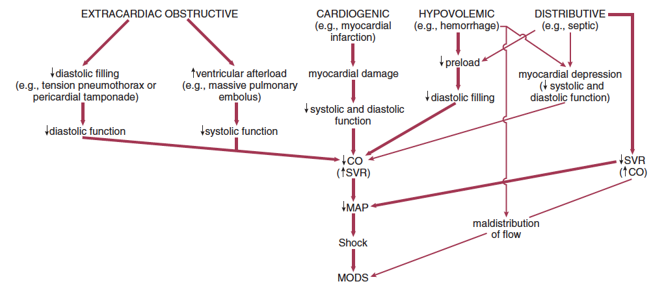

For cardiogenic, hypovolemic, and obstructive shock, hypotension is primarily due to decreased cardiac output with systemic vascular resistance rising secondarily.

With distributive (particularly septic shock), hypotension is primarily due to a decrease in systemic vascular resistance with a secondary increase of cardiac output.

