Shock 2013 – Neutrophils in IRI

Questions:

- True/False: As evidence for the injurious role of neutrophils in IRI, induced neutropenia in animal models of IRI have been found to decrease tissue necrosis and preserve endothelial function.
- True/False: IRI damage in the liver occurs after neutrophil migration across the epithelium, in contrast to the other organ systems discussed.
- What is the Haber-Weiss reaction?

Neutrophils:
- Primary responders to IRI
- ROS produced when NADPH oxidase (nicotinamide adenine dinucleotide phosphate) is activated by adhesion of proinflammatory cytokines
- Block reperfusion by tissue necrosis and immune response
- Secrete pro-inflammatory cytokines/chemokines – positive feedback loop of neutrophil activation
- Migration causes loss of epithelial barrier integrity and downregulation of JAMC (junctional adhesion molecule-C). JAMC prevents reverse migration of neuts with is associated with ARDS, SIRS, MODS

Positive feedback of neutrophils:
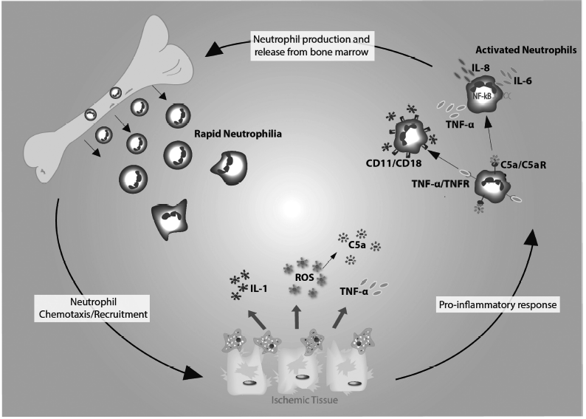

Organ | IRI mechanisms of neutrophils
Heart | ROS – causes and worsens damage  TNFa, IL1, IL6, IL8, PAF (plt act factor), Macrophage inhibitor factor 2, Complement  Adhesion molecule upregulation on endothelium neut migration (CD11/CD 18, P-selectin, ICAM-1  Neuts contribute to no-reflow phenomenon  Neut migration across endothelial barrier leading to loss of tight junction and possible multiple organ failure
Kidney | Responsible for vascular permeability and damage via migration into interstitium  Cause tubular cell injiey, endothelial cell injury, and dendritic cell injury  Dendritic cells are chemotaxic for additional neutrophils.  IL-8 initiates tissue injury by free radicals and proteases  Nephron destruction by ICAM-1, P-selectin mediated adhesion of neuts  Neut degranulation causes injury  No-reflow: blockage of capillaries by neuts and RBCs  Complement activation also facilitates damage. Formation of the MAC attack complex leads to increased expression of TNGa, IL6 and decreased crry (complement inhibitor
Lung | Increased microvascular permeability  Alveolar capillary endothelial cell injury  Decreased lung tissue ATP levels  Neut infiltration  Neut recruitment leads to more injury via ROS, IL8 PAF TNFa MPO, increasing lung permeability and facilitating additional damage
Liver | Main chemoattractants are MIP-3, keratinocyte chemoattractant. TNFa, IL1b IL8 neut accumulation and inc CD 11/ CD18 expression  Neuts adhere within sinusoids independent of selectins (no rolling)  Damage occurs after neut migration across epithelium and are in close proximity to hepatocytes. Occurs by oxidative stress. ***different than other organs***
GI | Uncommon  Neut infiltration villi destruction  ROS is initial source of damage  Complement acts thru ROS and neut activation

Haber-Weiss reaction: generates hydroxyl radical from hydrogen peroxide and superoxide, catalyzed by iron

Fe3+ + •O2- Fe2+ + O2
Fe 2+ + H2O2 Fe 3+ + OH- + •OH-

Net reaction: •O2- + H2O2 •OH + OH- +O2

