Rose and Post Chapter 6
- 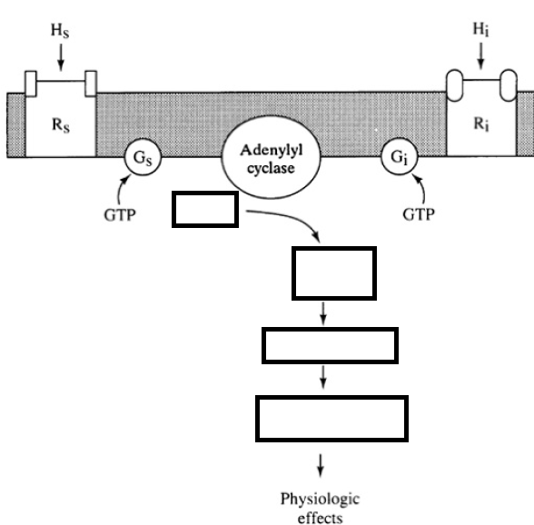
- Where is Antidiuretic hormone synthesized in the body
  - Adrenal medulla
  - Hypothalamus
  - Posterior pituitary
  - Peritubular capillaries
- Where is Antidiuretic hormone stored in the body
  - Adrenal medulla
  - Hypothalamus
  - Posterior pituitary
  - Peritubular capillaries
- The ADH-induced increase in collecting tubule water permeability occurs primarily in the ___________________ cells
- True or False: The main intravascular osmoreceptors that stimulate the release of ADH are located in the femoral arteries as opposed to the carotids
- True or False: Extravascular osmoreceptors are located in the small bowel and can stimulate release of ADH in response to hypertonic ingesta.
- True or False: In general, the plasma sodium concentration is the primary osmotic determinant of ADH release.

- Explain how aldosterone works in the cortical collecting tubule.

- True or False: NSAIDs may have a detrimental effect in those patients with advanced heart disease/failure.
- True or False: Dexmedetomidine will result in diuresis and natriuresis.

- 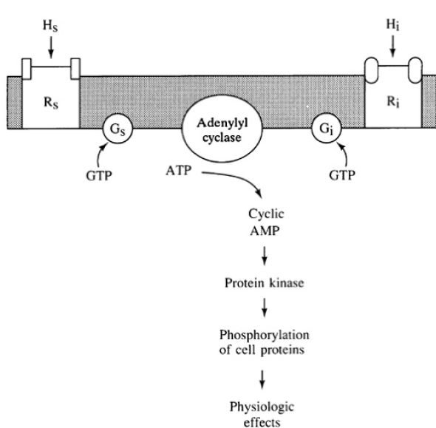

- Where is Antidiuretic hormone synthesized in the body
  - Adrenal medulla
  - Hypothalamus
  - Posterior pituitary
  - Peritubular capillaries
- Where is Antidiuretic hormone stored in the body
  - Adrenal medulla
  - Hypothalamus
  - Posterior pituitary
  - Peritubular capillaries
- The ADH-induced increase in collecting tubule water permeability occurs primarily in the principal cells
- True or False: The main intravascular osmoreceptors that stimulate the release of ADH are located in the femoral arteries as opposed to the carotids
- True or False: Extravascular osmoreceptors are located in the small bowel and can stimulate release of ADH in response to hypertonic ingesta.
- True or False: In general, the plasma sodium concentration is the primary osmotic determinant of ADH release.
- Explain how aldosterone works in the cortical collecting tubule.
- Aldosterone stimulates ionic transport in these cells by increasing the number of open Na+ and K+ channels in the luminal membrane as well as the activity of the Na+-K+-ATPase pump in the basolateral membrane
- True or False: NSAIDs may have a detrimental effect in those patients with advanced heart disease/failure.
- True or False: Dexmedetomidine will result in diuresis and natriuresis.

