Rose and Post Ch 5 Madden

Questions:

1. List the 4 segments of the distal nephron in sequential order

2. How do thiazide diuretics work?

3. Draw a principle cell. What is their main function?

4. Draw an intercalated cell. What is their main function? What are the two types?

5. The distal tubule normally reabsorbs _________% of the filtered NaCl

Questions with answers:

1. List the 4 segments of the distal nephron in sequential order
Answer:
  - Distal tubule
  - Connecting segment
  - Cortical collecting tubule
  - Medullary collecting tubule

2. How do thiazide diuretics work?
Answer: By inhibiting the Na-Cl cotransporter in the distal nephron (binds to the Cl site)

3. Draw a principle cell. What is their main function?
Answer: Contribute to Na reabsorption and K secretion

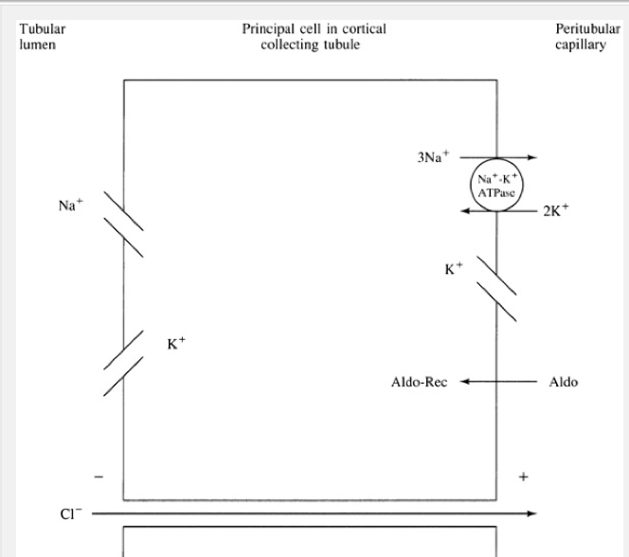
4. Draw an intercalated cell. What is their main function? What are the two types?
Answer: Na+ independent regulation of acid base balance
Type A and Type B

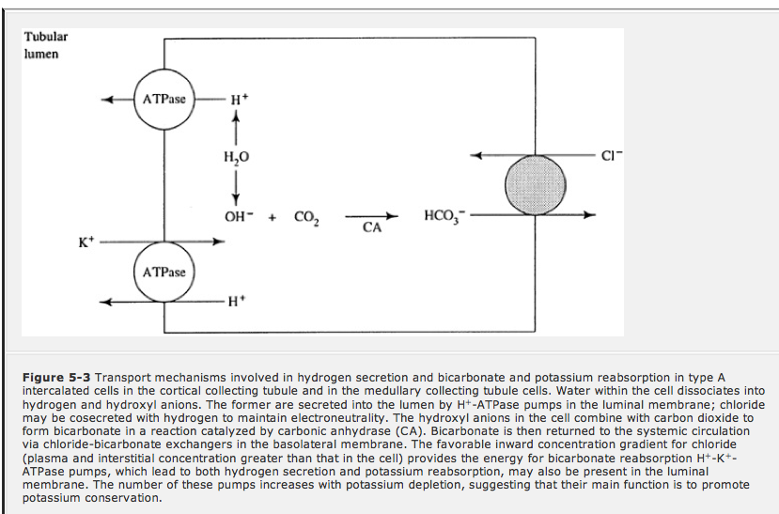

5. The distal tubule normally reabsorbs _________% of the filtered NaCl
Answer: 5%

Functions of the distal nephron – summary:
- Begins at the macula densa (at the end of the cortical thick ascending limb)
- Consists of 4 segments each with distinct cell types:
  - Distal tubule
  - Connecting segment
  - Cortical collecting tubule
  - Medullary collecting tubule
- Collecting tubules is where final quantitative changes in urinary excretion are made
- Maximal concentration of the urine, maximal potassium excretion, maximal urine acidification and sodium conservation occur in the collecting tubules
- Distal nephron is relatively impermeable to water (in the absence of ADH) and sodium
  - Therefore tubular fluid sodium is able to fall below that of plasma (unlike in the PT) as the back leak of sodium from the interstitium back into the tubule down its concentration gradient does NOT occur in the distal nephron
- TOTAL reabsorptive capacity of the distal nephron is low
  - Less activity of Na-K-ATPase than in other parts of the nephron
    - Except that of the thin descending and ascending limbs of the LH where transport is passive
- 3 intra-renal mechanisms that minimize changes in delivery to the distal nephron
  - Autoregulation
    - Maintains GFR in the presence of variations in renal artery pressure
  - Tubuloglomerular feedback
    - Lowers GFR if the load to the macula densa is enhanced
  - Glomerulotubular balance
    - Proximal and loop reabsorption increase if there is an increase in GFR

DISTAL TUBULE:

Sodium and water:
- Distal tubule normally resorbs 5% of filtered NaCl

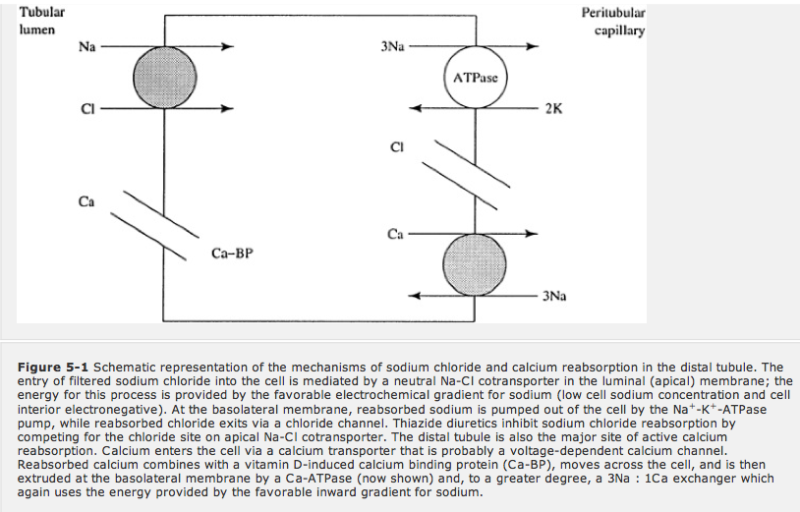

- Na-Cl co-transporter is affected by thiazide diuretics
  - With chronic thiazide therapy you may see:
    - Hypokalemia
    - Metabolic alkalosis
    - Hypocalciuria
- DT Na reabsorption varies with Na delivery to the distal nephron
  - Participates in glomerulotubular balance
  - An increased Na delivery results in a proportional rise of segment Na reabsorption

- The fluid entering the DT normally has a [Na] of 75meq/L
  - When this is lowered to 40meq/L, further reabsorption effectively stops
- The DT does not really participate in water reabsorption and does not respond to the addition of ADH

Calcium:
- Early cortical distal nephron (early cortical TAL, distal tubule and connecting segment) is a major site of calcium regulation
- Regulated by:
  - PTH
    - Major
  - Calcitriol
    - Induced production of calcium binding protein (CBP)
- Both hormones cause calcium reabsorption
- Elevated calcium intake some excess calcium is reasbrobed increased serum calcium suppression of PTH release decreased calcium reabsorption in the distal tubule

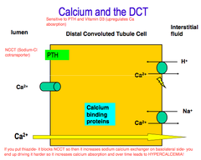
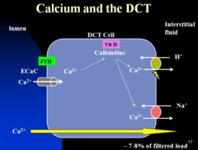

- Calcium can be reabsorbed independently from sodium

Hydrogen and potassium:
- Not as much as an effect on these 2 things as the collecting tubules have (ie much more H exretion, HCO3 reabsorption and K excretion occurs in the collecting tubules)

CONNECTING SEGMENT:
- Lies between the distal tubule and cortical collecting tubule
- Impermeable to water even in the presence of ADH
- Responsive to PTH and calcitriol
- Partially reabsorbs sodium by Na-Cl cotransporter that is thiazide sensitive
- Responsive to aldosterone

CORTICAL COLLECTING TUBULE:
- 2 cell types
  - Principle cells
    - 65%
    - Transport NaCl
  - Intercalated cells
    - H⁺ and HCO3⁻ handling
- Cortical and medullar collecting tubules reabsorb 5-7% of filtered Na+
  - This area mainly responds to alterations in dietary Na+ intake

Principle cells:

Sodium and potassium:
- Play a role in net Na reabsorption
  - Depends on generation of a lumen negative potential via the Na-K-ATPase and subsequent leakage of K+ back out of the cell - (electrogenic movement of Na)
    - Electrogenic Na movement
    - Passive Cl movement
    - K secretion via aldosterone sensitive channels
  - Na moves thru the apical membrane via an Na Channel
    - These channels can lower urine Na to 5meq/L if needed in volume depleted states
- ****Main site for K excretion****
  - K secretion via aldosterone sensitive channels, as occurs with electro genic sodium reabsorption (due to generation of a lumen negatibe potential as Na moves into the cells)
  - Transport of Na out of the cell via the Na-K-ATPase moves K+ into the cell, therefor permitting an intracellular pool for continued K+ secretion out of the cell, which is the primary determinant of urinary [K+]
- Aldosterone plays a role in these transport processes:
  - Increases numbers of open Na channels in the apical membrane
    - Diuretic amiloride may block these channles
  - Later increase in Na-K-ATPase activity and open luminal K+ channels

- Natriuretic peptides reduce the number of these apical membrane Na+ Channels

Water:
- Water permeability is low in the basal state (in contrast to the PT)
- Permeability increases in response to ADH
  - Insertion of aquaporins (Aquaporin-2)
    - Remember aquaporin 1 is in PT
- ADH increases permeability, thus the dilute tubular fluid equilibrates with the isosomotic cortical interstitium
  - Water moves out of the tubular fluid
  - This helps with urine concentration as it allows a LOWER volume of fluid to reach the hyperosmotic medulla (which the fluid will equikibrate with the interstitium here and concentrate the urine; this lower volume helps reduce/prevent medullary wahsout)
- ADH also stimulates K+ secretion
  - Via insertion of more K+ channels in the apical membrane

Intercalated cells:

Hydrogen and Bicarbonate:
- Na+ - independent regulation of acid base balance

TYPE A INTERCALATED CELLS
- Net effect is H+ loss in the urine and increase in plasma HCO3
  - This process is stimulated by acidemia

- Aldosterone stimulates activity of the H+-ATPase
    - Hyperaldosteronism excessive urinary H+ loss and metabolic alkalosis
    - Vice versa with hypoaldosteronism

- In a metabolic alkalosis:
  - Kidney will secrete HCO3 into the urine
  - This is done by the TYPE B INTERCALATED CELLS that have a reversal in the polarity of the transporters (relative to type A)

- Distal RTA:
  - Mutations in H-ATPase
  - Disorder of diminished acid secretion

TYPE B intercalated cell diagram
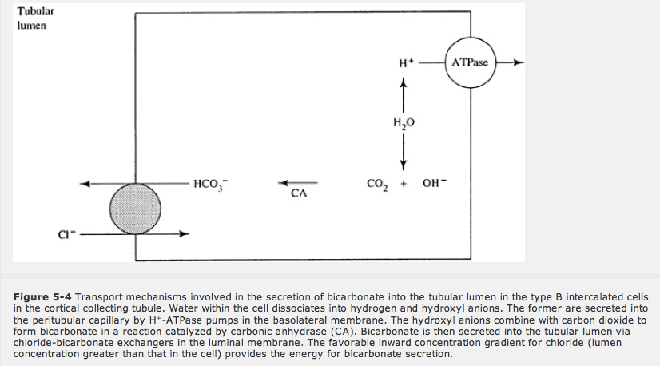

Potassium:
- Cortical collecting tubule normally secretes K+
- Can reabsorb K+ in the presence of K depletion
- Mediated by type A and B intercalated cells:
  - Via H+-K+-ATPase in the apical membrane that reabsorbs K+ and secretes H+
    - Activity of this transporter is increased with hypokalemia
    - This transporter also contributes to the increased in H+ secretion in the presence of a metabolic acidosis
  - With the type B intercalated cell
    - K+ reabsorption is linked to Cl reabsorption via the Cl-HCO3 exchanger
Water:
- Intercalated cells are relatively impermeable to water in the basal state
- Minimally responsive to ADH
  - ADH mainly affects the adjacent principal cells

MEDULLARY COLLECTING TUBULE:
- Division between outer and inner medullary collecting tubule:
  - The level at which the thick ascending limb of the loop of henle begins

Outer medulla:
- Hydrogen:
  - Majority of cells are comparable to the intercalated cells
    - Involved in active H secretion by H+-ATPase and H+-K+-ATPase in the apical membrane
    - Activity here is much greater than that of the cortex
    - Stimulated by aldosterone and acidemia
    - **** this segment plays an important role in acidifying the urine and in the excretion of ammonium***
      - Ammonium excretion is the main way the kidneys get rid of dietary acid load

- Potassium:
  - Can reabsorb K+ here
  - Similar to how the cortical intercalated cells do it

- Water:
  - The major function of the outer medullar collecting tubule is urinary concentration
  - Impermeable to water at a basal state
  - Very responsive to ADH
  - Outer medulla is impermeable to urea

Inner medulla:

- Sodium:
  - Occurs mainly through a cation channel
  - Lumen negative potential drives the passive reabsorption of Cl- via the paracelluar route (just like the cortical collecting tubule)
  - Aldosterone has an effect
  - Movement is electogenic (and not due to concentration gradients as the lumen here may have a lower Na concentration than the cell interior; ie can be as low as 5meq/L in the lumen here)
  - Na reabsorption falls with volume expansion
    - Less aldosterone
    - Natriuretic peptide release
      - Activates guyanyl cyclase increased cGMP
        - cGMP diminishes the number of open Na channels in the luminal membrane
- Water:
  - Responsive to ADH
    - Allows equilibration with hyperosmotic interstitium
  - High basal urea permeability
    - Specific urea transporters in the basolateral (and to a lesser degree apical) membrane
    - Net urease permeability is increased 4 fold in response to ADH
    - These characteristics allow urea to accumulate in the medullary interstitium where it accounts for ½ of the interstitial solute and therefore limits urinary water loss by contributing to the excretion of maximally concentrated urine

- Potassium:
  - Can reabsorb or secrete K+ here
  - Can drop urine K to as low as 5-15meq/L

- Hydrogen:
  - Can secret H+ in response to aldosterone and acidemia

