Rose and Post
- Label the following diagram

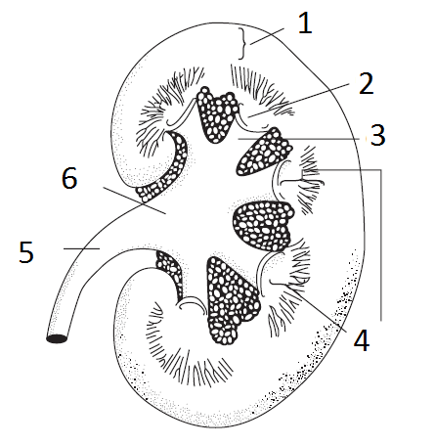
- The ____________________ of the afferent arteriole and the __________________ compose the juxtaglomerular apparatus, which plays a central role in ____________secretion
- The ___________________ reabsorb sodium and chloride and secrete potassium, in part under the influence of aldosterone; and the _____________________ secrete hydrogen or bicarbonate and reabsorb potassium, but play no role in sodium balance
- Label the diagram
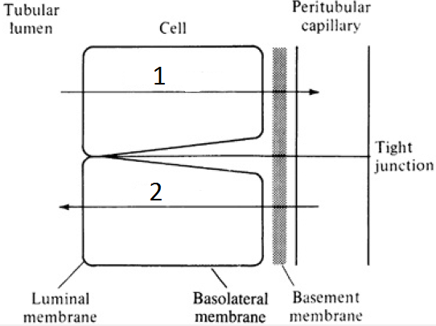

- The luminal membrane is also known as the ______________membrane
- The glomerular basement membrane is both __________ and ___________________ selective with regards to filtration.
- Where is prorenin synthesized
  - Macula Densa
  - Juxtaglomerular cells
  - Adrenal glands
  - Vascular endothelium
- Increase, decrease or no change?

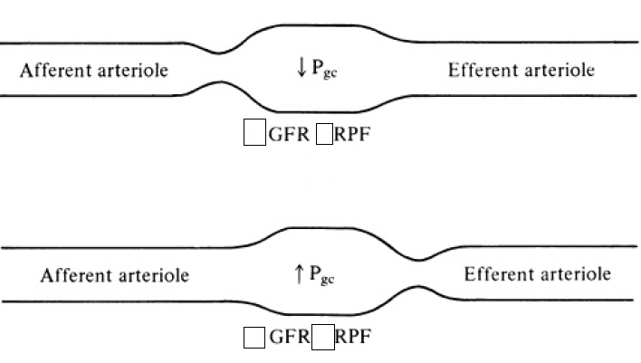

- Label the following diagram

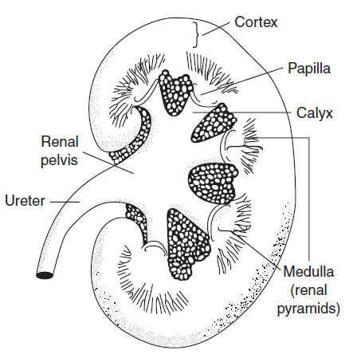

- The juxtaglomerular cells of the afferent arteriole and the macula densa compose the juxtaglomerular apparatus, which plays a central role in renin secretion
- The principal cells reabsorb sodium and chloride and secrete potassium, in part under the influence of aldosterone; and the intercalated cells secrete hydrogen or bicarbonate and reabsorb potassium, but play no role in sodium balance
- Label the diagram

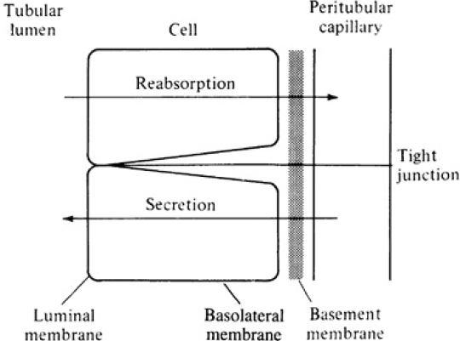
- The luminal membrane is also known as the apical membrane
- The glomerular basement membrane is both size and charge selective with regards to filtration.
- Where is prorenin synthesized
  - Macula Densa
  - Juxtaglomerular cells
  - Adrenal glands
  - Vascular endothelium
- Increase, decrease or no change?
