Rose and Post CH 8 Madden

Questions with answers:

1. Define effective circulating volume.
Answer:
The effective circulating volume refers to that part of the extracellular fluid (ECF) that is in the arterial system and is effectively perfusing the tissues
- A better physiological definition is the pressure perfusing the arterial baroreceptors in the carotid sinus and glomerular afferent arterioles, since it is changes in pressure (or stretch) rather than volume or flow that is generally sensed at these sites.

2. Although the loop of Henle and the distal tubule make an important overall contribution to net Na+ handling, transport in these segments primarily varies with the amount of Na+ delivered (meaning reabsorption is flow-dependent). T or F?
Answer: True

3. The neurohumoral regulation of Na+ reabsorption according to body needs occurs primarily in the proximal and collecting tubules. T or F?
Answer: True

4. SIADH (SIAD) is characterized by water retention, which leads to both hyponatremia and volume expansion. As a result, this disorder is initially associated with enhanced Na+ excretion. T or F?
Answer: True

Regulation of effective circulating volume:

- The effective circulating volume refers to that part of the extracellular fluid (ECF) that is in the arterial system and is effectively perfusing the tissues
- A better physiological definition is the pressure perfusing the arterial baroreceptors in the carotid sinus and glomerular afferent arterioles, since it is changes in pressure (or stretch) rather than volume or flow that is generally sensed at these sites.
- In congestive heart failure, for example, the effective circulating volume is reduced because a primary decrease in cardiac output lowers the pressure at the baroreceptors. As will be discussed below, this decline in pressure and flow induces compensatory fluid retention by the kidney, leading to expansion of the extracellular fluid. The net result is effective volume depletion in association with increases in both the plasma and total ECF volumes.
- Hemodynamic changes with advanced cirrhosis and ascites:
  - In this disorder, the ECF volume is expanded because of the ascites; the plasma volume is increased, in part as a result of fluid accumulation in the markedly dilated but slowly circulating splanchnic venous circulation; and the cardiac output is often elevated
  - Despite all of these signs suggesting volume expansion, most of the excess fluid is hemodynamically ineffective, and these patients behave as if they were volume-depleted as a result of marked peripheral vasodilatation.
- This is exemplified by reductions in systemic vascular resistance and blood pressure, a very low rate of urinary Na+ excretion (often below 10 meq/day), a reduction in the blood volume in the cardiopulmonary circulation, and a progressive increase in the secretion of the hormones typically released in response to hypovolemia: renin, norepinephrine, and antidiuretic hormone (ADH)

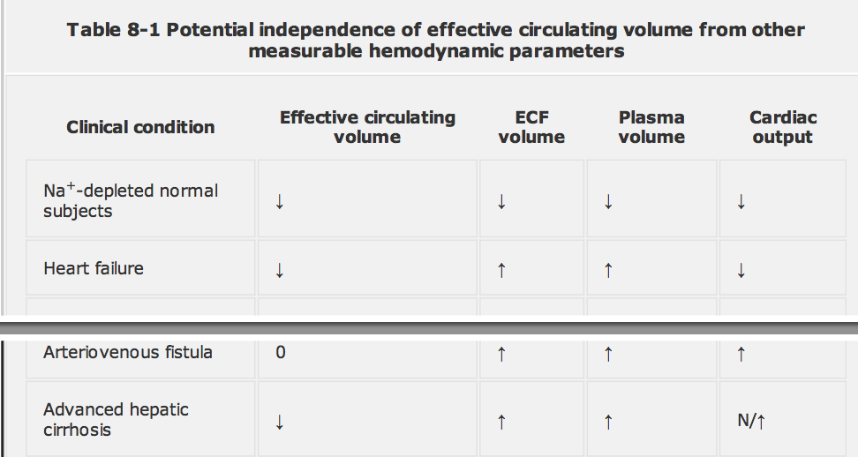

EFFECTIVE CIRCULATING VOLUME, RENAL SODIUM EXCRETION, AND THE STEADY STATE
- The kidney is the primary regulator of Na+ and volume balance, as urinary Na+ excretion responds in an appropriate manner to changes in the effective circulating volume
  - When there is an increase in volume, as after a Na+ load, Na+ excretion rises in an attempt to lower the volume toward normal
  - Conversely, the kidney retains Na+ in the presence of effective volume depletion.

Regulation of effective circulating volume:

Volume receptors:
- Carotid sinuses
- Aortic arch
- Afferent glomerular arterioles in the kidney

- Stretch is sensed in these locations
  - This allows effective volume control, since pressure and volume are usually directly related

- Volume receptors - Afferent glomerular arterioles in the kidney
  - Stretch receptors in the juxtaglomerular apparatus
  - To a lesser degree the macula densa
  - These receptors affect volume balance by influencing the activity of
    - Renin-angiotensin-aldosterone system
    - Endothelin
    - Nitric oxide

- Volume receptors - extrarenal receptors (such as those in the atria and the carotid sinus)
  - Primarily govern the activity of the sympathetic nervous system and ANP

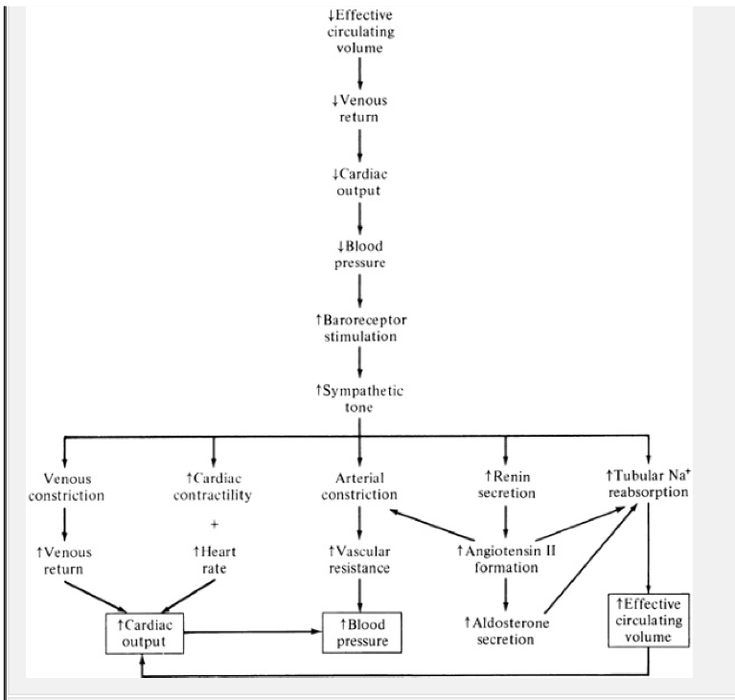

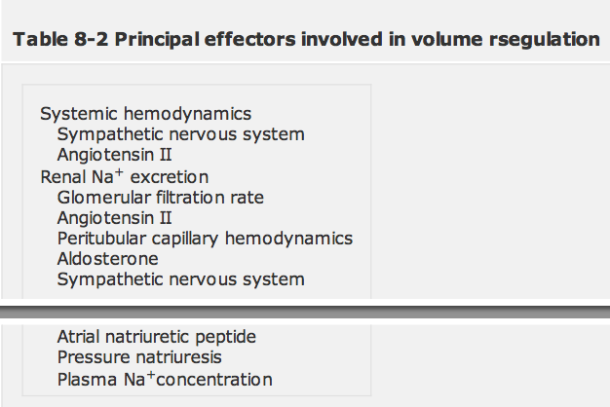

Mean arterial pressure = cardiac output × systemic vascular resistance
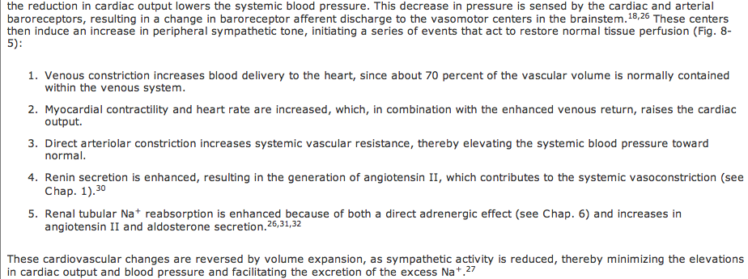

ATII:
- It raises the blood pressure by arterial vasoconstriction, both directly and by enhancing the release and effect of norepinephrine, and it induces renal Na+ retention, both directly and by increasing the secretion of aldosterone
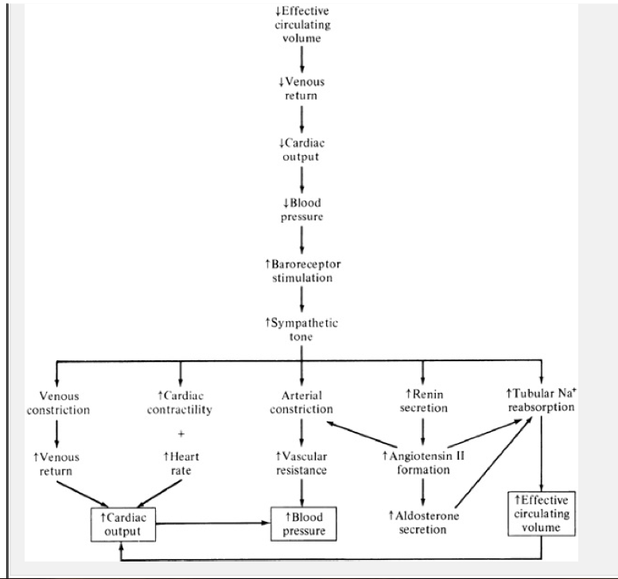

- Renal Na+ excretion varies directly with the effective circulating volume. When the effective volume is expanded, the urine Na+ concentration can exceed 100 meq/L. In contrast, the urine can be rendered virtually
- Na+-free (urine Na+ concentration as low as 1 meq/L) in the presence of volume depletion and normal renal function
- These homeostatic changes in Na+ excretion can result from alterations both in the filtered load, determined primarily by the glomerular filtration rate (GFR), and in tubular reabsorption, which is affected by multiple factors.

Tubular reabsorption:
- Although the loop of Henle and the distal tubule make an important overall contribution to net Na+ handling, transport in these segments primarily varies with the amount of Na+ delivered, i.e., reabsorption is flow-dependent
- In comparison, the neurohumoral regulation of Na+ reabsorption according to body needs occurs primarily in the proximal and collecting tubules
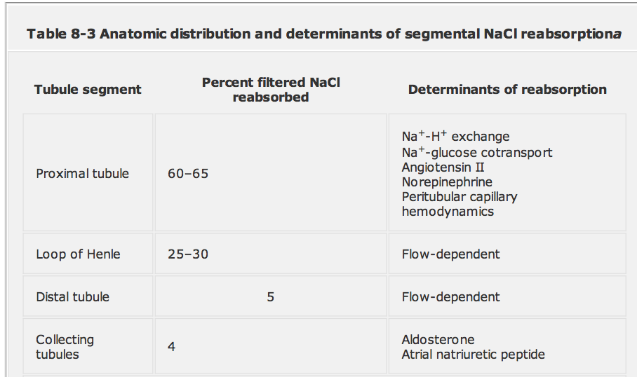

Pressure natriureisis:
- In normal subjects, a small elevation in blood pressure results in a relatively large increase in the urinary excretion of Na+ and water
- This pressure natriuresis phenomenon does not require neurally or humorally mediated sensor mechanisms, since changes in volume directly affect the cardiac output and therefore the systemic blood pressure

SIADH:
- Is characterized by water retention, which leads to both hyponatremia and volume expansion. As a result, this disorder is initially associated with enhanced Na+ excretion.

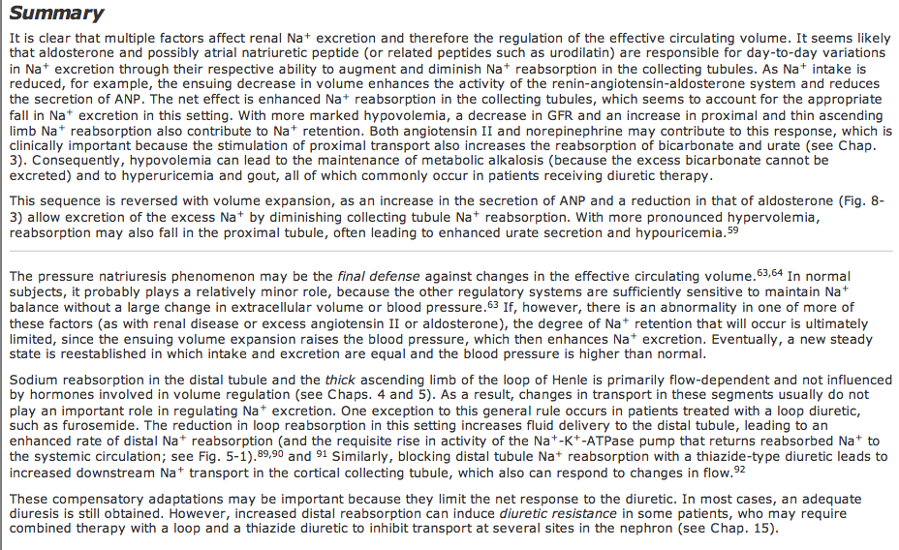

Volume regulation vs Osmoregulation:
- The plasma osmolality is determined by the ratio of solutes (primarily Na+ and K+ salts) and water, whereas the extracellular volume is determined by the absolute amounts of Na+ and water that are present

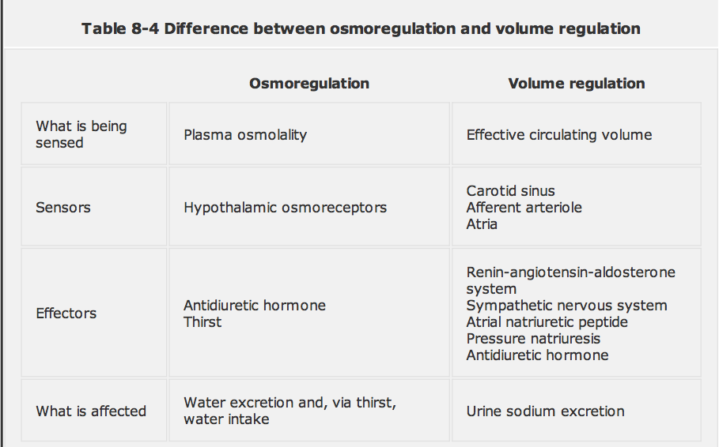

- Notice that osmoregulation is achieved by alterations in water balance; Na+ handling is not directly affected unless there are concurrent changes in volume.
- Volume regulation, on the other hand, attempts to maintain tissue perfusion. Different sensors and effectors are involved in this process, as it is urinary Na+ excretion, not osmolality, that is primarily modified. The only major area of overlap involves the hypovolemic stimulus to ADH release; the ensuing water retention will then help to restore normovolemia.

