Rose and Post CH 6 – Madden

Questions:

1. What is the net effect of IP3? How does it do this? Is this action short or sustained?

2. What is the effect of DAG? Is this action short or sustained?

3. ADH is synthesized in the _______________and _________________nuclei in the ___________________. It is released from the _______________________.

4. Name the 2 major receptors for ADH. List their primary actions.

5. List the functions of ADH.

6. List the stimuli for ADH release:

7. Where is the primary site of aldosterone action?

Questions with answers:

1. What is the net effect of IP3? How does it do this? Is this action short or sustained?
Answer:
- Elevation of cytosolic calcium concentration this calcium binds to calmodulin and causes phosphorylation
  - Causes release of intracellular calcium stores from the ER
  - Increases extracellular calcium uptake
  - SHORT DURATION

2. What is the effect of DAG? Is this action short or sustained?
Answer:
- Activates protein kinase C
- Sustained affects on cell activity

3. ADH is synthesized in the _______________and _________________nuclei in the ___________________. It is released from the _______________________.
Answer: supraoptic, paraventricular, hypothalamus, posterior pituitary.

4. Name the 2 major receptors for ADH. List their primary actions.
Answer:
2 major receptors:
  - V1
    - Vasoconstriction
    - Enhance prostaglandin release
  - V2
    - Mediate anti-diuretic response

- A third receptor, the V3 or V1b receptor, appears to mediate the effect of ADH on the pituitary, facilitating the release of ACTH.
5. List the functions of ADH.
Answer:
- Augment the water permeability of the luminal membranes of the cortical and medullary collecting tubules
- Na+ reabsorbtion and K+ secretion
- Increase vascular resistance via activation of V1 receptors
- Stimulates the production of prostaglandins Particularly prostaglandin E2 and prostacyclin
- ACTH release
- Release of vWF and VIII via V2 receptors

6. List the stimuli for ADH release:
Answer:
  - Hyperosmolality
  - Reduced effective circulating volume

7. What is the primary site of aldosterone action?
Answer:
- Acts mainly in the distal nephron connecting segment and collecting tubules

Summary:

Effects of hormones on renal function:

Hormones synthesized in the kidney:
- Calcitriol
- Kinins
- Prostagalndins
- Erythropoietin

Mechanism of hormone action:
- Most hormones have their affect by activating specific cellular proteins via phosphorylation or synthesis of new proteins
  - This is done by affecting adenyl cylcase, guanyl cyclase, phosphatidyl inositol
  - Or in the case of steroids affect RNA transcription

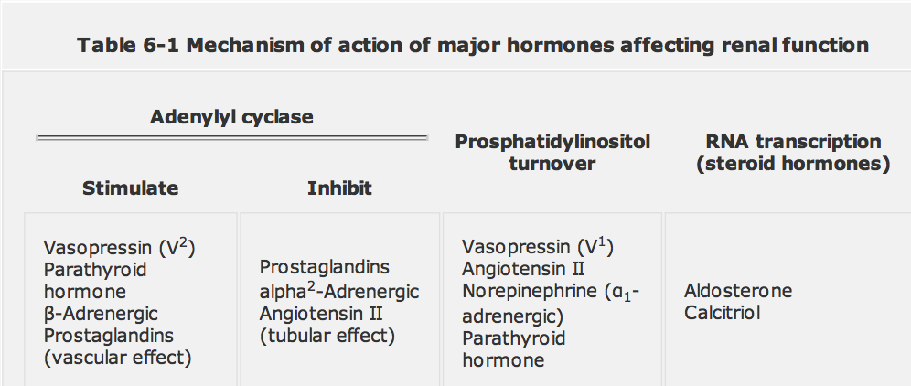

Adenyl cyclase:
- Hormone binds to receptor on cell
- Hormone-receptor complex then affects activation of guanine nucleotide regulatory protein (G protein)
  - G_{s}
  - G_{i}

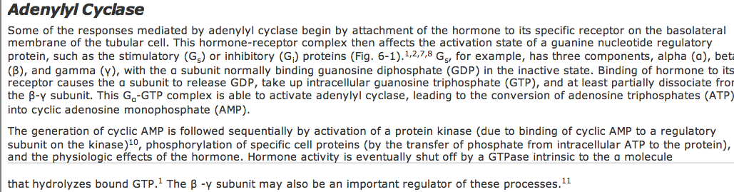

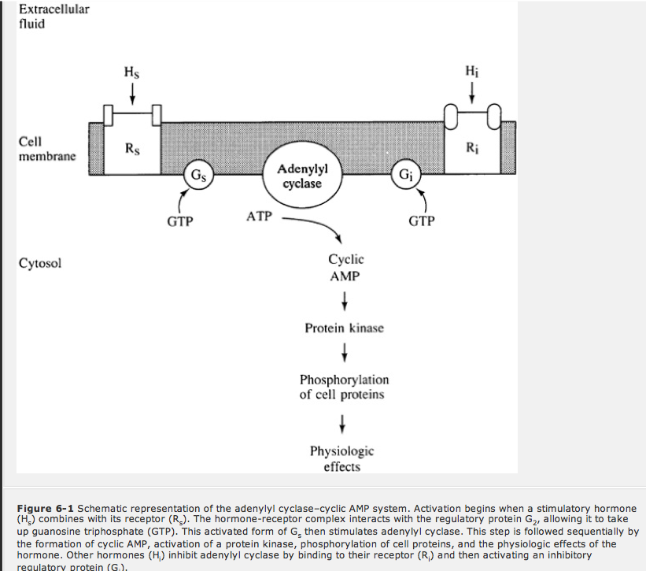
- On the other hand, activation of Gi results in diminished adenylyl cyclase activity and a reduction in cellular cyclic AMP levels.
- Like Gx, Gi also dissociates into α, β, and γ subunits.
Guanlyl cyclase:
- Similar pathway
- formation of cyclic GMP
  - leads to phosphorylation of specific cell proteins
- Mediates the actions of:
  - ANP
  - Nitroprusside
  - Nitroglycerine
- This receptor has intrinsic cyclase catalytic domain (therefore no Gs or Gi)
- ANP:
  - Stimulates the formation of cGMP
  - Leads to closing of Na+ channels in the luminal membrane of the inner medullary collecting duct

PIP turnover:
- Turnover of membrane lipids
- Hormone (ATII, Norepi)binds to receptor activation of a G protein stimulate membrane bound phospholipase C this promotes breakdown of a membrane lipid (phosphatidylinositol) into 2 compounds IP3 and DAG
  - IP3
    - Acute effects of the hormone
    - Causes release of intracellular calcium stores from the ER
    - Increases extracellular calcium uptake
    - *** net effect is elevation of cytosolic calcium concentration***
      - This calcium binds to calmodulin leading to phosphorylation of specific cell proteins and the physiologic effects of the hormone
    - The calcium effects are SHORT LIVED
  - DAG
    - Sustained effects of the hormone
    - *** activates protein kinase C ****
      - this compound causes the desired changes in cell activity
    - Note: arachidonic acid is attached to DAG and may be released from it in response to PLA2 (PLA2 is hormonally activated)
      - This may explain how ADH release increases local prostaglandin production, and in part how prostaglandins affect ADH
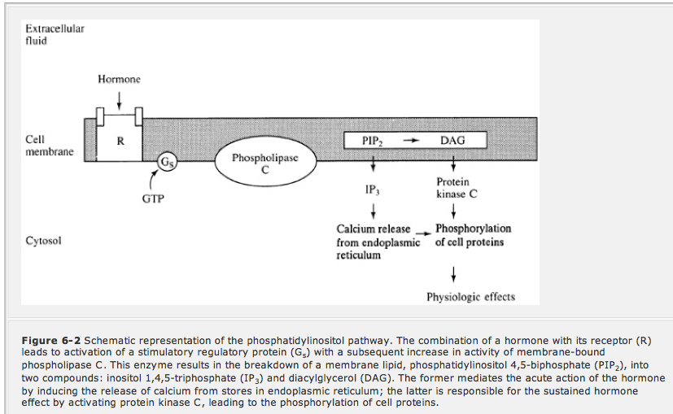

RNA Transcription:
- Steroid hormones:
  - Aldosterone
  - Calcitriol
  - Cortisol
- ALL RESULT IN NEW PROTEIN SYNTHESIS
- Hormones are lipid soluble diffuse across cell membranes bind to cytosolic receptors
  - Hormone-receptor attachment unmasking of DNA binding site on receptor
  - Hormone receptor complex migrates to the nucleus and bind to specific sites near genes that are responsible for the physiologic effects of that hormone
  - Subsequent steps include mRNA and rRNA transcription and the synthesis of new proteins
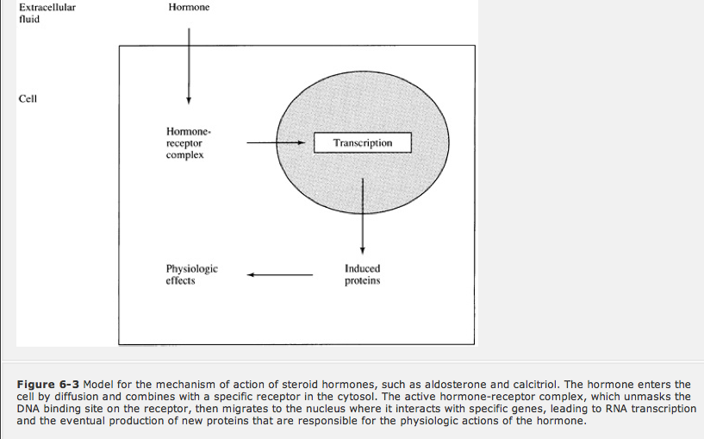

ADH and WATER balance:
- Human form called arginine vasopressin
- Synthesized in the supraoptic and paraventricular nucleus in the hypothalamus
- Secretory granules containing ADH migrate down the axons of the supraopticohypophyseal tract into the posterior lobe of the pituitary, where they are stored and subsequently released after appropriate stimuli
  - Note: Some of the secretory granules produced in the paraventricular nuclei enter the cerebrospinal fluid or the portal capillaries in the median eminence
    - Median eminence ADH probably accounts for the observation that lesions of the posterior pituitary or supraopticohypophyseal tract below the median eminence do not usually lead to permanent diabetes insipidus, since ADH produced in the hypothalamus still has access to the systemic circulation
- Metabolized rapidly by the liver and kidney
  - T ½ in circulation is 15-20min
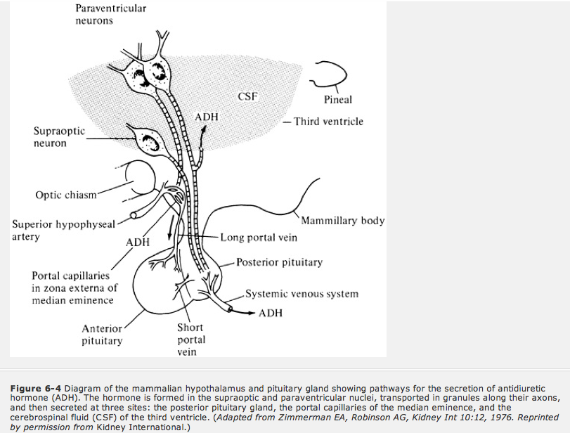

Actions of ADH:
List the functions of ADH.
- Augment the water permeability of the luminal membranes of the cortical and medullary collecting tubules
- Na+ reabsorbtion and K+ secretion
- Increase vascular resistance via activation of V1 receptors
- Stimulates the production of prostaglandins Particularly prostaglandin E2 and prostacyclin
- ACTH release
- Release of vWF and VIII via V2 receptors

1. Augment the water permeability of the luminal membranes of the cortical and medullary collecting tubules, thereby promoting water reabsorption via osmotic equilibration with the hypertonic interstitium
  - Primarily occurs in the principal cells
- 2 major receptors:
  - V1
    - Vasoconstriction
    - Enhance prostaglandin release
  - V2
    - Mediate anti-diuretic response

- Activation of adenylyl cyclase by ADH via the V2 receptor initiates a sequence of events in which a protein kinase is activated, leading to preformed cytoplasmic vesicles that contain unique water channels
- The principal ADH-sensitive water channel, called aquaporin-2, is normally stored in the cytosol; and under the influence of ADH, it moves to and fuses with the luminal membrane, thereby allowing water to be reabsorbed down the favorable osmotic gradient.

- A third receptor, the V3 or V1b receptor, appears to mediate the effect of ADH on the pituitary, facilitating the release of ACTH.
2. Reabsorption of Na+ and excretion of K+
- The rate of distal urinary flow is normally an important determinant of the rate of K+ secretion and subsequent excretion
- The stimulation of K+ secretion allows ADH to regulate water transport without interfering with that of K+

3. Vascular resistance
- Increase vascular resistance via activation of V1 receptors
  - Via PIP turnover
  - Really gets ramped up during states of volume depletion; general basal effect is pretty low (as BP is generally maintained by RAAS and the sympathetic NS)

4. Stimulates the production of prostaglandins
- Particularly prostaglandin E2 and prostacyclin
- Occurs in a variety of cells within the kidney, including those in the thick ascending limb, collecting tubules, medullary interstitium, and glomerular mesangium
- The prostaglandins that are produced then impair both the antidiuretic and vascular actions of ADH
  - Reduction in ADH generation of cAMP
  - These findings have suggested that a short negative feedback loop may be present in which ADH enhances local prostaglandin production, thereby preventing an excessive antidiuretic response.
    - It is of interest, however, that the effect of ADH on prostaglandin synthesis is mediated by the V1, not the antidiuretic V2, receptors.
    - Activation of the V1 receptors promotes phosphatidylinositol turnover, leading to the formation of diacylglycerol, from which arachidonic acid, the precursor of the prostaglandins, can be releasedvia activation of phospholipase A2
- The major function of the ADH-prostaglandin relationship may involve the regulation of renal hemodynamics. ADH, acting via the V1 receptors, is a systemic and renal vasoconstrictor. The local production of prostaglandins by the kidney (particularly the glomeruli) minimizes the increase in renal vascular resistance, thereby maintaining renal perfusion.
5. Affects on ACTH release
- ADH is cosecreted with corticotropin releasing hormone (CRH) from single neurons in the paraventricular nuclei and promotes the secretion of ACTH by corticotropes in the pituitary via activation of V3 receptors.
  - Cortisol has an inhibitory effect on the secretion of both CRH and ADH from the paraventricular nuclei.
  - Adrenal insufficiency removes this inhibitory effect, leading to a persistent rise in ADH release.
  - The associated impairment in water excretion can result in water retention and hyponatremia, a common electrolyte disorder in patients with cortisol deficiency
6. Release of vWF and VIII
- ADH, acting through the V2 receptors, also can stimulate the release of factor VIII and von Willebrand factor from vascular endothelium.

CONTROL OF ADH SECRETION:
- Major stimuli for ADH release:
  - Hyperosmolality
  - Reduced effective circulating volume
- In general, the plasma sodium concentration is the primary osmotic determinant of ADH release, since Na+ salts are the major effective extracellular solutes
- Glucose may cause ADH release in uncontrolled diabetes (as it acts as an effective osmole)
- Osmoreceptors
  - Located in the hypothalamus
  - These cells are permeable to water (via water channels) and change in cell size (as the cell tries to equilibrate with plasma based on osmolality [ie. down the concentration gradient that exists between the plasma and cell]) results in stimulation or inhibition of ADH release

- The osmotic threshold for thirst has been reported to be either 2 to 5 mosmol/kg higher than or roughly equivalent to that for ADH release

- Non-osmotic ADH release:
  - In response to decreased effective circulating volume
  - Parasympathetic afferents in the carotid sinus baroreceptors are of primary importance
  - Changes in the rate of afferent discharge from these neurons affect the activity of the vasomotor center in the medulla and subsequently the rate of ADH secretion by the cells in the paraventricular nuclei
- Other:
  - Nausea (humans)
  - Stress (humans)
  - Pregnancy (humans)
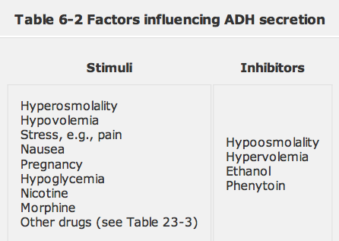

ALDOSTERONE:
- Aldosterone in the zona glomerulosa, and glucocorticoids (particularly cortisol), androgens, and estrogens in the zona fasciculata and reticularis.
- 17α-hydroxylase, the enzyme necessary for cortisol and androgen synthesis. More importantly, the final steps in the conversion of corticosterone to aldosterone, the addition of an hydroxyl group at the 18-carbon position and its subsequent oxidation to an aldehyde, occur only in the zona glomerulosa
  - These two reactions are mediated by a single multifunctional cytochrome P450 enzyme called aldosterone synthase
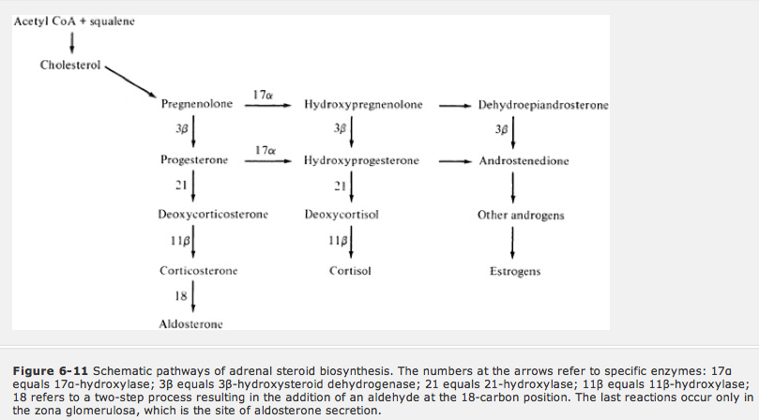

Actions of aldosterone:
- Acts mainly in the distal nephron connecting segment and collecting tubules (mainly on principal cells)
  - Reabsorption of Na+ and Cl-
  - excretion of K+ and H+

- Diffuses into tubular cytosol then binds with a receptor moves to the nucleus binds to nuclear chromatin enhances mRNA and rRNA new protein synthesis

Reabsorption of Na+ and Cl-

- Aldosterone stimulates ionic transport in these cells by increasing the number of open Na+ and K+ channels in the luminal membrane as well as the activity of the Na+-K+-ATPase pump in the basolateral membrane
  - The aldosterone-induced elevation in luminal Na+ permeability promotes Na+ diffusion into the tubular cell; this Na+ is then returned to the systemic circulation by the Na+-K+-ATPase pump.
  - The movement of Na+ through its channel is electrogenic in that it creates a lumen-negative potential difference.
  - Electroneutrality is maintained in this setting either by passive Cl- reabsorption via the paracellular pathway or by K+ secretion from the cell into the lumen.
  - Na+ reabsorption also enhances K+ secretion by a second mechanism: The transport of reabsorbed Na+ out of the cell by the Na+-K+-ATPase pump increases K+ entry across the basolateral membrane. The ensuing rise in cell K+ concentration permits continued K+ secretion, which is the primary determinant of urinary K+ excretion

Excretion of K+ and H+
- Intercalated cells
- Their main function in normal conditions is H+ secretion via H+-ATPase pumps in the apical membrane; they do not contribute to net Na+ reabsorption
- Aldosterone also indirectly stimulates H+ secretion in the cortex via its effect on Na+ reabsorption in the principal cells. The associated generation of a lumen-negative potential creates a favorable electrical gradient for H+ accumulation in the lumen
  - These effects of aldosterone are probably permissive, since there is little evidence that acid-base balance directly influences aldosterone release

Other:
- Aldosterone reduces the concentration of Na+ and raises that of K+ in colonic and salivary secretions and in sweat

CONTROL OF ADLOSTERONE SECRETION:

- Major stimuli of aldosterone secretion:
  - ATII
  - Hyperkalemia (or elevations in plasma K+)
    - Direct effect on the glomerulosa

- Other stimuli:
  - ACTH
  - Hyponatremia

- Angiotensin II and hyperkalemia act on the zona glomerulosa, promoting the conversion of cholesterol to pregnenolone and, more importantly, of corticosterone to aldosterone via stimulation of aldosterone synthase

- Aldosterone secretion is suppressed by ANP

RAAS:
- Remember ATII primarily works in the proximal tubule
- Remember aldosterone work in the cortical and papillary collecting tubules

ACTH:
- Released from the ANTERIOR PITUITARY
- Enhances glucocorticoid and androgen synthesis
- Causes a transient rise in aldosterone

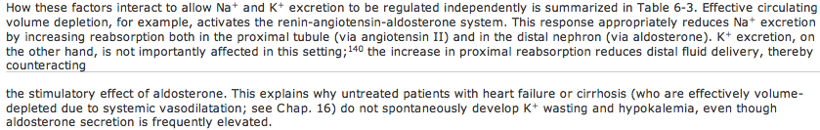
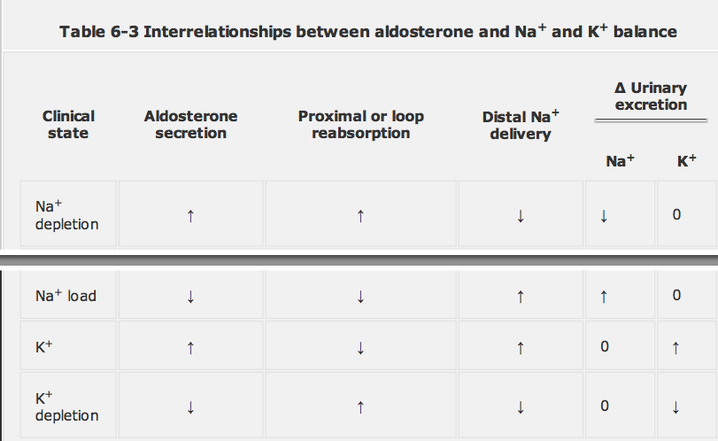

- K+ secretion is highly dependent upon the rate of sodium and water delivery to the cortical collecting tubule
- K+ balance can influence Na+ reabsorption in the thick ascending limb of the loop of Henle (and perhaps the proximal tubule)

ANP:
- Released from myocardial cells in the atria and in some cases the ventricles,
- Most of the physiologic actions of ANP appear to be mediated by attachment to specific receptors on the cell membrane, with subsequent activation of guanylyl cyclase and the formation of cyclic GMP
- ANP has two major actions:
  - It is a direct vasodilator, lowering the systemic blood pressure
  - Increases urinary Na+ and water excretion.

***** Thus net effects are natriuriesis and decreased blood pressure*******

- ANP directly increases the GFR and reduces Na+ reabsorption; the natriuretic action appears to be primarily due to the inhibition of sodium reabsorption in the medullary collecting tubule.
  - The rise in GRF induced by ANP is associated with little or no change in renal blood flow, suggesting that ANP produces both afferent arteriolar dilation and efferent arteriolar constriction
  - The direct tubular effect appears to be mediated by a cyclic GMP-dependent protein kinase, which closes the Na+ channels through which luminal Na+ normally enters the cell

- May also do the following:
  - Reduce basal renin release
  - Inhibit ATII and K+ induced aldosterone secretion
  - Diminish response to ADH

- ANP is primarily released from the atria in response to volume expansion, which is sensed as an increase in atrial stretch.
- There is also evidence that the carotid and renal baroreceptors contribute to ANP release by sending afferent signals back to the brain

BNP:
- Is a natriuretic hormone that is homologous to ANP.
- It was initially identified in the brain but is also present in the heart, particularly the ventricles.
- The circulating concentration of BNP is less than 20 percent of that of ANP in normal subjects but can equal or exceed that of ANP in patients with congestive heart failure.
- The physiologic role of this hormone remains to be determined.
- The infusion of BNP to normal volunteers suggests that the compound has natriuretic activity similar to that of ANP.
- In addition, it may be responsible for the cerebral salt-wasting syndrome that can accompany severe neurologic injury, as with subarachnoid hemorrhage

PROSTAGLAINDINS:
- derived from the metabolism of arachidonic acid, with the initial step being catalyzed by the cyclooxygenase (COX) enzyme

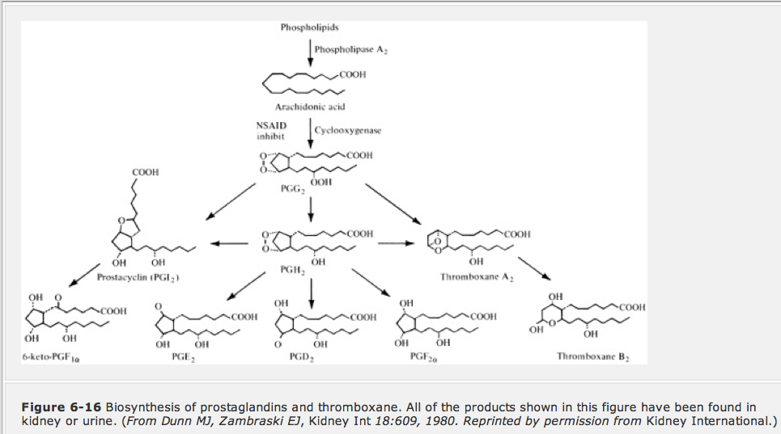

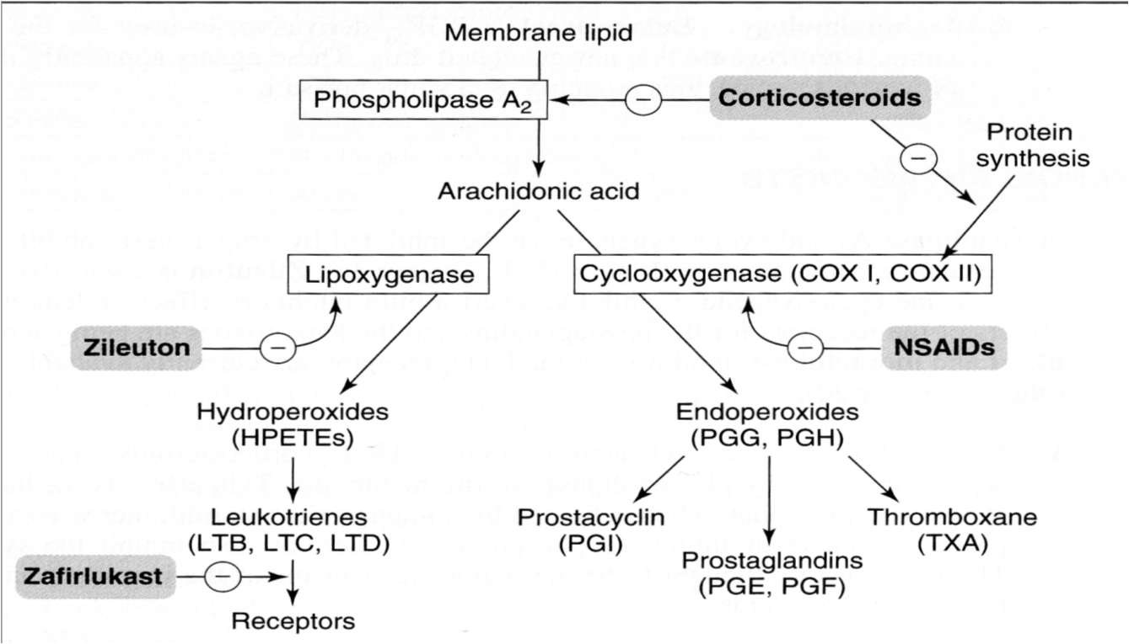

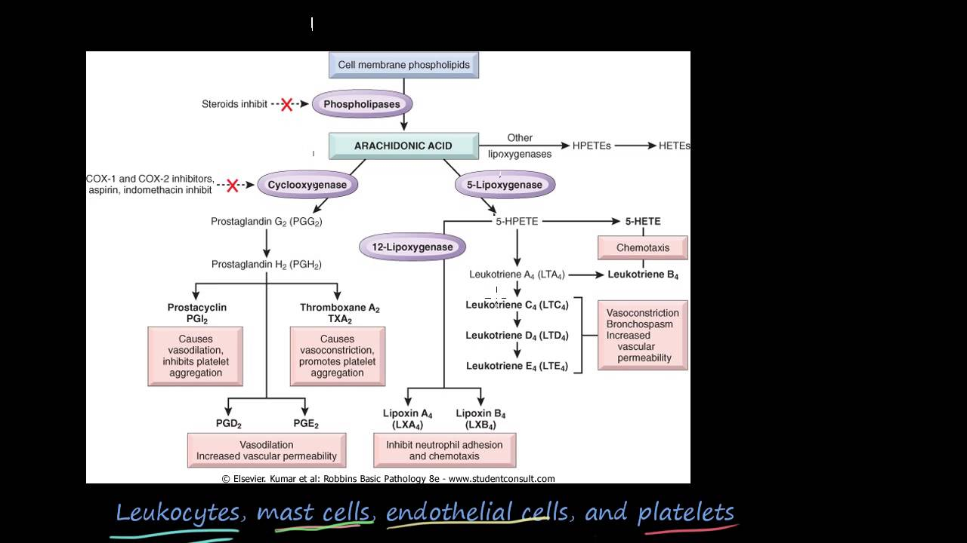

- Produced at a variety of sites within the kidney, including glomerular and vascular endothelium, the medullary and to a lesser degree the cortical collecting tubule cells, and the renomedullary interstitial cells.
- In general:
  - The tubules primarily synthesize PGE2
  - The glomeruli produce both PGE2 and prostacyclin

