Name of  Drug | Class of Drug  Indication | Pharmacology/  Actions | Adverse Effects | Contraindications | Drug Interactions
Atropine | Naturally occurring alkaloid  antimuscarinic agents: is a competitive antagonist of the muscarinic acetylcholine receptors  (types M1, M2, M3, M4 and M5)  Uses: reduce secretions of the respiratory tract, Treatment of bronchoconstrictive disease, bradycardia, sinoatrial arrest, and incomplete AV block, antidote (overdoses of cholinergic agents, organophosphate, carbamate, muscarinic mushroom, blue-green algae intoxication), Hypersialism | In cardiac uses, it works as a nonselective muscarinic acetylcholinergic antagonist, increasing firing of the sinoatrial node (SA) and conduction through the atrioventricular node (AV) of the heart, opposes the actions of the vagus nerve, blocks acetylcholine receptor sites, and decreases bronchial secretions.  Atropine induces cycloplegia by paralyzing the ciliary muscles | increased vasoconstriction, heart rate, coronary blood flow, blood pressure, mild CNS stimulation, and decreased nasal congestion and appetite, increase urethral sphincter tone, panting  OVERDOSE: hyperthermia, mydriasis, tachycardia, hypertension, vomiting, disorientation, and seizures | glaucoma, synechiae, hypersensitivity, myocardial ischemia, GI obstructive disease, paralytic ileus, severe ulcerative colitis, obstructive uropathy, and myasthenia gravis | Amantadine, Other Anticholinergic Agents, Antihistamines, Disopyramide, Meperidine, Phenothiazines, Procainamide, Primidone , Tricyclic Antidepressants, Alpha-2 Agonists, Amitraz, Antacids, Digoxin, Ketoconazole, Metoclopramide
Glycopyrrolate | Antimuscarinic agent: similar to atropine but does not cross BBB. Blocks cholinergic transmission.  Uses: sinus bradycardia, sinoatrial arrest, and incomplete AV block. Reduces salivary, tracheobronchial, and pharyngeal secretions, as well as decreasing the acidity of gastric secretion.  It is also used in conjunction with neostigmine, a neuromuscular blocking reversal agent, to prevent neostigmine's muscarinic effects such as bradycardia. | Like other anticholinergic (antimuscarinic) agents, it inhibits the action of acetylcholine on structures innervated by postganglionic cholinergic nerves and on smooth muscles that respond to acetylcholine but lack cholinergic innervation. | mydriasis, tachycardia, and xerostomia. Similar to atropine except less CNS effects and less arrhythmogenic | narrow angle glaucoma, tachycardias, ileus, urinary obstruction  CAUTION: hepatic or renal disease, geriatric or pediatric patients, hyperthyroidism, hypertension, CHF, tachyarrhythmias, prostatic hypertrophy, or esophageal reflux, GI infections | Amantadine, Other Anticholinergic Agents, Antihistamines, Disopyramide, Meperidine, Phenothiazines, Procainamide, Primidone , Tricyclic Antidepressants, Alpha-2 Agonists, Amitraz, Antacids, Digoxin, Ketoconazole, Metoclopramide
Furosemide | Loop diuretic: inhibits Na-K-2Cl symporter in the thick ascending limb of the loop of Henle  Uses: congestive heart failure, edema, hypertension, diuresis, treatment of hypercalcemia, renal impairment, treatment of hyperkalemia | Furosemide is active from inside the tubular lumen. The degree of diuresis is determined by the amount of furosemide that reaches the renal tubular lumen, not the plasma concentration.  Inhibition of this co-transporter results in increased renal excretion of water, sodium, chloride, potassium, calcium, magnesium, ammonium, hydro- gen ion, and possibly phosphate.  Because of the large NaCl absorptive capacity of the loop of Henle, diuresis is not limited by development of acidosis, as it is with the carbonic anhydrase inhibitors.  By inhibiting the transporter, the loop diuretics reduce the reabsorption of NaCl and also diminish the lumen-positive potential that derives from K⁺ recycling. This electrical potential normally drives divalent cation reabsorption in the loop, and by reducing this potential, loop diuretics cause a decrease in Mg²⁺ and Ca²⁺ reabsorption.  Additionally, furosemide is a noncompetitive subtype-specific blocker of GABA-A receptors.  Pharmacokinetics  * Molecular weight (daltons) 330.7  * % Protein binding 91–99  * % Excreted unchanged in urine 80–90  * Volume of distribution (L/kg) 0.07–0.2 | electrolyte imbalances (especially potassium, calcium, magnesium and sodium), ototoxicity, gastrointestinal disturbances, hematologic effects (anemia, leukopenia), weakness, and restlessness  Hyperglycemia is a reported side effect. | anuria, hypersensitivity, profound dehydration  CAUTION: preexisting electrolyte abnormalities, impaired hepatic function (may precipitate hepatic coma), and diabetes mellitus | ACE Inhibitors, Aminoglycosides, Amphotericin B, Corticosteroids, Digoxin, Insulin, Salicylates (reduces excretion), Theophylline, sucralfate, NSAID

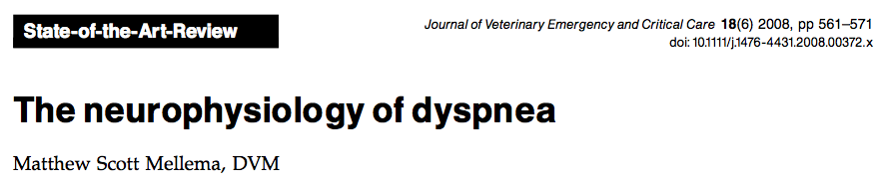

- Studies have shown that aerosolized furosemide protects against bronchoconstriction and inhibits the cough reflex in addition to reducing pulmonary edema when absorbed systemically; this does not explain the efficacy of aerosolized furosemide in patients whose dyspnea is not due to congestive heart failure or asthma.
- In human subjects, it has been found that agents known to enhance the firing of pulmonary slowly adapting receptors (SARs) can alleviate the sensation of dyspnea without altering central respiratory drive.
- Treatment of rats with a nebulized SAR sensitizing agent (furosemide) enhances SAR firing in response to lung inflation.
- Behavioral escape responses to airway occlusion are reduced in lightly anesthetized cats when treated with nebulized furosemide.

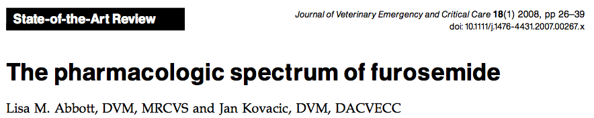
- Furosemide is used primarily for its properties as a loop diuretic; however, it has many other actions that may be clinically applicable.
- Furosemide has a vasodilatory effect that precedes diuresis that may confer its immediate benefit in patients with volume overload.
- Furosemide can be inhaled to relieve dyspnea in patients with bronchospasm.
- Furosemide also shows promise as an adjunct to antiseizure therapy to help control epilepsy, status epilepticus, and acute ischemic damage related to seizures.
- It has activity as an antioxidant, iodine depletive, and may increase thoracic lymph duct flow.
- Reported furosemide side effects include altered drug metabolism, electrolyte depletion, ototoxicity, mucociliary impairment, endocrine and exocrine pancreatic effects, delayed wound healing, sulfonamide toxicity, and thyroid binding interference.

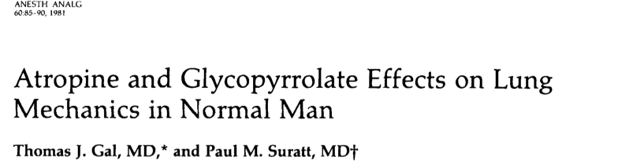
- To assess the comparative bronchomotor effects of large systemic doses of glycopyrrolate and atropine intravenous glycopyrrolate (10 pg/kg), atropine (20 pg/kg), or a placebo was administered to six healthy male volunteers in double-blind fashion.
- Both drugs produced bronchodilation reflected by significant decreases in airway resistance and increases in specific airway conductance (SGAW)compared to placebo.
- Glycopyrrolate increased SGAW to a maximal level of 100% +/- 7% above control; bronchodilation persisted at this level for more than 4 hours after drug administration.
- Atropine increased SGAWto a maximum of 88% +/- 5% above control 30 minutes after administration, but SGAWreturned to control levels between 3 and 4 hours after the drug was given.
- Both drugs increased maximum expiratory flow rates over the same time course.
- Lung elastic recoil was decreased by both drugs over the full range of lung volume.
- The 32% maximum increase in heart rate after glycopyrrolate was significantly less ( p < 0.01) than the 60% increase after atropine.
- It was concluded that vagal blockade with glycopyrrolate dilates large and small airways to the same extent as atropine, but that the effect is more sustained and associated with less cardiac vagal blockade.
- Lower doses of glycopyrrolate were also studied and the findings showed that maximal bronchodilation is achieved with lower doses (3.2 pg/kg), which are commonly used in routine premedication.

Questions:

- What is the mechanism of action of atropine?

- What is the mechanism of action of furosemide?

- What is the mechanism of action of glycopyrrolate?

- What is the proposed mechanism by which nebulized furosemide alleviates the sensation of air hunger?

- According to the abovementioned study evaluating the effects of atropine and gylcopyrrolate on lung mechanics in normal men, it was concluded that vagal blockade with glycopyrrolate dilates large and small airways to the same extent as atropine, but that the effect is more sustained and associated with less cardiac vagal blockade. T or F?

- The degree of diuresis is determined by the amount of furosemide that reaches the renal tubular lumen, not the plasma concentration

Questions with answers:

- What is the mechanism of action of atropine?
Answer: antimuscarinic agents: is a competitive antagonist of the muscarinic acetylcholine receptors (types M1, M2, M3, M4 and M5)

- What is the mechanism of action of furosemide?
Answer: Loop diuretic: inhibits Na-K-2Cl symporter in the thick ascending limb of the loop of Henle

- What is the mechanism of action of glycopyrrolate?
Answer: antimuscarinic agents: is a competitive antagonist of the muscarinic acetylcholine receptors (types M1, M2, M3, M4 and M5)

- What is the proposed mechanism by which nebulized furosemide alleviates the sensation of air hunger?
Answer: enhances the firing of pulmonary slowly adapting receptors (SARs) can alleviate the sensation of dyspnea without altering central respiratory drive.

- According to the abovementioned study evaluating the effects of atropine and gylcopyrrolate on lung mechanics in normal men, it was concluded that vagal blockade with glycopyrrolate dilates large and small airways to the same extent as atropine, but that the effect is more sustained and associated with less cardiac vagal blockade. T or F?
Answer: true

- The degree of diuresis is determined by the amount of furosemide that reaches the renal tubular lumen, not the plasma concentration. T or F?
Answer: True

