Name of Drug | Class of Drug/Indication | Pharmacology/  Actions | Pharmacokinetics | Adverse Effects | Contraindications | Drug Interactions
Doxapram | General CNS/Respiratory Stimulant  Dogs, Cats,Horses: To stimulate respiration during and after GA and/or to speed awakening and reflexes after anesthesia.  To treat resp depression in small animals caused by reactions to radiopaque contrast media or for barbiturate overdosage.  -Useful to offset suppression of GA agents when laryngeal function is being assessed.  Neonates: To stimulate respirations following dystocia or c-section. | General CNS stimulant, all levels of CNS affected.  -Effects of respiratory stimulation are a result of direct stimulation of the medullary respiratory centers and, possibly, through the reflex activation of carotid and aortic chemoreceptors.  -Transient increases in RR and volume occur, but increases in arterial oxygenation usually do not follow.  (Usually increases the work associated with respirations with resultant increased oxygen consumption and CO2 production) | Onset of effect in humans and animals after IV admin within 2 mins.  -The drug is well distributed into tissues.  -In dogs, doxapram is rapidly metabolized and most is excreted as metabolites in urine within 24–48 hrs.  -Small quantities of metabolites may be excreted up to 120 hrs after dosing. | -Hypertension, arrhythmias, seizures, and hyperventilation leading to respiratory alkalosis  (most probable with repeated or high doses)  -Has been shown in experimental animals to increase myocardial oxygen demand and reduce cerebral blood flow. | -Not a substitute for artificial (mechanical) resp support  -Hypersensitivity  -Contraindications from humans: seizures, head trauma, uncompensated HF, severe hypertension, cardiovascular accidents, respiratory failure secondary to NM disorders, airway obstruction, PTE, pneumothorax, acute asthma, dyspnea, or whenever hypoxia is not associated with hypercapnia.  Use with caution: asthma, arrhythmias, tachycardias.  Use with extreme caution: cerebral edema or increased CSF pressure, pheochromocytoma or hyperthyroidism. | -GA: inc epi release  -Halothane: sensitize myocardium to catecholamines  -Muscle relaxants  -Sympathomimetic agents
Name of Drug | Class of Drug/Indication | Pharmacology/  Actions | Pharmacokinetics | Adverse Effects | Contraindications | Drug Interactions
Albuterol | B adrenergic agonist (predominantly B2)  Bronchodilator | Stimulates production of cAMP through activation of adenyl cyclase.  Relaxes bronchial, uterine, GI tract, vascular smooth mm.  At usual doses, minimal B1 activity.  Promotes shift potassium intracellularly via stim Na-K-ATPase, stim of B-receptors in B- cells in pancreas promotes release of insulin, stim of B-receptors in liver promotes gluconeogenesis and glycogenolysis---hyperglycemia | Absorbed rapidly and well after oral admin. Effects occur within 5 minutes after oral inhalation; 30 minutes post PO (tablets). Duration 3-6hrs post inh, 12 hrs post PO.  Metabolized in liver to inactive metabolite. (4’-O-sulfate)  Doesn’t cross BBB; crosses placenta.  Duration of effect generally persists for 3–6 hours after inhalation and up to 12 hours (depending on dosage form) after PO. | *Dose related  -Tachycardia, arrhythmias  -Hypertension  -CNS excitement, tremors  -Hypokalemia  -Hypophosphatemia  -oral thermal injury  -The S-form may potentially increase airway inflammation in cats. As "regular" albuterol is the racemic form (R,S-albuterol) it may also increase airway inflammation and its use in cats should be limited to acute, rescue treatment only and not for chronic treatment | -Individuals who are hypersensitive  -Caution with Diabetes, HyperT4, Hypertension, Seizure disorders, Cardiac Disease  -Late pregnancy (may inhibit uterine contractions) | -B-blockers: antagonize action of albuletol  -Digoxin: albuterol may inc risk of arrythmias  -Inhalation anesthetics: albuterol may predispose to ventricular arrhythmias  -Other sympathomimetic amines: may inc risk of developing other cardiac effects  -Tricyclic antidepressants or MAOIs: may potentiate vascular effects of albuterol
Name of Drug | Class of Drug/Indication | Pharmacology/  Actions | Pharmacokinetics | Adverse Effects | Contraindications | Drug Interactions
Epinephrine | Α and B adrenergic agonist  Anaphylaxis and CPR  -Added to local anesthetics to retard systemic absorption and prolong effect. | -Relaxes bronchial and iris mm.,  -Antagonizes effects of histamine,  -Increases glycogenolysis and gluconeogenesis and raises BG,  -Positive inotrope/  Chronotrope  If given rapidly IV: direct stimulation of the heart (increased heart rate and contractility), and increases systolic blood pressure.  If given slowly IV: produces a modest rise in systolic pressure and a decrease in diastolic blood pressure. Total peripheral resistance is decreased because of beta effects.  -Alpha 1 vasoconstrictive effects decrease edema | -Well-absorbed IM/SQ (SQ 5-10 min, IM sl faster)  -Immed effects IV  -Doesn’t cross BBB  -Crosses placenta, distributed in milk  -Actions ended by uptake and metabolism of drug in sympathetic nerve endings  -Met in liver and other tissues by MAO and catechol-O-methyltransferase (COMT) to inactive  -Very short-acting  -Epinephrine is rapidly metabolized in the GI tract and liver after oral administration and is not effective via this route | -Tachycardia  -Arrhythmias  -Hypertension  -Tremors  -Anxiety/fear  -Vomiting  -Hyperuricemia  -Lactic acidosis | -Contraindicated in narrow angle glaucoma, hypersensitivity, in shock d/t non-anaphylactoid causes, during GA with halogenated hydrocarbons or cyclopropane, during labor, with cardiac disease  -Use with caution in conditions where vasopressors contraindicated (thyrotoxicosis, DM, hypertension)  -Use caution with pre-fib rhythms  -Use caution in hypovolemia  -May cause necrosis/sloughing if inj with local anesth in small appendages | -Alpha antagonists  -Alpha 2 agonists  -General anesthetics  -Antihistamines  -B-blockers  -Digoxin  -Nitrates  -Levothyroxine  -Phenothiazines  -Oxytocic agents  -Sympathomimetic agents  -Reserpine  -Tricyclic antidepressants
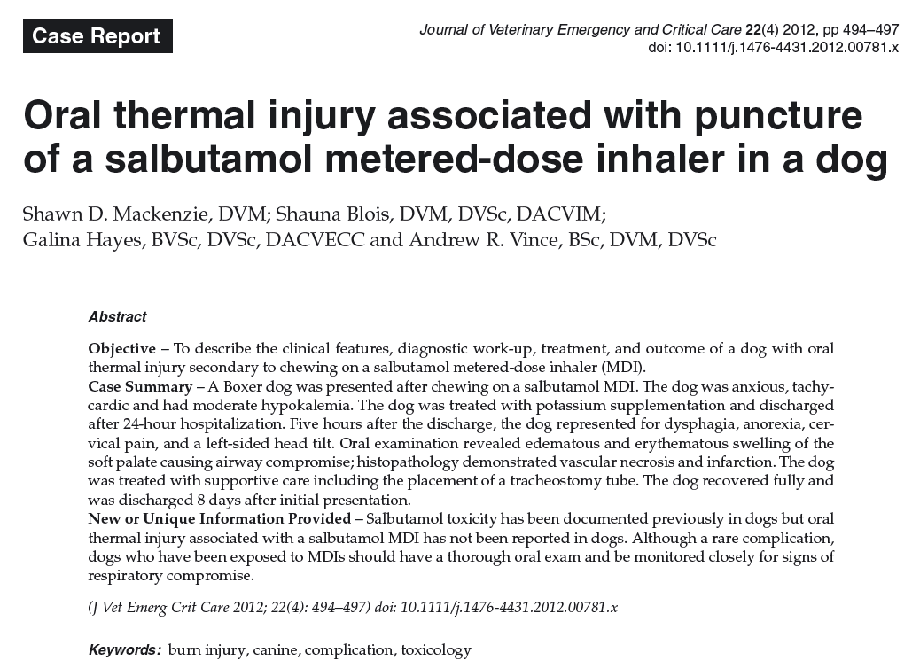
Possible mechanisms for aerosol-associated injuries include chemical burns from the pharmaceutical or the propellant, thermal injury due to physical effect of severe cooling of the skin (frostbite), a mechanical abrasive effect of the aerosol, or any combination of these factors

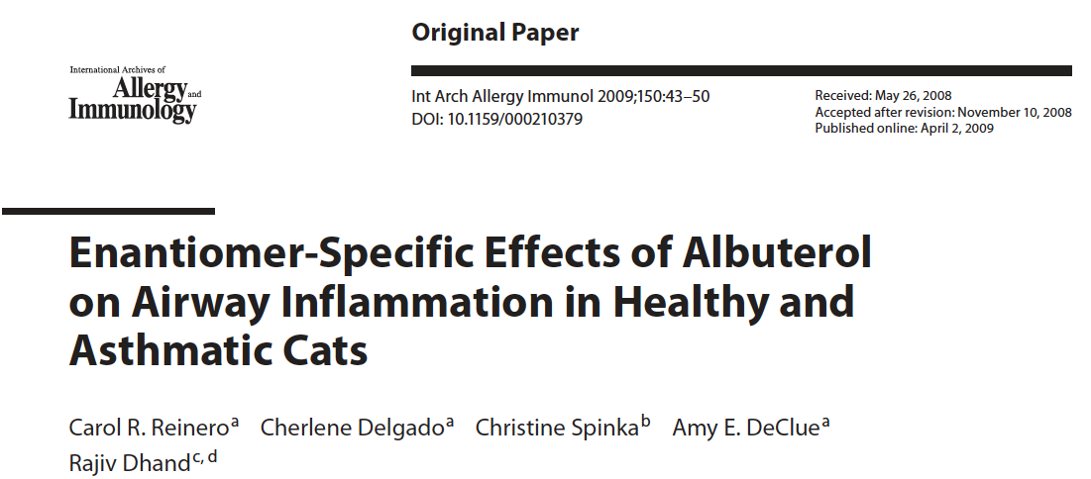
Background: Racemic (R,S)-albuterol is a 1:1 mixture of an R- enantiomer which has bronchodilatory and anti-inflammatory effects, and an S-enantiomer which is associated with increased airway hyperreactivity and proinflammatory effects. Proinflammatory effects of regularly inhalated and S- albuterol have not been studied in a whole-animal model.

Methods: Six healthy and 5 experimentally asthmatic cats were randomized to receive inhaled R,S-albuterol, S-albuterol, R-albuterol, or placebo (saline) twice daily for 2 weeks, followed by a 6- week washout before crossover to the next treatment. Bronchoalveolar lavage fluid was collected for cell counts and cytokine analysis prior to and at the end of each 2-week treatment.

Results: Healthy and asthmatic cats receiving R,S- and S-albuterol had higher total lavage cell numbers (p = 0.04 and p = 0.02, respectively) than those receiving R-albuterol and placebo. The number of lavage eosinophils and the TNF-bioactivity was higher in asthmatic cats receiving R,S- and S-albuterol compared with those receiving the other treatments (p = 0.03 and p = 0.004, respectively). In healthy cats, the number of lavage neutrophils was higher when they received R,S- and S-albuterol compared with other treatments (p = 0.04).

Conclusion: Airway inflammation is induced in both healthy and asthmatic cats with regular inhalation of racemic and S-albuterol, but not with R-albuterol.

Racemic albuterol ( R,S -albuterol), a 1: 1 mixture of an R -enantiomer and an S -enantiomer, is the most commonly prescribed short-acting b2 -agonist in the USA. R -Albuterol (levalbuterol) is responsible for the clinical bronchodilator activity of racemic albuterol, and when given at proportionally equivalent nebulized doses as racemic albuterol, it possesses superior bronchodilatory properties. Several investigators have shown that S –albuterol is not inert, but likely works in opposition to R - albuterol; in a number of in vitro and in vivo studies, administration of S -albuterol was associated with increased airway hyperreactivity and proinflammatory effects

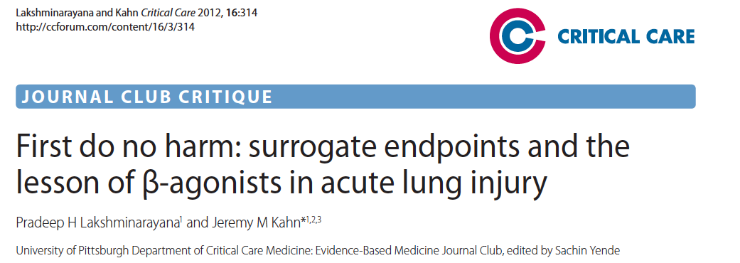
Background
β2-Adrenergic receptor agonists accelerate resolution of pulmonary edema in experimental and clinical studies of ALI

Methods
Objective: To determine whether an aerosolized β2-agonist would improve clinical outcomes in patients with ALI.
Design: Multi-center, phase III randomized, placebo controlled clinical trial.
Subjects: Patients who were intubated and receiving mechanical ventilation, had bilateral infiltrates consistent with edema on frontal chest radiograph, had a ratio of PaO2 to FIO2 (fraction of inspired oxygen) of 300 or less, and not had clinical evidence of left atrial hypertension. A maximum enrolment of 1,000 patients was planned.
Intervention: Patients were randomized to receive aerosolized albuterol (5 mg) or saline placebo every 4 hours for up to 10 days.
Outcomes: The primary outcome variable was ventilator free days (VFD). Secondary outcome measures included mortality before hospital discharge on day 60 and day 90, the number of intensive care unit (ICU)-free days and the number of organ failure-free days.

Conclusions
These results suggest that aerosolized albuterol does not improve clinical outcomes in ALI patients. Routine use of β2 agonist therapy in mechanically ventilated ALI patients cannot be recommended

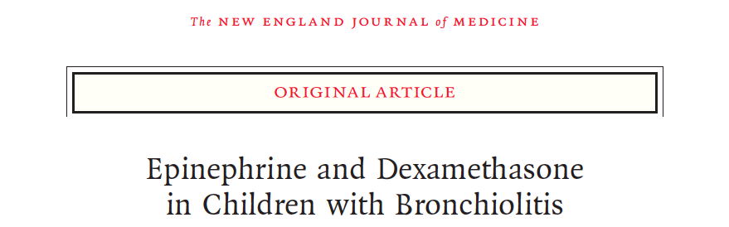
Background Although numerous studies have explored the benefit of using nebulized epinephrine or corticosteroids alone to treat infants with bronchiolitis, the effectiveness of combining these medications is not well established.
Methods We conducted a multicenter, double-blind, placebo-controlled trial in which 800 in- fants (6 weeks to 12 months of age) with bronchiolitis who were seen in the pediatric emergency department were randomly assigned to one of four study groups. One group received two treatments of nebulized epinephrine (3 ml of epinephrine in a 1:1000 solution per treatment) and a total of six oral doses of dexamethasone (1.0 mg per kilogram of body weight in the emergency department and 0.6 mg per kilogram for an additional 5 days) (the epinephrine–dexamethasone group), the second group received nebulized epinephrine and oral placebo (the epinephrine group), the third received nebulized placebo and oral dexamethasone (the dexamethasone group), and the fourth received nebulized placebo and oral placebo (the placebo group). The primary outcome was hospital admission within 7 days after the day of enrollment (the initial visit to the emergency department).
Results Baseline clinical characteristics were similar among the four groups. By the seventh day, 34 infants (17.1%) in the epinephrine–dexamethasone group, 47 (23.7%) in the epinephrine group, 51 (25.6%) in the dexamethasone group, and 53 (26.4%) in the placebo group had been admitted to the hospital. In the unadjusted analysis, only the infants in the epinephrine–dexamethasone group were significantly less likely than those in the placebo group to be admitted by day 7 (relative risk, 0.65; 95% confi- dence interval, 0.45 to 0.95, P=0.02). However, with adjustment for multiple comparisons, this result was rendered insignificant (P=0.07). There were no serious ad- verse events.
Conclusions Among infants with bronchiolitis treated in the emergency department, combined therapy with dexamethasone and epinephrine may significantly reduce hospital admissions.

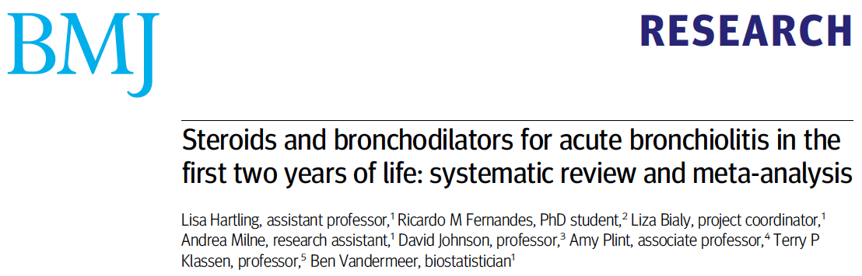

Objective To evaluate and compare the efficacy and safety of bronchodilators and steroids, alone or combined, for the acute management of bronchiolitis in children aged less than 2 years.

Design Systematic review and meta-analysis.
Inclusion criteria Randomised controlled trials of children aged 24 months or less with a first episode of bronchiolitis with wheezing comparing any bronchodilator or steroid, alone or combined, with placebo or another intervention (other bronchodilator, other steroid, standard care).

Review methods Two reviewers assessed studies for inclusion and risk of bias and extracted data. Primary outcomes were selected by clinicians a priori based on clinical relevance: rate of admission for outpatients (day 1 and up to day 7) and length of stay for inpatients. Direct meta-analyses were carried out using random effects models. A mixed treatment comparison using a Bayesian network model was used to compare all interventions simultaneously.

Results 48 trials (4897 patients, 13 comparisons) were included. Risk of bias was low in 17% (n=8), unclear in 52% (n=25), and high in 31% (n=15). Only adrenaline (epinephrine) reduced admissions on day 1 (compared with placebo: pooled risk ratio 0.67, 95% confidence interval 0.50 to 0.89; number needed to treat 15, 95% confidence interval 10 to 45 for a baseline risk of 20%; 920 patients). Unadjusted results from a single large trial with low risk of bias showed that combined dexamethasone and adrenaline reduced admissions on day 7 (risk ratio 0.65, 0.44 to 0.95; number needed to treat 11, 7 to 76 for a baseline risk of 26%; 400 patients). A mixed treatment comparison supported adrenaline alone or combined with steroids as the preferred treatments for outpatients (probability of being the best treatment based on admissions at day 1 were 45% and 39%, respectively). The incidence of reported harms did not differ. None of the interventions examined showed clear efficacy for length of stay among inpatients.

Conclusions Evidence shows the effectiveness and superiority of adrenaline for outcomes of most clinical relevance among outpatients with acute bronchiolitis, and evidence from a single precise trial for combined adrenaline and dexamethasone

Questions:
- Albuterol toxicity in dogs (through puncture of canister) can result in hypokalemia. What is the mechanism of action that leads to hypokalemia?

- List three other adverse effects of albuterol.

- True or False. Aerosolized albuterol has been shown to improve clinical outcomes in ALI patients

- Doxopram has been shown in experimental animals to ______________________ (increase/decrease) myocardial oxygen demand and _________________ (increase/decrease) cerebral blood flow

- True or False. Combined therapy with dexamethasone and ________________may significantly reduce hospital admissions among infants with bronchiolitis treated in the emergency department, combined
  - Albuterol
  - Doxapram
  - Epinephrine

Questions and Answers:
- Albuterol toxicity in dogs (through puncture of canister) can result in hypokalemia. What is the mechanism of action that leads to hypokalemia?
Promotes shift potassium intracellularly via stim Na-K-ATPase

- List three other adverse effects of albuterol.
Dose related tachycardia, arrhythmias, hypertension, CNS excitement, tremors, hypokalemia, hypophosphatemia

- True or False. Aerosolized albuterol has NOT been shown to improve clinical outcomes in ALI patients

- Doxopram has been shown in experimental animals to ______________________ (increase/decrease) myocardial oxygen demand and _________________ (increase/decrease) cerebral blood flow
Has been shown in experimental animals to increase myocardial oxygen demand and reduce cerebral blood flow

- True or False. Combined therapy with dexamethasone and ________________may significantly reduce hospital admissions among infants with bronchiolitis treated in the emergency department, combined
  - Albuterol
  - Doxapram
  - Epinephrine

