Rose & Post Ch 3 and 4 Madden

Questions:

1. What is the equation for filtration fraction?

2. Decreased RPF and increased GFR will increase the filtration fraction and increase the capillary oncotic pressure. T or F?

3. _____________% of the filtrate is normally reabsorbed in the proximal tubule?

4. ____________% of bicarbonate is normally reabsorbed in the proximal tubule?

5. List 3 intra-renal mechanisms that act to prevent fluid delivery from exceeding the limited total resorbtive capacity of the collecting tubules.

6. Why is BUN increased in the blood in low volume states (why does pre-renal azotemia occur)?

7. From a physiologic standpoint, how does the administration of high sodium containing fluids and loop diuretics theoretically lower blood calcium levels?

8. The kidney is the major site of metabolism for polypeptide hormones such as insulin, gastrin and glucacon. T or F?

9. Elevating the urine pH is an important component of treating salicylate intoxication. T or F?

Questions with answers:

1. What is the equation for filtration fraction?
Answer: GFR/RPF

2. Decreased RPF and increased GFR will increase the filtration fraction and increase the capillary oncotic pressure. T or F?
Answer: True

3. _____________% of the filtrate is normally reabsorbed in the proximal tubule?
Answer: 55-60%

4. ____________% of bicarbonate is normally reabsorbed in the proximal tubule?
Answer: 90%

5. List 3 intrarenal mechanisms that act to prevent fluid delivery from exceeding the limited total resorptive capacity of the collecting tubules.
Answer:

1. Glomerulotubular balance
- Constant fractional reabsorption
2. Autoregulation
- Keeps GFR constant despite variations in renal artery pressure
3. Tubuloglomerular feedback
- Lowers GFR if the load to the macula densa of the early distal tubule is increased

6. Why is BUN increased in the blood in low volume states (why does pre-renal azotemia occur)?
Answer: Bicarbonate is reabsorbed in parallel with Na⁺ in the PT. Low volume states result in increased resorption of Na⁺ (and thus H20) in the PT, therefore resulting in a concurrent rise in BUN.

7. From a physiologic standpoint, how does the administration of high sodium containing fluids and loop diuretics theoretically lower blood calcium levels?
Answer:
- The passive reabsorption of calcium in the PT and loop of henle is dependent on NaCl transport
  - You may decrease blood calcium levels by increasing sodium intake, and thus reducing the reabsorption of Na in the PT and LH thus promoting calciuresis OR by inhibiting Na-K-2Cl cotransporter

8. The kidney is the major site of metabolism for polypeptide hormones such as insulin, gastrin and glucacon. T or F?
Answer: True

9. Elevating the urine pH is an important component of treating salicylate intoxication. T or F?
Answer: True

CH 3 Summary - Proximal Tubule:

- 55-60% of the filtrate is normally reabsorbed here
- Primary event of proximal tubule function is active Na⁺ transport
  - This allows water and other solutes to be reabsorbed passively
- Some H⁺ secretion in this segment
- Almost all filtered glucose and a.a. are reabsorbed in this segment
- % reabsorption in this segment:
  - 90% HCO3
  - 65% Na⁺
  - 55% Cl⁻
- Water resorption
  - Proximal tubule is highly permeable to water
  - Due to aquaporin 1 (different than aquaporin 2 in collecting tubules that increase permeability in this segment in response to ADH)
- The preferential resorption of HCO3⁻ in the early PT results in osmotic water transport and subsequent rise in tubular Cl⁻ concentration
  - This Cl⁻ gradient is sufficient to allow as much as 1/3 NaCl and water resorption to occur passively through the tight junctions
- In general, filtered Na⁺ enters the cell passively across the luminal membrane and then is actively transported via the Na-K-ATPase into the intercellular space
  - The removal of Na and other solutes from the lumen initially lowers lumen osmolality, creating an osmotic gradient of up to 15mmHg that promotes resorption of water
  - Water movement is also promoted by the preferential reabsorption of NaHCO3 in the early proximal tubule that leads to an elevation of Cl⁻ in the tubular fluid; this makes the effective luminal osmolality even lower (since the tight junctions are relatively permeable to Cl⁻, which therefore functions as an ineffective osmole)
- Na-K-ATPase promotes Na⁺ entry into the cell:
  - Creates a favorable electrochemical gradient for passive Na entry into cells
    - Pump causes intracellular Na⁺ to be as low as 20-30meq/L
    - Pump contributes to the cell interior negative potential by promoting the net loss of cations (3Na⁺ out: 2K⁺in)

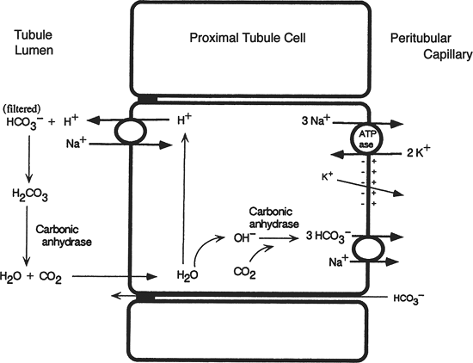

- Amino acids, phosphate and glucose are reabsorbed by cotransport into the cell with Na⁺ on the luminal surface
  - Solute cotransport is a major source of Na⁺ movement into the cell
  - Mediated by carrier proteins
  - Both sites need to be occupied for cotransport to occur
- Na⁺ entry also occurs via antiport with H⁺
  - H⁺ secretion leads to HCO3 resorption
- K+ channels on the basolateral membranes are ATP sensitive and vary in parallel with the activity of the Na-K-ATPase
  - ie. build up of ATP in the cell as a result of reduced pump activity (for example in the circumstance of decreased Na resorption) results in down regulation of K⁺ channels and less K⁺ leaves the cells
  - ATP inhibits K⁺ channels
- NaHCO3 resorption is via secondary active transport (see above diagram)
  - Na-K-ATPase is driving force

- Note: Patients with renal ischemia may have alterations in membrane polarity (ie. pumps and channels move to inappropriate locations) and/or cell permeability, and thus may have reductions in Na⁺ resorption

- Cl⁻ resorption:
  - Some is resorbed in exchange for formate
  - Other mechanisms – poorly understood
  - Cl leave basolateral membrane by a K/Cl cotransporter or Cl specific channels
- Passive mechanism of proximal transport
  - Accounts for 1/3 of proximal fluid resorption
  - Glucose, a.a., bicarb resorbed in greater amounts than CL
    - Tubular fluid has similar osmolality to plasma but a higher Cl concentration
    - Cl goes across the tight junctions down its gradient along with Na and H2O
    - Water moves across tight juctions down an osmotic gradient and NaCl follows by solvent drag and diffusion (since water loss raises solute concentration in the lumen)
    - Here Cl is an ineffective osmole
- Summary:
  - Na-K-ATPase and Na-H antiporter is the main determinant of Na and H20 resorption in the proximal tubule
  - Na/H antiporter functions:
    - Directly promotes HCO3 resorption (esp in early PT)
    - Preferential resorption of HCO3 and H2O creates the gradient for passive Cl resorption
    - Promotes active Cl resorption

- ATII has an overall stimulatory effect of NaCl and H20 resorption in the PT by acting on pumps (ie Na/H antiporter) but not on net acidification
- Dopamine diminishes Na resorption
  - Inhibits Na/K/ATPase and Na/H antiporter
  - Natriuretic response to volume expansion
- Filtration fraction:
  - GFR/RPF
    - Decreased RPF and/or increased GFR will increase the filtration fraction and increase the capillary oncotic pressure
    - Efferent arteriolar constriction increases hydraulic pressure and therefore increases GFR
    - Efferent arteriolar constriction increases renal vascular resistance and therefore decreases RPF

Glomerulotubular balance:
- Relationship between glomerular filtration and tubular reabsorption
- For a change in GFR there is a proportional change in tubular reabsorption
  - The absolute level of tubular resorption is directly related to the filtration rate
    - A constant fraction is resorbed
  - The fractional tubular resorption remains roughly constant despite changes in GFR

- 3 intrarenal mechanisms that act to prevent fluid delivery from exceeding the limited total reabsorptive capacity of the collecting tubules:
- Glomerulotubular balance
      - Constant fractional reabsorption
- Autoregulation
      - Keeps GFR constant despite variations in renal artery pressure
- Tubuloglomerular feedback
      - Lowers GFR if the load to the macula densa of the early distal tubule is increased

*** See Page 87 for a summary ***
- Key point: the proximal tubule and loop of henle are responsible for the reabsorption of the bulk of the filtrate, with the distal nephron (mainly the collecting tubules) making small variations in electrolyte and water excretion in accordance to changes in intake

Bicarbonate:
- 80% of the filtered bicarb is reabsorbed in the PT
- Accomplished by the active transport of H⁺ out of the cell into the lumen
  - Mediated by the Na⁺-H⁺ antiporter in the PT
  - Mediated by the H⁺ATPase in the distal nephron
- Resorbed in parallel with Na
  - May be a problem in hypovolemic patients with a metabolic alkalosis
    - hypovolema perpetuates alkalosis; HCO3 excretion will rise only when the stimulus for Na and Cl retention is removed by restoration of normovolemia

Glucose:
- Resorbed in parallel with Na
  - Cotransport with Na in PT enters the cell then leave the basolateral membrane by glucose transporters (that are independent of sodium)
- Early nephron S1 S2 high capacity low affinity carriers that remove most the filtered glucose
  - SGLT2
- Later S3 high affinity receptors take in 1 glc with 2Na (the sodium gradient favors glucose transport into the cell)
  - SGLT1

Urea:
- End product of protein metabolism
- Lipid soluble; crosses most membranes passively
- Resorption of water in the PT increases the [Urea] in the tubular fluid thus it moves passively into the cell down its concentration gradient
- 50-60% of filtered urea is excreted
- BUN varies inversely with GFR
- May be elevated in high production states: GI bleeding, high protein diet
- Elevated with volume depletion:
  - In this case, increased proximal Na resorption causes a rise in BUN (as it rises in parallel with Na resorption)
  - This is pre-renal azotemia

Calcium:
- Approximatelty 40% of Ca²⁺ is bound to albumin and is not filtered at the glomerulus
- Of the remaining 60%
  - 50% is ionized
  - 10% is bound to citrate, bicarbonate or phosphate
- Filtered Ca²⁺ is resorbed and 5% is excreted
  - 80-85% is resorbed in the PT and Loop of Henle
    - most of this resorption is passive following NaCl and H20 reabsorption
- Excretion is mainly performed by the cortical distal nephron in the DT and cortical thick ascending limb of the loop of Henle and connecting segment
- PTH and Vit D stimulate Ca²⁺ resorption
  - Stimulates calcium entry into cell (down concentration and electrochemical gradient via carrier proteins)
  - Calcium leaves the cell via the basolateral membrane Ca⁺-ATPase and 3Na⁺-1Ca²⁺ exchanger
- Remember: PTH is the major stimulus for calcitriol production
- Hypoparathyroidism reduction in tubular resorption in calcium, thus you get calcium in the urine despite low blood calcium levels
  - Even if you give vitamin D here and raise blood calcium levels, you still have decreased PTH and thus limited ability to reabsorb calcium in the nephron and thus you may get an increase in the amount of calcium excreted in this circumstance and may get calcium stone formation
- The passive reabsorption of calcium in the PT and loop of henle is dependent on NaCl transport
  - You may decrease blood calcium levels by increasing sodium intake, and thus reducing the reabsorption of Na in the PT and LH thus promoting calciuresis OR by inhibiting Na-K-2Cl cotransporter
- You may lower calcium exretion by enhancing Na⁺ reabsorption and thus calcium reabsorption via:
  - Induction of hypovolemia with low sodium intake and a diuretic (**diuretic must work distal to the TAL of the LH***)

Phosphate:
- 80-95% of filtered amount is reabsorbed mainly in PT
- Na⁺- Phosphate specific co-transporters in the luminal membrane
- 3 Na⁺- 1HPO4⁻²
- Inward sodium gradient drives phosphorus intake despite a decreasing luminal phosphorus concentration
- PT phosphate transport is mediated by:
  - Serum phosphate concentration
  - PTH
- Low blood phosphate upregulation of phosphate transporters restoration of phosphate levels
- High blood phosphate and high PTH levels diminish phosphate reabsorption and enhance urinary excretion
- Metabolic acidosis can affect phosphate reabsorption
  - Transporter function is diminished leading to enhanced urinary excretion
    - Beneficial effect as this enhances buffer excretion, thereby allowing more acid to be excreted

Magnesium:
- Protein bound
- 70-80% is filtered
- 3% is excreted
- Most of the filtered Mg is reabsorbed in the thick ascending limb of the loop of henle and distal convoluted tubule (and NOT in the PT like most the other ones)
- Hormones may stimulate the reabsorption of Mg
  - ADH
  - PTH
  - Glucagon
  - Calcitonin
  - Beta agonists

Uric Acid:
- Formed from the metabolism of purine nucleotides
- Uric acid Urate⁻ + H⁺
- Most uric acid circulates as the urate anion
- Filtered urate is entire in the proximal tubule
  - Reabsorption of most the filtered urate occurs early in the PT
  - Secretion by the organic anion secretory pathway in the mid-proximal tubule of an amount equal to ~ 50% of the filtered load
  - Post secretory reabsorption of most the secreted urate in the late PT
- Only 6-12% is excreted
- Urate reabsorption varies directly with Na⁺
  - Urate exchanged for OH (OH comes from H20 and the left over H gets exchanged for Na at the Na-H antiporter)
Proteins:
- Almost entirely reabsorbed in the PT
- A.a enter the cell by cotransport with Na
- Large proteins are hydrolyzed by brush border peptidases and taken into the cell as a.a. (ex. ATII)
- Others enter via carrier mediated endocytosis
- *** EARLY PT REABSORPTION and catabolism of proteins:
  - preservation of nitrogen balance by minimizing urinary losses
  - maintenance of homeostatis – kidney is the major site of metabolism for polypeptide hormones such as insulin, gastrin and glucacon

Citrate:
- An important determinant of net citrate reabsorption is acid base balance
- More citrate is reabsorbed on the presence of an academia
- Citrate is metabolized to bicarbonate
  - 1 meq citrate generates 3meq bicarbonate
  - increasing citrate reabsorption in the presence of academia prevents loss of alkali in the urine
- Hypokalemia also enhances proximal citrate reabsorption

NOTE: elevating the urine pH is an important component of treating salicylate intoxication
- Elevating urine pH lowers free H⁺ concentration, this results in lower urinary salicylic acid concentration and will minimize back diffusion of secreted salicylic acid, thereby increasing total drug excretion

Ch 4 Summary – Loop of Henle and the Counter Current Mechanisms:

- LH has a hairpin configuration in the medulla
- Limbs:
  - Descending limb
  - Thin ascending limb
  - Medullary thick ascending limb
  - Cortical thick ascending limb ends at the macula densa
- Major functions of these segments:
  - Reabsorb 25-35% of filtered NaCl
    - Mainly in TAL
  - Reabsorb NaCl in excess of water
    - This is essential for being able to excrete urine with an osmolality different than that of plasma
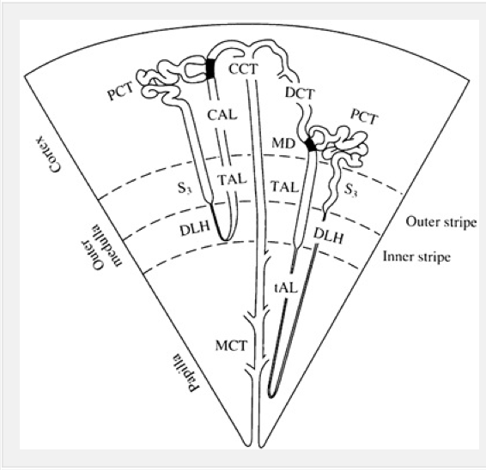
Cell model of NaCl transport:
- Active transport in the TAL is driven by the Na⁺-K⁺- ATPase in the basolateral membrane
  - Activity of this transporter is highest in TAL
    - Indicates importance of Na reabsorption at that site
  - 2 important functions of this pump
    - 1. Pumps Na out of the cell which then goes into the peritubular capillaries and the systemic circulation
    - 2. Maintains a low intracellular [Na]
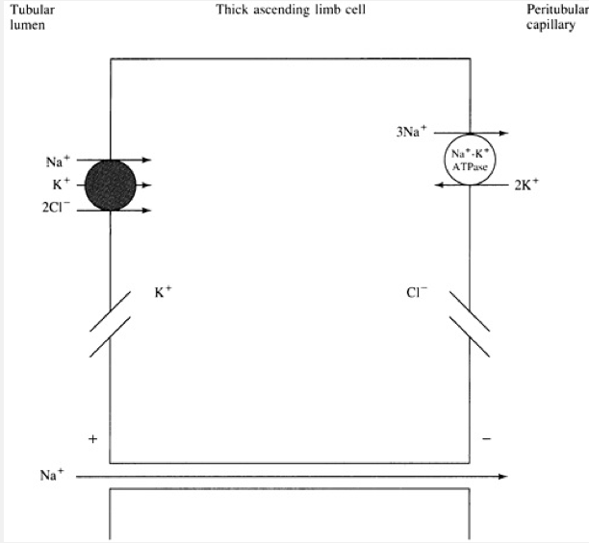
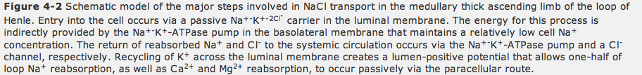

- loop transport is different than that of PT
- Glc, aa and phosphate are almost entirely removed in PT (by coupled transport with Na)
- Loop Na⁺ resorption is not linked to organic solutes, and must occur by…
  - Coupled transport with Cl⁻
OR
  - Na⁺-H⁺ exchange leading to HCO3 resorption

Important characteristics of loop NaCl reabsorption:

1. Affinity of Na and K is high
- Cl⁻ delivery is rate limiting
  - Net NaCl transport increases directly with tubular fluid Cl⁻ concentration
  - Loop diuretics appear to compete for the Cl⁻ site on the carrier, thus inhibiting NaCl resorption

2. K⁺ recycles across the luminal membrane
- Via specific K channels
- Thus reabsorbed K is returned to the lumen for continued activation of the Na⁺-K⁺-2Cl⁻ carrier
- Activity of these K channels is inhibited by ATP
- This is linked to Na+ reabsorption (based on how much ATP the Na-K-ATPase uses in response to the amount of Na entering the cell (ie. the More Na entering, the more that has to be pumped out, the more ATP used for this process, the less ATP present to inhibit K channels and vice versa)

3. The back leak of cationic K+ and the movement of reabsorbed Cl- (via a Cl- Channel) into the peritubular capillary generates a net positive current from capillary to lumen.
- Creates a lumen positive potential difference
- This drives the passive paracelluar reabsorption of cations Mg++, Ca++ and Na+

Role of LH in acid base balance:
Medullary thick limb
- Reabsorbs most of the HCO3 that is delivered out of the PT
  - Has an effect on acid base balance
  - Mainly mediated by Na+-H+ exchanger
  - Loop bicarb reabsorption is stimulated by acidemia
- Reabsorbs NH4⁺
  - NH4⁺ substitutes for K+ on the Na-K-2Cl cotransportet
  - Net effect is recycling ammonia in the medullar
    - therefore maximizing urinary NH4⁺ in the presence of an acid load

Role in Urine Calcium Excretion:
- Passively reabsorbed in the TAL
  - Following lumen positive gradient generated by Na reabsorption
- Calcium sensing receptors in the basolateral membrane of cells in the TAL
  - Binding of calcium to the receptors generates arachidonic acid which inhibits K+ channels in luminal membrane
    - Inhibition of K+ channel prevents K+ recycling reduces NaCl resorption by the Na-K-2Cl cotransporter
    - This diminishes the lumen positive gradient thus reducing passive resorption of calcium

Renal medulla:
- For every 2 Cl absorbed (using the Na-K-2Cl cotransporter) one Na is actively transported out of the call by the Na-K-ATPase and one Na is passively reabsorbed between the cells
- Renal medulla is poorly oxygenated
  - Usually receives less than 10% of the renal blood flow
  - Vasa recta – results in exchange of oxygen from oxygen rich blood leaving the cortex (descending capillary limb) to oxygen poor blood draining the inner medulla (ascending capillary limb)
  - *** prone to hypopefusion acute tubular necrosis***
  - Cells of the TAL and distal PT function normally function in a borderline ischemic environment

Loop reabsorption:
- In the PT reabsorption is limited by the amount of luminal solutes (aa. bicarbonate, glc) that are available for cotransport with NA
- *** solute concentration is the limiting factor in the PT***
- 2 factors restrict net absorption in the PT
  - Fall in tubular Cl- concentration (which will decrease the activity of the Na-K-2Cl cotransporter)
  - Reduction in NaCl concentration below that of plasma promotes the backleak of NaCl into the lumen across the tight junctions
- ADH stimulates NaCl reabsorption by increasing activity of the Na-K-2Cl cotransporter in the medullary TAL
  - This reduces [Cl-] in the cortical thick limb (thereby limiting resorption in this region)
    - Net effect is that resorption is increased in the medulla
    - This permits efficiency of the counter current system and subsequent urinary concentration
- Cortical TAL plays a role in Mg++ and Ca++ resorption

Countercurrent mechanism:
- Includes:
  - Loop of henle
  - Cortical and medullary collecting tubules
  - Blood supply to these segments
- Helps form a dilute or concentrated urine (relative to plasma)
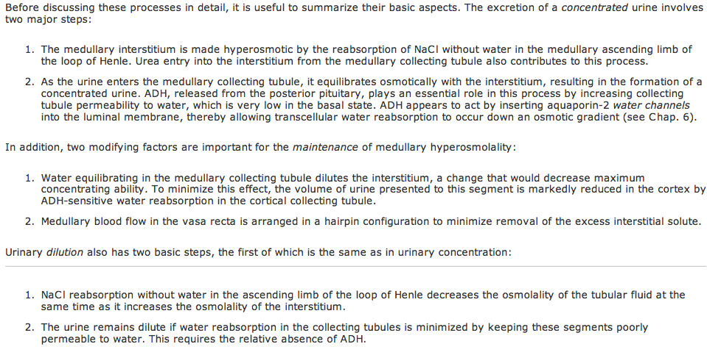

- Countercurrent multiplication – the process by which the interstitial osmolality is increased from 280 to 900-1400mosm/kg
- This is achieved by the differences in permeability and transport characteristics between the descending and ascending limbs of the loop of henle
  - Descending limb is permeable to water and to a lesser degree NaCl and urea
  - Ascending limb is impermeable to water but is able to transport NaCl into the interstitium

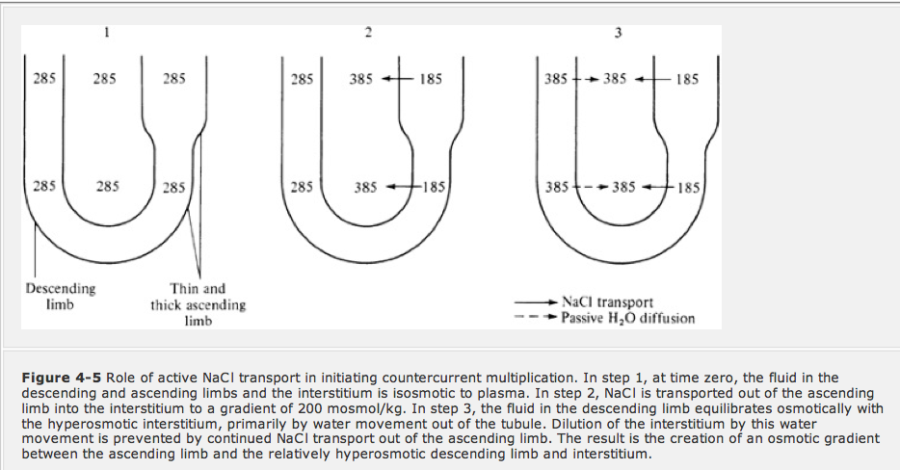

- After the countercurrent exchange fluid leaving the ascending limb of the loop of henle is hypoosmotic to plasma
  - The final osmolality of the urine is mainly determined by the permeability of the collecting tubules (which depends on ADH)
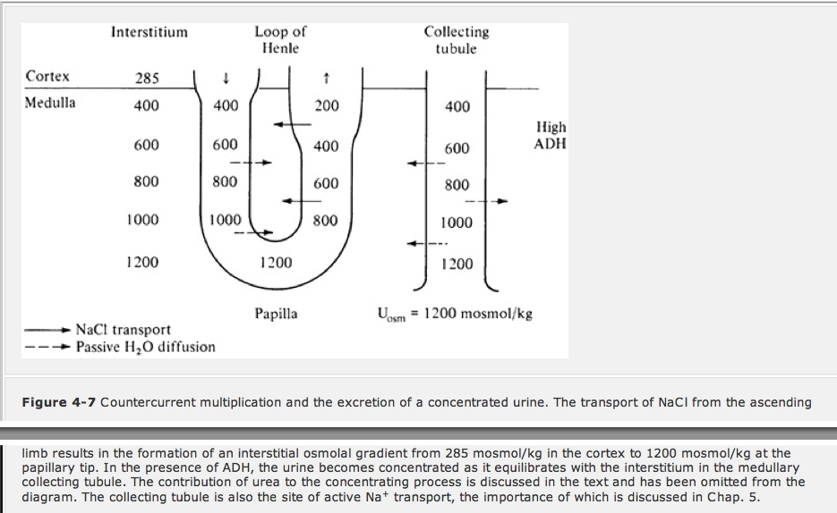

Collecting tubules:
- In a basal state, it is relatively impermeable to NaCl
  - This permits a high NaCl concentration in the interstitium (allows this concentration gradient between the tubular fluid and interstitium to be present)
- ADH increases water permeability by inserting aquaporin 2
  - Reabsorbed water returns to the systemic circulation via the vasarecta
  - Mainly works in the cortical collecting tubule
- Cortical collecting tubule participates in urine concentration
  - The volume of fluid presented to the medullary CD is markedly reduced by ADH induced water reabsorption
  - This reduction in tubular fluid volume permits the concentration of urine to proceed in the medulla, without dilution of the medullary interstitium

Note: Active NaCl transport still occurs in the collecting duct, therefore the most dilute urine that can be achieved is 50-75mosm/kg

Role of urea:
- Moves down the concentration gradient from the inner medullary collecting tubule into the interstitium
- Provides ~ ½ of the 1200mosm/kg of the interstitial medullary concentration gradient
- ADH plays a central role in this process
  - As water is reabsorbed from the tubule of the cortex and outer medulla, the concentration of urea in the tubular fluid rises since these segments are impermeable to urea
  - Permeability of the collecting duct to urea is high in the inner medulla (and is increased by ADH)

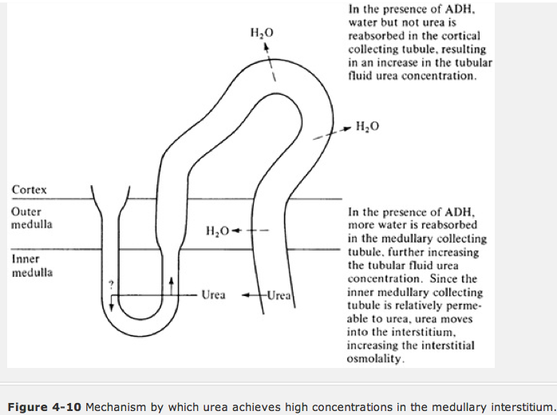

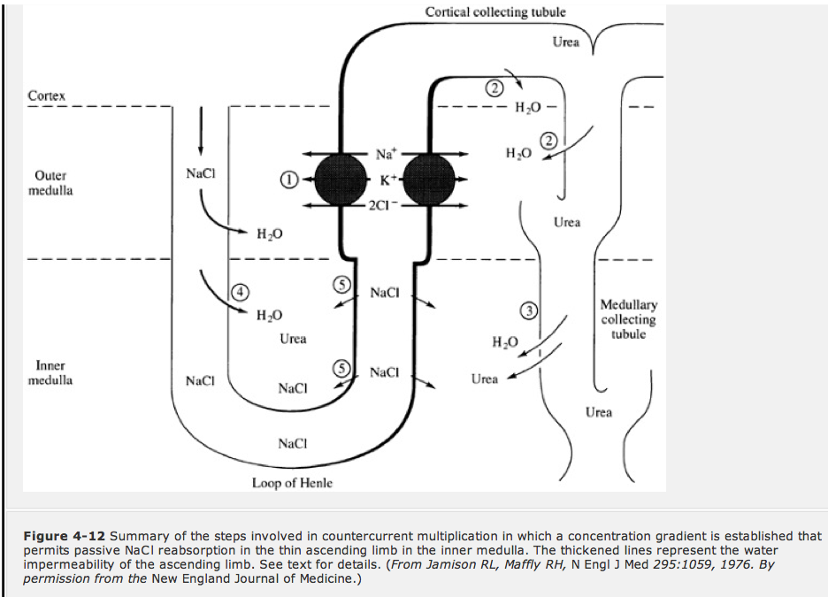

Countercurrent exchange: vasa recta

- Capillaries of the vasa recta are derived from the efferent arterioles of the juxtamedullary glomeruli
- Return NaCl and H20 absrobred from the LH to the systemic circulation
- Ascending limb has a low hydraulic pressure and a high oncotic pressure that favors fluid reabsorption (flow rate of the ascending is almost twice that of the descending)
- Also plays a role in maintenance of the medullary concentration gradient
  - VR reaches osmotic equilibrium with the interstitium

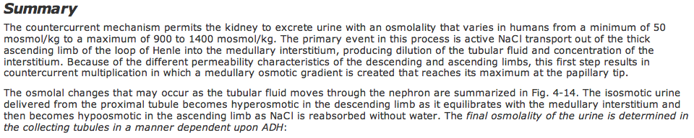

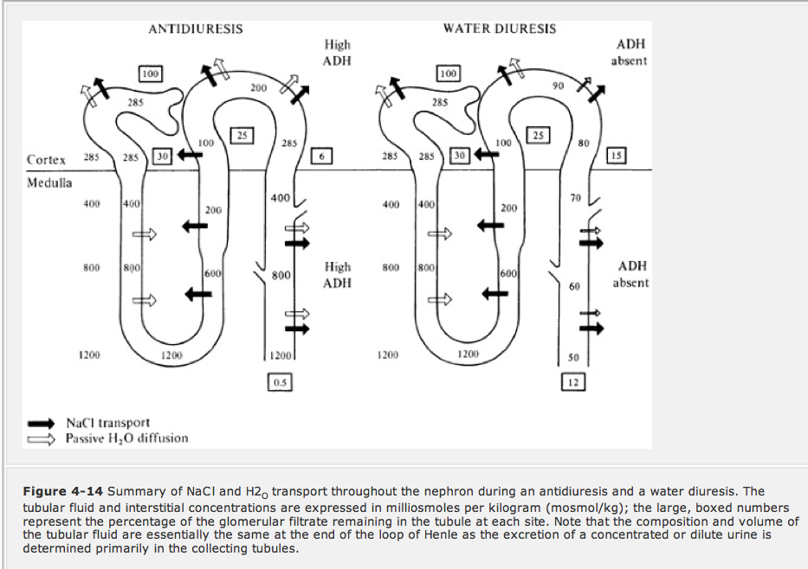

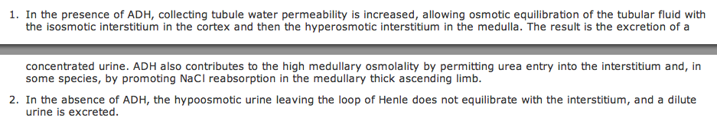

Cell volume:

