COMPENDIUM 2008

Hemodialysis: Primarily diffusion-based, set intervals, for 4-5 hours at a time. Fast blood and dialysate flow rate. Not portable. Have specialized water purification requirements, require large quantities of dialysate that must be produced on-site (complicated reverse-osmosis water treatment equipment). Maintenance.

CRRT: continuous, gradual blood purification. Diffusion and convection. Until kidney function returns. Gradual nature, advanced filtering capabilities: more closely approximates kidney function. Better control of acidosis and electrolyte imbalance. Use of convection – removal of larger molecules. Cage-side. Prepackaged fluids. Less maintenance.

CRRT – 4 easy steps
1.Blood diversion from the patient to the CRRT unit
2.Addition of anticoagulant to the blood
3.Removal of uremic toxins and normalization of electrolytes
4.Blood is returned to the patient

Vascular access:
Dual-lumen temporary dialysis catheter: maximization of blood flow, minimization of recirculation of processed blood.
11.5 Fr for medium/large dogs; 7 Fr for small dogs/cats; 2 single-lumen 5Fr KT for very small patients.
JUGULAR
KT used ONLY for dialysis
Aseptic

Anticoagulation:
Blood purification is performed in an artificial kidney named the dialyzer
Contact with tubing (even if made with highly biocompatible material) can lead to activation of the coagulation cascade.
Prevent clotting: high volume of blood used in the unit; clotting leads to blood loss (!small patients); need to replace the unit (blood is not purified during this time).

- Systemic anticoagulation with heparin CRI.
  - Heparin binds to and activates antithrombin; inhibition of factors IX, X, XI, XII.
  - Many with integrated heparin infusion pumps
  - Monitoring: ACT
  - Protamine sulfate if need to be reversed
- Local anticoagulation with citrate
  - As blood enters the system, citrate is infused with citrate.
  - Citrate chelates calcium (important cofactor at several steps of the clotting cascade)
  - Calcium chloride added to blood before it is returned to the patient
  - Risk of hypocalcemia and metabolic alkalosis
  - One Hn study: fewer complications. Improved outcomes

Blood purification:
- Diffusion: movement of molecules from an area where they are in high concentration to an area where they are in lower concentration.
  - Limited by: pores size
  - Dialysate is continuously replaced (maintenance of the gradient)
  - Dialysate contains precisely measured concentrations of electrolytes and buffers (to replace body deficiencies, correct disturbances)
    - Example: to correct metabolic acidosis, bicarbonate is added to the dialysate
- Convection: blood traveling within the semipermeable membrane is exposed to a positive transmembrane pressure; pressure inside the membrane is positive relative to the pressure outside the membrane, this difference pushes fluid out of the blood and across the semipermeable membrane
  - Fluid carried across the membrane (with toxins, electrolytes): ultrafiltrate; fluid is then removed from the dialyzer and disposed of as effluent.
  - Technically more challenging: large amounts of fluid and associated electrolytes are rapidly removed from the blood; need to be carefully replaced (to avoid dehydration, electrolytes imbalance)
  - Convection is better than diffusion for bigger molecules
- Adsorption: adherence of molecules to the membrane and removal from the circulation

System features:
- Central control unit: to coordinate the movement of peristaltic pumps – blood pump, dialysis solution pump, effluent pump, replacement solution pump
- Dialysis solution, replacement solution, effluent (dialysis solution and ultrafiltrate): continuously weighted
- All fluids are packaged: it is possible to calculate the expected weight of each based on the unit’s settings; calculated weights vs actual weights – if there is a difference = alarm.

Modes of operation:
- Slow continuous ultrafiltration (SCUF)
  - Least complex, most rapid
  - Convection
  - Ultrafiltrate is not replaced, blood becomes more concentrated
  - Hn: heart failure
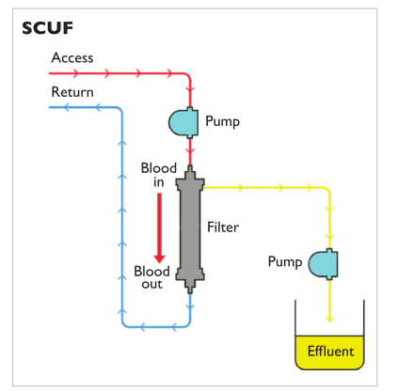
- Continuous venovenous hemodialysis (CVVHD)
  - Diffusion
  - Similar to hemodialysis
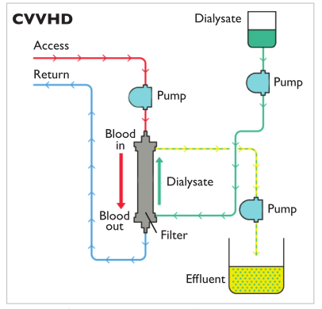
- Continuous venovenous hemofiltration (CVVH)
  - Similar to SCUF (convection)
  - But the ultrafiltrate is replaced (sterile, balanced electrolyte solution) – added before or after* blood travels through the dialyzer.
    - When fluids are added before it enters the dialyzer, the excess fluid is removed by convection; less likely to clot; less effective in removing uremic toxins.
  - As the hemoconcentration increases, risks that that blood sludges, clots, clogs
    - Increasing hemoconcentration limits the amount of fluid that can be removed by 20-25%.
    - Lesser risk with SCUF because it is faster
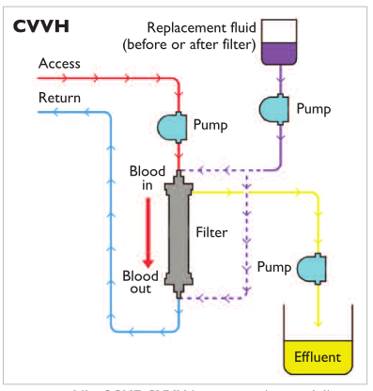
- Continuous venovenous hemodiafiltration (CVVHDF)
  - Diffusion and convection
  - Greatest possible scope of treatment options
  - Replacement fluid
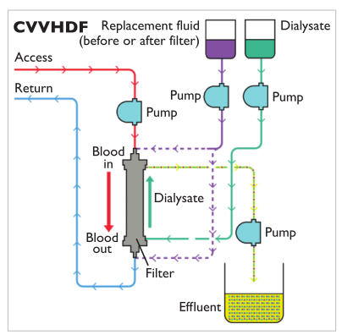

*It is not clear which mode of operation provides the most effective blood purification. Convection* (CVVH and CVVHDF) = significant advantage in the removal of blood solutes. Diffusion (CVVHD) – just as effective for small solutes; less dialyzer malfunctions/clotting. Role of larger molecules in AKI – less clear.

Indications
- AKI - until the kidney recovers function (how long = ?)
- Intoxication
  - Size
  - Free or non-PT bound
  - Volume of distribution
    - Ability of CRRT to remove a toxin is inversely proportional to its volume of distribution – CRRT removes substances within the vasculature.
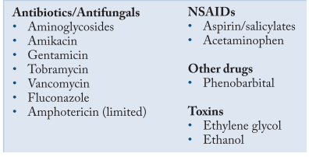
Complications
1. Coagulation
2. Bleeding
3. Hypotension (large volume in the circuit; convection and reduction in blood volume)
Larger patients receive an amount of crystalloid = to the volume of blood needed to fill the circuit; smaller patients receive colloids or blood.
4. Dialysis disequilibrium (when osmotic changes occur rapidly cerebral edema)

CRRT in dogs and cats – VCNA
- Convection: exposing to blood to a positive transmembrane pressure
  - Creation of a negative pressure around the membranes
  - Creation of a positive pressure within the membranes
  - Both
- Dialyzer
  - Blood is divided into thousands of strawlike semipermeable membranes (that are bathed in a solution (dialysate) that flows countercurrent to the blood – hemodialysis)
- Filtration fraction
  - (Ultrafiltrate rate ml/min x100)/(blood flow rate ml/ml x [1-HCT value]) of 25-30% can be achieved before the risk of clotting significantly increases.
- Citrate anticoagulation
  - Many of the calcium-citrate complexes are lost through the dialyzer (effluent) – the remaining citrate returns to the patients; metabolized by liver into bicarbonate metabolic alkalosis.

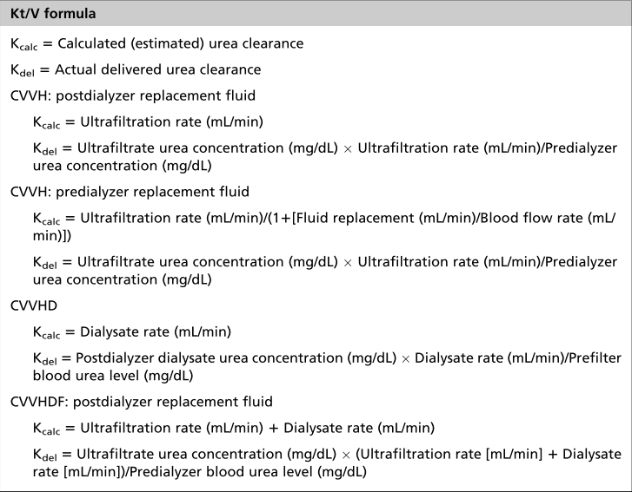
- Kt/V = 1. 4
  - Produces satisfactory reductions in the concentration of urea and provides adequate control of acid-base and electrolyte balance in oliguric and anuric patients.
  - K = urea clearance (ml/min)
  - t = time (min)
  - V = volume of distribution (urea)
    - Equal to TBW in ml = 60% x BW x 1000
- Entire CRRT unit pathway is routinely replaced q48h.
- Small patients
  - Circuit: 50-84 ml to fill the tubing and dialyzer.
  - Prime the circuit with whole blood or FFP&pRBC
  - A problem arises because the strawlike semi-permeable membranes of most CRRT dialyzers are composed of acrylonitrile and sodium methallyl sulfonate copolymer (AN69). When exposed to acidic blood, these membranes activate bradykinins, which can potentiate life-threatening hemodynamic instability.
Because stored blood products typically have a low pH, such blood primes can prove fatal. This problem can be circumvented by attaching both the CRRT patient-access and patient-return lines to the bag containing stored blood products and allowing the CRRT machine to correct the pH and remove the activated bradykinins. Thus, the bag of blood receives treatment as if it were a patient – approximately 30 minutes. It is important to properly anticoagulate the blood being treated because the replacement fluids/dialysate typically contain calcium. Similar problem in people treated with ACEI.

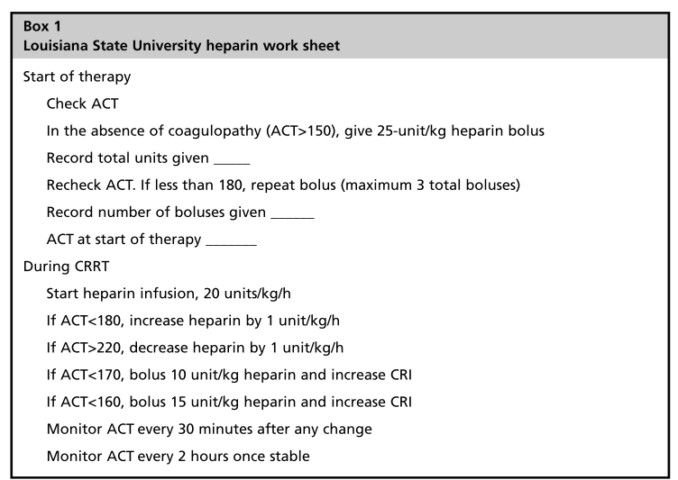

A clinical review of peritoneal dialysis

- PD = involves the exchange of solutes and fluid between the peritoneal capillary blood and the dialysis solution across the peritoneal membrane.
- Osmosis (ultrafiltration)
  - Fluid moves from a solution of lower to a solution of higher osmolar concentration.
  - Osmotic gradient created by osmotic agent (dextrose) in the dialysate
  - Water moves into the dialysate
- Solute exchange by diffusion and convection
  - Waste products in higher concentration in the blood
  - Diffuse across the peritoneum into the dialysate
  - Rate of diffusion depends on: size, charge, concentration gradient of the particles
  - Urea: 60 Da; Creatinine: 113 Da
  - Clearance of lower MW solutes is lower with PD than with hemodialysis
  - Convection: movement of solute across a membrane simply because it is trapped in the flow of fluid (movement of solutes along with water = solvent drag)
- Indications
  - AKI
    - Oliguria or anuria
    - BUN > 100; Creat > 10
    - Failure of medical management
      - Correction of electrolytes, acid-base disturbances, fluid overload
  - Toxins
  - Severe hepatic encephalopathy
  - Hypo/hyperthermia
  - Presurgical management of uroabdomen/UTO
- Contraindications:
  - Coagulopathy
  - Peritoneal fibrosis/adhesions
  - Peritonitis
  - Vascular leak states
  - Hypoalbuminemia
  - Hernias (diaphragmatic, inguinal, abdominal)
- Dialysate
  - In general: contain glucose, lactate, sodium, potassium, calcium; high lactate and dextrose, high osmolarity, low pH
  - Acetate not a good buffer: loss of ultrafiltration, sclerosing peritonitis
  - Dextrose concentration
    - Can lead to hyperglycemia, hyperinsulinemia, decrease in glucagon, hyperlipidemia, weight gain
    - High concentration high osmolarity large fluid removal dehydration/hypovolemia, loss of PT
    - High concentration of dextrose = deleterious long-term
    - Degradation of large concentration of glucose cytotoxic glucose degradation products (GDPs), GDPs react with a.a. advanced glycosylation endproducts (AGEs) fibrosis, loss of ultrafiltration
    - Other options (people): icodextrin (glucose polymer), amino acid solutions
  - Commercial dialysate: Dianeal; if not available = LRS
    - P-Lyte, Normosol contain acetate…
    - 0.9% saline: predisposes to formation of peritoneal adhesions and fibrosis (not recommended if long-term PD may be needed)
    - LRS
      - Add dextrose (1.5%, 2.5% or 4.5%)
      - Depending on hydration status
      - Higher concentration: high fluid removal and ultrafiltration (fluid overload), lower concentration: normovolemic
    - If normal saline is used: add sodium bicarbonate as a buffer
    - Heparin?
      - Commercial dialysate does not contain heparin
      - 500 U/L during initial exchanges, than up to 5d thereafter
- Catheter
  - Ideal: reliable, rapid dialysate flow rate, no leak, no infection
  - No consensus in people: most widely used = straight Tenkhoff
  - Silicone elastomer or polyurethane
  - Numerous side holes
  - Tenckhoff (mini-surgical approach, laparo, percutaneous blind, fluoroscopy), Blake silicon fluted drain, fluted T catheter, (surgical placement), acute PD catheter with coaxial design (surgical), Jackson Pratt (surgical)…
- Catheter placement
  - Mini-surgical approach, blind percutaneous placement using a trocar or using a guidewire (Seldinger technique), or direct visualization by laparoscopic placement
  - No consensus
  - Omentectomy
    - To prevent obstruction by omentum
    - If patient already undergoing ex.lap
    - If PD for more than 3d when using simple tube catheters or Tenkhoff
  - Strict aseptic technique
  - U-cath prior to avoid bladder trauma
  - Usually mild sedation and local anesthesia (percutaneous or mini-surgical)
  - Lateral or dorsal recumbency
  - Prophylactic use of a first generation cephalosporin at the time of PD catheter placement
  - Percutaneous: trocar or modified Seldinger technique
  - Midline or paramedian – level of ombilic
  - Purse string suture
  - Can be sutured to the rectus sheath (purse string) or 3 purse strings – parietal membrane, inner and outer sheet of the rectus fascia
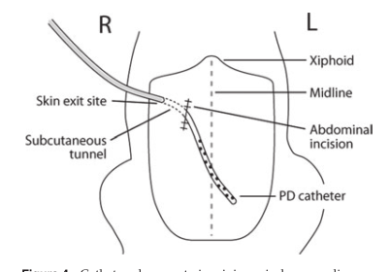
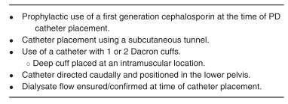
- Complications: hemorrhage, perforation of the intestine, kinking of the catheter with drainage problems, catheter malplacement within fascial planes, leakage of dialysate, peritonitis, and wound infection.
- Cover with bandage

- Starting dialysis
  - Y-connector or 3 way stopcock
  - Flush before fill: to allow the line to be flushed free of any bacterial contamination, before infusing dialysate into the patient
- Warm fluid
- Passive filling: no more than 10 minutes ; drainage no more than 15 minutes
- Dwell time: 20 minutes – 6 hours
- After dwell period: the dialysate is drained out and discarded, then replace by a new dialysate
- Fill, dwell, drainage = exchange
- When possible, dialysis free period of 10-15d after catheter insertion…
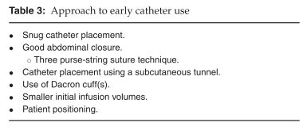
- Initial volume: 10-20 ml/kg – prevent leakage and cardiovascular complications; infusion over 5-10 minutes; shorter initial dwell time < 45 minutes. Monitor for nausea, discomfort, respiratory compromise – drain by gravity. Repeat every hour; after 24 hours, can try to increase to 30-40 ml/kg
- The amount of solute and fluid removed during PD depends on
  - Volume and tonicity of the dialysis fluid
  - Dwell time
  - Intrinsic solute transport characteristics of the peritoneal membrane.
- Rate of fluid removal is greatest at the beginning of each exchange (no absorption of glucose yet, no dilution of glucose by removed fluid/solutes yet)
  - The amount of fluid removed can be enhanced by increasing the glucose concentration of the dialysis fluid and/or maintaining a maximally effective osmotic gradient by increasing the frequency and decreasing the dwell time of the exchanges.
- Solute exchange: primarily by diffusion
  - Most important determinant of ….: volume of dialysate
    - As the fill volume increases, more surface of the highly vascularized peritoneal membrane is available for solute exchange.
    - Optimizing PD efficiency includes increasing the fill volume to the maxiimal tolerable volume and if this does not achieve anticipated improvement in patient status and/or renal parameters, then increasing the number of exchanges to enhance solute clearance.
  - Ideally around-the-clock
    - Once patient improvement is noted,and target values are met,dialysis can be extended to every 4–6 h but should continue throughout the 24-h day. For these later fluid exchanges, the dialysate should remain in the abdomen between exchanges (4–6 h)
  - As a general rule of thumb, dialysate (effusate) volume should = infused volume if a 1.25% dextrose solution is used; should be > infused volume if a 2.5% or 4.25% dextrose solution is used (correction of overhydration). Should effusate be less than infusate at any given cycle, consider patient hydration or catheter occlusion. Patient repositioning may allow successful drainage.
- Analgesia/post-op/monitoring
  - Opioids
  - Antiemetic
  - Treat underlying condition: attention if needs ATB – adjust dose and frequency of admx (PD subtherapeutic concentration; renal excretion if AKI…)
  - Body weight, hydration
  - PCV/TP, electrolytes, BG, osmolality, renal parameters, UOP
  - Gross evaluation of dialysate after each exchange: +/- cytology, gram, culture
  - Nutrition
- Complications
  - Catheter obstruction (fibrin, kinking, clot, omental wrapping) and migration
    - Never try to aspirate with a syringe (unless gentle aspiration); complete obstruction; xrays, dynamic catheterography ; can try to flush with high pressure (20 cc syringe) – can try tPA, heparin or urokinase (fibrin)
  - Dialysate leak
  - Inadequate dialysis
  - Development of hypoalbuminemia
  - Electrolyte abnormalities
  - Pelvic limb edema
  - Pleural effusion
  - Catheter exit-site infections
  - Peritonitis
    - ATB into dialysate – more effective than systemic route
    - First generation cephalosporin
- Prognosis
  - In a study of 27 cats and dogs: 22% survival
  - Another study (leptospirosis) 4/5 dogs
  - Can be successful for acute ischemic renal injury, EG
  - If possible reversible cause
  - Usually 3-7 d of dialysis, and then several days in hospital (IVFT during polyuric phase)

Dibartola – Peritoneal dialysis
- Diffusion: permeability of membrane, surface area, concentration of solute on either side, overall resistance, size – for urea, creatinine, small solutes
- Ultrafiltration: movement of water; osmotic/oncotic gradient. Surface area and capillary blood flow.
- Convection: when solutes are carried along with the bulk flow, not important in PD (more in HD)
- Transport of water – 3 pores theory
  - Large pores: clefts in the endothelium – macromolecules; very small numbers
  - Small pores: clefts in the endothelium – LMW substances; larger numbers
  - Ultrasmall pores: aquaporin 1 – water; induced by exposure to hyperosmotic solutions
- Mass transfer area coefficient (MTAC): theoretical clearance that would occur if the concentration gradient for a solute is infinitely high.
- Osmotic gradient, MTAC, rate of diffusion: highest at the beginning of the dwell time.
- Indications
  - Oliguric, anuric AKI
  - AKI associated with nonresponsive uremia
  - Posterenal failure: UTO, rupture UT
  - Toxins: EG, ethanol, barbiturates
  - Volume overload
  - Hypercalcemia
  - Hyperkalemia
  - Hypothermia
  - Hyperthermia
  - Pancreatitis
- HD: more efficacious in altering water an solute balance, $$$ (equipment and supplies), expertise
- PD: more efficacious in removing uremic middle molecules, simple, labor intensive
- Contraindications
  - Peritoneal adhesions
  - DH, PCDH
  - Thoracic or abdominal surgery
  - Inguinal or abdominal hernias
  - Hypercatabolic states – burns
- Dacron cuffs: to promote fibrous attachments (ingrowth of fibroblasts) – placed in the rectus muscle and in the SQ tunnel.
- Surgically placed if PD for > 24 hours
- ¼- ½ of the calculated final volume for the first 24 hours
- Dialysate solutions are buffered, slightly hyperosmolar crystalloid solutions designed to pull fluid, potassium, urea, and phosphate from the plasma into the dialysate while providing diffusible buffer and other needed compounds such as magnesium and calcium.
- Hypertonic dextrose appears to favor capillary vasodilation and promotes solute drag.
- 1.5% dextrose: normovolemic/dehydrated; 2.5%- 4.25%: mildy to severely overhydrated
- Heparin 250-1000 U/L should be added to the dialysate for the first few days after KT placement (prevent occlusion) – minimally absorbed by patient’s circulation.
- Glucose itself is harmful to the peritoneum
  - Activates the polyol pathway and the secretion of TGF-B1, monocyte chemoattractant protein-1, fibrinonectin.
  - Can lead to peritoneal fibrosis, neoangiogenesis (enlargement of peritoneal vascular surface area loss of osmotic gradient and impairment of UF)
  - Nonenzymatic glycosylation of tissue proteins --. AGEs; deposition of AGEs in the vascular wall leads to UF failure
  - GDPs are formed during heat sterilization process of dialysate = aldehydes (formaldehyde) and dicarbonyl products (glyoxal, methylglyoxal).
    - Toxic to fibroblast
    - Enhances production of vascular endothelial frowth factor
    - Trigger the formation of AGEs (faster than glucose)
- Icodextrin
- Bicarbonate-based solution ; need to double chamber bag (separation from calcium) – less pain
- 1.1% amino acid solution
- 30-40 ml/kg during a 10-minute period; 30-40 minutes (dwell time), drainage 20-30 min period.
- Recovery of 90-100% of infused solution
- Dialysis cycles q1-2h
- Reasonable target for BUN and creatinine: 60-100 mg/dL; 4-6 mg/dL
- Acute vs chronic dialysis protocol. Longer dwell time (3-6 h), 3-6 excahnges per day
- Goal to maintain BUN at 70
- Longer dwell time for larger molecule (creatinine)
- Gradual reduction of # of exchanges, rest periods.
- Conversion of the anuric/oliguric state to polyuria, stabilization or improvement of azotemia: primary indications for D/C of PD
- Complications
  - Leakage
  - Obstruction
  - Infection (exit site, tunnel)
  - Hypoalbuminemia
    - PT losses may increase dramatically when peritonitis is present
  - Peritonitis- Staph
  - Pleural effusion
  - Dyspnea
  - Changes in hydration status
  - Electrolyte abnormalities
- Dialysis disequilibrium
  - Dementia, seizures, death
  - Early exchanges, especially with extreme azotemia, acidosis, hypernatremia, hyperglycemia
  - With rapid removal of solutes influx of water into brain cells
  - Adjustment: fewer exchanges or longer dwell times

Hemodialysis – Langston
- Dialysate may be circulated through the dialyzer to allow diffusive clearance (hemodialysis), or fluid may be removed from the patient to allow convective clerance (hemofiltration), or both techniques may be used simultaneously (hemodiafiltration).
- Intermittent HD: diffusion, may include HF
- Continuous therapies: diffusion, convection or both
- Extracorporeal RRT: intermittent and CRRT
- Use of diuretics = widespread – lack of conclusive positive impact on outocome
  - If loop diuretics, osmotic diuretics or other fail w/in hours – early referral for dialysis.
- Chronic HD should be recommended when signs of uremia are no longer controlled by medical management. Creatinine > 5 mg/dl. Main sign of uremia = anorexia.
- Return of normal appetite is expected with adequate dialysis.
- Overall survival for dogs/cats tx with HD for AKI 41-52%; infectious and ischemic causes = better px than toxics, in general.
- Non survivors: generally die/euthanized due to extra-renal conditions. 1/3 due to failure of recovery of renal function. Also on going uremic signs, dialysis complications, unknown causes…
- Survivors: 50% regain normal renal function ( = normal creatinine) and 50% have persistent CKD.
- Clinical scoring system for outcome prediction of dogs with AKI receiving HD has been developed. Not been independently validated, should not be used in the decision-making process for an individual patient; help to ID appropriate candidate for HD?
- Catheter
  - Minimally thrombogenic, flexible, nonirritating
  - Polyurethane, polyethylene, polytetrafluoroethylene, silicone, carbothane.
  - Polyethylene: stiff and kinks – temporary KT

  - Polyurethane: some rigidity at room temperature (placement), becomes softer and more flexible at body temperature.
  - Double lumen: to allow removal and return of blood
  - Central vein
  - Lumen that provides blood egress from the body: arterial port; lumen that provides blood return to the body: venous port.
  - Arterial lumen: usually shorter (to avoid uptake of blood returning from the dialyzer (access recirculation).
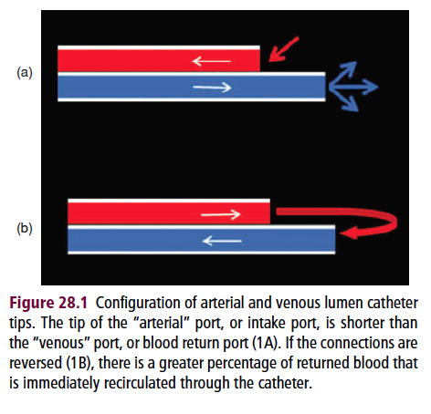
  - Sometimes 2 single lumen KT, separate vessels or same vessel.
  - If single opening (tip or side port): partial occlusion
  - Less risk for obstruction if multiple ports.
  - If ports are positioned circumferentially around the KIT: blood flow can continue even if the wall is sucked against the ports on one side of the KT.
  - If side ports are small: blood will preferentially flow through the tip – side ports superfluous.
  - If side ports are large: KT is weaken and increase the amount of heparin that diffuses out of the KT between dialysis Tx.
  - Double D configuration: highest lumen volume with lowest surface contacting the blood to diminish shear stress, modest outer circumference.
  - C-shaped
  - Temporary KT: tapering tip to facilitate percutaneous placement.
  - Permanent KT: tips separated (IV portions act like 2 separate KT placed in the side vein – external portions bound together) – side ports can be placed circumferentially – increased flexibility (movement with cardiac cycle) – decrease fibrin sheath formation.
  - Arteriovenous fistula or graft: preferred access in people for chronic HD.
    - Artery surgically anstomosed to a vein – section of autologous vein or synthetic graft (PFTE) – within a month: endothelial cells line the graft – endothelial cells of the autologous vein segment take on characteristics of arterial endothelium. – Access can then be used by percutaneous puncture of the aretial and venous segment with large gauge neddles at each dialysis Tx. Between Tx, no anticoag is needed because blood is continually flowing through the graft/fistula – completely enclosed under the skin (infection = rate). Canine HD model: brachial-cephalic access.
  - Temporary, nontunneled KT can be placed in OR – frequently placed in a clean procedure room. Aseptic technique. Sedation and/or local anesthetic. Usually percutaneously. Seldinger technique. Acute dialysis < few weeks.
  - Permanent HD KT: external cuff (Dacron) – a portion in SQ pocket (separates the site where the KT exits the skin from the site where the KT enters the vessels) – Dacron cuff placed in the SQ pocket. Up to 2 years. GA generally used. Consider placement of feeding tube at the same time.
  - Larger KT is better: Flow is proportional to the diameter and inversely proportional to the length. Poiseuille equation: Q = (k*P*D⁴)/(L*V)
  - Intermittent Tx: 15ml/kg/min/ blood flow.
  - CRRT: 3-5 ml/kg/min
  - Fluoroscopic guidance: top at the jct of CVC and RA. – if not available: postprocedure Xrays.
  - KT only for ERRT
- Anticoagulation
  - Between Tx
    - UFH or sodium citrate
    - Any locking solution should be removed prior to the next use of the KT
  - Aspirin is routinely used.
- Access recirculation : see picture above
  - Decreases efficiency of Tx by diluting the blood withdrawn with blood that has just returned from the dialyzer (« clean » blood returned to be dialyzed again). If attached in the normal configuration : recirculation < 5% ; if connections are reversed : 13-24% - greater flow rate can be achieved with reversed connection (will offset the decrease in efficiency) ; During initial HD (efficiency purposefully decreased to limit complications – may be reversed to create recirculation).
  - Measured by techniques that alter the venous line blood and then detection of the presence of altered blood in the arterial line.
    - Dilution with saline (US or light transmission)*
      - Injection of bolus of saline in venous line dilute the blood detected by US placed on the venous blood line. If there is recirculation, the blood entering the arterial line will also be diluted (smaller degree) ; detected by arterial line US sensor. % calculated by the machine. Also hemoglobin monitors – less accurate.
    - Change in temperature (cooling)
    - Conductivity (HS)
    - Hemoconcentration (UF)
- Catheter complications
  - High rate of thrombosis
    - Intraluminal or extraluminal (form around the tip – +/- attached to vessel wall ; in RA = they act like a ball valve – allowing ingusion but occluding KT and preventing aspiration)
    - Flush with saline then filled with locking solution (heparin, citrate…)
    - Systemic anticoag has not been shown to decreased intraluminal thrombosis.
    - Signs : inadq blood flow, inability to aspirate KT
    - Try to dislodge trombus : flush – dislogement does not appear to cause clinically relevant PTE. Alternative : tPA (10 min dwell time, can increase to up to 1-2 hours)
    - Mechaninical disruption : guidewire
    - US : to see thrombi in RA and CVC
    - Risk factors : venous stasis (volume depletion, hypotension, immobilization, CHF), enhanced coagulability, vessel wall trauma.
  - Central venous stenosis – facial edema (cranial vena cava stenosis or obstruction) and decreased in dialysis efficiency.
  - INFECTIONS*
  - KT dislodgement
- Dialyzer
  - Semi-permeable membrane arranged in hollow fibers
  - Blood flows through the center of the fibers – fibers bathed in dialysate –large surface area for diffusive clearance, minimal volume of blood used to fill the dialyzer.
  - Blood enters at the top and exits at the bottom ; dialysate generally enters at the bottom (countercurrent).
  - Semi-permeable membranes
    - Cellulosic (cuprophane) , modified cellulosic (hemophan ; substituted hydroxyl groups with a substance likely to activate the patient’s complement system) or synthetic (* ; larger pores, better middle molecule clearance, less reactive, less bioincompatibility reactions – polysulfone, polymethylmethacrylate (PMMA), polycarbonate, polyamide, polyacrylonitrile, methallyl sulfonate, polyacrylonitril polyacrylonitrile – thicker, assymmetric structure, dense blood contact surface, more open supporting structure)
  - Ideal pore size : passage of small to middle-sized uremic toxins, restrict loss of albumin.
  - Dialysis membrane has the largest surface area (compared to KT, dialysate, blood lines…) – most likely to cause biologic reaction. Less with synthetic membrane.
  - Activation of the complement cascade coagulation cascade. Inflammation, thrombosis, conversion of HMW kininogen to kinin increased permeability, decreased vascular resistance, inflammation.
  - W/in 15 minutes : decreased neutrophils and plt (sequestered in pulmonary capillaries) – return to normal w/in 3-4 hours. Neutrophils and plt aggregation in lungs impairs O2 transport. Complement induces AW and vessels constriction, increases edema in lungs (permeability) decreased O2. Other signs of dialyzer reactions : hyper/hypotension, dyspnea, couging, sneezing, wheezing, choking, conjunctival injection, headache, muscle cramps, back pain, abdominal pain, chest pain, nausea, vomting, fever, chills, flushing, urticaria, pruritus, death.
  - Cooling the blood can decrease complement activation.
  - Adhesion of PT to the dialyzer membrane decreases bioincompatibilty subsequent uses reduce reactions. Less risk with synthetic membranes.
  - Clearance of a dialyzer : volume of blood completely cleared of a certain solute during a single pass through the device – identical to the concept of renal clearance.
    - Markers of solute clearance : urea, creat, phosphorus, vitamin B12, inulin. – ml/min
  - Coefficient of UF (K_{UF}) : measure of hydraulic permeability of the membrane – water flux
    - # of ml of water that can be removed per hour for each 1 mmHg tramsmembrane pressure (= difference in hydraulic pressure between blood compartment and dialysate compartment)
      - Higher K_{UF} : remove larger volumes of fluid in a given time with a lower TM pressure. Average veterinary patient : even lower K_{UF} can remove adq volume to normalize hydration.
      - Hydrostatic pressure decreases from top to the bottom and increase in oncotic pressure at the bottom due to UF : possible back-filtration at the bottom.
        - Allows endotoxins/contaminants to enter the blood compartment
        - More likely to occur with high K_{UF} without UF
          - To avoid : Nominal rate of UF and IV fluid replacement (if does not need fluid removal)
  - High-flux dialyzers : large pores, high K_{UF}, clearance of middle molecules.
  - High-efficiency dialyzers : high urea clearance (large surface area) – larger priming volume.
- Extracorporeal circuit
  - Tubing that carries blood from KT to machine/dialyzer and returns it to the patient
  - Nonthrombogenic material
  - Monitoring of pressure in the circuit before and after dialyzer
  - Any air-blood interfaces : risk of thrombosis – able to detect bubbles
- Dialysate
  - Water quality, production of dialysate, machine – see text
  - CRRT uses prepackaged sterile dialysate – avoid necessity for a water tx system and associated monitoring.
- Methods of clearance
  - Diffusion : particles ; high to low concentration
  - Constant flow of dialysate – equilibrium is never reached between blood and dialysate.
  - Extremely fast dialysate flow rate maximize diffusive clearance – 300-800 ml/min in IHD. Continous Tx : lower flow rate (40 ml/min)
  - UF : water ; hydrostatic pressure gradient ; negative pressure on the side opposite the blood compartment.
  - Convection : solute drag
  - Middle molecules : convection > diffusion
  - Small molecules : diffusion
  - HF : convection
  - Adsorption : when substances bind to the dialyzer membrane – limited (saturation after approximately 30 minutes) – better : charcoal and other hemoperfusion tehcniques
- Prescription
  - Modality : intermittent vs continuous
  - Schedule : daily versus EOD
  - Intensity : amount of blood processed, convective clearance rate, dialysate flow rate
  - Dialyzer type and size
  - Dialysate composition
  - UF rate
  - Most commonly used measure of clearance : urea reduction ratio (URR)
    - (PreTx BUN – postTx BUN)/preTx BUN
  - Most commonly used measure of dialysis dose in people : Kt/V
    - Dialyzer clearance, time , Vd
- Mode and schedule
  - With AKI : initial considerations
    - Rate of clearance and intensity
    - Rapid clearance : DDS
    - Short time, moderately slow BF rate
    - Targer URR : 0.25-0.5
    - Alternative : sustained low efficiency dialysis (SLED) or CRRT
      - SLED : IHD machine, BF 1.3 ml/kg/min for 6-24 hours vs CRRT : similar BF but slower dialysate flow rate, more convection.
      - Better for unstable patients – less likely to induce hypotension.
  - Chronic dialysis in veterinary patients : minimal recommendations = 4 hours (cats), 5 hours (dogs) – 2-3 times a week.
  - Select URR, select # liters of blood to be processed – see figures.
    - First Tx : slower rate of reduction – longer Tx ; then faster BF rate.
      - Smaller dialyzer for first Tx
    - KT and patient will limit BF rate.
  - Attention : hemolysis pressure more negative than -350 mmHg (arterial side) ; if more negative than -200 mmHg deliver less blood flow than is indicated = overestimation of the amount of dialysis delivered.
- Dialyzer
  - If total EC circuit volume > 20% blood volume :use colloid instead of saline (priming solution) – or oxyglobin, blood products
- Dialysate
  - Similar to plasma water
  - Sodium can be adjusted throughout the Tx – at the beginning higher sodium to prevent rapid change in osmolarity when urea removal is rapid (prevention of DDS). – sodium profiling.
  - Dialysis machine proportions the dialysate concentrate based on the sodium concentraion – individual adjustment of other component is not possible – can be made by using different concentrates (with or without potassium…with or without calcium). Bicarbonate is incorporated separately – adjusted independently from sodium.
  - Most IHD uses dialysate flow rate of 500 ml/min – adjustable. Clearance depends more on blood flow rate than dialysate flow rate. For the same dialysate flow rate, clearance will be higher with higher blood flow rate. Higher dialysate flow rate also increases clearance. (vs CRRT dialysate flow rate betweem 0-40 ml/min – faster flow rates have a substantital effect on clearance).
  - Usually countercurrent circulation – if reversed : decreased clearance (may be useful in the first hours of Tx).
  - Temperature of dialysate : usually lower than pets’ body temperature : blood is cooled ; vasoconstriciton, avoid hypotension.
  - For non renal reason : attention hypophosphatemia (hemolysis) add phosphorus to the dialysate.
  - When used for EG intoxication : ethanol is dialysable – add some to the dialysate to maintain steady state.
- Ultrafiltration
  - Desired volume depends on hydration status.
  - Single short IHD tx – fluid removal should not exceed 20 ml/kg to avoid intradialytic hypotension.
  - Effective profile : faster rate of fluid removal at the beginning (when extra fluid is readily accessible in the bloodstream) and then slower rate (shift from IS to IV space)
  - In IHD (high dialysate flow rate) : addition of UF for convective clearance contributes relatively little to the overall solute clearance.
- Single needle dialysis
  - Only one vascular acess lumen is available or single lumen KT or one lumen of double lumen KT non functional…
  - Single needle mode : Y-connector to connect both arterial and venous tubing segments.
  - Far less effective (50% of the dialysis time is spent withdrawing blood) – recirculation of the dialyzed blood.
  - Try to maintain fast blood flow rate and higher SV (amount of blood removed in each cycle) – limited by the type and condition of the KT
- Anticoagulation
  - Heparin
    - Bolus of UFH at the start then CRI – Can D/C 30-60 minutes before the end – clotting times start normalizing. Clotting time : 1.6-2X normal.
    - ½ life : 40-120 minutes
    - Protamine = antidote
      - Can be given as a CRI (regional heparinization) –rarely used
    - LMWH : also possible, less risk of bleeding, rare used, $, no monitoring (bedside)
  - Citrate
    - Regional anticoagulation
    - Infusion of calcium to the patient to avoid hypocalcemia
    - Metabolized at the liver (to bicarbonate) : attention if liver disease
    - Leads to metabolic alkalosis – lower bicarbonate may be needed
  - None
    - Flush the extracorporeal circuit with saline (50-150 ml) every 15-30 min- extra volume removed by UF. Rapid blood flow rate. Increase in transmembrane pressure can predict thrombosis (monitor this parameter). Usually Tx is limited to < 1.5 h without anticoagulation in many patients.
  - Complications
    - Bleeding
    - Thrombosis (patient)
    - Thrombosis (dialyzer)
      - Decreases the surface area and efficiency
    - Thrombosis at the air-bood interface in the arterial or venous drip chamber.
    - If entire coagulation of the extracorperal circuit : the blood can’t be returned to the patient !!! Uncommon if rapid blood flow is maintained w/out excessive periods of stopped flow due to KT malfunction.
- Monitoring
  - Blood pressure
    - Volume of blood in the circuit vs patient’s blood volume (smallest circuit : 70 ml)
    - UF – removes fluid from IV which is replenished by IS and IC (D/C or give bolus of crystalloid)
    - Activation of complement hypotension
  - IV blood volume
    - Continous hemoglobin monitor (if not receiving transfusion and not bleeding : change in Hb reflects changes in plasma volume from UF or fluid infusion) – if decreased by > 10%/hour, the rate of UF should be decreased.
  - Anticoagulation
    - ACT (= aPTT) – preTx, at 30 min after any dose adjustment, q1h
    - iCa (<0.25-0.40 mmol/L)
- Dialysis adequacy
  - Renal function : creatinine, BUN, phosphorus, potassium
    - Urea itself is not highly toxic unless present at EXTREMELY HIGH concentration – BUT it correlates to outcome, because it is a suitable marker for other SMALL MW molecules. Not a good marker for middle MW molecules or high MW toxins.
    - Time-averaged urea concentration : TAC
      - Provides a measure of the average urea exposure over the week.
      - Area under the urea measurement curve/time
    - With rapid blood and dialysate flow rates in a short dialysis time, the blood compartment is readily cleared of urea, but IC compartment lags behind in clearance.
      - Rebound of urea : urea from the IC – equilibration
    - URR
      - URR= (BUNpre - BUNpost)/BUNpre
      - In IHD, can be predicted by the volume of blood processed (no convective clearance)
      - If < than expected : clotting, recirculation
    - Kt/V
      - K : clerance of the dialyzer ; t : time ; V : volume of distribution
      - Kd= Qb x ((BUNin – BUNout)/BUNin)
        - Dialysance : measure of solute mass transfer from blood to dialysate. Dialysance of sodium = dialysance of urea.
      - Uread Vd = same as the TBW = 58-60% BW
    - Urea pool
      - Single pool : simplest = urea diffuses freely and rapidly throughout the entire volume of distribution
      - Double pool model: differential rates of urea clearance from certain regions (IC)
- Patient management
  - DDS
    - First few dialysis tx – risk factors: severely azotemic, small patients, pre-existing neurologic dz, rapid dialysis, low dialysate sodium relative to the patient.
    - Exact cause =?; interstitial cerebral edema
      - Slower diffusion of urea from cells of the CNS in relationship to removal of urea from blood IC hyperosmolality
      - Decrease in urea transporters and increase in aquaporins in the brain
      - But urea gradient between brain and blood is quantitatively insufficient to cause cerebal edema
      - Paradoxic CNS acidosis from rapid correction of systemic metabolic acidosis
    - Less risk with CRRT or SLED
    - Higher dialysate sodium concentration
    - Infusion of mannitol in at-risk patients
    - Signs may occur during or up to 48 hours afterwards – Tx: mannitol and supportive care.
  - Hypertension
    - Posterior reversible encephalopathy syndrome – not caused by dialysis but many patients are hypertensive.
  - Uremic encephalopathy
  - Aluminum toxicity – contamination of dialysate water or oral aluminum-containing phosphate binders –neuro, hemato, NM
  - Subdural hematoma? Ischemic stroke. IC hemorrhage.
  - Uremic polyneuropathy
- Blood pressure
- Hemostasis
  - Anticoagulation and uremic bleeding tendencies
  - 3 issues to be addressed in a patient that is actively bleeding
    - Decrease ongoing loss
    - Correct anemia
    - Support affected organs
  - Stop anticoagulation
    - Protamine, FFP, uremic bleeding = thrombocytopathy
    - EPO, desmopressin, cryoprecipitate, conjugated estrogen
- Thrombosis
  - RA thrombosis – routinely seen w/in 2 weeks of KT placement
- E- and acid-base disorders
  - Hyperkalemia
    - Anuria or severe oliguria
    - Can also occurs in non-oliguric patients: when the GFR is < 10% of normal
    - Common with AKI: because the kidney has not compensated yet by increasing the efficiency of potassium excretion.
    - ACEI, potassium-sparing diuretics, PG inhibitors, heparin, non-specific B-blockers, penicillin, aldosterone deficiency, inorganic acidosis, diet: can contribute
    - Use potassium-free dialysate
    - SLED or CRRT for more sustained potassium control in the first day
    - Tx to shift potassium IC prior to dialysis will reduce the efficacy of dialyse to clear potassium (not in the blood to be cleared)
    - Sodium polystyrene resin
      - PO or enema
      - Sodium is released when potassium binds the resine, potassium is trapped and removed by GI
      - Between Tx
  - Sodium – hypo and hyper
  - Metabolic acidosis
    - Dialysis removes organic and inorganic acid solutes
    - Bicarbonate in the dialysate diffuses into the blood to buffer retained acids
  - Magnesium
- Anemia
  - Remember: 5-10 ml of blood remains in the dialyzer after the Tx
  - Bleeding, anticoagulation, blood sampling
  - RBC survival shortened with uremia
  - Excessive negative pressure hemolysis
  - Uremic toxins and inflammation inhibit EPO
  - Myelofibrosis from renal osteodystrophy related to renal 2nd hyperPTH
  - Aluminum toxicity
  - Transfusion (blood product or oxyglobin), EPO, iron
- Bone and mineral
  - Phosphorus removed during dialysis comes from IC pool
  - PTH = uremic toxin
    - Middle molecule – removal limited during conventional dialysis – high-flux dialyzer and convection help removal of PTH
  - iCa
- Water balance
  - Volume overload – kidney not able to excrete water appropriately
  - Hypoalbuminemia – vasculitis – accumulation w/in IS
  - Polyuria with end-stage CKD dehydration
  - Enteral nutrition can contribute to overload
- Nutrition
  - Attention: fluid overload; may need UF
  - AKI: highly catabolic disease – need PT to correct/ameliorate negative nitrogen balance
  - CKD: a.a are lost in the dialysate – protein restriction may not suitable.
  - Most renal diets are rich in potassium – attention hyperkalemia
  - Carnitine, taurine, a.a. : lost in the dialysate – supplementation
- Infection
  - Common in people
  - KT-related: exit site, KT infection, bacteremia
    - Biofilm that adheres to the walls of the KT, protect the bacteria
    - Blood culture
  - Thrombosis correlated with an increased rate of infection
  - Staph and gram –
  - Other sites: lungs, UTI (gram negative: Klebsiella and E.coli), skin, soft tissue
- Respiratory system
  - Activation of complement: temporary sludging of activated neutrophils and plts in pulmonary capillaries, impairment of O2 diffusion
  - Pulmonary haemorrhages
  - Pulmonary edema
  - Uremia increased permeability
  - PTE
- GI
  - Uremia
  - Antiemetic drugs
- Drug dosing
  - Drugs that are primarily excreted by the kidneys require dose adjustment
    - Loading dose does not need to be adjusted unless Vd is significantly altered (large changes in TBW)
  - Long ½ life: extending the dosing interval
  - Dose reduction while maintaining the interval between doses generally leads to more constant serum levels.
  - MW > 500 Da are poorly cleared by conventional dialysis – clearance may be enhanced with synthetic membrane commonly used in veterinary ERRT
  - If highly PT or tissue bound or highly lipid soluble: not dialyzed (high volume of distribution)
  - If significantly cleared by dialysis: may require additional dosing after dialysis Tx to maintain therapeutic level
  - With CRRT with convection: molecular size and Vd become less limiting than with IHD, but limited pK data is available.
  - CRRT = GFR of 10-50 ml/min
  - Increase the dose of nontoxic drugs by 30% over the drug dose estimated for the degree of renal failure?
- Non renal uses
  - Toxins with small MW, minimal PT binding, small Vd
    - Hemoperfusion: involves placing a charcoal-filled cartridge in the EC circuit
  - Isolated UF for diuretic resistant CHF
  - Removal of cytokines and inflammatory mediators from septic patients?
  - Therapeutic plasmapheresis

