Renal replacement therapy

Questions
- Please name 2 techniques commonly used to prevent blood coagulation during CRRT.

- What is the difference between SCUF and CVVH?

- How can you increase the amount of fluid removed by peritoneal dialysis (2)?

- Please define hemodialysis access recirculation. When can hemodialysis access recirculation be advantageous?

- Middle size molecules are better removed by…
  - Diffusion
  - Convection
  - Ultrafiltration
  - Absorption

Questions & Answers
- Please name 2 techniques commonly used to prevent blood coagulation during CRRT.
Systemic anticoagulation with CRI of heparin
Local anticoagulation with citrate

- What is the difference between SCUF and CVVH?
Both used convection clearance, but in CVVH the ultrafiltrate is replaced.
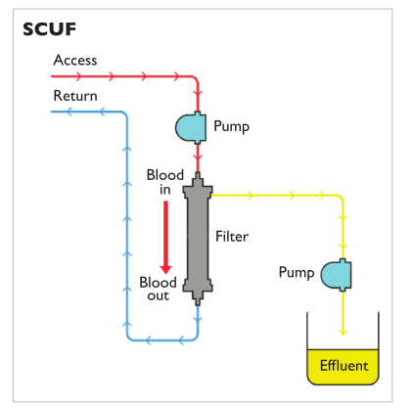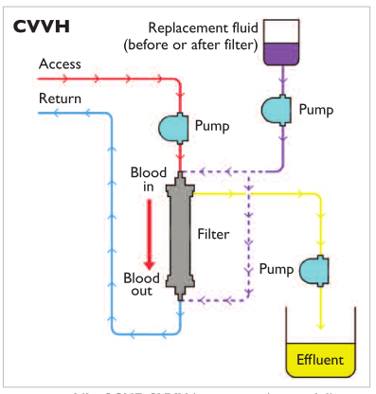
- How can you increase the amount of fluid removed by peritoneal dialysis (2)?
By increasing the glucose concentration of the dialysis fluid.
By maintaining a maximally effective osmotic gradient by increasing the frequency and decreasing the dwell time of the exchanges.

- Please define hemodialysis access recirculation. When can hemodialysis access recirculation be advantageous?
Hemodialysis access recirculation occurs when dialyzed blood returning through the venous port re-enters the extracorporeal circuit through the arterial port, rather than returning to the systemic circulation. The arterial lumen is usually shorter to avoid access recirculation. When the lines are attached in the normal configuration, access recirculation is < 5%. If connections are reversed: 13-24%. During initial HD, when efficiency may be purposefully decreased to limit complications, access recirculation can be advantageous.
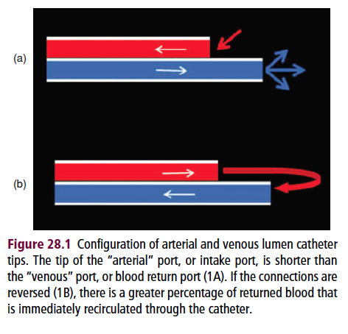
- Middle size molecules are better removed by…
- Diffusion
- Convection
- Ultrafiltration
- Absorption

