REVIEW OF MEDICAL PHYSIOLOGY – GANONG: Chapters 4-7

QUESTIONS
- Please name the 3 types of macroglia and their respective function.

- Please describe the mechanisms that increase intracellular calcium concentration in smooth muscle and in skeletal muscle.

- Please choose the correct statement:
  - Excitatory postsynaptic potentials (EPSPs) are synaptic inputs that hyperpolarize the postsynaptic cell.
  - EPSPs bring the membrane potential closer to threshold and closer to firing an action potential.
  - EPSPs are produced by opening Na+ and Cl- channels.
  - Excitatory neurotransmitters include: acetylcholine, glutamate, GABA and dopamine.

- Please complete: NMDA receptor is a ______________________ receptor. When ______________ AND _______________ bind to the receptor, the closed ion channel opens, but at the resting membrane potential, the channel is blocked by ___________________. This block is removed by _____________________________________. When the block is removed, __________________ and __________________ enter the neuron.

- What is the fate of serotonin after its release from serotoninergic neurons?

QUESTIONS & ANSWERS
- Please name the 3 types of macroglia and their respective function.
Oligodendrocytes: production of myelin in the CNS;
Schwann cells: production of myelin in the peripheral nervous sytem;
Astrocytes: make up the BBB, production of substances that are trophic to neurons, maintenance of appropriate concentration of ions and NT.

- Please describe the mechanisms that increase intracellular calcium concentration in smooth muscle and in skeletal muscle.
Smooth muscle: Depolarization of smooth muscle opens voltage-gated Ca2+ channels in the cell membrane. Calcium (from the ECF) flows into the cell down its electrochemical gradient increase in IC calcium concentration. Calcium can also enter the cell through ligand-gated channels (hormone or NT) or it can be released from the sarcoplasmic reticulum by second-messenger (IP3)-gated mechanisms.

Skeletal muscle: The rise in IC calcium concentration is caused exclusively by release from the sarcoplasmic reticulum. Remember: calcium does not enter the cell from the ECF. Depolarization of the T tubules causes change in their voltage-sensitive dihydropyridine receptors opens Ca2+-release channels (ryanodine receptors) on the sarcoplasmic reticulum.

- Please choose the correct statement:
  - Excitatory postsynaptic potentials (EPSPs) are synaptic inputs that hyperpolarize the postsynaptic cell. FALSE – EPSPs are synaptic inputs that depolarize the postsynaptic cell; IPSPs are synaptic inputs that hyperpolarize the postsynaptic cell.
  - EPSPs bring the membrane potential closer to threshold and closer to firing an action potential. TRUE
  - EPSPs are produced by opening Na+ and Cl- channels. FALSE, by opening Na+ or Ca2+ channels; IPSPs are produced by opening Cl- channels.
  - Excitatory neurotransmitters include: acetylcholine, glutamate, GABA, and dopamine. FALSE; GABA is an inhibitory NT.
- Please complete: NMDA receptor is a GLUTAMATE receptor. When GLUTAMATE AND GLYCINE bind to the receptor, the closed ion channel opens, but at the resting membrane potential, the channel is blocked by MAGNESIUM . This block is removed by PARTIAL DEPOLARIZATION PRODUCED BY OTHER INPUTS TO THE NEURON. When the block is removed, CALCIUM and SODIUM enter the neuron.
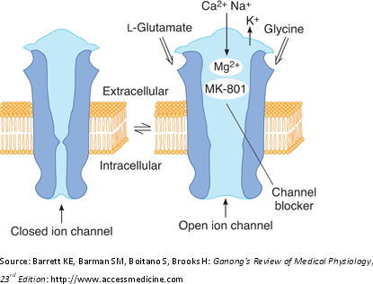

- What is the fate of serotonin after its release from serotoninergic neurons?
Much of the released serotonin is recaptured by an active reuptake mechanism and inactivated by monoamine oxidase (MAO) to form 5-HIAA (principal urinary metabolite of serotonin).

