Questions
- In CRRT, Blood is purified by which three mechanisms?

- Fill in the Blanks. In all but the smallest patients, a dual-lumen temporary dialysis catheter is placed in the jugular vein using the ________________ technique.

- Fill in the Blanks. Anticoagulation of the CRRT circuit is usually accomplished with __________ or _________________

- Anticoagulation effects of CRRT are monitored by
  - ACT
  - PT
  - PTT

- Name two complications that can be caused by citrate anticoagulation?

- The formula Kt/V is a commonly used measure of CRRT treatment adequacy – urea clearance over time. A Kt/V of __________ produces satisfactory reductions in the concentration of urea and provides adequate control of acid-base and electrolyte balance in oliguric and anuric patients
  - 1.0
  - 1.4
  - 2.0
  - 2.4

- Name two complications of CRRT

- The ability of CRRT to remove a substance such as a toxin or drug from the blood depends on:
  - Circulating concentration of drug only
  - Amount that is protein bound and ionic nature
  - Protein binding, size and volume of distribution
  - Size and ionic nature

Answers
- Blood is purified by which three mechanisms?
  - Diffusion - Diffusion is the tendency of molecules in solution to move from an area of higher concentration to that of lower concentration.
  - Convection - In this process, blood traveling within the semipermeable membranes is exposed to a positive transmembrane pressure—that is, the pressure inside the membrane is positive relative to the pressure outside the membrane—and this pressure difference pushes fluid out of the blood and across the semipermeable membrane
  - Adhesion - In this process, blood traveling within the semipermeable membranes is exposed to a positive transmembrane pressure—that is, the pressure inside the membrane is positive relative to the pressure outside the membrane—and this pressure difference pushes fluid out of the blood and across the semipermeable membrane

Larger molecules are more effectively cleared by which principle? Convection

- Fill in the Blanks. In all but the smallest patients, a dual-lumen temporary dialysis catheter is placed in the jugular vein using the ________________ technique.
Seldinger – maximize blood flow and minimize blood recirculation

- Fill in the Blanks. Anticoagulation of the CRRT circuit is usually accomplished with __________ or _________________
Heparin or citrate
Heparin - binds to and activates antithrombin, a circulating protease inhibitor that inhibits the active form of clotting factors IX, X, XI, and XII
The citrate chelates serum calcium, which is an important enzyme cofactor at several steps in the clotting cascade.

Calcium is an essential cofactor required throughout the clotting cascade.
Before the patient’s blood enters the CRRT circuit, citrate is infused, which chelates the calcium and renders the blood unable to clot. Many of the resulting calcium-citrate complexes are lost through the dialyzer as effluent, while the remaining citrate returns to the patient and is metabolized by the liver into bicarbonate. The patient’s physiologic calcium levels are maintained by infusing calcium directly to the patient.

- Anticoagulation effects of CRRT are monitored by
  - ACT
  - PT
  - PTT

- Name two complications that can be caused by citrate anticoagulation?
  - Alkalosis from citrate metabolism
  - hypocalcemia and hypercalcemia are common life-threatening complications

- The formula Kt/V is a commonly used measure of CRRT treatment adequacy – urea clearance over time.
A Kt/V of __________ produces satisfactory reductions in the concentration of urea and provides adequate control of acid-base and electrolyte balance in oliguric and anuric patients
  - 1.0
  - 1.4
  - 2.0
  - 2.4

The formula Kt/V is a commonly used measure of CRRT treatment adequacy – urea clearance over time. Total solute removal per period (Kt) is the product of clearance (K in milliliters per minute) and time (t in minutes) that the patient receives treatment per day. patient’s volume of distribution (V in milliliters)

- Name two complications of CRRT
  - Coagulopathy
  - Hypotension – Although the cause of the blood pressure drop at the start of therapy is likely to be multifactorial, the amount of blood needed to fill the CRRT circuit is at least partly the reason.

- The ability of CRRT to remove a substance such as a toxin or drug from the blood depends on:
  - Circulating concentration of drug only
  - Amount that is protein bound and ionic nature
  - Protein binding, size and volume of distribution
  - Size and ionic nature

Additional Questions
- True or False. Use of convection in CRRT provides a significant advantage in the removal of larger molecules than can be achieved with IHD.

- Which of the following uses a a sterile balanced electrolyte solution is used to replace the ultrafiltrate (replacement fluid)?
  - slow continuous ultrafiltration (SCUF)
  - continuous venovenous hemofiltration (CVVH)
  - continuous venovenous hemodialysis (CVVHD)
  - continuous venovenous hemodiafiltration (CVVHDF)

- ___________ a purely convective modality, generates ultrafiltrate that is not replaced.
  - slow continuous ultrafiltration (SCUF)
  - continuous venovenous hemofiltration (CVVH)
  - continuous venovenous hemodialysis (CVVHD)
  - continuous venovenous hemodiafiltration (CVVHDF)
SCUF, CVVH purely convective modalities, CVVHD diffusive, CVVHDF combines the diffusive characteristics of CVHD with the convective properties of CVVH

- True or False. In postdialyzer configuration there is a lower risk of clotting, but is much less efficient

In postdialyzer configuration the blood is first hemoconcentrated within the dialyzer and then a sterile balanced electrolyte solution is added before the blood is returned to the patient. The benefit of operating in postdialyzer configuration is that it is efficient, however, as the blood becomes increasingly concentrated within the dialyzer, there is a risk of sludging and clotting. Although the predialyzer configuration has a lower risk of clotting, it is much less efficient.

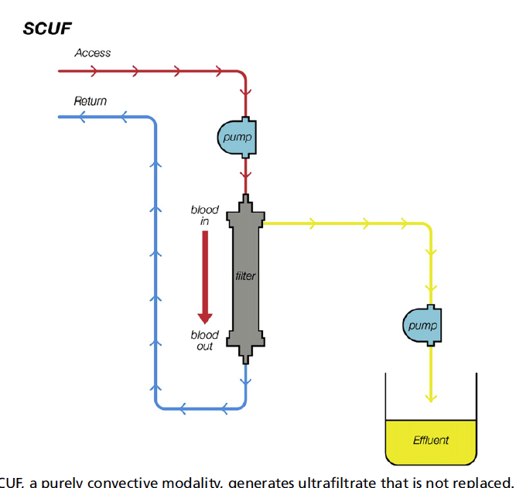

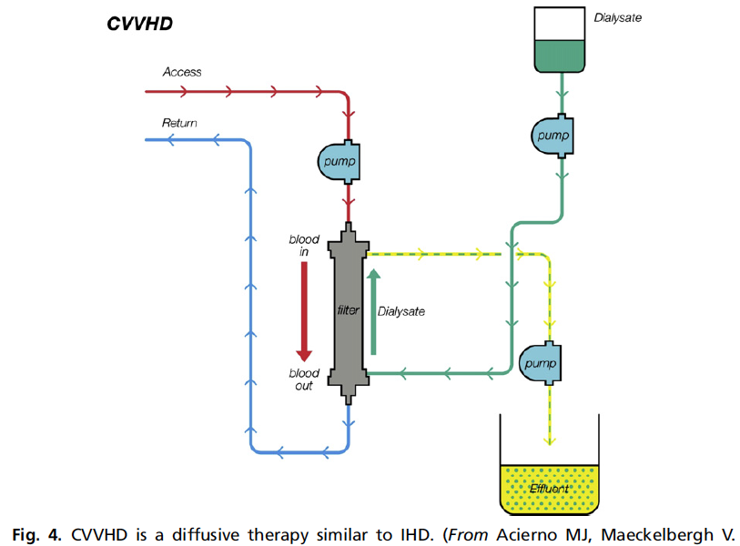

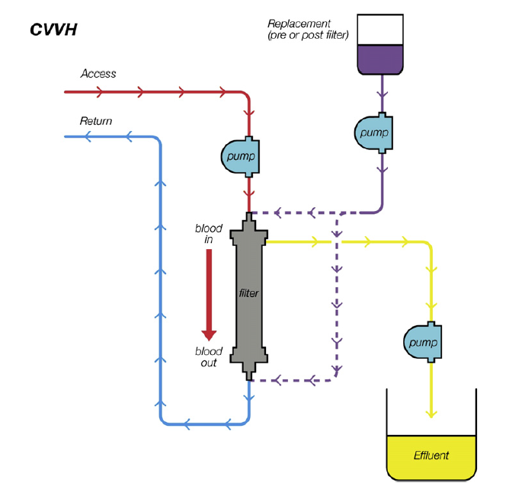
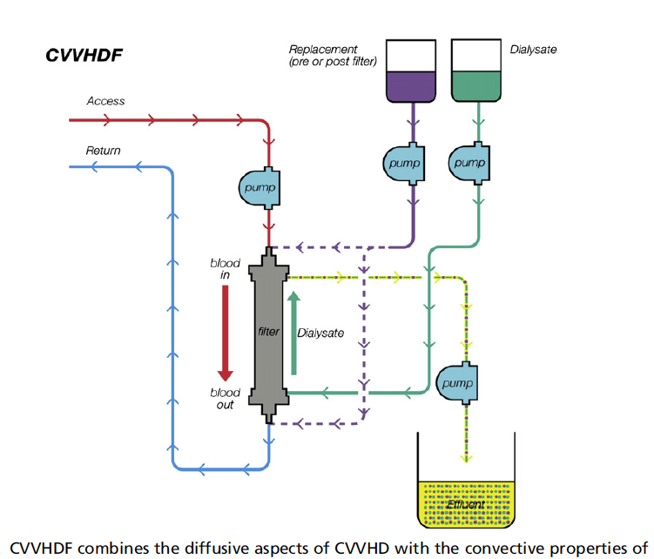

Although CRRT involves sophisticated technology, the actual process of blood purification can be divided into four easily described steps: (1) blood is diverted from the patient to the CRRT unit, (2) anticoagulants are added to the blood, (3) uremic toxins are removed and electrolytes normalized, and (4) the blood is returned to the patient.

