Questions for ScvO2 and ionized hypocalcemia:
- Assuming a normal arterial oxygen saturation, the following are causes of a high mixed venous oxygen saturation (SvO2):
- Tension pneumothorax
- High fractional inspired oxygen concentration
- Ventricular septal defect
- Anemia of chronic disease

- Assuming a normal arterial oxygen saturation (SaO2), which of the following is a cause of a low mixed venous oxygen saturation (SvO2):
  - Cirrhosis of the liver
  - Volume overload
  - Acute respiratory distress syndrome
  - Cardiac tamponade

- What is the equation for the O2 extraction ratio

- In the following diagram please label the 3 main shock states (Distributive, Cardiogenic, Hypovolemic) as to which curve they would belong to.
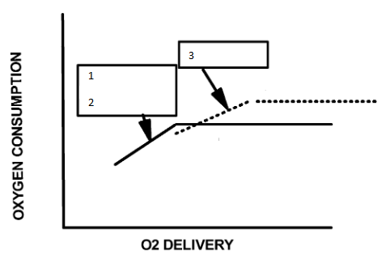
5) List three potential causes of hypocalcemia of sepsis

Questions and answers:
- Assuming a normal arterial oxygen saturation, the following are causes of a high mixed venous oxygen saturation (SvO2):
- Tension pneumothorax
- High fractional inspired oxygen concentration
- Ventricular septal defect
- Anemia of chronic disease

2. Assuming a normal arterial oxygen saturation (SaO2), which of the following is a cause of a low mixed venous oxygen saturation (SvO2):
  - Cirrhosis of the liver
  - Volume overload
  - Acute respiratory distress syndrome
  - Cardiac tamponade
Generally speaking, the mixed venous oxygen saturation is proportional to cardiac output. Thus, conditions with a low tissue oxygen delivery (DO2) such as hemorrhage, hypovolemia, cardiac tamponade, tension pneumothorax and acute anemia have a low MvO2; indicating high tissue extraction of oxygen. Conditions with a high tissue DO2 such as cirrhosis or excessive inotropic therapy have a high MvO2. Septic shock and acute respiratory distress syndrome are exceptions to this generalization, possibly due to the presence of a defect in cellular oxygen utilization, or peripheral shunting of blood.
3, What is the equation for the O2 extraction ratio
  - Oxygen extraction (O2ER) = VO2/DO2= (CaO2-CvO2)/CaO
4, In the following diagram please label the 3 main shock states (Distributive, Cardiogenic, Hypovolemic) as to which curve they would belong to.

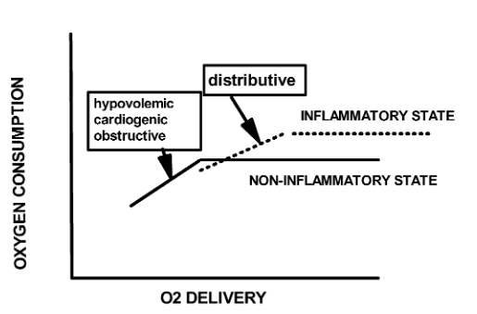
5. List three potential causes of hypocalcemia of sepsis
Potential causes include the following: impaired PTH secretion or action, impaired vitamin D synthesis or action, hypomagnesemia, chelation of calcium, alkalemia, accumulation of calcium in tissues or cells, or elevation of calcitonin precursors

Low central venous oxygen saturation is associated with increased mortality in critically ill dogs

Key Points
- Area under the receiver operator curve analysis selected a central venous oxygen saturation of 68% as the point below which a fall in central venous oxygen saturation was associated with increased mortality risk. Association NOT Causation
- Decreased ScvO2 suggests a mismatch between oxygen supply (DO2) and tissue oxygen consumption (VO2) in the tissues upstream from the point of measurement. ScvO2 falls either when tissue oxygen delivery falls below a critical level, or tissue oxygen consumption increases without a comparable and concurrent increase in oxygen delivery. A high ScvO2 can occur with relative tissue inactivity, hypothermia and mitochondrial dysfunction.
- Association between increased mortality risk and high ScvO2, hypothesized to be because of a combination of sepsis-associated microcirculatory alterations resulting in functional shunting of oxygen at the capillary level, together with mitochondrial dysfunction and failure of cellular respiration and oxygen uptake

Incidence of ionized hypocalcemia in septic dogs and its association with morbidity and mortality: 58 cases (2006-2007)
Key Points
- The following 3 hormones are responsible for calcium homeostasis: parathyroid hormone (PTH), calcitriol, and calcitonin. In response to hypocalcemia, the parathyroid gland releases PTH which stimulates calcium mobilization from bone and decreases calcium excretion through the kidneys. In addition, PTH promotes the formation of calcitriol (1,25-dihydroxyvitamin D3), which increases gastrointestinal calcium absorption. Therefore, PTH and calcitriol function to raise blood ionized calcium concentrations to normal limits. In response to hypercalcemia, the thyroid gland releases calcitonin, which decreases calcium mobilization from the bones and absorption from the gastrointestinal tract, and promotes calcium excretion through the kidneys. Thus, the antagonistic effects of PTH with calcitriol and calcitonin function to maintain calcium homeostasis through their effects
- Potential causes include the following: impaired PTH secretion or action, impaired vitamin D synthesis or action, hypomagnesemia, chelation of calcium, alkalemia, accumulation of calcium in tissues or cells, or elevation of calcitonin precursors
- Ionized hypocalcemia occurs in a greater percentage of patients with sepsis compared to critical illness and may be correlated with mortality.

