ISCHEMIA-REPERFUSION INJURY

QUESTIONS

- Please name and describe the 3 programs of cell death.

- Which of the following is a master regulator of the cellular response to low oxygen?
  - PHD: prolylhydroxylase
  - NF-ΚΒ: nuclear factor ΚΒ
  - HIF: hypoxia-inducible factor
  - MAPK: mitogen activated protein kinase

- True or False: Apoptosis, unlike necrosis, is not immunostimulatory and does not induce inflammatory response. Explain your answer.

- Which of the following is NOT endogenously produced?
  - H2
  - CO
  - NO
  - H2S

- Explain how breakdown of ATP to adenosine can result in enhanced endothelial barrier function.

QUESTIONS & ANSWERS

- Please name and describe the 3 programs of cell death.
Necrosis: Cell and organelle swelling with subsequent rupture of membranes and spilling of intracellular content.

Apoptosis: Caspase signaling cascade that induces self-contained cell death, shrinkage of the cell and nucleus, preservation of the membranes until late in the process.

Autophagy: Adaptive response to sublethal stress, proteolytic degradation of cytosolic components at the lysosome

- Which of the following is a master regulator of the cellular response to low oxygen?
  - PHD: prolylhydroxylase
  - NF-ΚΒ: nuclear factor ΚΒ
  - HIF: hypoxia-inducible factor
  - MAPK: mitogen activated protein kinase

- False - Apoptosis, unlike necrosis, is not immunostimulatory and does not induce inflammatory response. Explain your answer.
Apoptosis was traditionally viewed as less immunostimulatory than necrosis. It was recently found that apoptotic cells could release ATP which induces chemotaxis.

- Which of the following is NOT endogenously produced?
  - H2 attenuation of accumulation of ROS and preservation of MT function
  - CO (from RBCs; heme) stabilization of HIF
  - NO (from L-arginine) reduction of apoptosis and prevention of hypoxic pulmonary vasoconstriction
  - H2S (from L-cysteine) suspended-animation like state

- Explain how breakdown of ATP to adenosine can result in enhanced endothelial barrier function.
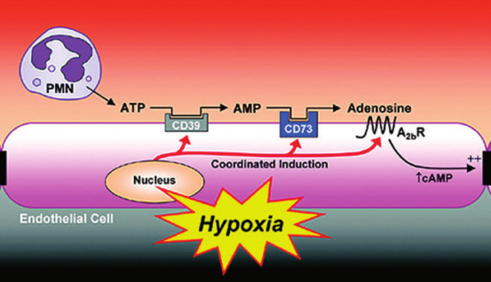
During the ischemic period, vascular hypoxia can cause increased vascular permeability. Studies using cultured endothelial cells exposed to ambient hypoxia (for example, 2% oxygen over 24 h) showed increased permeability after hypoxia exposure caused by lower cAMP levels. Intracellular cyclic AMP results in enhanced barrier function.

